Assignment:
A Markov Model helps to predict behavior by creating a stochastic model that assigns probabilities to the likelihood of staying in a particular state or changing to a new state.
Assignment submission must be a PDF that includes the following:
Refer to Appendix 1 – Markov Models.

- Code to create Table 1 and screenshot of Table 1 using the NEW WEATHER DATA (TABLE 1 must include column and row headings)
- Code to create Table 2 and screenshot of Table 2 using the NEW WEATHER DATA (TABLE 2 must include column and row headings)
- Updated Simulation Code
- Screenshot of the results of running the Updated Simulation Code
Your code must also include the following:
- Comments within your code should be sufficient to explain all functionality and usage.
- Error handling messages should also be included in your code, if not provided by MATLAB.

NEW WEATHER DATA: RRRSRRRRRSSSRSSSSSRRRRRRRRRRSSSSSSSRRRRRSSRRSSSSRRRSSSSSRRRRRSSRRSSSSSSSSSRRRRRRRSSSRSSSRRRRRRSSRSSR

Appendix 1 – Markov Models
[Sourced from https://www.mathworks.com/academia/courseware/introduction-to-engineering-analysis.html]
Let’s assume that the weather on any given day can be categorized as either sunny or rainy. We track the weather in Vancouver over 100 days:
RRRSRRRRRRRRRSSSSSRRRRRRRRRRRRRRRRRRRRRRRRRRSSSSRRRRRRRRRRRRRSSRRRRRRRRRRRRRRRRRRSSSRSSSRRRRRRSSRSSS
We also assume that the weather on the previous day has an effect on tomorrow’s weather (this is unlike the independent coin flips in the example in Appendix 1). Thus, we count the joint occurrences of the weather.
SS = 15
SR = 7
RS = 8
RR = 69
Re-organizing this data:
TABLE 1 << First Output of Assignment (include code in submission)

 | S | R
S | 15 | 7
R | 8 | 69

Normalizing each row such that each row sums to 1:
TABLE 2 << Second Output of Assignment (include code in submission)

 | S | R
S | 0.68 | 0.32
R | 0.10 | 0.90

This Markov matrix tells us the following: If today is sunny, there is a 0.68 probability that it will be sunny again tomorrow and a 0.32 probability that it will be raining. However, if today is rainy, there is a 0.90 probability that it will continue to rain tomorrow and only a 0.10 probability that it will become sunny. In other words, if it’s raining today, it will probably rain tomorrow. This can be visualized as a state diagram:
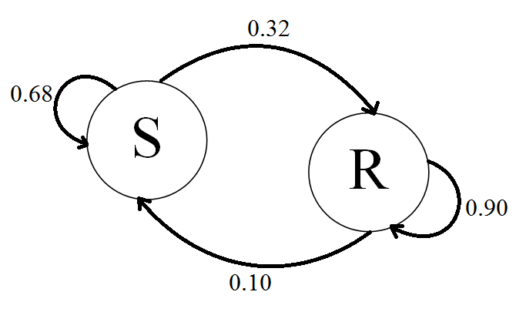
This simple two-state Markov chain can be simulated with the following MATLAB code:
SIMULATION CODE EXAMPLE << Assignment requires that it is updated with new s & r values
s = 0.68;
r = 0.9;
N = 100; %number of trials
rr = rand(1, N); %random numbers to simulate each trial
outcome = zeros(1, N);
display = 'SR'; %"sunny" is denoted by 1, "rainy" is denoted by 2

%Select a random initial state
outcome(1) = randi(2,1);

for ii = 2:N
if outcome(ii-1) == 1
%If today was sunny
if rr(ii) <= s
%Tomorrow will be sunny
outcome(ii) = 1;
else
%Tomorrow will be rainy
outcome(ii) = 2;
end
elseif outcome(ii-1) == 2
%If today was rainy
if rr(ii) <= r
%Tomorrow will be rainy
outcome(ii) = 2;
else
%Tomorrow will be sunny
outcome(ii) = 1;
end
end
end

display(outcome) <<< Include screen shot after script is run.

