In this project, you will research the relationship between nutritional information (total fat, carbohydrates (carbs), and proteins) of fast food.
You must use 10 items (a hamburger, a cheeseburger, chicken, fries, a drink, a dessert) from the menu of a burger restaurant. You will connect linear models to this real-world data. You will model your system numerically, graphically, and in written form. It is expected that your final written presentation will be well organized, make connections to your real-life scenario, and demonstrate your understanding of modeling.
Data Collection:
- Go to the nutritional information website for fast food (http://www.fastfoodnutrition.org/) to find your restaurant information to collect your data points (beverages, desserts, etc).
- Use two of the following of the given nutritional information items: carbohydrates, total fat, and protein to compare.
- Collect at least 10 pieces of data based on the nutritional information you chose to compare, including the 6 topics listed above.
- You will use this data to create a model that can be used to analyze the relationship between nutritional components of fast food.
Project Components. Using Google Sheets. Your project must include the following:  - A table illustrating the nutritional information you have collected from the website.  - Three visual display (graph) of your data that clearly communicates the nutritional information.  - A model/line of best fit for the data set and an explanation of how it was determined.  - An explanation of what the slope and y-intercept mean in the context of the problem.  - An analysis of the relationship between the two nutritional information items you selected.  - A mathematical explanation of the appropriateness of your model.  - Google Slide or Power point of your research  - Be ready to present your project to the class. | Guiding Questions:  - In which ways can I clearly communicate the nutritional information?  - How can I determine an appropriate model for the data set?  - How can residuals help me evaluate the appropriateness of my model?  - How can the correlation coefficient help me evaluate the appropriateness of my model?  - What is the implication of each nutrient to our health?  - What conclusion can you draw from your data?

Example: Data Display (Google Sheets):

SHS Burgers | Total Fat | Carbohydrates | Protein
Bacon Burger | 57 | 48 | 48
Hamburger | 13 | 28 | 10
Cheeseburger | 16 | 28 | 14
Fries (large) | 5 | 72 | 22
Coca Cola | 0 | 51 | 0
Chicken Burger | 22 | 42 | 25
Grilled Chicken Salad | 36 | 16 | 14
Ice Cream Sundae | 5 | 52 | 6
Caramel Ice Frappe | 4 | 72 | 22
Ham, Egg and Cheese Biscuit | 16 | 33 | 22

Steps:
      - Enter data
      - Highlight data
      - Insert – Chart
      - Chart Editor – create final scatter plot graphs
      - Play around with different graph views ( Stacked Column Chart )

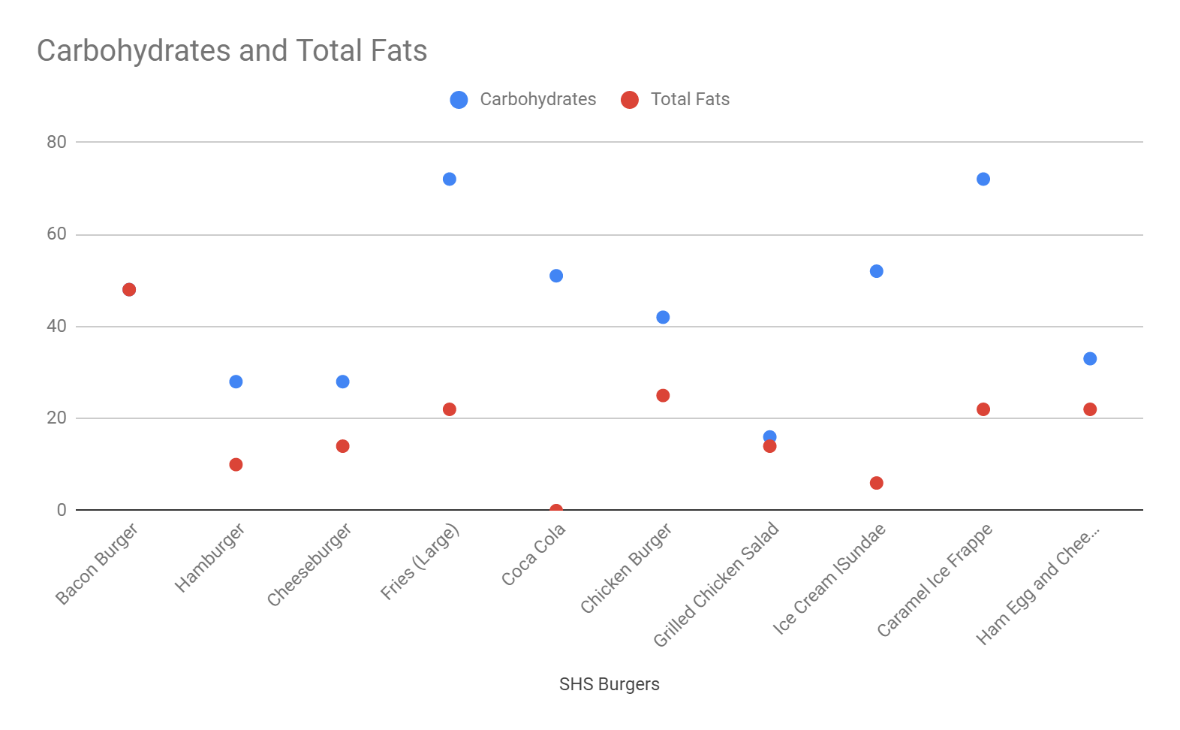

Model/Line of Best Fit (use calculator): | Interpretation of the Line of Best Fit
Two Student-Produced Questions about the model and answers:  - Question # 1 (Ex. What item had the highest amount of carbs? )  - Answer #1  - Question #2  - Answer # 2 | Correlation Coefficient (find r value):
An analysis of the relationship (causation) between the two nutritional information items you selected. (2 points)

Is your model an appropriate representation of the data? Why or why not? What other model would be a more appropriate representation (explore other graphs). (4 points)

Google Slide 20 pts
- Cover/Title Page (2 slides)
- How we started/what we did
- Table- 1 slide
- Charts - 3 slides
- Conclusion (4 slides)
- Carbohydrate: (high/low)
- Protein:(high/low)
- Fat: (high/low)
- My conclusion
(Total Slide: 12 or more)

Grade
- Google Slide 20 pts
- Google Sheet 14 pts
- Worksheet and analysis 25 pts
- Presentation 20 pts

