Magma properties and eruption style: determining gas content and eruption style from evidence preserved in volcanic rocks

*This version of the lab does not require a sample kit. Students will be given all of the data needed, and can be shown photos of lavas and pumice or can see samples of pumice and lava from your department collection. It is best to provide hand samples for students to look at, or even to try out Archimedes method as a side activity. You ideally should provide pumice, scoria from a Strombolian eruption, and obsidian from silicic lava flow for students to see.

Magma is a substance that forms in the crust from partially molten rock. It is composed of a gas phase (bubbles), liquid rock, and solid mineral crystals. How do we know? We can see evidence of all three things in volcanic rocks! Crystals are solid minerals that form when magma cools. Liquid rock is present as a melt phase. When cooled quickly, the melt part of the magma freezes to form glass. Magma can cool a little bit to make crystals, but still be partially molten. Mineral crystals “swim” around in the melt. Gas bubbles are trapped in magma when it erupts. When the magma freezes after it erupts, the gas bubbles are frozen into the rock, forming holes or “vesicles”.

The gas part of the magma can lead to an explosive eruption if the magma cannot get rid of the gas quickly as it rises up to the surface. Large pressures can build up as the gas expands when pressure on the magma is released. When the magma is stiff (high viscosity) and the pipe or conduit the magma is traveling in is sealed off, the large gas pressures can cause very high energy explosions. The magma is pulverized (fragmentation) into fine ash and larger pieces like pumice.

If we know how much gas a magma contains, how stiff (or viscous) it is, how fast it is moving up to the surface, and whether the pipe or conduit is sealed, we can determine how likely it is for an eruption to be explosive (making a lot of hazardous ash) or effusive (making much less hazardous lava flows).

Objective: In this lab you will estimate volcanic rock porosity/vesicularity from bulk density, and use the percent vesicularity as a proxy for magma gas content. You will determine how explosive an eruption was based on the amount of gas preserved in different types of volcanic rocks.

Learning outcomes:
1) Learn about different volcanic rocks that have different amounts of vesicles and the types of eruptions that created them.

2) Estimate the amount of gas a magma had by calculating volcanic rock bulk density and porosity.

3) Learn about data quality, statistics, and analytical uncertainty in a basic way.

4) Apply the results to a simple model of eruption style as a function of magma gas content

Part 1 – Learn about different types of volcanic rocks that have different vesicularities.

Definitions:
Volcanic rock – an igneous rock that erupted from a volcano and cooled quickly (at least in part) in air or water on the surface of the Earth.

Vesicles – trapped gas bubbles that were frozen into a volcanic rock when it was erupted. Vesicles are holes in the rock, now filled with air, that were once the gas bubbles in the magma before it erupted.

Pumice – a particularly “frothy” or foamy rock that has a lot of vesicles:

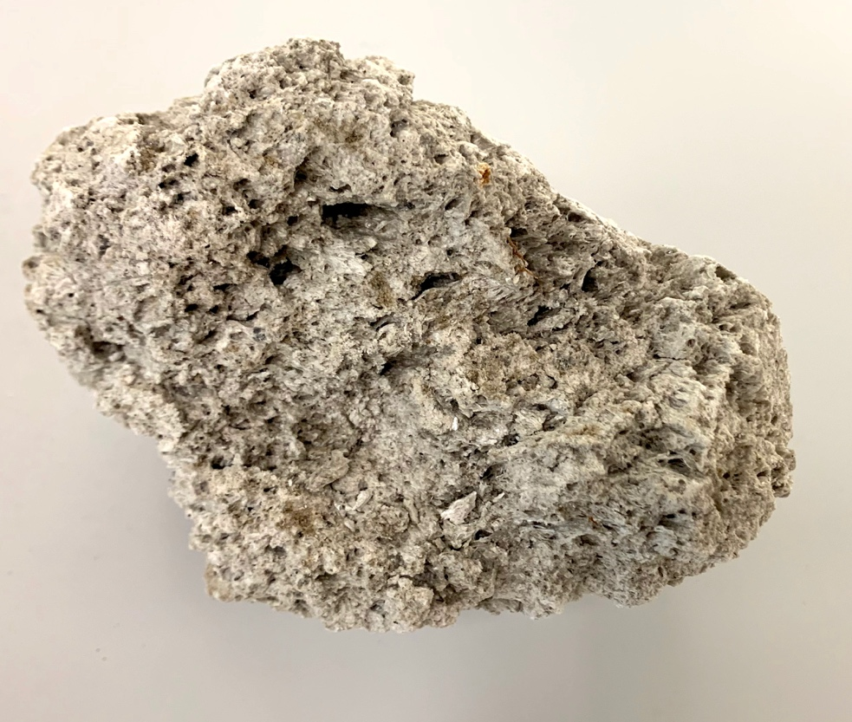
Photo of pumice from the 1883 Krakatau eruption

Scoria – a volcanic rock that has a medium amount of vesicles.
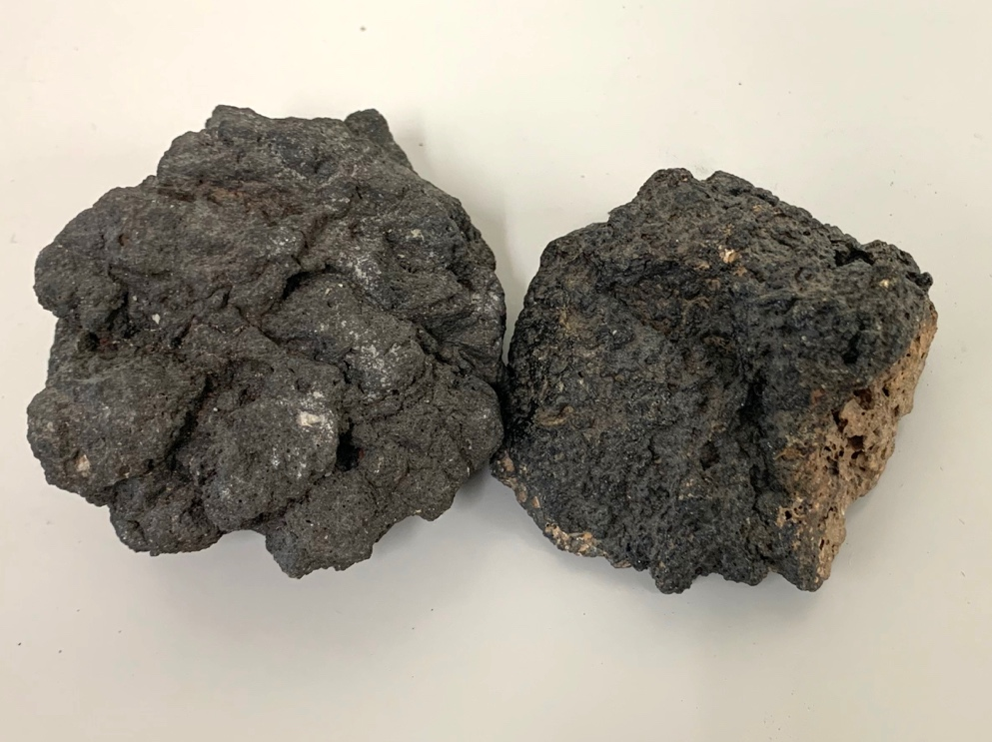
Photo of scoria from a cinder cone

Lava – a dense type of volcanic rock that does not have as many vesicles.
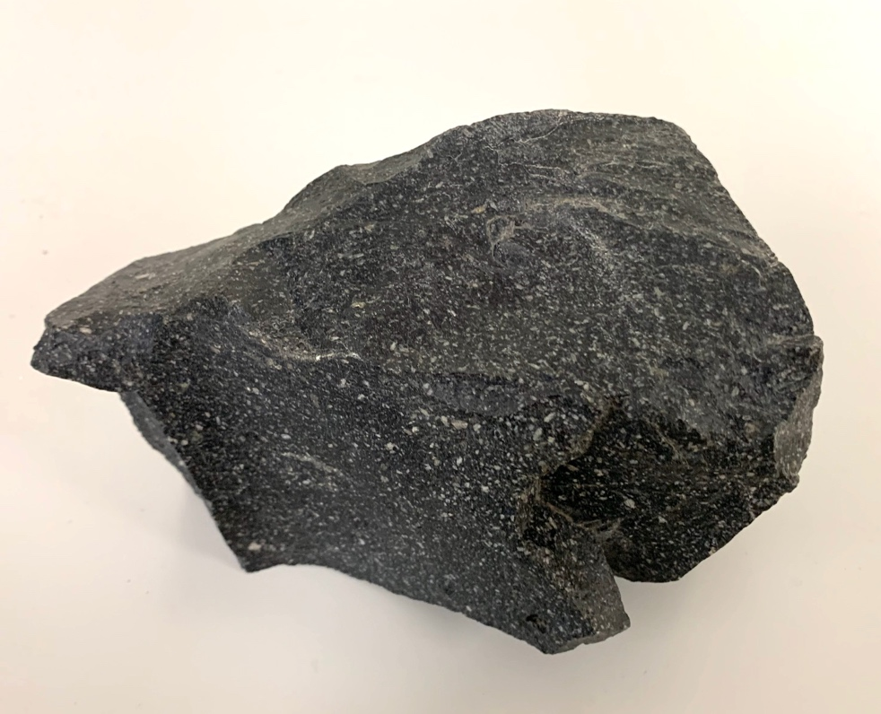
Photo of lava from Popocatepetl volcano, Mexico

Examine the photos of each of the types of samples (and/or take a look at the samples provided by your instructor). Answer the following questions:

1. Approximately how many vesicles does each type of sample have? Do your best to make an estimate of the percentage of vesicles in each of the example photos/samples.

Pumice -

Scoria -

Lava -

2. Based on your estimates, do you think any of these samples could float in water?

3. If you were to imagine that the rock samples were once molten magma beneath the volcano, what do the vesicles represent? (ie what were the vesicles when they were still in the molten magma?)

4. If you have hand samples available, pick each one up and determine how much you think each weighs, relatively. On the scale below, write down where the pumice, scoria and lava samples should be in terms of their weights:

-------------------------------------------------------------------------------------------------------
Lightest weight Heaviest weight

5. In the space below, write down the amount of gas you think the magma had in it when each of the samples erupted:

----------------------------------------------------------------------------------------------------------------
The least amount of gas The most gas rich

6. Let’s use gas content alone as a way to determine relatively how explosive each eruption must have been to produce each of the samples. In the space below, rank each sample in terms of how explosive you think their eruption was:

-------------------------------------------------------------------------------------------------------
Least explosive Most explosive

Archimedes principle applied to estimating magma gas contents

Part 2. Calculating magma vesicularity from the percentage of vesicles in a sample of volcanic rock from an eruption.

In this section, you will use data given to you to estimate the amount of gas in different types of magmas from data collected from the volcanic rocks each eruption produced. You will use this information to estimate how explosive each type of eruption was, based on gas content.

The density of an object is equal to its mass divided by volume: Density = mass/volume

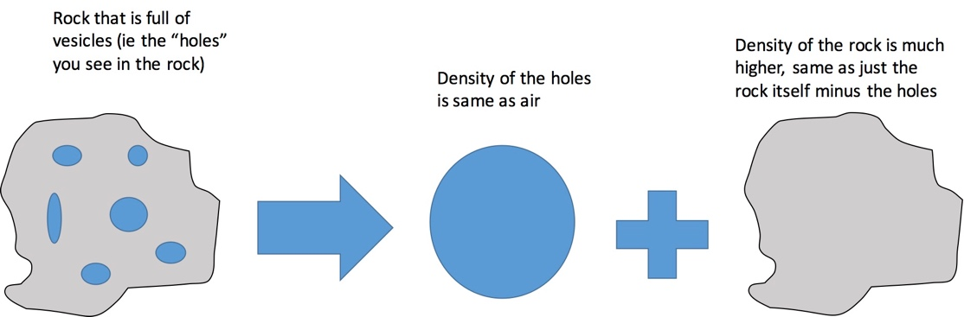
Figure showing the concept of bulk density. Dense rock density of a rock without vesicles is just the density of the solid rock part. The bulk density of a rock that is full of vesicles is a combination of the density of the air-filled holes and the solid rock part.

The approximate percentage of gas in a magma can be estimated by measuring the percent of a volcanic rock made up of the vesicles. If we can use volcanic rock samples to estimate the content the gas had in the magma as it rose in the conduit, all we need to do is estimate the volume of vesicles compared with the total volume of the volcanic rock sample. Easy, right? But how does one go about measuring the volume of a highly irregularly shaped object, and then all the “holes” within it?

To solve this volume problem, Archimedes principle can be used. An object submerged in water will be buoyed (or lifted) up by a force that is the same as the weight of water displaced by the object. If you imagine getting into a bathtub completely full of water, you know water will slosh out of the tub because you added your volume to the tub and displaced some of the water. Diagram of how to measure the density of an object using Archimedes method
Diagram of how to measure the density of an object using Archimedes method

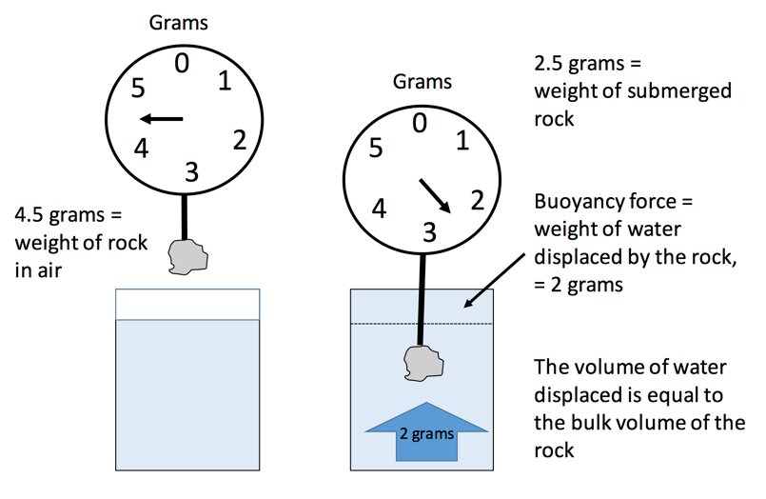
Because the volume of an object is linked to weight by density, we can use this method to measure the volumes of the rock samples.

7. You are given data for three types of volcanic rocks that were measured using Archimedes method: pumice, “scoria”, and lava. The data you are given is the bulk density determined using Archimedes principle in the Experimental Petrology Lab at UAF from three different volcanoes: Aniakchak caldera, Alaska; Okmok caldera, Alaska, and Obsidian dome (Inyo domes), California.

Table of density data for the different types of volcanic rocks:
Sample | Bulk Density (grams per cubic cm) | Dense Rock Density | % Vesicularity | Gas content (high, medium, low)
Aniakchak, Alaska
98ACJL008A | 0.71 | 2.60
98ACJL2-1 | 0.63 | 2.60
98ACJL2-2 | 0.76 | 2.60
Okmok, Alaska
99JLOKMS J2 #34 | 1.62 | 2.70
99JLOKMS J2 #26 | 1.54 | 2.70
99JLOKMS J2 #38 | 1.56 | 2.70
Obsidian dome, CA
17NAGINYO-11-3-OD | 2.21 | 2.35
17NAGINYO-9-3-OD | 2.23 | 2.32
16JFLINYO-40B-OD | 2.07 | 2.25

8. Calculate the percent vesicles in each sample, using the following formula:

Percent vesicles = 100 * [(Dense rock density – bulk density)/Dense rock density]

Show your work for at least one of the sample calculations:

9. Fill in the columns in the table above with your answers.

10. Now calculate some simple statistics. Calculate the average percent vesicles (vesicularity) in each type of sample from the three measurements from each (lava, scoria, pumice).

Average = (v1 + v2 + v3)/3 where v1 = vesicularity estimate 1, and so on.

Average vesicularities:

Aniakchak pumice:

Okmok scoria:

Obsidian dome lava:

Standard deviation is a measure of how close together or far apart the set of measurements is from each other. Each measurement even on the same type of sample can be different based on a few things, like measurement error (ie the measurer made a mistake) or natural differences in the densities of each sample – not all rock samples will give exactly the same result even if they were made by the same process.

11. Calculate standard deviation for each sample set/type, using the following equation. Standard deviation is s. First calculate sum of the difference between each value and the average value, and then square that number. Then, multiply the sum of squares value by 1/n, where n is the total number of measurements (3 for each sample). Then, take the square root of that value:

$$σ= \sqrt{\left(\frac{1}{n}\right)*\sum{{\left(value-average\right)}^{2}}}$$

Show your work:

12. Write in the standard deviation for each of the samples below:

Aniakchak pumice:

Okmok scoria:

Obsidian dome lava:

13. Examine your statistical data. Assume that the average values you calculated for each of the datasets are a good representation of the true percent vesicularities of each magma and that a good dataset includes measurements that are all within 10% of that value. Calculate the percent difference by dividing the standard deviation by the average value, and multiple by 100. Compare your percent difference estimate against the 10% threshold for each sample below. Are the data in each sample set good to within 10%?

Pumice –

Scoria –

Lava –

14. If you imagine each of these samples represents when the magma erupted, what do the % vesicles represent?

15. Based on your answer above, revisit your ranking of each type of sample in terms of how explosive the eruption that created it was. Was your initial, weight only based estimate correct?

Part 3. What about how strong and solid, or weak and leaky the volcano pipe is?
In real volcanoes, the behavior of the gas alone does not completely determine the eruption style. The pipe carrying magma up to the surface can create a strong, sealed or weak, leaky container for the rising magma as the gas expands. In this section, you will learn how much gas can expand when a magma rises to the surface and loses pressure, and how expanding magma gas can create a lot of pressure in the conduit. If the pressure is high and the conduit is sealed, the eruption will likely be explosive and make a lot of pumice and ash. If the pressure is relieved by a conduit with “permeable” (leaky) walls, then the eruption is more likely to be effusive and produce lava flows.

Estimating how much gas expands in magma as it rises up to the surface:

The ideal gas law is Pressure * Volume = n * gas constant * temperature. If the temperature does not change, then P*V = a constant. This equation provides a simple way to see how pressure and volume of a gas in magma are related. Simply, the lower the pressure, the bigger the gas volume, and vice versa. When a magma is deep in the crust, pressure on it from all the overlying rock is big. When the magma rises up towards the surface, the pressure is progressively lessened as it goes up.

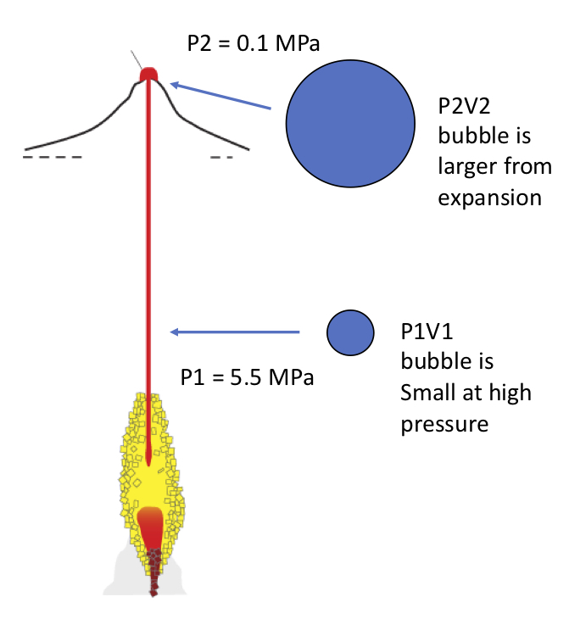
Deep in the crust, the bubble is at Pressure P1 and has volume V1. When the magma rises up, the bubble now has Pressure P2 and Volume V2

If P1V1 = P2V2 and we set an initial pressure on the magma from the overlying rocks of 5.5 MPa and a final pressure of 0.1 MPa (which is equal to the atmospheric pressure on the surface of the Earth), we can estimate how much larger the bubble can be just from the gas volume expansion as pressure is released:

Cartoon showing relative bubble size with depth inside the volcano conduit

16. Calculate how much bigger the bubble will be as a multiplier on its original volume V1:

V2 = V1 * P2/P1

V2 = ______ V1

17. What do you think might happen if the bubbles expand really fast and by a lot inside of a sealed up conduit?

A simple experiment to demonstrate sealed versus leaky conduit pipe:

A fun way to watch the effects of a sealed versus leaky conduit can be done using an Alka Seltzer table in a plastic film cannister, with a little water added.

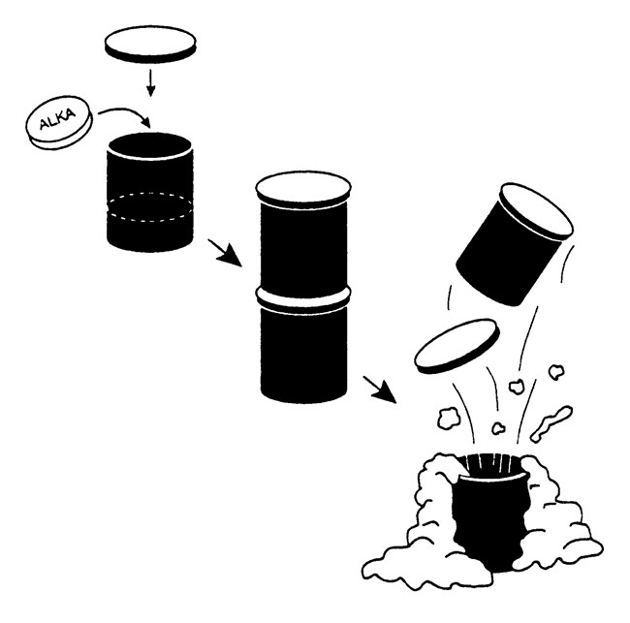
From NPS website: https://www.nps.gov/crmo/learn/education/activity-2d.htm

Materials:

Two plastic film cans – one with holes poked into it using a pin. Alka Seltzer tablets. Water. A towel to clean up with. Safety glasses – For this experiment, everyone close to the action must wear safety glasses!

Procedure:

a) Add water to the film canister until it is about 1/3 full. Drop the Alka Seltzer tablet into the can, snap the lid closed, and step back! Students and teacher should be using safety glasses for this exercise.

b) Repeat with a second film can with the holes poked into it with the pin. This one is messy so have some towels handy and do it on a surface that can’t be harmed, like a lab table.

18. Describe the results from each experiment below in your own words. Notice things like – did either make a sound? What did they sound like? How high did the film can go? What happened to the bubbles in the can with holes in it? And anything else students want to observe.

19. From the film can experiment, what would you expect to happen in a gas-rich magma inside a tightly sealed up (impermeable) conduit?

20. What do you expect should happen in a gas-rich magma that is inside a conduit that has walls full of cracks, holes, and other openings?

21. Which type of conduit do you think is most likely to cause an explosive eruption? Which will cause an effusive eruption?

Part 4. Wrap up - revisit and summarize your work and models.
Use what you learned in this lab to describe the connections between gas content in a volcanic rock and the most likely type of eruption (explosive or effusive) that created it.

22. Briefly describe how magma gas content and a sealed up versus leaky conduit can lead to explosive or effusive eruptions.

23. For each type of sample you studied, describe the type of eruption that created it below:

Lava-

Pumice-

Scoria-

