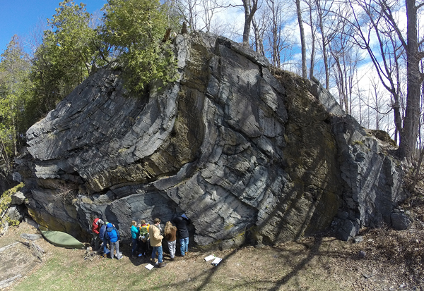
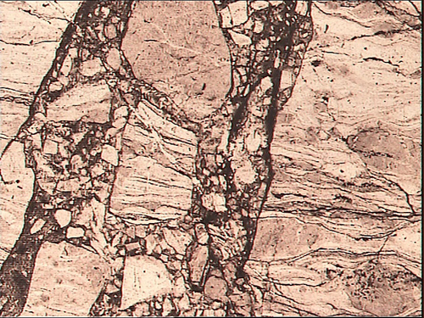
Structural Geology

Spring 2019
Syllabus ver. 1.0

Barbara Tewksbury
Science Center 1013; X4713
btewksbu@hamilton.edu
Office hours: MWF 11-12:30
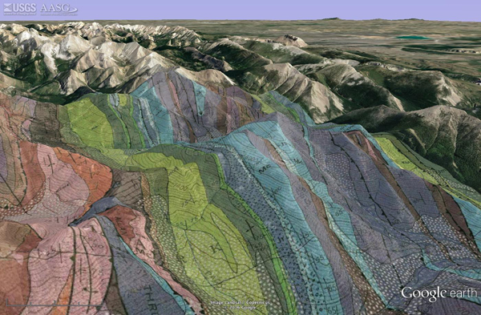
TR 3:00-4:30
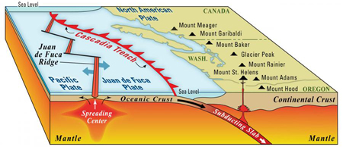
Not available MWF 12:30-2

Goals
- To enable you to describe and interpret geologic structures in unfamiliar geologic maps and aerial/satellite images, to construct cross sections, to infer geologic history from map and image data, and to interpret structures in the context of regional tectonic history.
- To enable you to make appropriate observations of structures at different scales, ask relevant questions, collect appropriate data, and make evidence-based interpretations about the processes and histories by which the rocks reached their present form.
- To enable you to combine the tools and concepts of structural geology with other geologic and geodetic data sets to evaluate the context, setting, cause, and risk of damaging earthquakes in a particular area and make related informed decisions.
- To expand your brains for rocks.
Each subdiscipline in geology provides its own unique perspective on how the Earth works. So, what do structural geologists worry about? What is their unique perspective? Structural geologists are concerned with changes in rocks produced when rocks are subjected to stress.

- What happens when rocks break? Why do some rocks break and not others?
- What actually happens inside rocks and minerals to produce folds at all scales when we normally think of rocks as being stiff and brittle?
- What governs rock strength? What determines how a rock responds to stress?
- How do structures evolve over time? What are the forces involved that cause all of this to happen, and where do these forces come from? How and why do they change over time?
- Can we use structures to constrain plate tectonic models for past events?
- How are the resources that we depend on, such as petroleum and water, influenced by the structures that develop in an area?
- How does an understanding of structural geology help us to predict and mitigate risk from natural hazards?

Week 1
Wed Jan 23 intro to the global context for crustal structures; interior of the Earth, crustal types, seismicity
Fri Jan 25 velocity vectors, strain style, types and locations of plate boundaries

Week 2
Mon Jan 28 birth and death of oceanic plates; continent-continent collision
Wed Jan 30 plate processes, isostasy, and topography
Fri Feb 1 introduction to Cascadia quiz on Basic Skills

Week 3
Mon Feb 4 intro to Cascadia
Wed Feb 6 basic fault terminology, strike and dip, strain significance of faults
Fri Feb 8 more on faults; maps and cross sections quiz on Basic Skills

Week 4
Mon Feb 11 normal fault systems, kinematics, and cross sections
Wed Feb 13 folds in layered rocks, basic fold terminology; map views, cross sections
Fri Feb 15 satellite images, maps, and cross sections of folds quiz on Basic Skills

Week 5
Mon Feb 18 fold and thrust fault systems and kinematics
Wed Feb 20 strain rate and strain style in American West in the context of PBO velocity vectors
Fri Feb 22 velocity vectors from PBO GPS installations in American West quiz on Basic Skills

Week 6
Mon Feb 25 earthquake basics; intro to focal mechanism solutions; Nisqually-type quakes in Cascadia
Wed Feb 27 slip vectors, P & T determinations
Fri Mar 1 Tohoku quake and significance for Cascadia quiz on Basic Skills

Week 7
Mon Mar4 Deformation in Puget Lowlands and Yakima regions
Wed Mar 6 Nisqually-type quakes; Geo map IDM
Fri Mar 8 sand table, topo maps, and outcrop patterns quiz on Basic Skills

Week 8
Mon Mar 11 structure contours, outcrop patterns of contacts
Wed Mar 13 apparent dip, outcrop width, determining strike and dip from maps
Fri Mar 15 more geologic map interpretations

Week 9
Mon Apr 1 more geo map interpretation, cross sections
Wed Apr 3 more practice with geologic map interpretation and cross sections
Fri Apr 5 prediction of Puget Lowlands structures based on velocity vectors

Week 10
Mon Apr 8 nature of the Seattle Fault Zone
Wed Apr 10 more on the Seattle Fault Zone
Fri Apr 12 response of rocks to stress; strength profiles of the crust and upper mantle

Week 11
Mon Apr 15 stress-strain relationships; rheology
Wed Apr 17 brittle deformation mechanisms: processes and products
Fri Apr 19 plastic deformation mechanisms: processes and products

Week 12
Mon Apr 22 PBO GPS data from Cascadia and ETS (episodic tremor and slow slip)
Wed Apr 24 ETS and deformation mechanisms
Fri Apr 26 stress equations; Mohr circle for stress

Week 13
Mon Apr 29 field trip prep – Bruntons, stereonets
Wed May 1 field trip prep – cleavage-bedding relationships, top indicators
Fri May 3 more field trip prep – geology of Glens Falls/Whitehall area
Sun May 5 Field trip to western Vermont will leave very early and be back about 9 pm

Week 14
Mon May 6 field trip wrap-up – Grenville and Taconic orogenies, tectonic context, modern analogs
Wed May 8 Mohr circle for stress and influence of pore fluid pressure
Fri May 10 high Pf case study: Lusi mud volcano

Week 15
Mon May 12 ETS revisited – rock rheology, pore fluid pressures, implications for megathrust risk

Friday May 17 Final Assignment due at 5 pm

Nuts and bolts
Class meeting times are Mondays, Wednesdays, and Fridays from 2-4:00. Please come to class a few minutes early so that everyone is ready to start on time. There may be a couple of days scattered throughout the semester when I will be out of town. I apologize for that, because I know it will inconvenience some of you to re-schedule the classes that we’ll miss. I will let you know about these as early as possible.

We will also be taking a one-day field trip at the end of April. This is a mandatory field trip, so please be sure to put it on your calendar right away.

I will commonly communicate with you via email. I expect you to check your email on a daily basis and to keep your email from going over quota.

Format of the course and your responsibilities
If you haven’t had a course from me before, you might be surprised by the structure of the class. I expect a lot, and I place a great deal of responsibility on you. After all, I can’t do your learning for you! I care very much that you learn in this course, and having me stand in front of you and talk at you for two hours at a stretch would allow me to present material but wouldn’t do much to help you learn. So! I will design class sessions around having you do structural geology, rather than having me talk at you about it. You will come away from this course with skills and knowledge in structural geology that you can use in the future, not just some material that you can spit back at me on a test.

I will also give you a homework assignment each class period. Daily homework is not busywork – the work you do will consolidate what we have done in the previous class and, more importantly, prepare you to move ahead in the next class. You should not expect that we will go over homework in class. I will assume that everyone has a solid grasp of the homework, and we will build from there. It is, therefore, your responsibility to complete your homework and turn it in on time at the start of class. If you have questions, you must come see me or Robert Welch (who is our TA) well before class. I do not mind if you talk over homework items with others in the class, but I do expect you to do your own work and not just copy someone else’s work. In the long run, you won’t learn much if you rely on someone else to figure it out for you, and, when the time comes to do it on your own (on an exam, for instance), you will be at a distinct disadvantage if you haven’t learned how to figure it out yourself.

Details about homework
Homework assignments are posted on Blackboard in the Documents folder. I will normally turn homework back before or during the following class. If you turn homework in late, I will take 10% off the grade. If you turn homework in after I have turned graded assignments back to the rest of the class, I will correct and return your homework but you will not receive a grade or credit. If I turn homework back late, you will get a 10% bonus.

Books and supplies
You’ll need the following for the course:
text: We will use an online structural geology textbook by Ben van der Pluijm and Steve Marshak. Please go to the following web site and purchase access for the semester: http://psgt.earth.lsa.umich.edu/#charges Access is only $10 - please DO NOT share access codes. That would be patently unethical and unfair to the authors. Once you have paid the access fee, you will get an email with an access code and password that will be good for the semester.
hand lens: If you don't own a hand lens, you will also need to buy one from me. It must be a regular hand lens, not the large brown magnifiers that you may have used in other classes.
protractor: you must buy a 360 protractor from me. They are $2.
equipment: You will need a mechanical pencil and an eraser (do not take notes in pen, please!!!), and, for many classes, you will need your hand lens and your laptop.
Please bring your pencil, eraser, laptop, protractor, and hand lens to class unless I say otherwise.

The Basics of Geology
Because this is a 200-level course, the Department expects you to bring a certain amount of basic knowledge in geology to this course. What we expect you to know (and which I will not go over in class) appears in the departmental handout “The Basics of Geology”. You will take a series of weekly quizzes on this material according to the schedule in the syllabus. Help sessions will be available early in the semester, if you need to bone up on the material.

Micro-exams questions
Instead of giving you a big honking midterm exam, I will add a few short open-book “exam” questions to homework assignments that are due on Mondays starting a couple weeks into the semester. The difference between homework and micro-exam questions is that you must work on them entirely on your own. Although questions will focus on what we have worked on most recently, it will be fair game for me to resurrect older topics to keep you on your toes.

The Final Assignment
I’ll give you more details later in the semester.

Grading
When all is said and done, I will calculate the grade that you have earned as follows:

problem sets and case studies 40%
final assignment 20%
Basic Skills quizzes 10%
cumulative micro-exam points 30%

Notice that I haven’t allotted a percentage for in-class work. I do not collect or grade your in-class work, because anything you do during class will be completed and corrected in class. That doesn't mean that in-class work doesn't count! In fact, completion of in-class work each week is mandatory, and you will have no opportunity to make up missed in-class work. If you don’t do your in-class work, your final grade will, unfortunately, suffer.

You can use the Blackboard Grade Center to track your graded assignments, and you should check it periodically to make sure that there are no errors or omissions. I will determine your final grade based on the percentages above and using Hamilton’s conversion from points to letter (98=A+, 95=A, 92=A-, 88=B+, 85=B, 82=B-, 78=C+, 75=C, 72=C-, 68=D+, 65=D, 62+D-, 58=F).

Disabilities
Hamilton College will make reasonable accommodations for students with properly documented disabilities. If you are eligible to receive accommodation(s) and would like to make a formal request for this course, please discuss it with me. You will need to provide Allen Harrison, Associate Dean of Students (Elihu Root House; ext. 4021) with appropriate documentation of your disability.

I have read the syllabus and course information for Geosc230 for spring 2019 and understand both my obligations and the consequences for not meeting those obligations.

_______________________________ ________________
Signature Date

