Teaching Notes: Topographic differencing: Earthquake along the Wasatch fault

Audience: Undergraduate to master-level students. The background material is designed for students who have some geologic background, for example students who are familiar with plate tectonics and the different kinds of faults. The exercise would fit well as part of a geophysics, structural geology, geomorphology, active tectonics, or geohazards course. The exercise has been used in a GIS class where some students had little geologic background. In this case, the exercise can still be successful as long as more time is dedicated to the pre-exercise lecture.

Skills and concepts that the students must have mastered: Basic knowledge of plate tectonics is ideal. For example, students should know about the different types of faults, although this material can be covered in the pre-exercise lecture. Students are not expected to have used CloudCompare software before or any other specific GIS software packages. Students are expected to do arithmetic and trigonometric calculations and to perform unit transformations.

How the activity is situated in the course: There is flexibility here and it depends on which type of course is using this activity. In a structural geology or geophysics course, this exercise would fit well within the seismic hazard and/or active faulting portion of the course. The exercise is stand-alone. The introductory lecture and introduction to CloudCompare take one hour. Three hours should be adequate for students to complete the majority of the lab. They may need to complete the write-up as a homework assignment.

Learning objectives:

- Visualize how earthquakes permanently deform landscapes: Surface rupturing earthquakes expose fault scarps at the Earth’s surface. In this exercise, students will map a fault scarp from a topographic hillshade.

- Describe the relationship between fault slip, surface displacement, and earthquake magnitude: Ideally, students will be able to visualize that earthquakes cause permanent movement of the Earth’s surface and understand that the amount of fault slip at depth controls the surface displacement.

- Interpret quantitative geospatial datasets: After students have made their measurements of surface displacement, they will plot and then interpret their results. To determine which type of fault was activated students must consider the noise in their measurements.

- Learn CloudCompare skills- load data, scissors, point picker, fine point cloud alignment. Students will gain practice working with geospatial and specifically point cloud datasets.

Higher-order skills: This exercise requires students to plot geospatial data on a topographic hillshade map. To determine the type of fault activated, they must determine how noise impacts their measurements of surface displacement. Estimating the amount of fault slip requires that students can visualize and plot their measurements on both a map and a 1D profile.

Other skills: Team work and writing-- We found that students like to work individually to make the displacement measurements and practice using CloudCompare. This means that students get maximum practice using these tools. They benefited from discussing the results in small groups and then as a class. Students are asked to write a report where they describe and synthesize their results.

Computer Software Prep: CloudCompare software is required. The software is open source and works on Mac, Windows, and Linux OS. We recommend downloading the most recent stable version of the software (i.e., not beta) available for your operating system (http://www.danielgm.net/cc/release/).

For Mac, open the dmg file and then click the Cloud Compare icon. A warning message saying that the application was downloaded from the internet may open. It is okay to open Cloud Compare. If you still cannot open Cloud Compare, you may have to go to System Preferences-> Security and Privacy-> Allow apps downloaded from: App store and identified developers. These instructions may change for future Mac OS. In this case, the solution is likely easily searchable on Google.

For Windows, the downloaded and run the exe file.

No other software is required. The rest of the exercise is best done with paper and pencil. Students need to make a few arithmetic calculations (adding, multiplication, trigonometry). These can be performed with a calculator, cell-phone, internet, etc.

Teaching Materials: https://opentopography.org/learn/ugrad_differencing

- Introductory lecture: Includes background material on seismicity in Salt Lake City, 3D differencing generally, and how to perform the 3D differencing in Cloud Compare.

- Handout with assignment: Includes written introductory material, the assignment, and several plots that are required to complete the assignment.

- Student video describing how to perform 3D differencing using Cloud Compare: We suggest that the instructor views this video prior to the lab class. The video covers similar material to the introductory lecture.

- Pre- and ‘post’- earthquake point cloud (.las files): 3 large tiles of pre- and post- earthquake. The ‘small.las’ file that may work better on some laptops or for a slower internet connection. Be sure to download at least one set of matching pre and post las files.

- Instructor video with explanations to the answers: Send an email to cpscott1@asu.edu for access.

- Written solutions to the quantitative questions. Send an email to cpscott1@asu.edu for access.

Places where students often struggle:

- CloudCompare:
  - Drawing boxes on CloudCompare: ICP displacement measurements are typically better for larger box sizes. As long as the boxes do not cross the fault, there is really no limit to the box size. It is very important that the reference window has a buffer on all sides relative to the compare window.

  - Color for CloudCompare measurements: The pre- earthquake dataset has RGB color, and the post-earthquake dataset does not. This can make it easier to tell the two datasets apart when looking over a student’s shoulder.

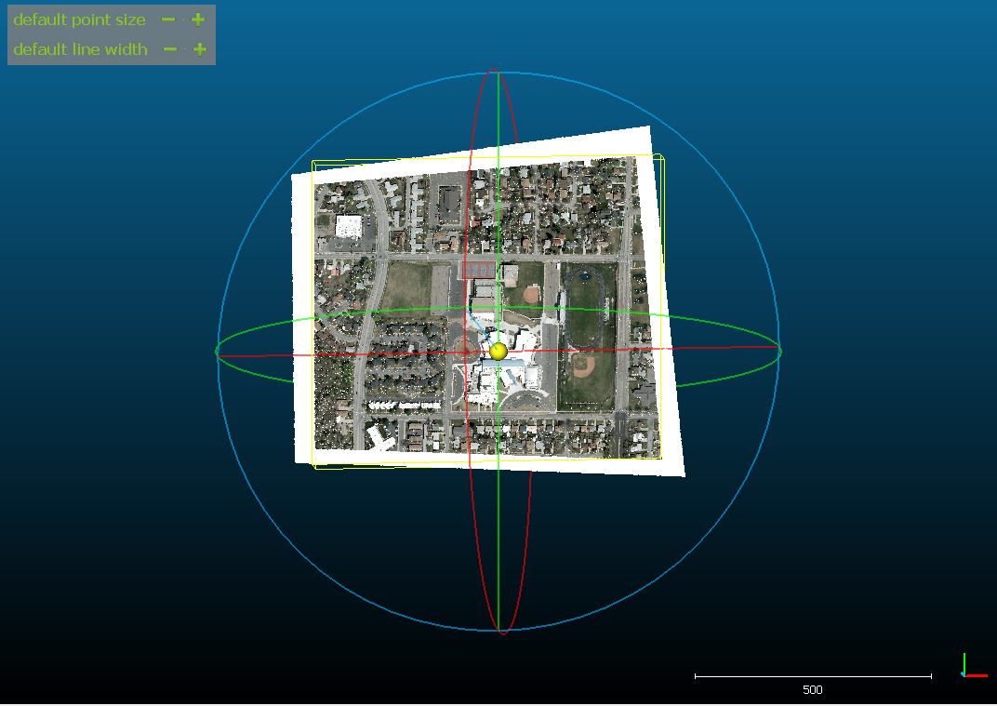

  - If a CloudCompare measurement does not look good or generates an error, it is best if the student ignores that individual measurement and makes a new measurement elsewhere.

  - In CloudCompare, there is no ‘back’ or ‘undo’ button. If you are looking for these buttons, it can be easier to restart CloudCompare and reload the data.

- For many students, the most challenging part of the exercise is determining the type of fault activated in the earthquake (e.g., normal, reverse, strike-slip). Overall the measurements that the students make should be consistent with a normal fault, but in detail each measurement has noise. Typically, the vertical displacements have less noise than the horizontal displacements. Some students struggle with the fact that their data contain noise, and asking them to think about the sources of noise can shift their perspective about how to interpret their measurements. Also, a suggestion to emphasize the vertical displacements helps many students get the correct answer and then they ponder why there is more noise in the horizontal displacements.

- We asked students to plot their measurements on the board. This helped to increase the sample size in the case that a student has a particularly noisy set of measurements. This also facilitated conversation between students as they decided how to collectively plot their measurements.

- In many classes, the vertical motion of normal faults is emphasized. But normal faults also produce significant horizontal motion in the direction perpendicular to the fault strike. So the students should expect some horizontal motion in normal faults when considering which type of fault was activated.

- Due to the logarithmic scale of earthquake magnitude, students should get approximately the correct magnitude even with some minor errors in the estimated fault geometry and the amount of slip. However, their estimated magnitude will be very wrong if they do unit conversions incorrectly (i.e., confuse meters with kilometers).

