Mono Lake Water Balance
Conceptual Model and Balance Equation

You will continue your exploration of Mono Lake by building your first model using the systems dynamics software Insight Maker (https://insightmaker.com).

Goals:
By the end of this unit you will be able to
- Use Converters and Links to add time series data to systems dynamics models.
- Evaluate the quality of fit between model results and observational data.
- Use your systems dynamics model to explore the potential effects of possible policy options.

Systems dynamics model of Mono Lake

In this unit you will build a systems dynamics model for Mono Latke based on your understanding of the physical picture you developed in the first part of the Modeling Mono Lake activity.

Insight Maker provides thorough documentation (https://insightmaker.com/guide). These instructions will introduce you to the basic functionality required to construct a simple box model (in our case a bathtub model).

Before modeling in Insight Maker you need to establish an account (https://insightmaker.com/user/register).

Once you have logged in click on 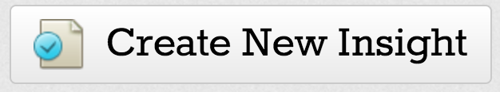 to create a new model. A new model page with basic instructions will appear. The basic modeling workflow moves from left to right. Read over the information on the slide. The links take you to the appropriate pages in the manual (click on the links for drawing tools and simulation. Then clear the demo model.

You will build your model by adding stocks and flows to represent the various components of the hydrologic system. You will also add some additional model components in order to define relationships between variables (for example converting volume of the lake to area) and to include historical data in the model (for example gauged stream flows and water export data). These data are available in the file Mono Lake Flows 1937-1983.xlsx. This Excel workbook has tabs for each of the variables that Vorster reports in his thesis. You should inspect this file now to understand the format, available data and units.

- Adding a stock
  - Start by creating a Mono Lake stock
    - Click on the Add Primitive drop down.
    - Choose Add Stock from the menu.
    - Click on the New Stock to see a list of parameters to the right.
    - Enter the name for your stock (Mono Lake), choose appropriate units for the stock and add the 1937 volume as your initial condition.
- Adding a flow
  - Move your pointer over the carboy stock and a small arrow 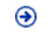 will appear.
  - Click on this arrow and drag it away from the stock to create a flow. You can click on the double arrow button in the toolbar to reverse the flow. Once again if you are clicked on the arrow you will see parameters in the pane to the right.
  - Enter a name for your flow (Gauged flow) and choose the appropriate units.
- Using converters to add data to your model
  - Add two converters
    - Gauged Sierra Streams
    - Gauged LADWP diversions
  - Add data from the file Mono Lake Flows 1937-1983.xlsx. This Excel workbook has tabs for each of the variables that Vorster reports in his thesis. This format will make it easy to copy and paste the data into the converter import window (see carboy lab for detailed instructions). Be sure to set the units.
  - Now you need to make the inflow aware of the converter values. You do this with Links. In order to make links you need to toggle the primitive connection setting from Flow/Transitions to Links 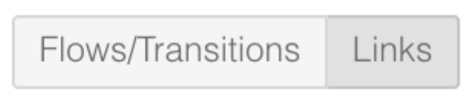by pressing on Links.
  - Now when you hover over a converter you will see a little arrow like when you made your flows.
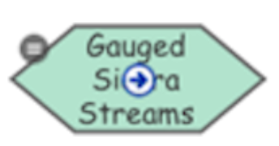
  - Click on the arrow and drag it to your Gauged Inflow.
  - Repeat this process for the Gauged Diversion converter.
  - Your model should look something like this
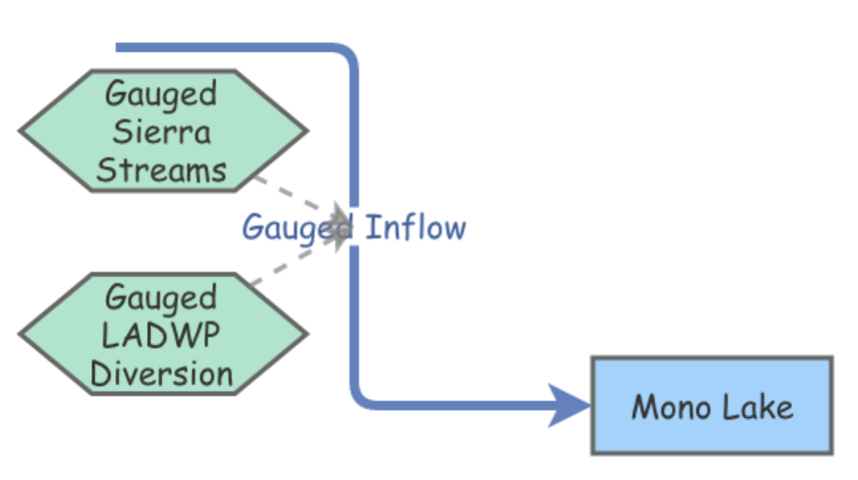
  - Click on the Gauged Inflow and open the Flow Rate equation editor. You should now see both converters in your list of available references (as well as Mono Lake).
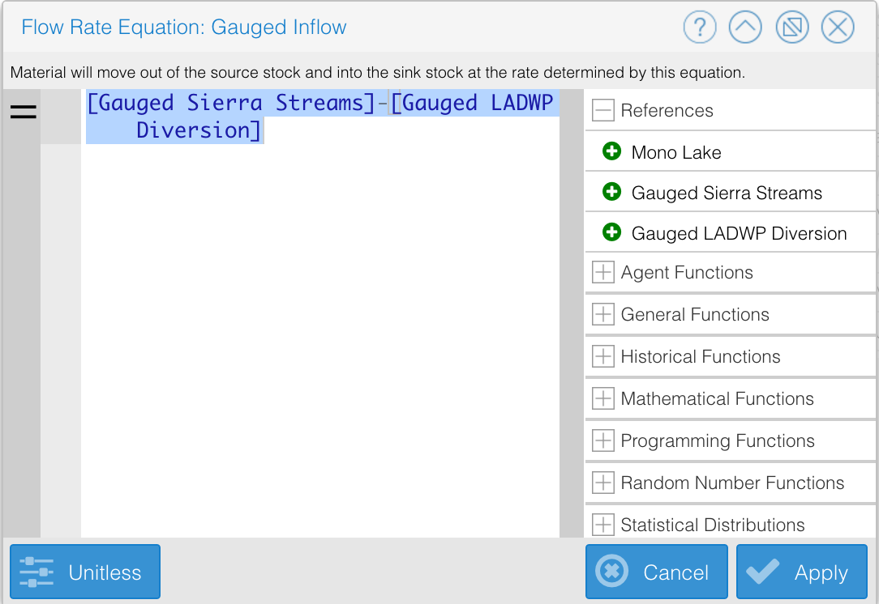

  - Add an equation to subtract the diverted water from the total flow.
- Continue by adding an outflow for Evaporation and a converter for the evaporation data. These data will need to be multiplied by the lake area. You therefore need to add another converter to calculate area from volume. Data from a lake bathymetry model made by Vorster are in the file Vorster Lake Survey Simple.xlsx.
- You’re almost there, but your stock is measured in volume, but the observations are lake surface elevation. You need to add one more converter to change volume to elevation. Once again, you’ll use the data from the Vorster bathymetry model. This time choose the volume and elevation columns for your import.
- Add the historic elevation data from the file MLC_Lake Levels 1850-2017.xlsx in another converter (without links) and you’re almost ready to test your model.
- Now you need to adjust your model parameters.
  - Click on the Settings button and the following window appears
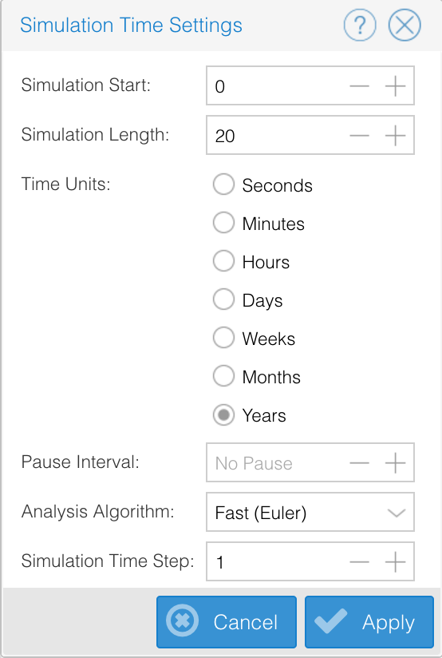 | You need to set the appropriate values here:  - Set time units to years  - Set the simulation start to 1937 and the length to 45 years.  - Set the time step to one year.  - Leave the algorithm as Fast (Euler) for now.
- How does the model fit the data? Let’s add a Variable to quantify the misfit.
  - Add a Variable Primitive to calculate your error.
  - Link your model elevation and the observed elevation Converters.
  - Add an equation to calculate the difference between the observations and your model.
  - Re-run the simulation and inspect your results. What is the range of errors? Do they appear to be equally distributed in each direction (positive/negative)? Are they approximately random in time?
  - Change your display to a table to view the error values.
- How do you think you could improve your model?
- Add additional inflows and outflows until you are satisfied with the fit to the data. You should be able to get within +/- a few feet of the observations with the data we have available to us.
- Testing policy options
Once you are satisfied that your model is a reasonable simulation of the Mono Lake water balance you can begin to use the model to explore some scenarios.
  - For our scenarios we will use average values and evaluate their impact into the future.
    - Clone your model so that you can keep the original and edit a copy. The Clone Insight button is at the very top of the window to the right.
    - To enter the average values you can either replace your time series values in your Converter with a single value (say 1960 for the middle of our time period (1937-1983)) or you can replace the Converters with Variables.
  - Test the following scenarios, including estimating steady-state elevation. Carefully evaluate the assumptions and their potential impacts for each model. What impacts would each scenario have on the lake and its ecosystem?
    - Run your average model with the same settings as before. How do the results compare to the historic data?
    - What would have happened to Mono Lake if LADWP had removed 100,000 acre-feet of water per year from 1941 onward? Be sure to adjust your initial conditions and settings.
    - In 1994 the State Water Resources Control Board ordered that LADWP observe maximum annual diversions depending on lake level. Until the lake reaches 6,392 ft. these diversions are
      - Below 6,377, no diversions are allowed.
      - Between 6,377 and 6,380, diversion of 4,500 acre-feet is allowed.
      - Between 6,380 and 6,391, diversion of 16,000 acre-feet is allowed.
Create a model that uses these criteria in a Converter to estimate how long it will take for the lake to reach the target elevation of 6,392 ft. Be sure to change linear interpolation to none. Enter the rules above as:
Elevation Export
6370 0
6377 4500
…
(Insight Maker extrapolates each value in the positive direction until another value is specified)

Based on your model do you think it’s likely that the target elevation will be met by 2020?

