Student Worksheet: What’s Shaking in Greenland?
Version: 3 – Last Updated – June 2017
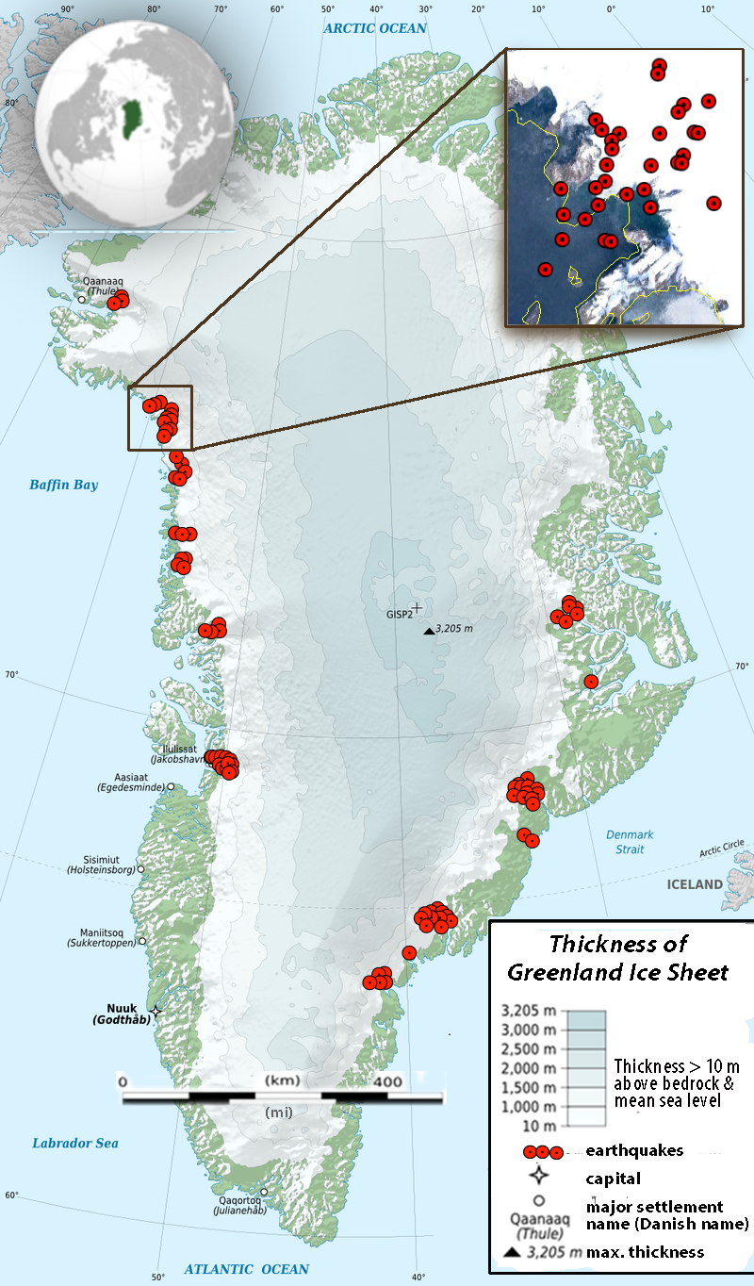

Greenland is on the North American Plate a long way from any plate boundaries. So why is Greenland recording seismic activity?
An earthquake is the sudden release of stored energy and propagation of seismic waves from an elastic source. While we generally think of this “source” as the breaking of rock along Earth’s faults, energy can be released from a variety of sources and propagate as seismic waves. In the past you may have seen seismograms from a variety of “sources” like trains, mines or even nuclear bombs (e.g. www.iris.edu/hq/inclass/animation/251). Most of these signals are short-period (that is, high frequency, or many cycles per second). In 2003, a new class of non-earthquake seismic events was discovered in data from seismic stations in Greenland. They found unique long-period (that is, low frequency, or a few cycles per minute) signals that were very different from typical seismic signals generated from earthquakes.

Figure 1: Map of Greenland with ice-sheet thicknesses and earthquakes. The inset shows close up of the earthquakes from Google Earth. Earthquake locations are from “Icequakes_1993_2010.kml”. Base image from https://commons.wikimedia.org/wiki/File:Greenland_ice_sheet_AMSL_thickness_map-en.png

When seismologists examined where and when these strange long-period seismic events occurred in Greenland, they found that these “icequakes” had unique characteristics. These icequakes were spatially correlated to the edges of the continental glacier, and exhibited variability over both annual and longer-term time scales. A fundamental question is: What causes icequakes in Greenland?

Part I: A continental glacier dominates Greenland’s landscape, as it covers over 80% of the island’s surface to a maximum thickness of 3205 m. Continental glaciers are vast sheets of ice that are thickest in the center. The weight of accumulating snow causes the glacial ice to spread and slowly flow outwards. At the edges of the continental glacier, the ice thins. Let’s begin our investigation by looking at where these icequakes occur. Open the file named “Icequakes_1993_2010.kml” in Google Earth to view the location of icequakes in Greenland. This data set contains icequake location, date, and magnitude information for Greenland from 1993 - 2010.

- View the data set from an Eye Altitude of ~2500km (this is label as “eye alt” and displayed in the lower right corner of Google Earth). Record your observations about where these icequakes occur.

- Use your textbook and/or the Internet to investigate the following parts of continental glacier system. Describe each feature below.

In addition, zoom/pan around Greenland to find each of these features. Once located, print out a screen shot from Google Earth and label features a) to g) (File>Print>Screenshot of the current 3D View). Hint: You will probably need regional views for (a & b) and close-up views for (c to g).

  - Zone of accumulation

  - Zone of ablation

  - Outlet glaciers

  - Icebergs

  - Melt ponds

  - Crevasse

  - Lateral Moraine
- Which of the major glacial features listed above is present near where clusters of icequakes occur?

- The question you are trying to answer is “What causes icequakes in Greenland?” Perhaps there is a connection to the process by which earthquakes occur? What do you already know about the causes of earthquakes? (Use the internet or your textbook to help if necessary).

Summarize your prior understanding of the causes of earthquakes using text and/or sketches:

- Describe at least two (2) questions that the location of the icequakes raises in your mind about “What causes icequakes in Greenland?”

Create a tentative claim or hypothesis, about causes of Greenland’s icequakes based on what you know about earthquakes, glaciers, and the evidence you have collected so far.

6) Describe at least two (2) questions that the location of the icequakes raises in your mind about “What causes icequakes in Greenland?”

Part II: Now that we have investigated where Greenland’s icequakes occur, let’s investigate the temporal distribution of these quakes.

- Describe the trends you see in the number of icequakes in Greenland from 1993 to 2009 in Figure 1.

- Could the trend you identified in Figure 1 be related in any way with the evidence and claim you collected and developed in Part I?

- Describe any trends you see in the number of icequakes in Greenland over the course of one year in Figure 2.

- The question we are trying to answer is “What causes icequakes in Greenland?” What evidence have you collected about how often icequakes occur over both short (annual) and longer time scales? In the space below, develop a tentative claim, or hypothesis, about causes of Greenland’s icequakes and list the evidence that supports your claim.
Your Claim:

Evidence that supports your claim:

Obtain the following graphs from your instructor. Examine and compare them to the icequakes frequency data presented in Figures 1 & 2.
    - Figure 3 – Average Monthly Air Temperature at Godthaab, Greenland (1993 to 2010).
    - Figure 4 - Average Annual Air Temperature at Godthaab, Greenland (1993 to 2010).

- Describe how these data support or refute your claim in Question #7 above.

- Describe at least two questions the weather and climate data raise in your mind about “What causes icequakes in Greenland?”

- By now you have some ideas about what causes icequakes in Greenland. However, these brief articles can provide you with some additional information about different mechanisms for icequakes. Summarize each in the space below.
Reading A) https://www.seeker.com/three-flavors-of-icequakes-found-rumbling-through-glaciers-1765043687.html
Reading B) http://www.sciencemag.org/news/2010/12/what-makes-glaciers-shake

Reading A)

Reading B)

- Modern science regards Earth as a system of interconnected parts. As a separate document, synthesize the evidence you have collected regarding “What causes icequakes in Greenland?” (Questions #5, 9, & 12) to create a multiparagraph explanation of how icequakes in Greenland exemplify the concept of “Earth as a system.” The following additional readings are likely to provide you with some additional information and ideas.
- ]www.sciencedaily.com/releases/2012/05/120503142420.htm
- www.livescience.com/20082-greenland-glaciers-velocity.html
- https://earthobservatory.nasa.gov/Features/Greenland/greenland_sidebar.php

As you write your argument, remember to do the following:
- State the conclusion you are trying to support.
- Include appropriate evidence and an adequate rationale.
- Organize your paper to enhance readability.
- Use a broad range of words, including vocabulary from the lab.
- Make sure your writing has an easy flow and rhythm.
- Correct grammar, punctuation, and spelling errors.

