**Mysterious motions along the Pacific Northwest Coast**

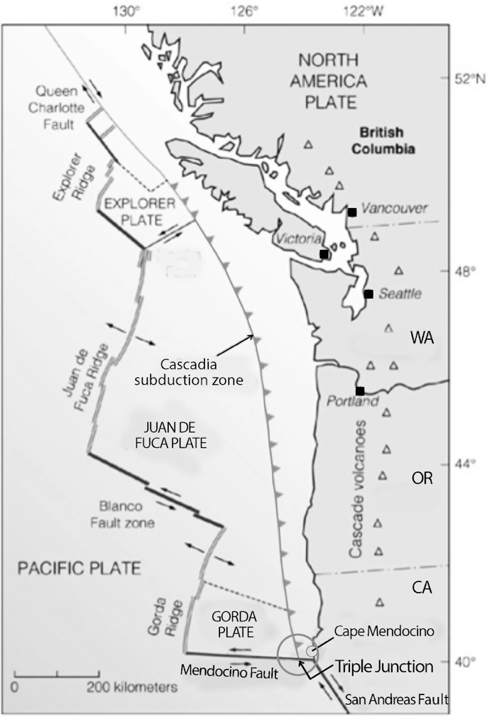Student Worksheet

Version: 3.1 – Last Updated – May 2017

Coastal areas of the Pacific Northwest are on the move. Sometimes the movement is felt by residents as an earthquake. Other times the motion occurs so slowly that only instruments, like high-precision Global Positioning System (GPS) stations, can detect its movement. To better understand this motion let’s investigate what is known about the area’s geologic setting. We’ll begin in the south, and examine the north later.

Cape Mendocino, California is located just onshore from a triple junction, or a place where three tectonic boundaries all meet (Figure 1). In this case, the San Andreas Fault (a transform plate boundary between the North American Plate and the Pacific Plate), the Cascadia Subduction Zone (a subduction zone which at the southern end is between the tiny Gorda Plate and North American Plate), and the Mendocino Fault (a transform plate boundary between the tiny Gorda Plate and the Pacific Plate) join together.

**Part 1 –** Since this area is geologically complex, let’s investigate what we might expect to occur in the region over time. Use your textbook, the Internet, and/or Google Earth to answer the following questions about the types of plate boundaries shown in Figure 1. Watch animation about plate boundaries found here: [www.iris.edu/hq/inclass/animation/492](http://www.iris.edu/hq/inclass/animation/492)

Figure 1: The tectonic setting of the United States Pacific Northwest coast. The large circle indicates the location of the Cape Mendocino Triple Junction. The smaller circle indicates the location of Cape Mendocino, CA.

*1) At transform faults, movement between the plates is*

a) towards one another

b) away from one another

▶▶▶▶c) horizontal, with plates sliding past one another

d) under one another

*2) The process in which an oceanic plate slides beneath a continental plate or another oceanic plate is known as*

a) exfoliation

b) transformation

c) divergence

▶▶▶▶d) subduction

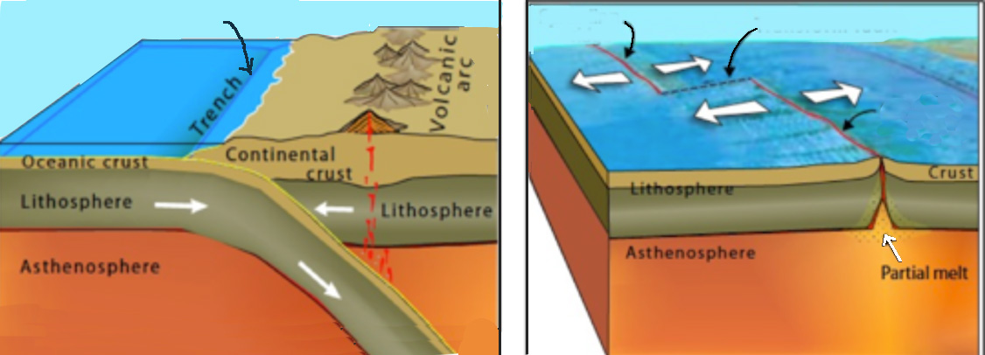

Figure 2: : Illustrations of three types of plate boundaries indicated by black arrows. Which are divergent, convergent, or strike-slip? To learn more about the layers of Earth labeled in the illustrations above, please watch [www.iris.edu/hq/inclass/animation/layers\_of\_the\_earth](http://www.iris.edu/hq/inclass/animation/layers_of_the_earth).

*3) The left image of Figure 2 best represents which of the following boundaries indicated on the map of the Cape Mendocino Triple Junction?*

▶▶▶▶a) Cascadia Subduction Zone

b) San Andreas Fault

c) Mendocino Fracture

d) Gorda Ridge

4) What evidence did you use to select your response to question 3 above?

Acceptable answers will include the following:

1. Figure 2a illustrates oceanic lithosphere sliding beneath continental lithosphere, as well as an on-land volcanic arc, and illustrates a subduction zone.
2. When the Cascadia Subduction Zone is viewed in Google Earth from an eye altitude of ~1500km, the offshore trench and inland volcanic arc (Cascade Mountain Range) are visible.

*5) The right image of Figure 2 best represents which of the following boundaries indicated on the map of the Cape Mendocino Triple Junction?*

a) Cascadia Subduction Zone

b) San Andreas Fault

c) Mendocino Fault

▶▶▶▶d) Gorda Ridge

*6) What evidence did you use to select your response to question 5 above?*

Acceptable answers include:

1. Figure 2 (right) shows new oceanic crust being formed at two, slightly offset spreading centers. The ends of these spreading centers are separated by a transform boundary where the crust is moving horizontally past one another.
2. When the Cape Mendocino, CA area is viewed in Google Earth from an eye altitude of ~1500km, a spreading ridge and associated transform fault are visible.

The Mendocino Fracture zone (or fault zone) is a fracture within the Pacific plate, west of the Gorda ridge. East of the Gorda ridge it is a transform boundary between the Gorda Plate to the north and the Pacific Plate to the south.

**Part 2**

On April 25, 1992 the entire Cape Mendocino, CA region moved to the west. This movement was detected and recorded by GPS stations installed throughout the area by scientists. The total amount and direction of the movement is illustrated in Figure 3.

Figure 3. A close-up map of the Cape Mendocino region. Circles on the map show the location of *four* GPS stations. Arrows, called vectors, indicate the direction and total amount of ground displacement on April 25th, 1992.

*7) Use a ruler and the information contained in Figure 3 determine how much the GPS station was displaced and complete Table 1 below.*

Table 1. Movement of California GPS stations on April 25, 1992.

|  |  |  |
| --- | --- | --- |
| **Station Name** | **Arrow length on map (cm)** | **Ground displacement (cm)** |
| Bear Ridge 2 | 35cm | 2.2cm |
| King Peak 2 | 11cm | 0.7cm |
| Pierce Ecc | 60cm | 3.75cm |
| Rhonerville | 27cm | 1.7cm |
| Average for 4 stations | 33.3cm | 2.1cm |

*8) What is a common object that is roughly equal to the average ground displacement that occurred on April 25, 1992 near Cape Mendocino, CA?*

There are numerous correct answers but the diameter of a U.S. nickel is roughly 2cm

*9) Which station experienced the greatest overall displacement?*

a) Bear Ridge 2

b) King Peak 2

▶▶▶▶c) Pierce Ecc

d) Rhonerville

*10) Look a back at Figure 3. Which of the following best describes the direction of movement of the station with the greatest overall displacement?*

▶▶▶▶a) West

b) East

c) Southeast

d) Northwest

*11) What could cause the Earth to suddenly move in this way? One possibility is an Earthquake. An Earthquake is the sudden movement of two blocks of Earth, frequently along plate boundaries. This occurs because Earth’s plates are in constant motion. Since the edges of the plates are rough, sometimes they get stuck on one another while the rest of the plate keeps moving. Once the plate has moved far enough, the edges unstick on one of the faults and the accumulated energy stored elastically in the rocks is released. This slow storing of potential energy followed by a sudden release in an earthquake is explained by the Elastic Rebound Theory. To see an example of the Elastic Rebound Theory for earthquake occurrence along a subduction zone, please watch the following animation (*[*http://www.iris.edu/hq/inclass/animation/91*](http://www.iris.edu/hq/inclass/animation/91)*). Given the presence of major plate boundaries in the region, including a subduction zone (Figure 1) it seems possible that an earthquake may have caused the ground motion shown in Figure 3. To collect evidence for this claim, visit the IRIS Earthquake Browser (*[*www.****iris****.edu/ieb/*](http://www.iris.edu/ieb/)*). The IRIS Earthquake Browser (IEB) is an interactive map for exploring millions of seismic event epicenters (normally earthquakes) on a map of the world.* Take a few moments and explore the data and tools.

Now, visit (<http://bit.ly/2qowaJP>). This pre-set view will allow you to see if any earthquakes occurred in the Cape Mendocino region that day. Use the “Open as Table” tool to collect detailed information. Use the space below to provide evidence that would support or refute the claim that the motion was caused by an earthquake (e.g. number of quakes, magnitude of quakes, location of quakes, times of quakes, etc).

Answers may vary somewhat depending on what region the students include. However, for the region immediately around Cape Mendocino, CA, the output should look something like this:

| **Mag** | **Depth km** | **Day** | **Time UTC** | **Lat** | **Lon** | **Location** |
| --- | --- | --- | --- | --- | --- | --- |
| 3.9 | 8.9 | 1992-04-25 | 22:25:23 | 40.22 | -124.52 | NEAR COAST OF NORTHERN CALIF. |
| 3.4 | 15.0 | 1992-04-25 | 21:26:09 | 40.28 | -124.56 | NEAR COAST OF NORTHERN CALIF. |
| 3.4 | 15.0 | 1992-04-25 | 21:09:12 | 40.29 | -124.22 | NEAR COAST OF NORTHERN CALIF. |
| 3.3 | 15.0 | 1992-04-25 | 20:29:15 | 40.30 | -124.40 | NEAR COAST OF NORTHERN CALIF. |
| 3.6 | 15.0 | 1992-04-25 | 20:12:35 | 40.38 | -124.38 | NEAR COAST OF NORTHERN CALIF. |
| 4.1 | 5.6 | 1992-04-25 | 19:50:40 | 40.23 | -124.39 | NEAR COAST OF NORTHERN CALIF. |
| 3.0 | 6.6 | 1992-04-25 | 19:41:59 | 40.33 | -124.42 | NEAR COAST OF NORTHERN CALIF. |
| 3.1 | 15.0 | 1992-04-25 | 19:30:46 | 40.32 | -124.21 | NEAR COAST OF NORTHERN CALIF. |
| 4.2 | 15.0 | 1992-04-25 | 19:15:35 | 40.17 | -124.13 | NEAR COAST OF NORTHERN CALIF. |
| 7.1 | 15.1 | 1992-04-25 | 18:06:04 | 40.36 | -124.05 | NEAR COAST OF NORTHERN CALIF. |

12) Based on your analysis of earthquake data for the question above, would you predict that people felt the ground movement shown in Figure 3 within this time period?

▶▶▶▶a) Yes

b) No

13) Justify why you selected your answer in #10 above?

Students may refer to other earthquakes of a similar magnitude (i.e. M7) that they have heard about as being felt or caused damage, they might have personally experienced an earthquake, or they refer to USGS’s “Did you feel it?”

14) Check and see using the USGS’s “Did you feel it?” community reporting tool (<https://earthquake.usgs.gov/earthquakes/eventpage/nc269151#dyfi)>. In what ways were your predictions correct or incorrect?

Students should be able to see that the earthquake was felt.

15) Watch the animation found here - <http://www.iris.edu/hq/inclass/animation/89>   
This animation is a potential model for what occurred on April 25, 1992. Use the evidence that you have collected in Table 1, the IEB, and the guidelines below to construct an argument either for or against this animation as a model for what occurred.

*A) Every argument is based on a* ***Claim*** *or a statement of your understanding about a phenomenon.* *Your Claim (Select One):*

1. *The animation is a good model for the movement of Cape Mendocino on April 25, 1992.*
2. *The animation is not a good model for the movement of Cape Mendocino on April 25, 1992.*

*B) Next, in the space below, identify* ***Evidence*** *or statements, data, photographs, or other information to support your claim. You might also use the Internet to find additional evidence to support your claim and reasons.*

Possible items include but are not limited to the following:

* The earthquake occurred onshore away from the trench
* The earthquake, M 7.1, released a large amount of stored energy
* GPS showed motion that was primarily westward
* Tsunami waves first came ashore at the North Spit station in Eureka 26 minutes after the earthquake. The largest surges were seen to the north at [Crescent City](http://en.wikipedia.org/wiki/Crescent_City,_California). The first packet of energy reached Crescent City in 47 minutes with a maximum wave height of 14 inches. A second, larger packet arrived later with a maximum amplitude of 21 inches.

*C) Finally, support your claim with* ***Reasons.*** *Reasoning illustrates why your evidence is the correct evidence to use in support of your claim. Reasoning typically includes describing the scientific knowledge or theory that applies to a particular claim and evidence.*

Possible items include but are not limited to the following:

* Prior to the earthquake, the subducting oceanic lithosphere built stress in the overriding continental lithosphere
* Storing enough energy for a magnitude 7.1 earthquake takes a long period of time
* During the earthquake the edge of the overriding crust becomes “unlocked” and moves back to the west
* Like the animation, a small tsunami, was generated from the April 25, 1992 earthquake.

16) Looking back at Figure 1 and thinking about what we have learned so far, what are the risks residents of N. California, Oregon, Washington, and British Columbia face as the Juan de Fuca plate subducts beneath North America. (Select all that apply.)

a) Forest Fire

▶▶▶▶b) Damaging earthquake

▶▶▶▶c) Tsunami

d) Tornado

**Part 3**

:GPS_TimeSeries_adapted.pdf

Figure 4: Sample GPS Time Series Data for a single station.

You have already looked at data from GPS stations presented as vectors. However, data from GPS stations can also be presented in a different way called Time Series Plots. Time series plots are used to look at the movement of the station over some time period rather than just rendering data as vectors showing the total motion over some time period (Figure 3). For example, the GPS data shown in Figure 4 are displayed at time series plots. These indicate the displacement of the station in some direction over time shown on the X axis. While the position of the station is recorded in three dimensions (that is, the North-South, East-West, and Vertical positions are measured), Figure 4 only shows the data for the East-West motion of a station to simplify the analysis of this dataset.

Because GPS time series show displacement over time, we can use relative displacements between adjacent data points to determine which direction the station was moving between each measurement. In the examples shown in Figure 4, the overall trends in the data over long time periods show the average rate and magnitude of displacement. Over shorter time periods, however, the relative displacement of a station may differ from the long-term averages. For instance, in the top panel of Figure 4, the long-term trend is that the station is moving to the east (eastward displacement increases with increasing time).

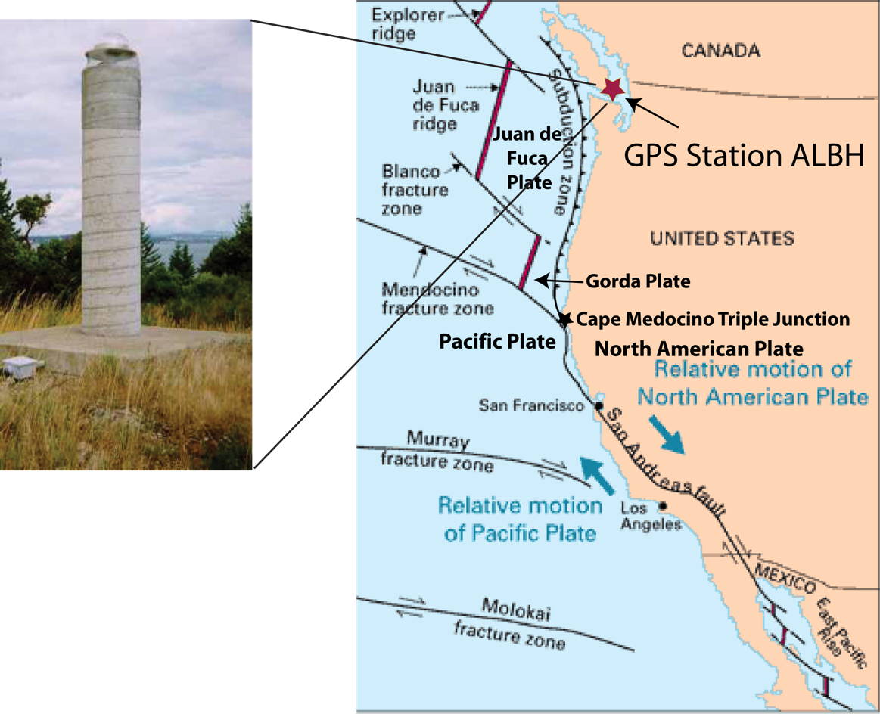Now let’s take a look at some recent GPS time series data recorded near the northern end of the Cascadia Subduction Zone. These data were recorded by station ALBH located on Vancouver Island, British Columbia (Figure 5).

Figure 5: GPS station ALBH (left) with a map of its location (right).

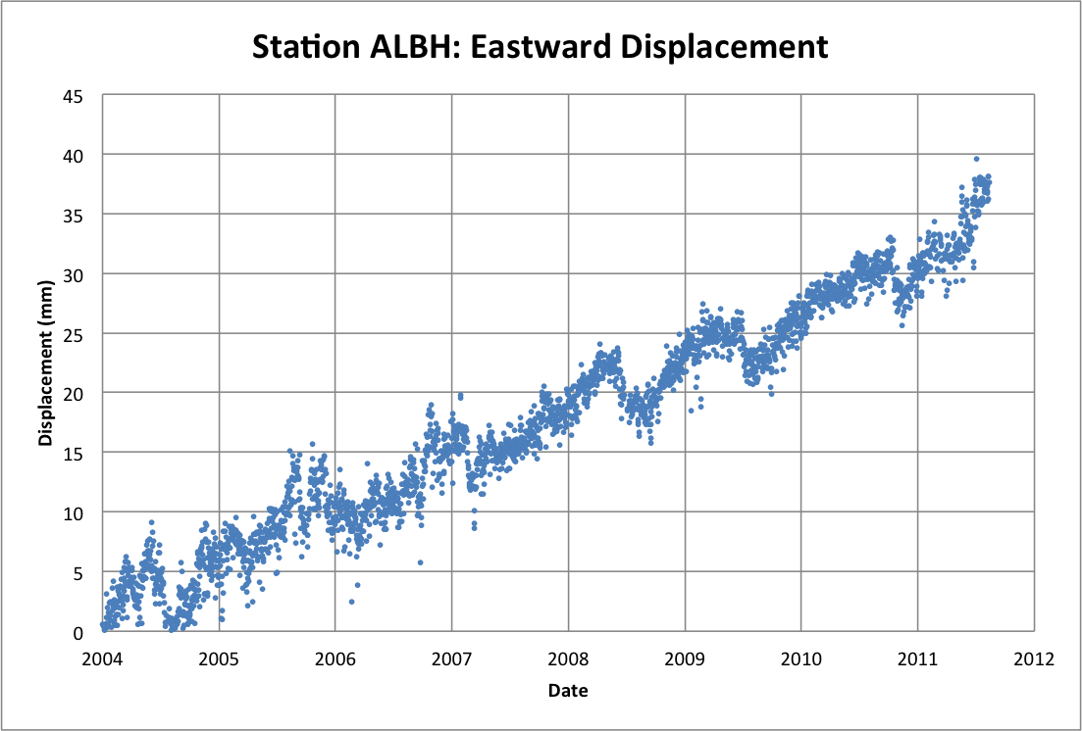

Figure 6 - East-West ground displacement at Station ALBH from 2004 to 2011.

20) Based on this graph, how far did GPS station ALBH move eastward between 2005 and 2010? Describe how you determined this value.

Roughly 20 mm, based on estimating the center of the point distribution for 2005 and 2010.

21) On average, how many mm per year does GPS station ALBH move eastward? Describe how you determined this value.

About 4 mm/year, based on the answer to #17

22) Which of the following statements best describes the overall motion of GPS station ALBH from 2004 to 2012?

a) Steady eastward movement

▶▶▶▶b) For every few steps to the east, one step back to the west

c) Moving eastward but with pauses when the motion stops

23) Based on what you have already learned, is the overall eastward movement of station ALBH surprising given its proximity to the plate boundary shown in Figure 5? Describe why you think so.

This is unlikely to be surprising given the ideas covered in the lab so far. The most appropriate answer is “no”, as illustrated in the animation (http://bit.ly/2rd0706), where onshore GPS stations are predicted to move eastward during subduction in this region.

24) Describe one possible explanation (Claim) for the episodes of westward movement in this region?

Given Parts 1 and 2 of the exercise students may conclude that earthquakes are a likely cause. Rebound of stresses accumulated from the convergence of the plate boundaries, and resulting earthquakes, could explain the periodic westward motion. One issue with this explanation is that earthquakes occur over short time scales and this westward motion appears to occur over weeks or months. Another issue is that earthquakes also occur during the time periods of eastward movement (anticipated answer as a segue into the next portion of this activity).

25) Over what sort of time period does this Westward movement appear to occur?

a) Years

▶▶▶▶b) Months

c) Weeks

d) Hours

e) Minutes

26) Based on your exploration of **Part 1** and **Part 2** of this exercise, you may have reasoned that earthquakes caused these episodes of westward displacement. Test this claim by using the IRIS earthquake browser ([www.iris.edu/ieb)](http://www.iris.edu/ieb)) to collect evidence during a period of time when the station moves westward. For example, you might try a time period from 3/1/2008 to 9/30/2008 (<http://bit.ly/2rcW44N>). Use the space below to list evidence that you could use to support or refute the claim (e.g., number of quakes, magnitude of quakes, location of quakes, times of quakes, etc.).

Students may list earthquake locations, times and magnitudes, but the magnitudes will be small, mostly less than M 3.0. The largest quake is a M3.8 that was offshore near the trench.

27) Does the evidence you found support the claim that an earthquake occurred during the periods when station ALBH moves westward? Why or why not?

The small earthquakes aren’t sufficiently large to have caused the large displacements shown in Figure 6, so they don’t support the claim.

28) Based on the earthquake data, do you think it is likely that the residents of the British Columbia region felt this general eastward (and periodically westward) motion?

a) Yes

▶▶▶▶b) No

Why or why not?

The movement was too slow to feel.

29) If you did not find any earthquakes of the same or larger magnitude than the April 25th, 1992 quake near Cape Mendocino, CA, then you need to reformulate a claim for what might cause these periodic changes in the displacement of the GPS station. What might be alternative explanations or claims that could explain this data?

Answers will vary but some may suggest that the pattern may be related to seasonal changes such as precipitation or temperature. Another possible suggestion is that the fault is “resetting” itself after moving eastward so consistently for so long.

**Part 4 -** Like you, scientists were confused by the GPS readings from station ALBH. They noticed that not only was GPS station ALBH experiencing periodic directional changes, but other GPS stations in the region of Canada and Washington State were also experiencing similar episodes of westward motion around the same time periods. In all cases, there were no large earthquakes that could explain this significant change in motion as you discovered above. Further, single earthquakes would likely not cause the change, given that the change in motion occurred over several months rather than a few days or weeks. Like you, scientists developed a number of alternative hypotheses for testing. These included seasonal variations in precipitation and other weather, problems with instrumentation, etc. However, none of these hypotheses could adequately explain the observations.

While the scientists did not find sudden releases of stored seismic energy that coincided with the changes in displacement direction at the GPS stations, in 2003 they did find seismic evidence of episodes of gradual energy release that corresponded to the westward motion. These low-level seismic signals, known as tremors, are “slow” earthquakes that cannot be felt. In the Pacific Northwest, the energy released during these periods of tremor activity were equivalent to the energy release of a magnitude 7 earthquake! While seismologists had observed these signals for at least a decade, they were so small that they assumed they were some sort of noise.

By studying these tremors across several seismic stations installed in the same area as the GPS stations, geologists realized that a portion of the subduction zone in this region of the US and Canada, known as the Cascadia Megathrust, was causing the combination of tremor and westward motion of the surface in a process now known as Episodic Tremor and Slip (ETS). Figure 7 illustrates the current model for ETS using seismic and GPS data as evidence.

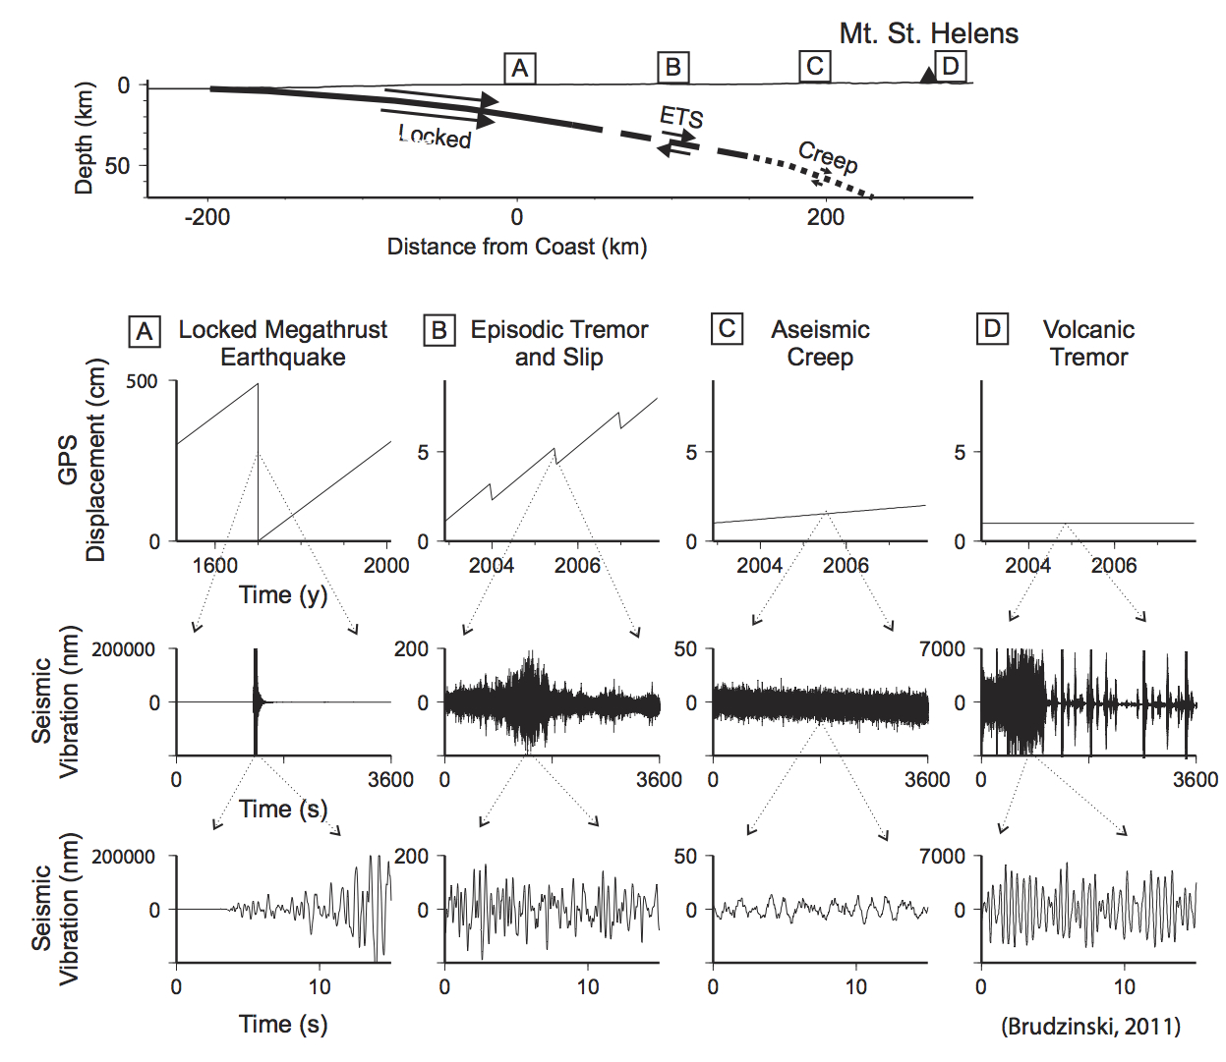

Figure 7 - Comparison of seismic and geodetic signals associated with different types of fault movement. Eastward motion is up on the GPS displacement vertical axis. Note the *very* different vertical scales on the seismic and GPS sensors.

The discovery of ETS has added to our understanding of how subduction zones behave. Figure 7 illustrates how GPS and seismic data might look for various positions over the subduction zone. For example, large, destructive earthquakes tend to occur in the ‘locked’ zone (Figure 7, Box A) where the energy from the plate motions is stored elastically for long periods of time and then is suddenly released as an earthquake. These regions are capable of producing “megathrust” earthquakes, which are the planet's most powerful quakes with magnitudes that can exceed 9.0. It is therefore very important to understand why, when, and how ETS occurs.

In contrast, the deepest segment of the subduction zone (Figure 7, Box c) simply “creeps” without storing and releasing energy in the form of an earthquake, because this material behaves plastically (such as pulling apart Silly Putty) rather than elastically (such as bending a wooden pencil).

Between the “locked” and “creeping” segments of the fault is a zone where the fault is stuck most of the time, but is weaker than the locked zone above it. In this weaker zone (Figure 7, Box B), scientists believe that gradual release of seismic energy through ETS occurs because fluid pressure reduces the load of the overriding plate enough to overcome the locking friction, but not enough to allow the rupture to occur suddenly.

For a review, watch the video <http://www.iris.edu/hq/inclass/animation/92>

Since its discovery in 2003, significant effort has been invested into studying ETS and related phenomena. It is important to understand how and why it happens, because the location of ETS along the plate boundary is useful to estimate how far inland future great earthquake ruptures will extend. For example, the spatial extent of the last great earthquake in the Pacific Northwest (which occurred on January 26, 1700) is still not well understood despite significant study. The presence of ETS well inland from the edge of the subduction zone suggests that strong ground shaking could extend further inland than previously believed, near large cities like Seattle, Portland and Vancouver,. Additionally, a number of scientists believe that ETS may be useful in monitoring the amount of stress on a fault as stresses build to generate large earthquakes. For example, changes in the location, recurrence, or migration of ETS phenomena could all serve as indicators of the increasing likelihood of fault rupture that could lead to a large earthquake.

30) Which type of event in Figure 7 produces the largest amplitude seismograms? (Note\* pay close attention to the vertical scale)

▶▶▶▶a) Locked Megathrust Earthquake

b) Episodic Tremor and Slip

c) Aseismic Creep

d Volcanic Tremor

31) Which type of event produces the smallest amplitude seismograms?

a) Locked Megathrust Earthquake

b) Episodic Tremor and Slip

▶▶▶▶c) Aseismic Creep

d Volcanic Tremor

32) Which statement best describes the GPS motion at Box B in Figure 7?

a) Steady eastward movement

b) Four steps east, two step back to the west

▶▶▶▶c) Moving primarily eastward with regular, short duration periods with westward motion.

33) The GPS motion at Box A and Box B in Figure 7 both show a zig-zag pattern of motion, however they are not the same. In the space below, based on what you have learned in this lab, compare and contrast the processes that causes each of these motions.

The motions of Box A and Box B generally follow a similar pattern of moving predominately eastward but with periods of westward motion. These two patterns differ with regards to how frequently and how much they move westward. For example, in Box A the ground may move eastwards steadily for 100s of years and then suddenly, in a single event move 100s of cm back to the west. This pattern is repeated, and is the process that creates the largest earthquakes on the planet.

Meanwhile, in Box B the ground moves eastward for many months and then moves back to the west for several months. This pattern is repeated and corresponds to slow slip events that are measurable via GPS and which can cause tremor that is detectable by seismometers, but the motion is too slow to feel.