Video Tutorial: How Does Nature Control Rock Fragment Shape?

===========================================================================================
YouTube source: https://www.youtube.com/watch?v=PkYDZsmMu5M
EZSnip resource: http://ezsnips.com/kTwtKHt_4lOJJ ; http://ezsnips.com/fBexKDXBPslek
Introduction:
When massive mountains of rock are weathered, rock fragments are frequently moved by a variety of forces, including the simple pull of gravity downslope, and the flow of fragments in flooded streams and rivers. You’ll learn more about how nature shapes rock fragments by examining several images, watching short videos, and answering the following questions. Make and record observations of the images, and discuss with your nearby peers the following questions as you consider information in the images and video snips.

Observe this image of angular rock fragments on a rocky hillside in Capitol Reef National Park (A) and some rounded boulders (B)
A) Capitol Reef National Park, hillslope. When massive rock is fractured by forces of weathering, fragments are loosened. You can see fragments lying on the ground below the layer of rock from which they came in the image below.
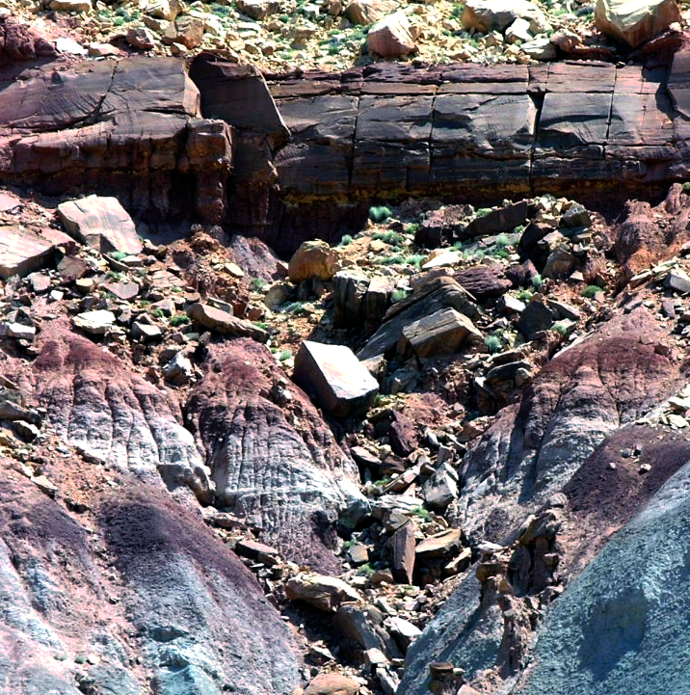
Picture taken by Daniel Mayer, icensed under the Creative Commons Attribution-Share Alike 2.5 Generic
B) Boulders
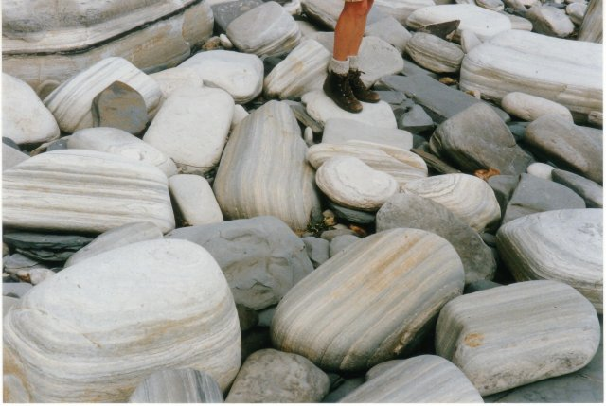
copyright by John Palmer, licensed for reuse under the Creative Commons Attribution-ShareAlike 2.0 license.
1. Examine the shapes of the rock fragments in images A) and B).
a. Write a brief (in bullet points) description in words (as we’ve practiced previously) of rock fragments in image A.
b. Sketch one or two individual fragments in image A to illustrate a representative shape.
c. Write a brief (in bullet points) description in words (as we’ve practiced previously) of rock fragments in image A.
d. Sketch one or two individual fragments in image B to illustrate a representative shape.

2. Before you get to watch the videos, talk to your buddies and discuss why you think the rock fragments are so differently shaped in these two different locations. Then summarize your thinking below.

3. Now watch the first video.
http://ezsnips.com/kTwtKHt_4lOJJ
Focus on the shapes of the rock fragments.
a. Describe shapes of the rock fragments.
b. Identify and describe the environment in which the rock fragments are being moved.

4. Now watch the second video.
http://ezsnips.com/fBexKDXBPslek
a. Describe shapes of the rock fragments.
b. Identify and describe the environment in which the rock fragments are being moved.

5. Now think about characteristics of the environment, and forces to which the rock fragments are subjected. Briefly explain why rock fragments develop angular shape in some environments, and rounded shapes in others.

(continued next page)
6. Examine the loose rocks in these images.
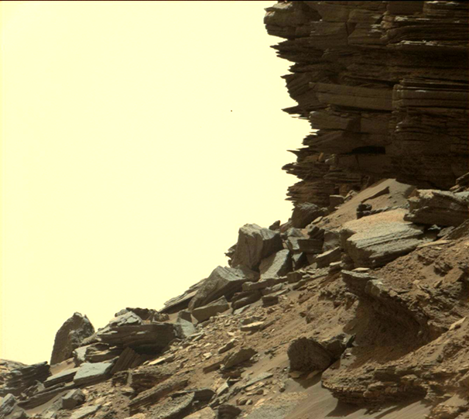
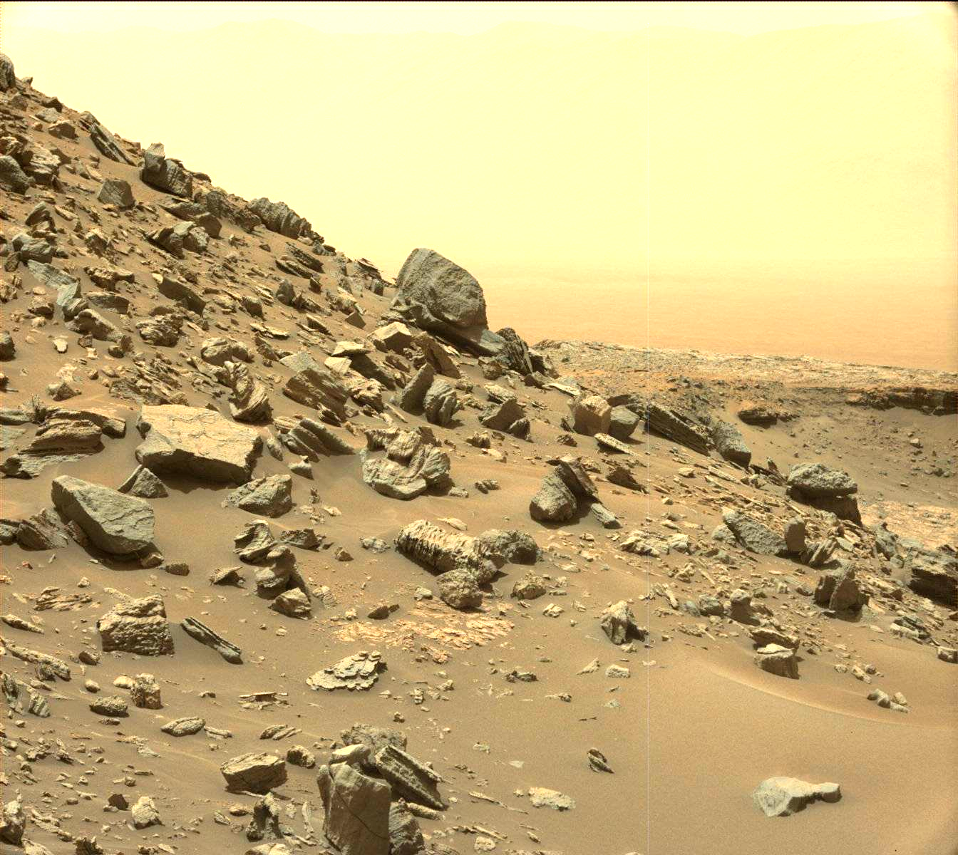
a. Describe shapes of the rock fragments.
b. Identify and describe the environment in which the rock fragments were (and possibly are being) moved.
c. Now think about characteristics of the environment, and forces to which the rock fragments are subjected. Briefly explain why these rock fragments developed angular, rather than rounded, shapes.
7. Finally, consult the website that provides additional information on the location at which these images were acquired. https://goo.gl/wF4TIX
Apply what you learned about nature’s forces that control the rounding (or not) of gravel-sized sediment to the sedimentary environment(s) present at the location where these images were acquired. Hypothesize a timeline (history) of the environment that would result in this deposit.

