Groundwater Lab

Introduction:
Even though groundwater only makes up an estimated 0.61% of the water on Earth, it accounts for 98% of the available fresh water (Fetter, 1999). In many parts of the world (including southwestern North America) water is the primary limiting resource for society and the surrounding ecosystems. Despite the central role of groundwater’s importance to society, few citizens understand even the basics of groundwater flow. You need to understand the fundamentals of groundwater flow and contamination. It may save you thousands of dollars when purchasing a home, it may save your community million of dollars in clean up costs, and it might preserve the rich biotic diversity in riparian areas.
In this lab we will explore the basics of groundwater movement, the effects of pumping wells, and groundwater contamination using an online version of a groundwater model that looks rather like an ant farm.

Goals and Objectives:
The groundwater “ant farm” model provides a wonderful hands-on experience that allows you to observe and manipulate a miniature hydrologic system. You and your lab partners will be able to see the results of changing recharge, pumping wells, and the surface contamination. Specifically, you will:
- Observe the saturated and unsaturated zones of the aquifer in the model
- Manipulate and observe variations in recharge and discharge
- Observe, record and explain what causes groundwater to flow.
- Observe the connections between surface water and groundwater using dyes.
- Examine the effect of pumping water from a well on groundwater flow.
During this lab, you will be asked to generate hypotheses about groundwater flow and then will be able to test your hypotheses using the "ant farm." You will not be graded on your hypotheses (except on whether or not you had one!). You will, however, be graded on your observations of the tests.
Before you start:
Watch the introductory video (https://vimeo.com/398697315).
This lab uses an online version of the ant farm groundwater model, found at https://pvw.kitware.com/sandtank/. You can explore the model on your own, using directions in the web sites manual (https://www.hydroframe.org/sand-tank-user-manual). At the bottom of the page, after the explanation of the various controls, you can find instructions for a basic run. Feel free to experiment with it before starting this lab.
In this lab, every line with bullets (dots) gives you instructions for things to do.
Every line with numbers asks questions that you need to answer to get credit for the lab. The number of points for each question is given in parentheses at the beginning of the question. Any question that starts with "prediction" should be answered before you do the next group of instructions - you are making a hypothesis about what you think will happen. The "prediction" questions will receive full credit as long as you answer them. The "observation" questions ask about things that happen when you run the model. The "generalization" questions deal with larger concepts, beyond the exam

Part 1: Groundwater flow
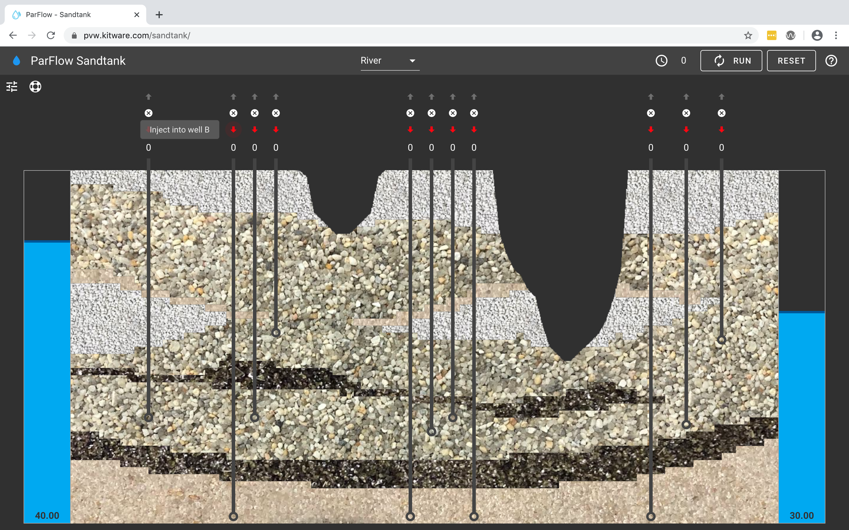
Figure 1. Screen capture of the basic groundwater model on the hydroframe website.
- Click on the hydraulic head slider (the top of the blue column on the left side of the model). Raise it until the number at the bottom reads 40.00.
- Set the Lake/River toggle to "Lake"
- Run the model by clicking the button that says "RUN" in the upper right corner of the window.
- (2 pts) Observation: The top of the blue area on the model represents the water table. Which direction does the water table slope?
- (2 pts) Observation: Describe the difference in height of the water level in the wells on the left side of the model versus the water level in the wells on the right side of the model.
- (2 pts) Observation: Layers above the water table are unsaturated. Which of the layers are unsaturated?
- (2 pts) ObservationLayers below the water table are saturated. Which of the layers are saturated?
- (2 pts) Observation: The two dark-colored layer have a lower permeability than the rest of the layers. Permeable layers that are entirely underneath a lower permeability layer are known as "confined aquifers." In this model, which layers are confined aquifers?
- (1 pt) Prediction: when you run the model, which direction will the water flow?
- Using the red (down) arrow, inject 2 units of dye into Well D (fourth well from the left, the shallowest well).
- Click "run" once. You should see a large red splotch appear at the bottom of the well.
- Click "run" a second time.
- (2 pts) Observation: Which direction does the red dye move?
- (2 pts) Generalization: Is that the same direction as the water table slopes, or the opposite direction from the slope of the water table?
- (1 pts) Prediction: If the slope of the water table were reversed, which direction would the dye move?
- Change the right hydraulic head slider to 45, and the left hydraulic head slider to 28.
- Click "Run" four times in a row.
- (2 pts) Observation: What direction did the dye move when the slope of the water table was reversed?
- (2 pts) Generalization: What controls the direction that water (and pollutants) move below the water table?
- (2 pts) Generalization: Imagine that you couldn't see the water table (because it is hidden under ground), but you can drill wells. How could you use the water level in the wells to figure out the direction that groundwater would move?
- Click "Reset."
- Click "Run." The model should now be back to its original condition.

Part 2: What happens when water is pumped out of a well.
- Raise the left hydraulic head slider to 45.
- Click "Run."
- (1 pt) Prediction: what should happen to the shape of the water table if you pump water out of the fourth well from the left (the same well you've been using)?
- Click the blue (up) arrow above Well D (the fourth well from the left) until the number below it reads "-20".
- Click "Run."
- (2 pts) Observation: What happens to the shape of the water table near the pumping well?
- Click "Run" several more times.
- (2 pts) Observation: What happens to the shape of the water table after you stop pumping water out of the well?
- Inject 5 units of dye into Well J (second from the right side of the model).
- Click "Run."
- (1 pt) Prediction: If you pumped water out of well K (the well on the right side of the model), what should happen to the dye that you injected into Well J?
- Click the blue (up) arrow to pump 20 units of water (-20) out of Well K (right side of the model).
- Click "Run".
- Pump 20 more units of water out of Well K.
- Click "Run" again.
- (2 pts) Observation: What happened to the red dye from Well J?
- (2 pts) Generalization: If Well K were your well, and the red dye were a pollutant, what would happen to the water quality from your well?

Part 3: Confining aquifers
- Raise the left hydraulic head slider to 45.
- Click "Run."
- Pump 5 units into Well B (2nd from left)
- Run (5 times)
- (1 pt) Prediction: Would the dye go into Well E?
- Pump 20 units from Well E (5th from left)
- (2 pts) Observation: did the dye go into Well E?
- (1 pt) Prediction: if you pump from Well F (next well to the right of Well E), would the dye go into Well F?
- Pump 20 units from Well F (6th from left)
- (2 pts) Observation: did the dye go into Well F?
- (2 pts) Generalization: how does the confining layer affect the ability of water and pollutants to travel upward into shallower wells?

