Suspended Sediment Flows

1. The major ocean current in the Gulf of Mexico is the Loop Current, a segment of the subtropical gyre in the North Atlantic. This current enters the Gulf from the Caribbean, makes a large loop as it turns eastward and then exits the Gulf of Mexico. After leaving the Gulf it becomes the Gulf Stream. It is common for the loop in the current to become so extreme that it pinches off into a ring (about 150 miles wide), just like a Gulf Stream ring. These rings travel along the continental slope into the western Gulf where they may retain their integrity for many months. They track along the edge of the shelf because they are deep features but they do affect shelf waters when the surface waters of the ring spill over onto the shelf.

The map below shows geopotential anomaly of a part of the Texas continental shelf and slope. These data clearly show a Loop Current ring. This one was studied and named Eddy Vasquez. This eddy or ring induced flow near it causing a cyclone to form and travel with it. The cyclone is also labeled on the map below.

After geopotential anomaly has been explained by your instructor, draw arrows to show the direction of circulation around Eddy Vasquez and the cyclone.
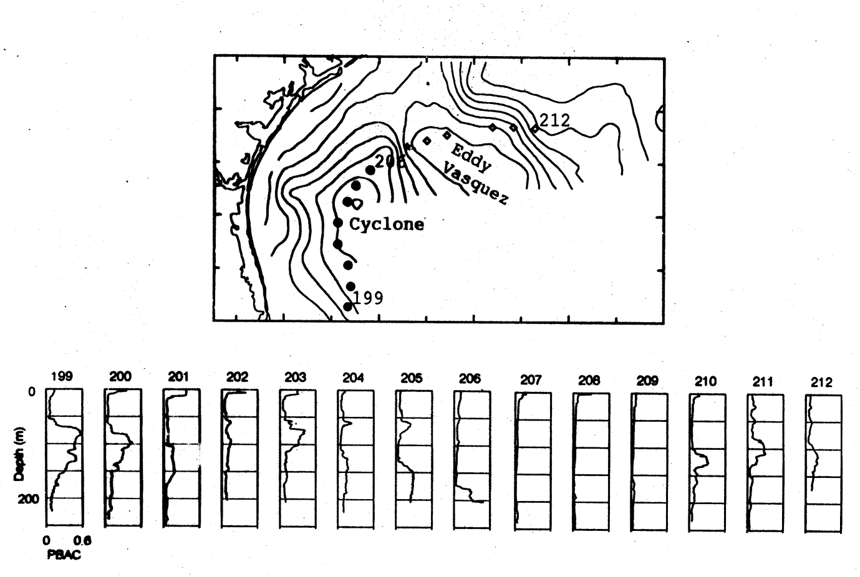

Data taken from
Sahl, L. E., D. A. Wiesenburg and W. J. Merrell. 1997. Interaction of mesoscale features with Texas shelf and slope waters, Continental Shelf Research, 17, no. 2:117-136.
The geopotential anomaly map was created using CTD data. The CTD package included a transmissometer and these data were examined to determine if the cyclone-anticyclone pair impacted sediment. The data are plotted above as particle beam attenuation coefficient (PBAC) profiles for stations 199-212. PBAC is a measure of suspended sediment concentration, where high values indicate higher concentrations. Stations 199-212 were located along the edge of the shelf, in about 200 m of water.

Work with a partner and decide if sediment was affected by the cyclone-anticyclone pair. Look to see if there are patterns in the PBAC data. Describe those patterns. Can these patterns be explained by the currents at the edge of the shelf?

The bottom nepheloid layer on the shelf had suspended sediment concentrations of about 1.8 mg/l. By comparison the concentrations indicated in the PBAC profiles above are low, less than 1 mg/l. Using a seawater density of 1,024.6 kg/m³ calculate the density of this same water if 1 mg/l of suspended sediment were added to it.

Examine the vertical section showing the density structure on the Texas slope. Consider the change in density due to adding suspended sediment. How far will the water sink (at station 169) due to adding the sediment?
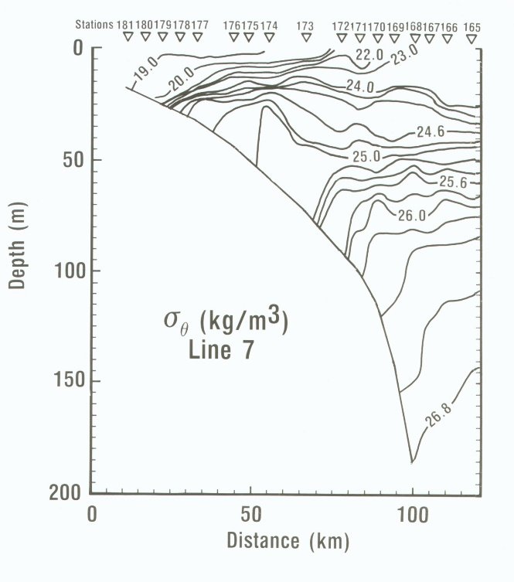
Based on your answer would this flow likely be classified as a lutite flow or a turbidity current?

