NAME:_____________________________ Section: _________________________________

Purpose(s) of video(s): observing, describing, summarizing, applying, estimating
EZSnips videos and Online Resources:
experimental crack formation in drying, muddy sediment http://ezsnips.com/vIvA4LN-u9dNo
3D imaging of modern mudcracks in the field http://ezsnips.com/J0sdfEK_NPBV7
Rock slab on Mars: https://www.nasa.gov/sites/default/files/thumbnails/image/pia21261.jpg
Introduction: Mudcracks are common features on the ground that we may observe when fine-grained sediment dries after saturation by water. Because mudcracks form only under particular conditions (the “right” sediment, the “right” sequence of environmental change), mudcracks are important sedimentary structures. You will learn about the mechanics of mudcrack formation and geometry in this exercise.

1. Although we may commonly encounter mudcracks in the field, watching how mudcracks form requires time and circumstance. However, mudcracks can be made in the laboratory. Here’s an example of experimental mudcracks. As Sgt. Joe Friday says: “Just the facts, Ma’am”. Watch the video and sketch the pattern you see in the final frame.
2. As the video is played a second time, observe the dynamics of mudcrack formation. Describe in a bullet list below steps in how mudcracks form.

3. Watch the video of modern mudcracks imaged in three dimensions. Describe in a bullet list particular features you observe.

4. Crack patterns outline single blocks of mud known as “tiles”. A single tile is shown (right). Note around the tile’s perimeter intersections of lines.

Sketch below the tile and intersecting lines.

4. A geometry of mudcracks. When a line intersects a tile, two angles are formed. See example, X and Y, as circled in the images below.
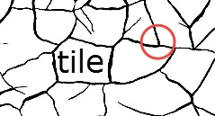
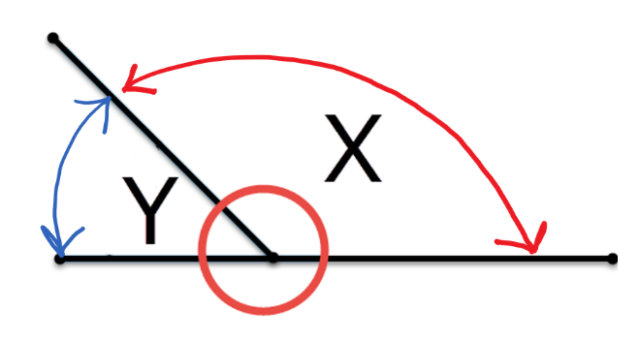
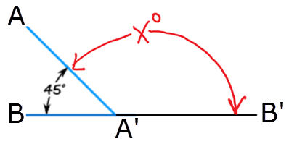
5. A rule applied to two straight lines that intersect is that the sum of two angles, like (X + 45) below, must equal a particular value.
Talk to your buddies – determine the sum of these two angles?
45 + X = _____________ degrees.

If you know the rule for the sum of these two angles, then you can determine the value for X in the image above.
X = _____________ degrees.

6. Now apply these principles to a diagram of natural mudcracks. Two intersections are circled and labeled.
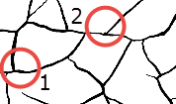
A) Estimate by eye and record the two angles for each circle. Record all your numbers below.
angle 1 angle 2

Circle #1: _________ __________

Circle #2: _________ __________

The quantitative analysis of mudcrack patterns provides insight into the environmental conditions of their formation, and these patterns can help us interpret similar features preserved found elsewhere. Examine this image taken by the Curiosity Rover of a rock slab on Mars.
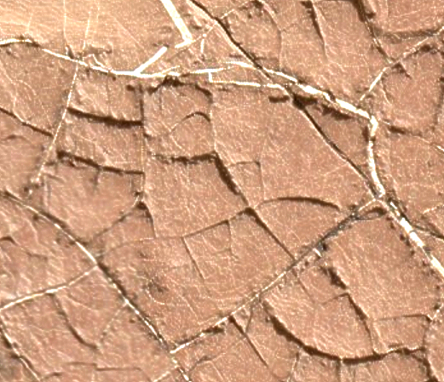
https://www.nasa.gov/sites/default/files/thumbnails/image/pia21261.jpg
Are these mudcracks? If not, why not? If so, what can we infer, if anything, about the environmental history of Mars (at least at this location)?

