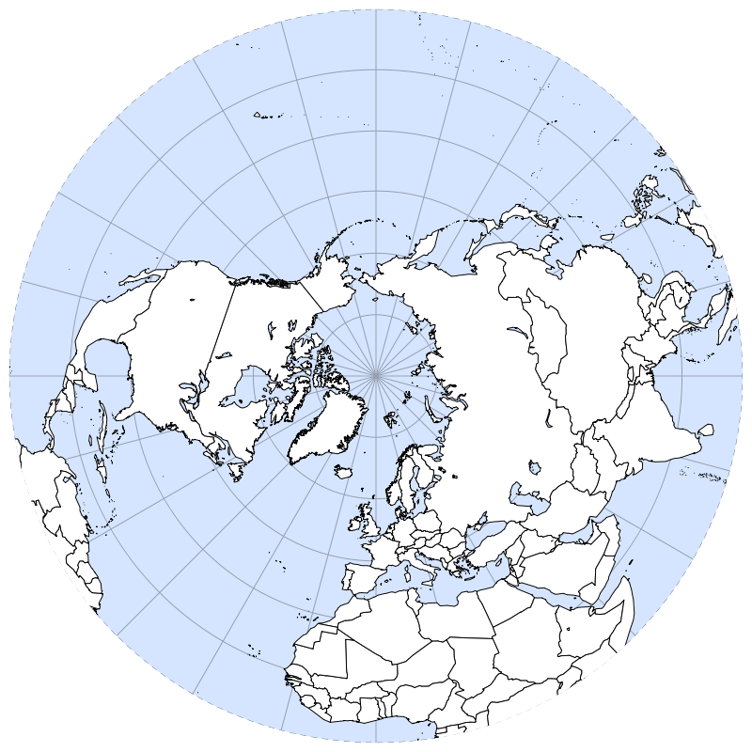

In the Northern Hemisphere, the Earth rotates *clockwise counterclockwise*

which creates a Coriolis Effect that deflects objects to the *right left*

Follow your professor’s instructions to demonstrate the Coriolis Effect.

**Coriolis Effect Activity**

*Geological Oceanography — Prof. Laura Wetzel*

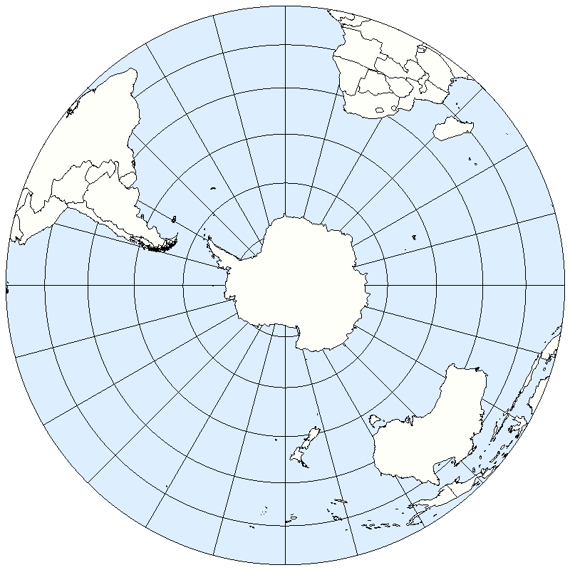

In the Southern Hemisphere, the Earth rotates *clockwise counterclockwise*

which creates a Coriolis Effect that deflects objects to the *right left*