Preparing student computers
Student laptops will need to have the Arduino IDE software installed.
To install the software
- Navigate to https://www.arduino.cc. Navigate to the software menu and choose downloads from the drop down menu.

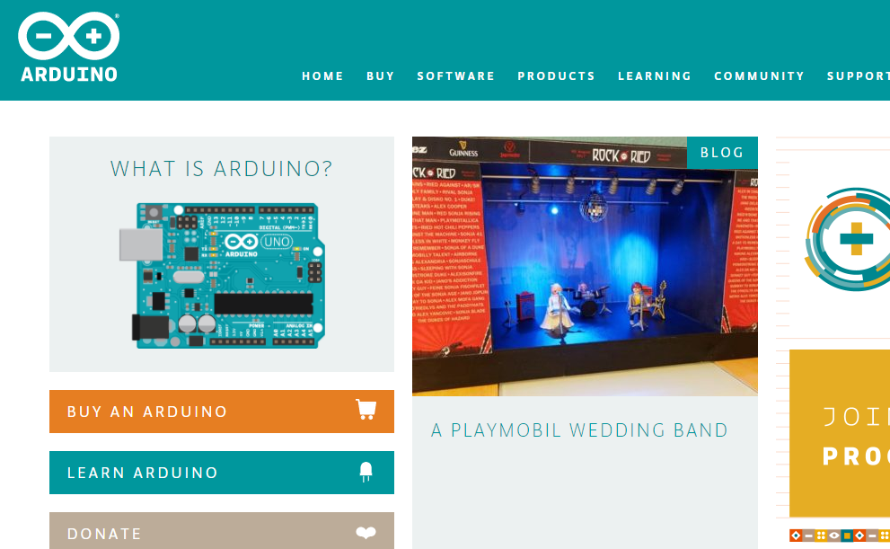

- Download the Arduino software for your operating system.
  - For Windows, use the Installer option (unless you know what you are doing).

- Contribute or not, as you see fit.
- Download and run the installer. Follow onscreen prompts and accept the default on what to install and where the program is placed. That way the instructor will always know where your program is located.

  - If you get a Windows Security message, click Install to continue

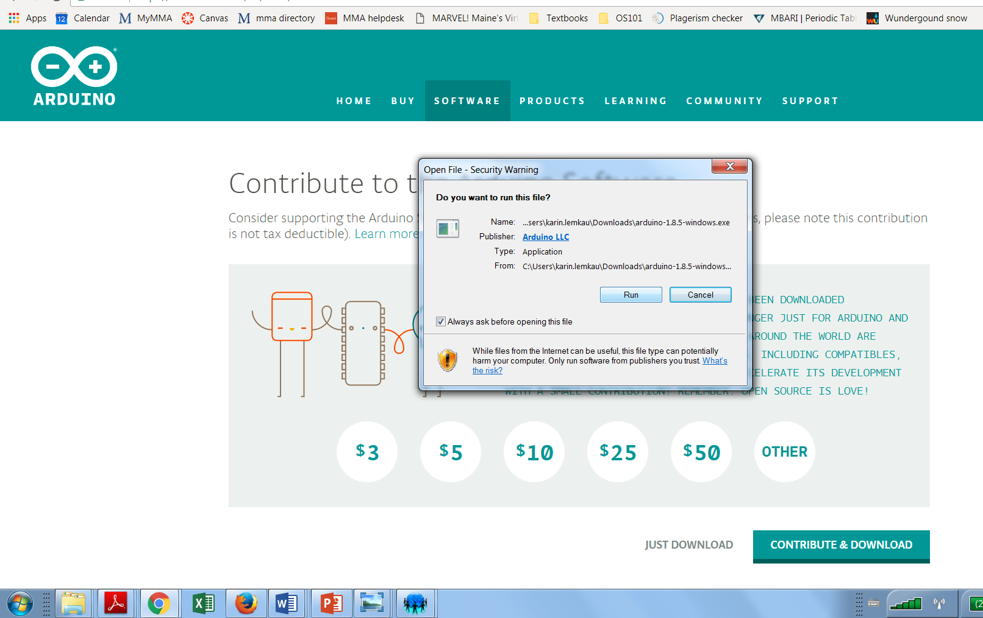

- When installation is complete, window will say Completed. Click close. Congratulations, you are now ready to start writing an Arduino sketch!

Installing Libraries
If your instructor directs you to download specific libraries for follow on activities, you should do so at this time. Below we show how to download libraries for building a temperature sensor. You may be instructed to download different libraries depending on your follow on activity.
- During installation an Arduino shortcut should have appeared on your desktop. Click the shortcut to open the software.
- Go to the Sketch menu and choose Include Library and then Manage Libraries.
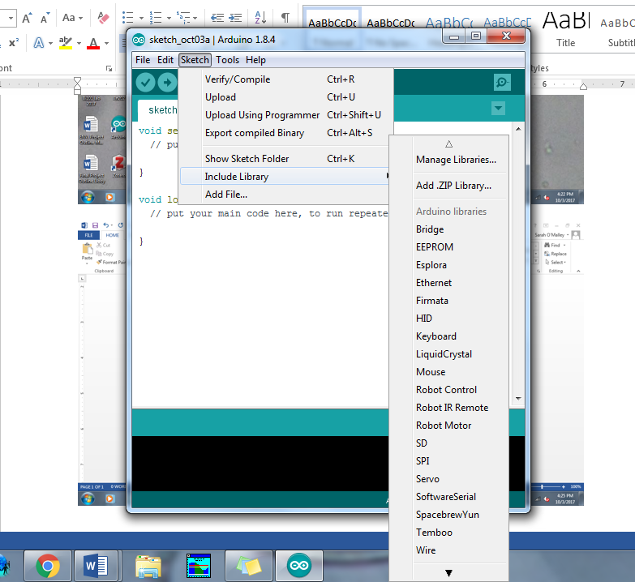

- The Library Manager dialog box will open. Under Topic select Sensors. Type “onewire” into the search box. Choose the MAX31850 DallasTemp by Adafruit selection, click More Info just once, to bring up the Install button, and then click Install.
- Now select MAX31850 OneWire by Adafruit. Click More Info, then click Install.
- Close the Library Manager dialog box.
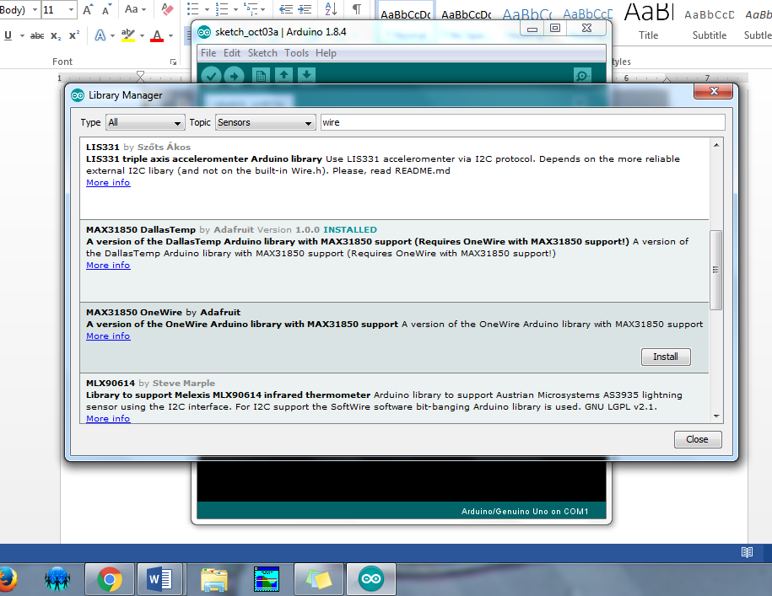
- Check to make sure the libraries installed. Go the Sketch menu (as in installing libraries step 2 above) and choose Include Library and then Manage Libraries. Scroll down to the recommended libraries and look to see that the installed libraries are listed.
