The Impact of Ocean Acidification on Coral Reef Ecosystems- INSTRUCTOR’s KEY
Introduction: Atmospheric CO₂ is on the rise due to anthropogenic emissions and the oceans have been shown to assimilate about 30% of all carbon in the atmosphere. In a process knowns as “ocean acidification”, CO₂ reacts with seawater to form carbonic acid, which subsequently alters the carbonate (carbon-based) chemistry and lowers the pH of the surface oceans. This change in pH makes the oceans more acidic, and makes it more difficult for some calcifying organisms, like corals, oysters, or sea urchins to build their skeletons or shells
Of particular concern to the scientific community are tropical coral reefs, which are critical habitats for many reef species and are vital to the world’s economy due to the ecosystem services they provide. Corals are colonial animals that build their skeleton out of calcium carbonate (CaCO₃), providing the “backbone” for the reef itself. Their survival is necessary to ensure the future health of coral reef ecosystems.
In this activity, you will explore how ocean acidification will impact calcifying organisms in the ocean, particularly reef-building tropical coral species. You will analyze real data and discover how corals (in particular coral skeletons made of CaCO₃) are threatened by ocean acidification.
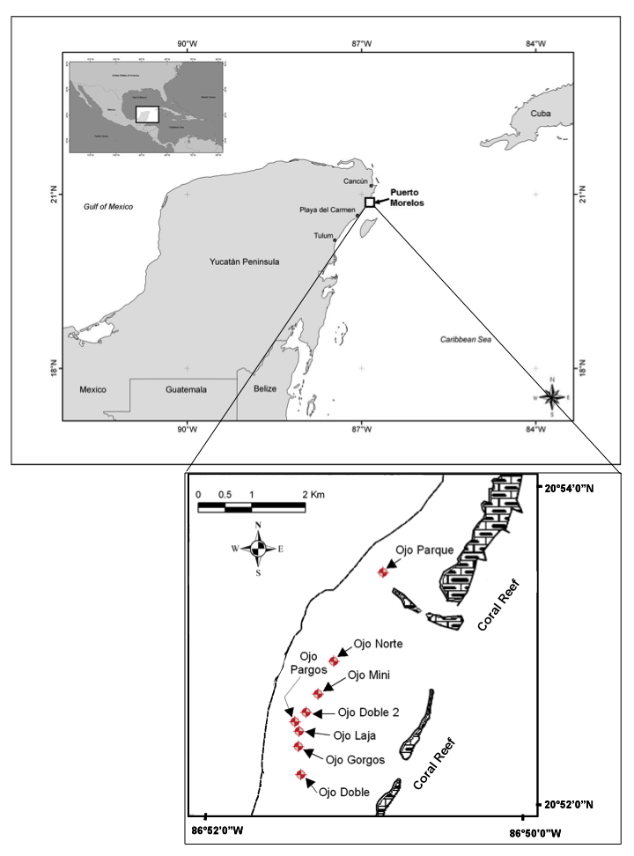
Part 1.1: Site Analysis and Experimental Design
Scientists are very concerned with the state of our coral reefs. They are constantly monitoring reef health and looking for ways to address how ocean acidification might impact coral growth in the future. A team of scientists are very concerned with the impacts of ocean acidification on a very specific type of coral, called Porites, which is a reef-building coral in many reef ecosystems across the world. They have identified several sites in the Caribbean Sea off the coast of Mexico that have naturally low pH, meaning that the natural environment has very specific locations where the pH is lower than the surrounding environment and mimics changes in pH expected to occur across the oceans by the year 2100.
As it happens, these sites, which do have coral growing in them, can be used as a proxy for future ocean acidification impacts to coral reefs. The map shows the locations of these sites, which occur about 500m offshore in about 4m deep of water, in the vicinity of the Mesoamerican Barrier Reef. While the water at these sites has lower than average pH, the water surrounding these sites (which also has Porites corals growing) has ambient pH, meaning average ocean values.
Scientists have determined ways to measure the calcification rates of corals (you will learn the specifics later!), but in order to do so they need to obtain coral samples from the field.
Your task will be to design an experiment for this field site that will address the question: How will a decline in surface ocean pH by the end of the 21st century impact tropical coral growth?

1. First, what are some important considerations for field work and data collection? That is, what things should you keep in mind when designing and implementing your field and laboratory components of the research? (Brainstorm here about equipment needs, sampling number, types of samples (i.e. experimental vs. control group), permitting requirements, etc).
Students can brainstorm individually and then as a group about the equipment or materials necessary to sample coral (they might talk about boats, scuba diving, etc). Some guiding questions can be helpful, like asking them how sampling in a different country (Mexico) might lead to various obstacles. Eventually, have them start thinking about what makes a good scientific experiment, like sample replication, site replication, and what might be the control vs. the experimental group in this case. It is sometimes helpful to bring up dependent and independent variables, which will help guide them through their own experimental design.
2. With your partner, design the experiment, keeping in mind the important considerations above. Assume you have plenty of funding and no real time constraints, that obtaining coral samples won’t be a problem, and that you were able to complete the experiment after you designed it. Brainstorm with your partner, then outline your experiment.
After the group discussion above, have them break into smaller groups to design the experiment and outline the steps needed. I have found it useful to facilitate a larger group discussion after this, as many groups will have thought of things that they did not.
3. (For an upper division writing class): On a separate piece of paper, write a methods section for a paper in which you explain what you did for your experiment and the types of samples and data you collected. Be sure your experiment is designed such that it answers the experimental question above. Remember: a methods section should detail the steps you took to obtain your data, but the data should not be discussed.
When giving this assignment to a writing class, this is a major portion of their grade for the activity. It is usually done as a follow-up assignment on their own at home and a rubric is provided based on the skills they need to have mastered for writing a methods section to a paper.
Part 1.2: Hypothesis: When designing experiments, scientists must always keep in mind the overarching goals of the project. Using the experiment you designed above, write a hypothesis for what you think the results of your experiment might show. Remember to define your independent and dependent variables.
_______________________________________________________________________________________________________________________________________________________________________________________________________________________________________________________________
Part 2: Data Analysis
In the following activity, you will analyze a set of corals obtained by the group of scientists mentioned in Part I above (from the same Caribbean field site). Some of the corals in this study grew in acidic conditions that will mimic the average pH of the oceans by the year 2100, while others grew in normal (i.e. present day) pH conditions. The corals were “cored” using an underwater drill that took a cylindrical sample of each coral in the experiment (see the Coral Coring Video, obtained from your instructor). You will take CT-scanned images of coral cores from the experimental and control regions and measure their rates of growth. Your task is to determine which corals were grown in lower pH conditions and draw conclusions about the impacts ocean acidification may have on coral reef ecosystems in the future.
Make sure to print high quality images of the photos, as the CT images can be very hard to read, particularly if copied incorrectly. You can give the students strips of paper to make their measurements rather than an actual ruler, as the scale bars may not line up with easy measurements on a ruler.
Part 2.1: Annual Extension
Porites is a coral that grows at a steady and measurable pace, and leaves growth bands like the rings on a tree. These growth bands can be seen in a CT-scanned image of a coral (the same type of CT that doctors would use to scan your brain in a hospital). A single year is recorded as one light and one dark band on each coral, so to measure how much a coral extends in a year, you simply have to measure the distance of one light and one dark band combined. (You will discover later why the coral has these bands.) Using the coral growth packet and a ruler, estimate the annual extension (in cm/year) for each of these corals for five consecutive years. Be careful of scales and units! Record the annual extension rates for the corals in an excel file or in the table below. Then calculate the averages and standard deviations for annual extension rates for each coral sample.
Student responses for the following table will often vary widely. That’s ok, and it’s also the point. Students should be able to understand that there is quite a bit of growth variability between individuals, even if they aren’t human organisms. In the end, there should be no observable differences in extension between the various samples. This should be especially clear if students use excel to make the graphs and mark the error bars.
Table 1: ANNUAL EXTENSION RATES in cm/year (round to the nearest 0.1)
Sample | A | B | C | D | E | F
Year 1

Year 2

Year 3

Year 4

Year 5

AVERAGE

Standard Deviation

Graph the average annual extension rates, with error bars (i.e. the standard deviation) in the space provided, or using excel. Don’t forget to label the x-axis with the sample name! Then use your graph to answer the questions that follow.

Average Annual Extension (cm/yr)

Sample ID

- Were there any significant differences in extension rates between corals A-F above? How do you know? (Hint: use the standard deviation that you calculated).
No there were no significant differences in annual extension. While extension varied between individuals, each sample was well within one standard deviation of the next sample, suggesting that no differences were significant.

- What does this result tell you about how fast corals extend in both the experimental and the control groups (i.e. acidified and non-acidified water)?
Corals appear to be growing at equal rates in both acidified and non-acidified water.

- Does this result surprise you? Why or why not?
Most students find this surprising, because they expect ocean acidification impacts to be immediate and severe. Students should be encouraged to keep exploring at this point!
Part 2.2: Density and Total Calcification
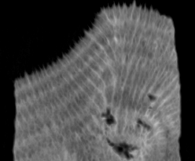
As you might have guessed, coral extension in a given year is only part of the story. That is, a coral can grow relatively quickly but still have reductions in overall calcification. How might that be? Think of a human with osteoporosis, which is a severe disease involving a decrease in bone density that particularly inflicts the elderly. With osteoporosis, the density of the material present (bone) is a key factor is deciding the overall health of the person, as people with osteoporosis have an increased risk of bone fractures. Corals can exhibit similar symptoms, where outwardly they look normal but may have differences in skeletal density. This is where the CT scanning machine really comes in handy for our corals. Not only can we see how quickly they grow (by counting growth bands as you did in Part 2.1), but the machine measures the density of the coral skeleton at any given point. In fact, the light and dark bands are due to changes in density in a given year…when growing conditions are optimal each year, the density of the skeleton will increase (look lighter on the CT scanner), and when growing conditions are less optimal, the skeleton will be less dense (look darker on the CT scanner).
1. Drawing arrows to the figure at right, label regions in the CT image where you think the coral may be growing optimally, and regions where the coral may be growing at a slower rate. What environmental factors do you think might drive these differences in growth rates?
The darker stripes at right correspond to less dense growth, and the lighter bands correspond to optimal growth. This is where students can talk about seasons, sea surface temperatures, etc.

The total calcification rate, or how much the coral calcifies in a given year, is determined by taking the extension (which you already measured) and multiplying it by the skeletal density:
Equation 1: Total Calcification (g cm⁻² yr⁻¹) = Annual Extension (cm yr⁻¹) * Density (g cm⁻³)
That is, the total calcification takes into account both the outward growth and the density of the material present.
Table 2 below reports the density of the skeleton for a given year for each coral you measured in Part 2.1 above. Calculate the average density per coral sample, and report these averages (and the standard deviation), either using excel or in the table below.
Table 2: AVERAGE SKELETAL DENSITY (g/cm⁻³) (round to the nearest 0.1)
Sample | A | B | C | D | E | F
Year 1 | 2.1 | 2.2 | 1.9 | 0.76 | 0.88 | 0.9
Year 2 | 1.98 | 1.96 | 1.8 | 0.55 | 0.72 | 0.81
Year 3 | 1.88 | 1.86 | 2.2 | 0.81 | 0.69 | 0.72
Year 4 | 2.3 | 2.1 | 1.87 | 0.51 | 0.84 | 0.76
Year 5 | 1.9 | 1.9 | 1.84 | 0.52 | 0.79 | 0.79
AVERAGE

Standard Deviation

Now use equation 1 to calculate the average calcification rate of each coral in excel. Graph the results (in excel or the space that follows). To find the combined standard deviation: If the standard deviations of X and Y are given by s_{x} and s_{y} then the standard deviation of the combined distribution, Z, is given by (s_{z})²= (s_{x})² + (s_{y})².
Table 3: Average Calcification Rate (g cm⁻²yr⁻¹) (round to the nearest 0.1)
Sample | A | B | C | D | E | F
Average Calcification Rate
Combined Standard Deviation

Average Calcification Rate (g cm⁻²yr⁻¹)

Sample ID

- Why is there a difference in calcification rates between the corals, even if there were no differences in extension?
There is a difference in calcification because calcification takes into account both growth (extension) AND density of the growth. Because certain corals had much less dense skeletons, these corals had much lower calcification rates. These differences were significant.

- Which corals had the strongest rates of calcification? The weakest?
Strongest calcification = ABC; Weakest Calcification: DEF.

- Which corals would you hypothesize grew in acidified conditions? Why? How does this compare to your hypothesis above?
Corals D, E, and F were likely growing in acidified conditions because they had the lowest overall calcification rates.

- Why might a coral want to extend rapidly, even at the cost of skeletal density?
Corals may be in competition for resources and the bigger they are, the more likely they may be to survive. This means that corals may be able to extend rapidly, but the result will be a weaker skeleton overall. This may decrease the overall fitness of the reef.

- Corals calcify (build their skeletons) with the mineral aragonite, which is a form of calcium carbonate (CaCO₃). Which corals had the most calcium carbonate present?
Corals A B and C had the most CaCO3 present.

Part III: Ocean acidification and calcifying organisms
Instead of using pH, scientists often use the “saturation state” (Ω) of seawater to calculate how easy...or difficult…calcification may be for marine organisms. Simply put, the saturation state is a measure of how much carbonate (CO₃²⁻) there is in the ocean. If the saturation state is high, there is plenty of available carbonate for organisms to calcify (the water is said to be super-saturated). If there is relatively little carbonate, the water is said to be under-saturated, at which point CaCO₃ will start to dissolve. The equation for saturation state is:
Equation 2: Ω = [Ca²⁺] [CO₃²⁻] / Ksp* where Ksp* is a constant
1. Using Equation 2 above, state what will happen to the saturation state (Ω) if the amount of calcium remains constant but the amount of carbonate drops?
Saturation state will decrease if the amount of carbonate in the oceans decreases.

As more CO₂ enters the surface oceans from the atmosphere, this CO₂ reacts with seawater to form carbonic acid, which then produces more protons (H+) in the water. These protons then attach themselves to carbonate (CO₃²⁻), thus reducing the saturation state by reducing the amount of carbonate available to organisms.
2. Using your results from the experiment above, which corals above are likely experienced lower saturation states? How do you know?
Corals D, E, and F likely experienced lower saturation states, because there was less calcium carbonate present overall for these corals. Lower skeletal densities mean it was more difficult for the corals to calcify, insinuating lower saturation states.

Sample | Saturation of water at time of sampling (Ω)
D | 0.7
E | 1.3
F | 2.1
A | 4.5
B | 4.2
C | 4.4
Now it’s time to see if you were right! The scientists recorded the saturation state of the water when they took the coral cores, thus giving us some indication of the saturation state in which the corals grew. These values are reported in the table at right. Check to see if your predictions are correct!

3. Below is a projection of how saturation state will likely change in the oceans over the next 100 years or so (Skaland et al., 2008). Using your knowledge of how calcification will likely respond to decreasing saturation in the ocean, graph how you think corals will respond to ocean acidification over the next century. Be sure to label the axes.

Students should be able to make a rough prediction where calcification decreases steadily as saturation state decreases over the 21st century.

Reflection: What has this experiment taught you about the impacts of ocean acidification on coral reefs in the future?

