Geology 140 Flood Lab

Part 1. Comparing and Contrasting Flood Types
In the following chart, provide a basic description of each flood type including the source/cause of the flood, factors that contribute to damage and time frame
Flash  Source:  Factors:  Time Frame: | Regional  Source:  Factors:  Time Frame:
Storm Surge  Source:  Factors:  Time Frame: | Tsunami  Source:  Factors:  Time Frame:

Part 2. Examining Statewide Data

Part A. Select a station from the USGS Water Stations in WA (see instructions on how to access on the Canvas page)
- What is the name of the gaging station and river associated with the station you selected?
- What is the current discharge at your station (number value)? Explain in words what that means.
- How does this current discharge compare to past activity in this location?
- How many years are on record and what does that tell you about the context of the current discharge? [is it above, normal, below; what is the probability of the level at this height based on historical data? (Refer to probability estimate meanings in this weeks’ lecture video)]
- Is this an upstream or downstream region and what does that mean about the possible type of flooding that could occur?
- What is one way that flooding risk could be mitigated (minimized) for this region?

Part B. Consider how vulnerable populations might be particularly impacted by flooding by first reading this article from Scientific American (pdf is available on Canvas page). Look at the map from the WA Tracking Network (instructions on how to do this are on the Canvas page).
- Based on the article from Scientific American, how does economic status impact vulnerability to floods?
- To investigate this vulnerability consideration more locally, you’ll use the WA Tracking Network maps to consider this. Start by selecting the Topic selection in the legend, and select, “Social Vulnerability to Hazards” option (see image below)
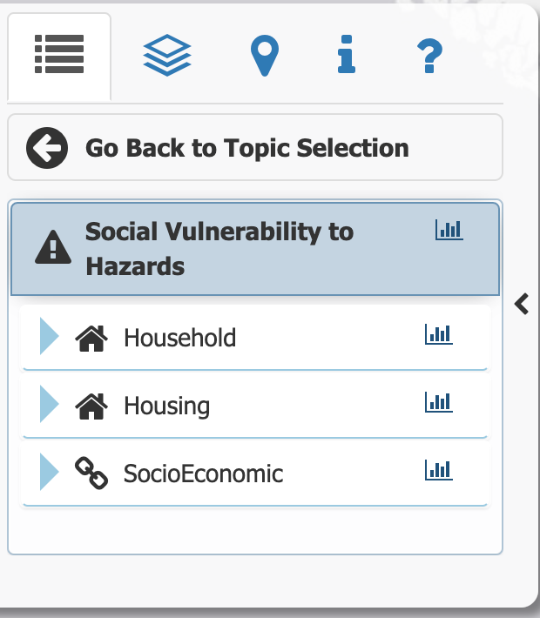

- Select 100-year Flood Zone option in the Map features part of the legend (see image below).
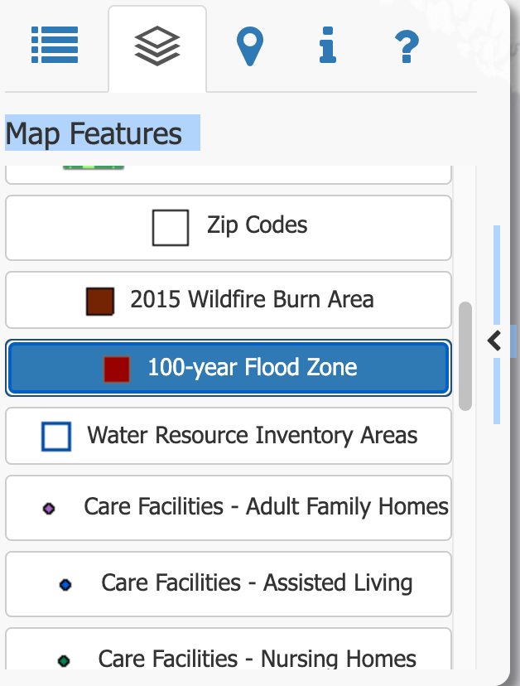
- Zoom into your specific river you focused on for part A of this lab and answer the following:
  - What is the vulnerability ranking for the region where you were examining data? Upon what is that based?
  - When considering the risk formula from week one: Risk = hazard x exposure (value) x vulnerability; what are several ways that the risk of a future flood could be mitigated?
  - What other variables might impact how likely flooding is to occur in your region of focus?
- What questions remain about flooding?

