You may want to use a template such as this as you guide the students step-by-step through the construction of this diagram. I start them off with a detailed description of the first calculation and then let them complete the construction of the reactions and the ∆G_{r} calculations for the rest. You may or may not want to include the balanced reactions and completed ∆G_{r} calculations in this template.

Use the Triangular diagram to determine the stable minerals that will go on the final activity diagram. Ubiquitous water – can be used to balance equations.
- Determine what minerals to consider.
- No hydrated pure silica phase-we won’t worry about SiO₂ (am) for this example.
- K₂O & KOH
- Al₂O₃ , Al (OH)₃ , Al O (OH)
corundum gibbsite boehmite
- No pure K-silicates exist
- No K-Al-O minerals exist
- Common Al-Si minerals:
kaolinite pyrophyllite kyanite
- Common K-Al-Si minerals:
microcline kaliophilite leucite muscovite
- Collect necessary ∆G_{f} for likely minerals (next page)
- Compose a table showing the compositions of the phases of interest in mole %. Start with the number of moles of K₂O, Al₂O_{3,} & SiO₂ in the mineral and then convert to mole percent. (next page)

- Plot the minerals of interest on the triangular diagram. (Figure A)
Examples of potential diagrams A – G are included in the PDF entitled: “triangular diagram demo-images”

- Determine which mineral is stable at the 3 apices. (Use ∆G_{R}) {Any ideas how ?}
  - ½ K₂O (s) + ½ H₂O (l ) ⇌ KOH (s)
∆Gr = ∆G_{f} ∘_{(KOH)} –[ ½ (∆G _{f} ∘ _{(K2O)} ) ₊ ½ (∆G_{f} ∘_{(H20)} )]
= -379.1 – [½ (-322.1) + ½ (-237.1)] = -99.5 kj/mol
Goes as written - KOH stable - so it occupies the lower left hand corner.
  - ½ Al₂ O₃ (s) + 1½ H₂0 (l) ⇌ Al (OH) ₃ (s)
∆G_{R} = -8.3 Gibbsite stable
Gibbsite stable

c. AlOOH (s) + H₂O (l) ⇌ Al (OH) ₃ (s)
Gibbsite stable

∆G_{R} = -2.2 Gibbsite stable
[Now you have Figure B/C.]
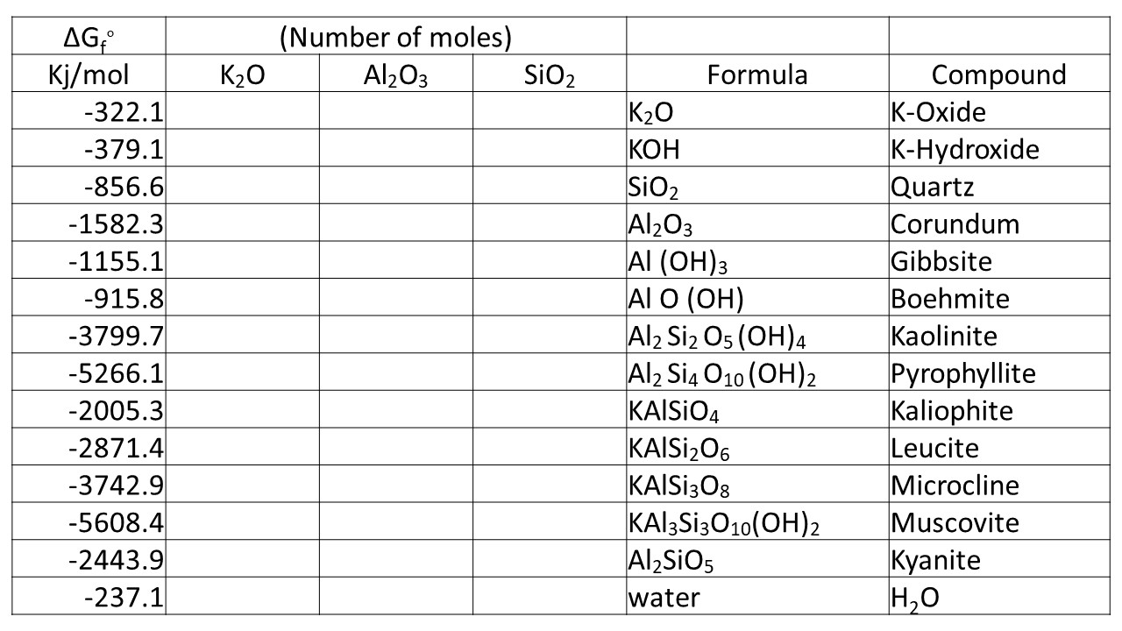

- Tie-lines connect stable coexisting phases.
- On your diagram (Figure B/C) you see lots of colinear phases on the outside but are they all stable? That is, is every segment between 2 minerals a tie-line?
- Start at one apex and work down
- Is pyrophyllite stable or does it react to form kaolinite + quartz?
Al₂ Si₂ O₅ (OH)₄ (s) ₊ 2SiO₂ (s) ⇌ Al₂Si₄O₁₀(OH)₂ (s) + H₂O (l)
∆G_{R} = +9.7
Pyrophyllite ≠ Stable
- Is kyanite stable w.r.t. kaolinite + gibbsite?
Al₂ Si₂ O₅ (OH)₄ (s) + 2Al(OH)₃ (s) ⇌ 2 Al₂ Si O₅ (s) + 5 H₂O (l)
∆G_{R} = +36.6 Kyanite ≠ Stable
Kyanite ≠ Stable
- Is kaolinite stable w.r.t. quartz + gibbsite ?
2SiO₂ (s) + 2Al(OH)₃ (s) ⇌ Al₂ Si₂ O₅ (OH)₄ (s) + H₂O (l)
∆G_{R} = -13.4 Kaolinite = Stable
Kaolinite = Stable
- Now check internal collinear phases (Figure D)
- leucite + quartz = microcline
KAlSi₂O₆ (s) + SiO₂ (s) ⇌ KAlSi₃O₈ (s) ∆ G_{R} = -14.9
Microcline = Stable
- microcline + kaliophilite ⇌ leucite ∆G_{R} = +5.4
KAlSi₃O₈ (s) + KAlSIO₄ (s) ⇌ KAlSi₂O₆ (s)
Leucite ≠ Stable
- kaliophilite + quartz ⇌ microcline ∆G_{R} =-24.4
KAlSIO₄ (s) + 2SiO ₂ (s) ⇌ KAlSi₃O₈ (s)
Microcline = Stable
- microcline + gibbsite ⇌ muscovite
KAlSi₃O₈ (s) + 2Al(OH)₃ (s) ⇌ KAl₃Si₃O₁₀(OH)₂ (s) + 2 H₂O (l)
∆G_{R} = -29.5 Muscouite = Stable
Muscovite = Stable
- kaolinite + kaliophilite ⇌ muscovite
Al₂Si₂O₅ (OH)₄ (s) + KAlSIO₄ (s) ⇌ KAl₃ Si₃ O₁₀ (OH)₂ (s) + H₂O (l)
∆G_{R} = -40.5 Muscouite = Stable
Muscovite = Stable
- muscovite + KOH ⇌ kaliophilite
KAl₃ Si₃ O₁₀ (OH)₂ (s) + 2KOH (s) ⇌ 3KAlSiO₄ (s) + 2H₂O (l)
∆G_{R} = -123.5 Kaliohphilite = Stable
Kaliophilite = Stable

Remember a stable intermediate phase does not eliminate the endpoints
(Left with Figure E)
Now
- Draw all possible tie-lines (Figure F)
Eliminate crossing tie-lines:
muscovite + quartz ⇌ microcline + kaolinite
KAl₃ Si₃ O₁₀ (OH)₂ (s) + 2SiO ₂ (s) + H₂O (l) ⇌ KAl Si₃O₈ (s) + Al₂ Si₂ O₅ (OH)₄ (s)
∆G_{R} = +16.1 (Quartz + Muscovite = Stable) (Figure G)

