Gesture Exercise: Primary Structures and Rotation

Part 1: Below is an outcrop photo of cross-bedding. Work in pairs to come up with a gesture to represent the relationship between a single cross bed and the bed sets. You want to use your hands to convey the shape and orientation of each surface (i.e. the bedding and the cross-bedding), and the geometric relationship between them.

Part 2: Consider the following two pictures. Can you use the same type of gesture for each of these? If so, go ahead and do so. If necessary, refine your gesture so that it works for all of the pictures.

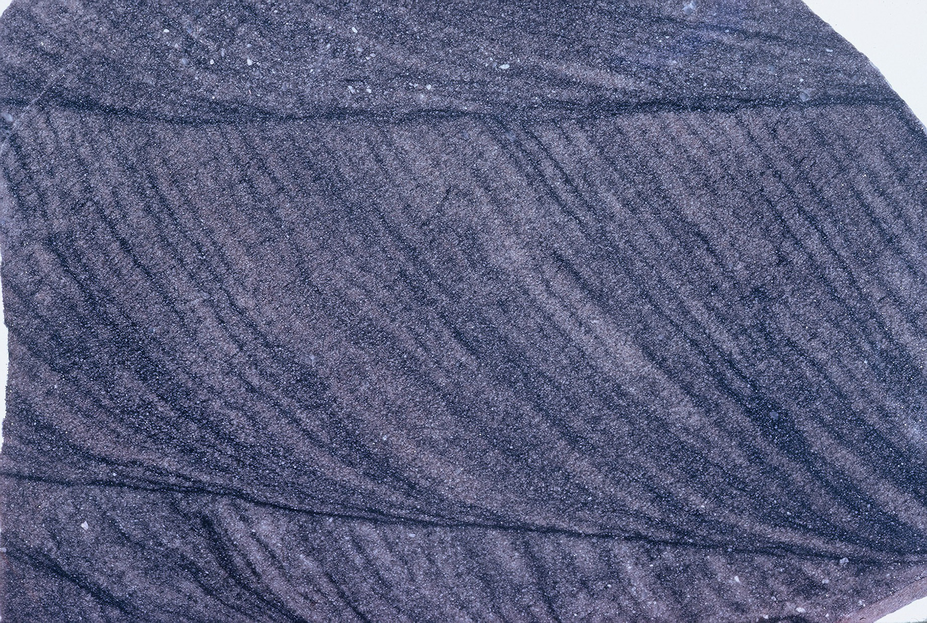

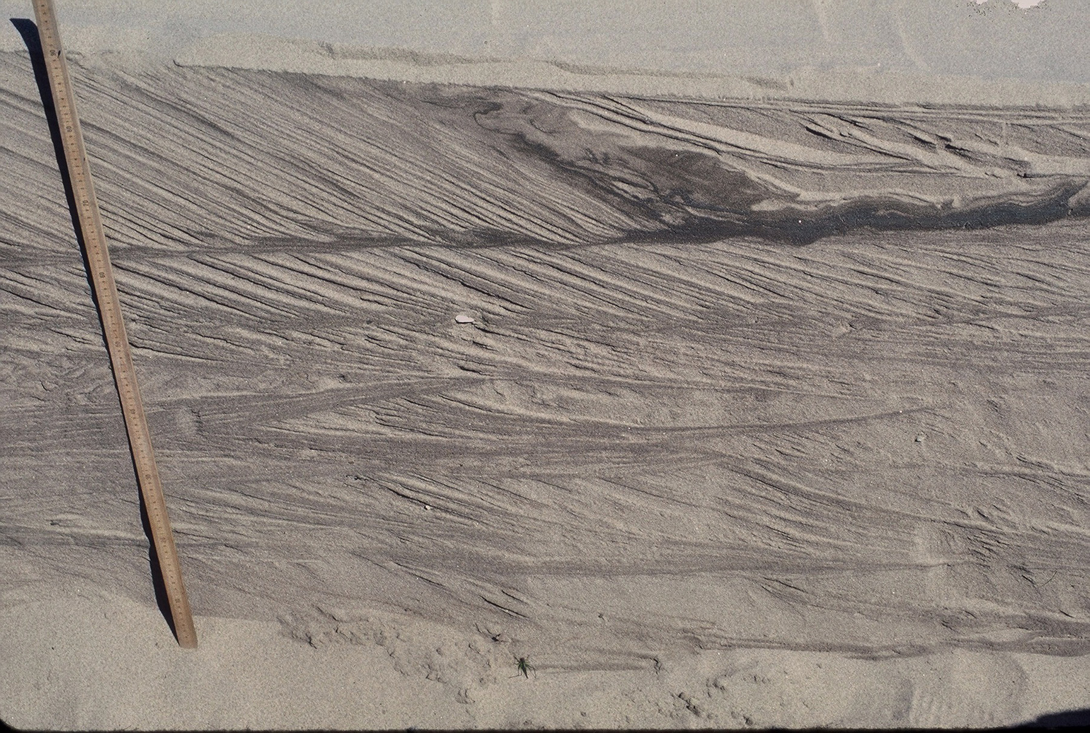

Part 3: Share and compare. Share your gesture with other students, and see whether they came up with similar or different ways of conveying the same information.

Part 4: The images you have looked at so far are of horizontal cross-bed sets. Consider the photos below, which show cross-beds that are no longer in the orientations in which they were deposited. Use your gestures to indicate their orientations.

Part 5: Using gesture to show motion: So far, every gesture we have used in this class has been to indicate orientation. But gestures can also be used to show motion, including (for example) deformation. Using the two photographs above, use gesture to indicate the orientation of the cross-beds when they were deposited; then, rotate your gesture to their current orientations. Convince yourself (and your partner) that, while this is not necessarily the rotational history of these cross-beds, it is one possible rotational history. [Hint: can you gesture a different history that ends in the same current orientation?]

