Understanding the building blocks of 3-D structures shown in 2-D polyhedral diagrams:
Different views of the same structural components
Carol Ormand and Barb Dutrow

Introduction and Context:
Mineral structures are commonly represented by polyhedral diagrams. These diagrams encode spatial information, showing the 3-D relationships of atoms and bonds within the mineral. It is important to be able to “read” these types diagrams: to visualize the ions and bonds within the polyhedra and within the mineral, including ions that are hidden from view. Moreover, these components of mineral structures may be viewed from multiple angles in order to convey specific information, and it’s important to be able to “read” those different views.

In this exercise, you will practice extracting information about atomic structures from polyhedral diagrams of minerals. We’ll start with individual polyhedra, since these are the building blocks of polyhedral diagrams. You may find it helpful to make paper models of polyhedra to translate these 2-D representations to 3-D. Paper diagrams can be found on this website: http://www.progonos.com/furuti/MapProj/Normal/ProjPoly/Foldout/foldout.html.

Part 1: Identifying polyhedra. For each image of a polyhedral die below, fill in the chart with (a) how many faces, edges, and corners you can see, (b) how many faces, edges, and corners it actually has, and (c) its shape. The first diagram is done for you as an example.

 | How many can you see? | How many does it have? | What shape is it?
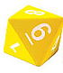 | Faces: 4  Edges: 9  Corners: 6 | Faces: 8  Edges: 12  Corners: 6 | Octahedron
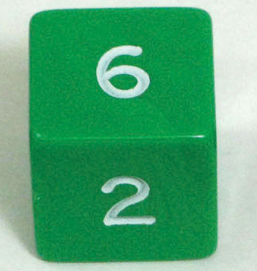 | Faces:  Edges:  Corners: | Faces:  Edges:  Corners:
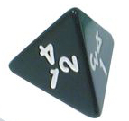 | Faces:  Edges:  Corners: | Faces:  Edges:  Corners:
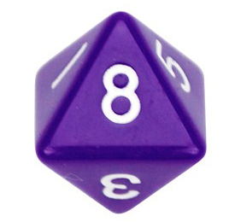 | Faces:  Edges:  Corners: | Faces:  Edges:  Corners:
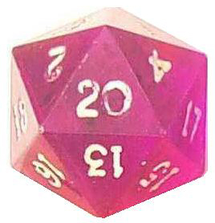 | Faces:  Edges:  Corners: | Faces:  Edges:  Corners:
Part 2: Tetrahedra and Octahedra. The polyhedra found commonly in silicate minerals are primarily tetrahedra and octahedra. Fill in the table below with the characteristics of these two polyhedra.

 | Number of faces | Number of edges | Number of corners
Tetrahedron
Octahedron

For each image below, identify whether it is a tetrahedron or an octahedron, and list how many of its corners are hidden from view. What do the corners on a polyhedron represent?

The first two diagrams are done for you as examples.

 | What shape is it? | How many CORNERS are hidden from view? |  |  | What shape is it? | How many CORNERS are hidden from view?
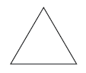 | Tetrahedron | 1 |  | 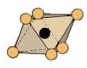 | Octahedron | 0
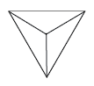 |  |  |  | 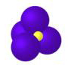
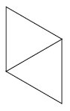 |  |  |  | 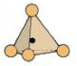
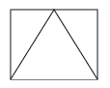 |  |  |  | 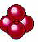
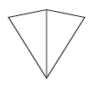 |  |  |  | 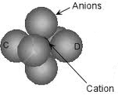
 |  |  |  | 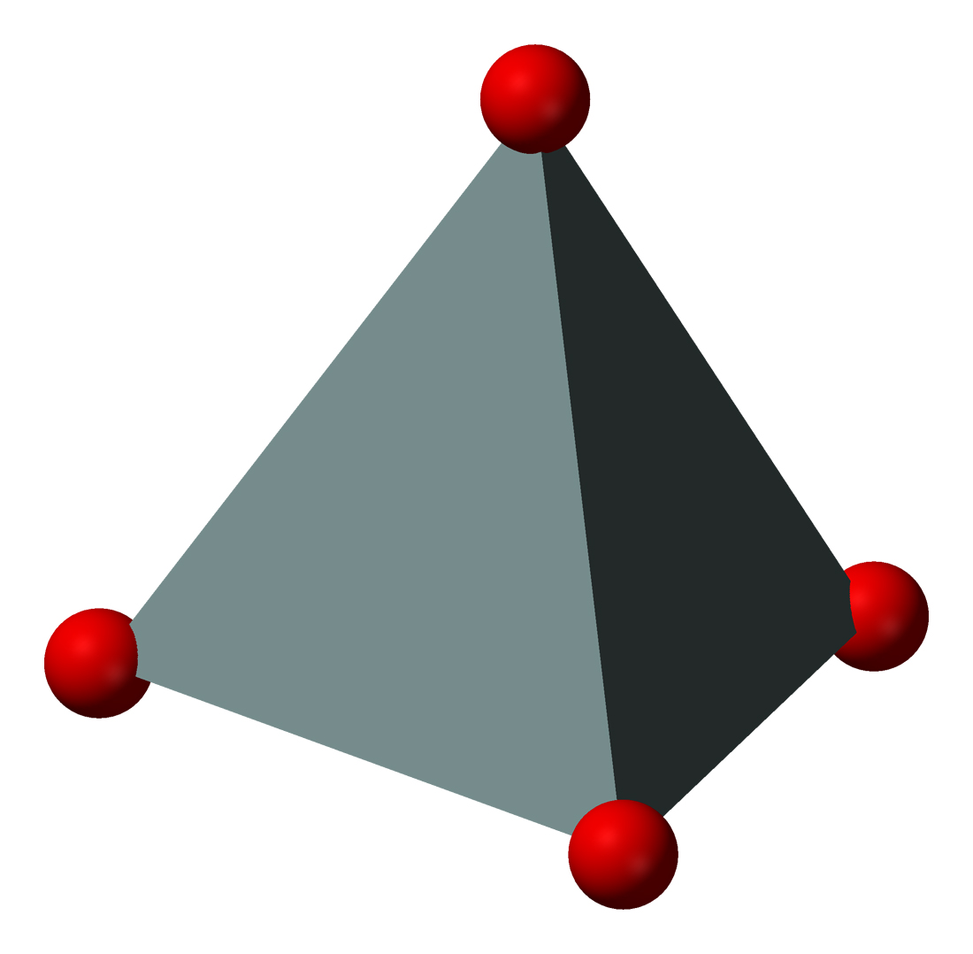
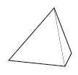 |  |  |  | 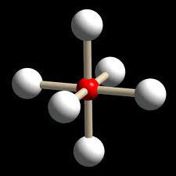
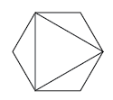 |  |  |  | 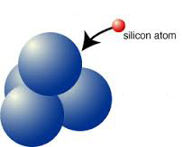
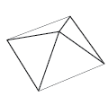 |  |  |  | 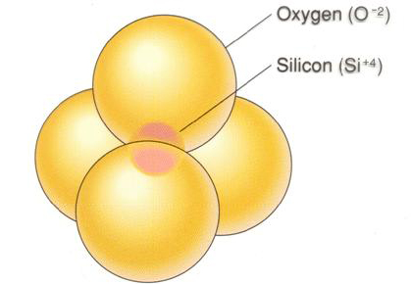

Part 3: Bonded polyhedra. The polyhedra found in silicate minerals are often bonded together, sharing oxygen atoms. We indicate this in diagrams by showing polyhedra sharing corners: each shared corner is a shared oxygen ion. For each of the diagrams below, indicate how many oxygens are present and how many of those you can “see” from the given perspective. The first diagram is done for you as an example.

 | How many oxygens can you see? | How many oxygens are present?
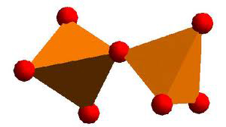 | 7 | 7
