Visualizing Phyllosilicates in 3-D
Barb Dutrow and Carol Ormand

Introduction:
Cognitive science research breaks spatial problem solving into three key cognitive tasks. One of these is visual comparison. If you become adept at visual comparison, you will also improve your ability to solving spatial problems. This exercise is designed to help you develop your visual comparison skills. This exercise focuses on comparing the 3-D structures of common phyllosilicates. Three of these mineral structures are shown below. The images in this exercise were created using CrystalMaker® software (http://www.crystalmaker.com). All structures share some similarities, and each has differences that distinguish it from the others. Some of these differences can be observed visually.

Self-assessment:
At the end of the exercise, you should be able to articulate the similarities and differences of these three phyllosilicate structures.

Biotite and Muscovite
The two images below show the structures of biotite (on the left) and muscovite (on the right), viewed at a very slight angle to the a-axis, with the c-axis vertical. Before you proceed to the questions, make sure you understand which of the geometric shapes in the images represent tetrahedra (T), which represent octahedra (O), and which represent the 10-fold site. Note that the figures below contain a mixture of visual elements: polyhedral and ball and stick.

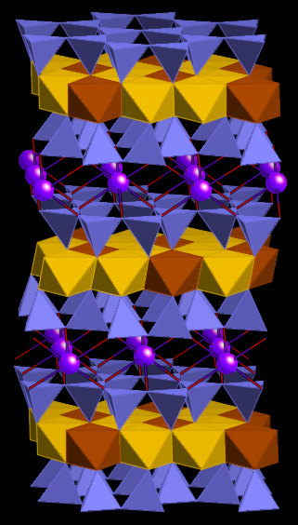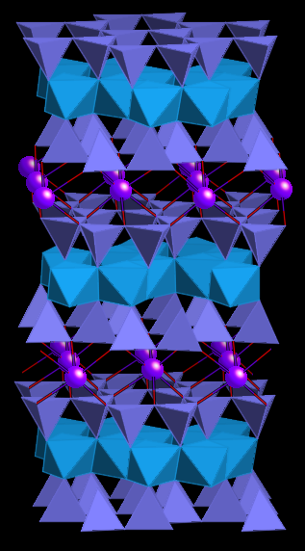
Biotite Muscovite
- Both of these minerals include T and O layers as part of their structures. Locate the T and O layers. Label those on the side of the figure. Note the orientation of the T layers. Do these represent T-O (open faced) or T-O-T (closed faced) structures?

- Draw a square bracket along the side to indicate the unit cell repeat distance along c. What is the size of the unit cell?

- Describe how each T and O fit within the general structure of each mineral.

- What is connecting the T-O-T sheets together?

- Chemically, what is the difference between biotite and muscovite?

- Can you see that difference directly in these diagrams?

- What is different between the two diagrams (other than the color of the octahedral sheet?)

- Summarizing, what are the similarities between the two mineral structures, and how are they different? Relate this to their chemical formulae.

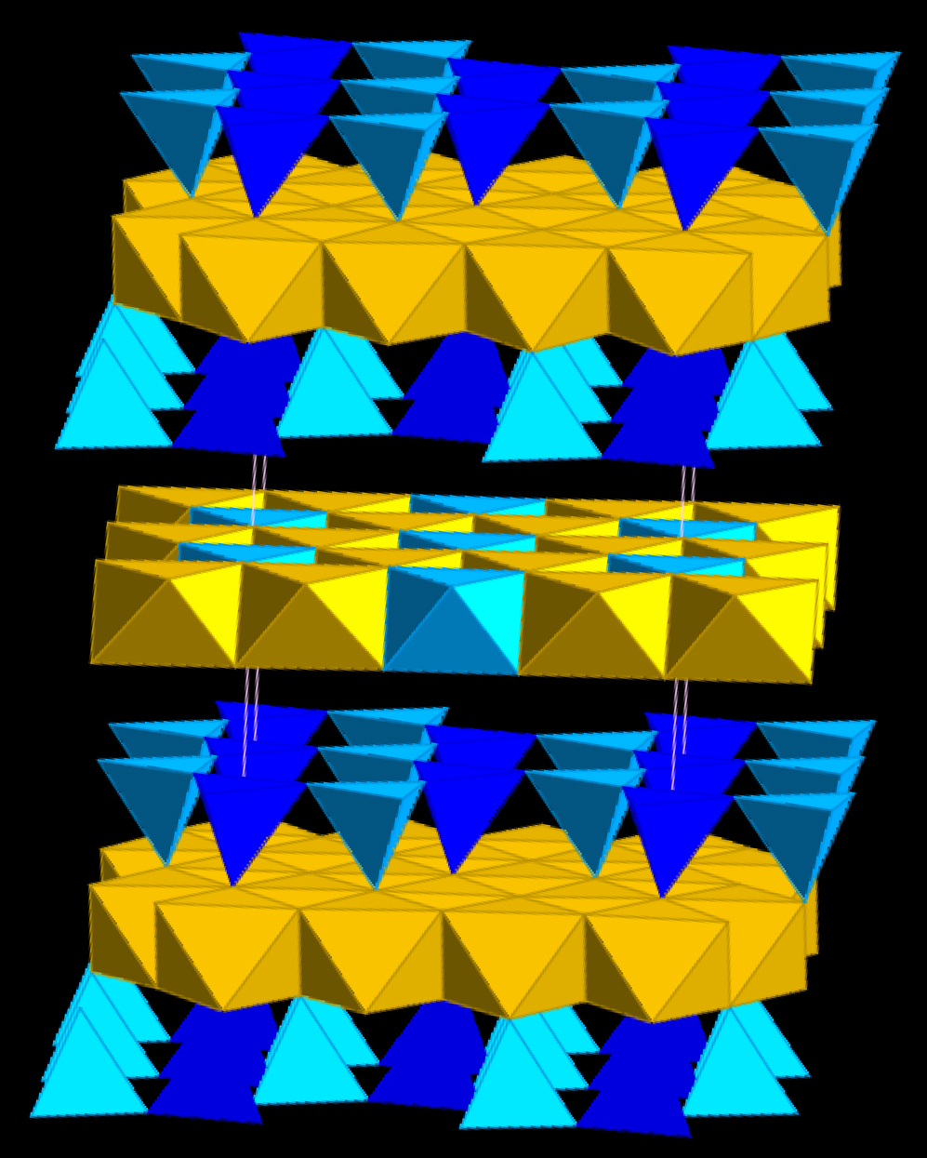
Biotite and Chlorite
The image on the right shows the structure of chlorite, as seen from the same perspective as the biotite and muscovite structures shown above. Here only polyhedral elements are shown.

- Chemically, what is the difference between biotite and chlorite?

- Label the T and O sheets in this diagram. Is this structure an open or closed T-O structure?

- Draw a unit cell along c. What is the repeat distance?

- What is the most notable difference between the structures of biotite and chlorite?

- In chlorite, what replaces the large interlayer (10-fold) site?

- Can you see the OH groups?

Muscovite and Chlorite
Compare the structures of muscovite and chlorite to answer the following questions.

- What is the most notable difference between the structures of muscovite and chlorite?

- What makes up the interlayer sites?

- What cation is present in muscovite but not in ‘end-member’ chlorite?

- What cation is present in chlorite but not in end-member muscovite?

  - In what structural site is Al found in each of these two minerals?

Synthesis
- Chemically, how do these three minerals vary? (How are they similar, and how are they different?)

- Structurally, how do these three minerals vary?? (How are they similar, and how are they different?)

