Microstructures Name:

Microstructures tell us what deformation processes have been active at the micro-scale, and those processes are valuable clues to the temperature, pressure, and strain rate history of a deformed rock. After completing this exercise, you should be able to
- Recognize common, important microstructures.
- Infer deformation mechanisms from microstructural observations.

For the exercises below, you may find it helpful to review the chapter on microstructures and deformation mechanisms in your textbook, particularly the figures.

Exercise 1: Match the microstructure(s) to the mechanism. (Note: multiple microstructures may map onto particular deformation mechanisms.)

Microstructures:
Crystallographic preferred orientation
Elongated, anhedral (i.e., not bound by crystal surfaces) grains
Fractured grains and angular grains
Quartz ribbons
Grain boundary bulging
Solution surfaces / stylolites
Strain (pressure) shadows
Subgrains
Tapered twins
Foam texture
Deformation mechanisms:
Cataclastic flow (cataclasis)
Dislocation creep
Bulging recrystallization (BLG)
Solution mass transport
High temperature grain boundary migration recrystallization (GBM)
Twinning
Subgrain rotation recrystallization (SGR)

Exercise 2: Similarities and Differences
Compare the microstructures in each of the pairs of photomicrographs below. What characteristics distinguish each microstructure from the one it is paired with?

Angular grains and fractures Foam texture
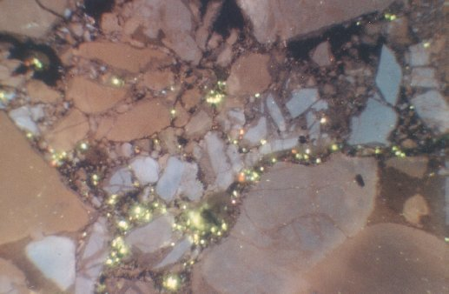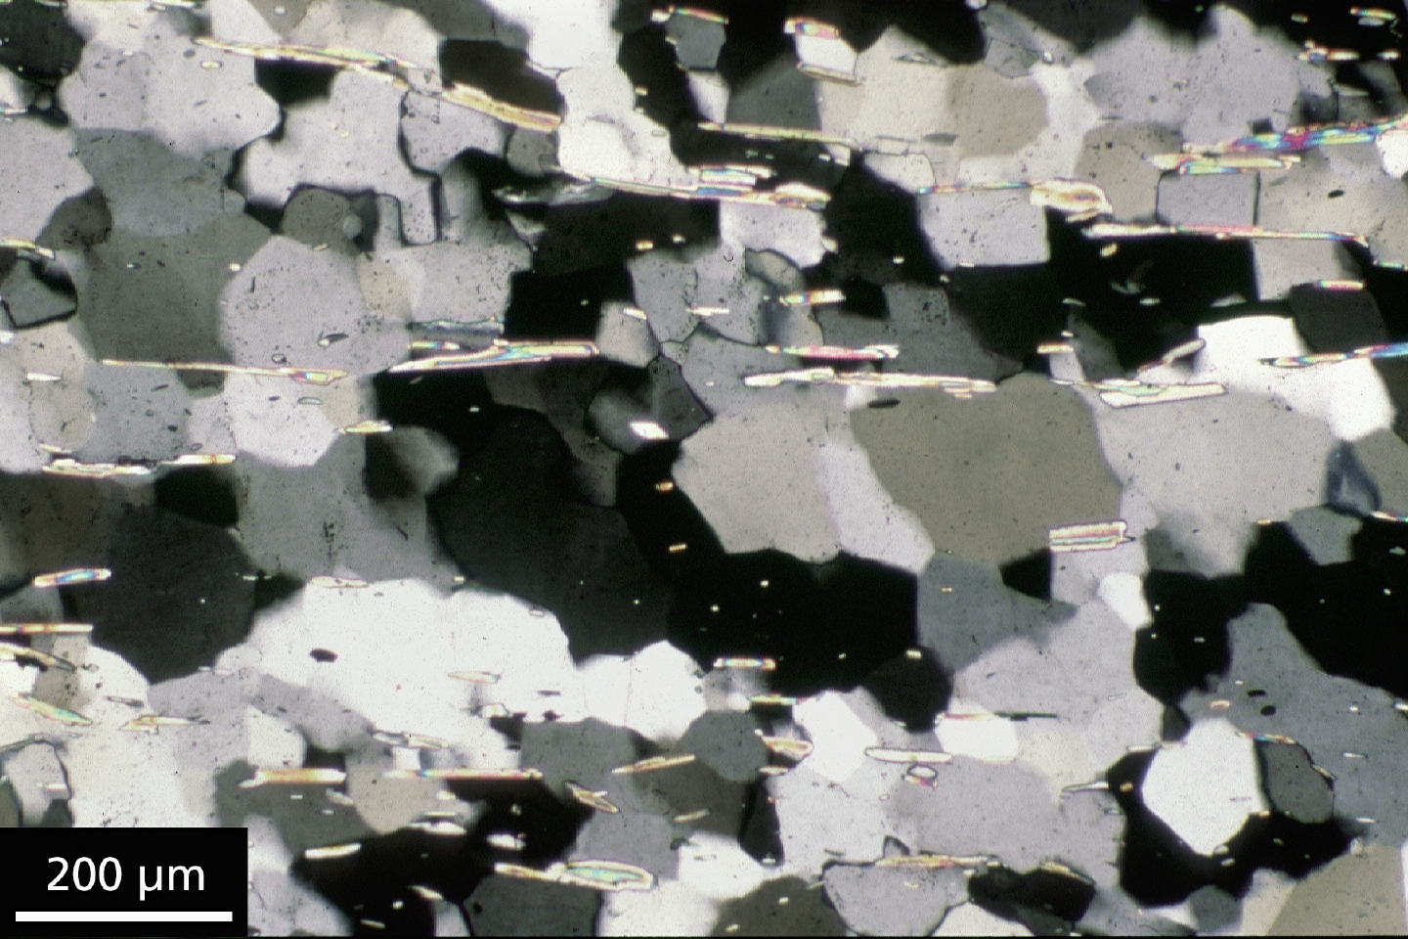
http://www.see.leeds.ac.uk/structure/assynt/skiagcl.htm http://virtualexplorer.com.au/special/meansvolume/contribs/tullis/Slides/025.JPG

Elongated quartz grains Strain shadow or wings on feldspar porphyroclast
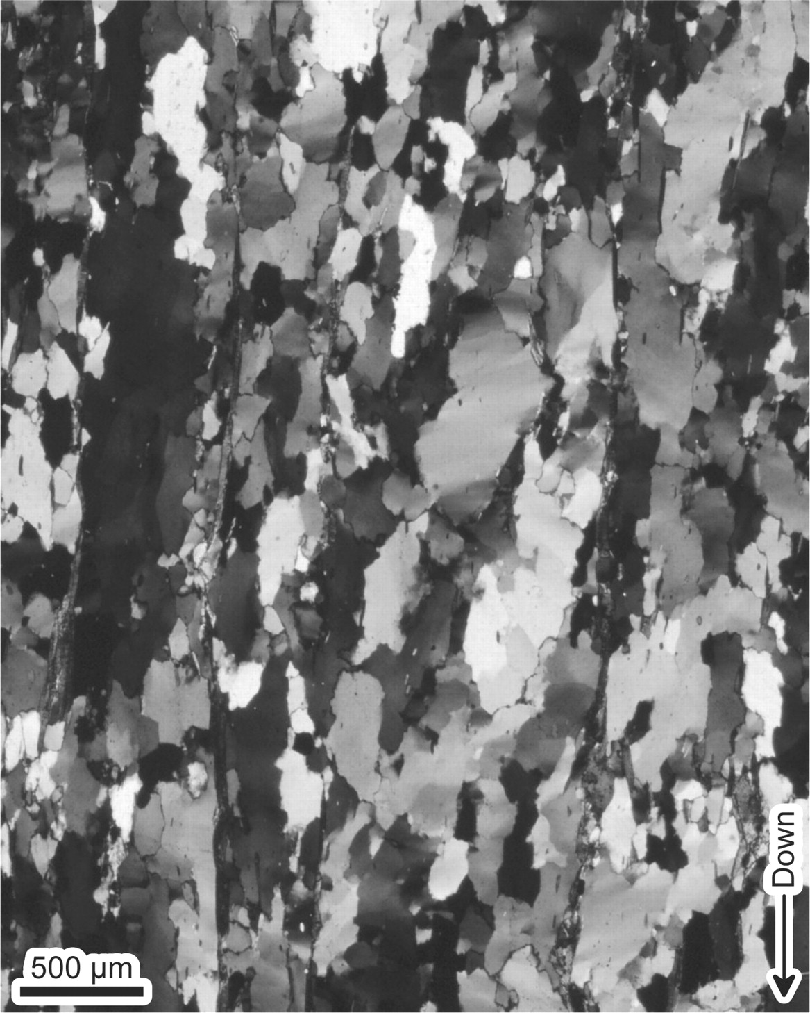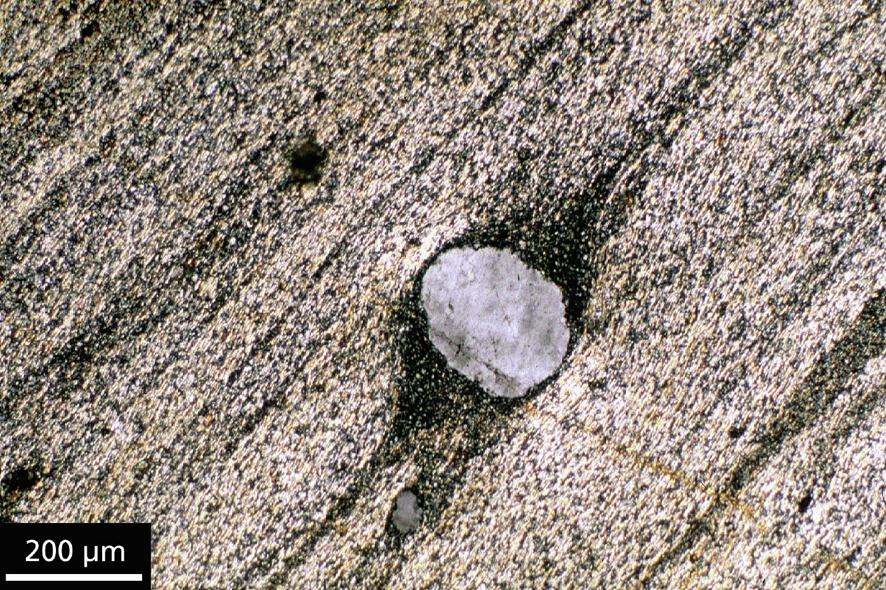
Allard and Portis (2013) http://virtualexplorer.com.au/special/meansvolume/contribs/tullis/Slides/085.JPG

Compare the microstructures in the quartz (long, thin, horizontal grains or quartz ribbons) and feldspar (porphyroclasts in the lower half) in the photomicrograph below. By what mechanisms are these different minerals deforming? Why do they deform by different mechanisms? What kind of porphyroclast systems are these, and what sense of shear do they record?

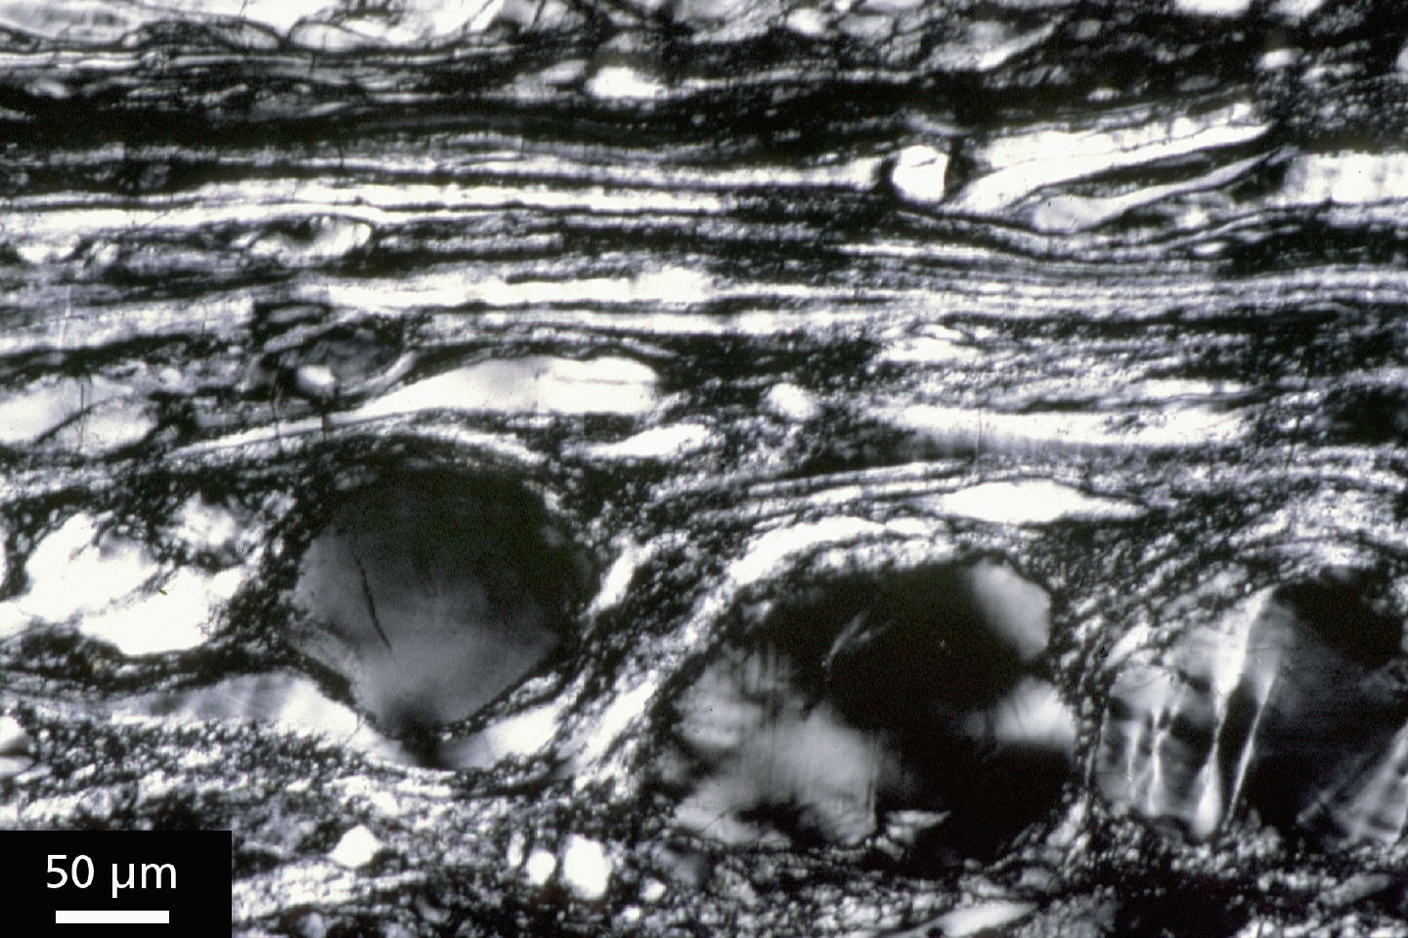http://virtualexplorer.com.au/special/meansvolume/contribs/tullis/Slides/061.JPG

If you cut this rock perpendicular to the slice you see above, through one of the porphyroclasts, would it look the same as this one or would it be different? If different, how?

Exercise 3: Identify microstructures and infer deformation mechanisms for each of the photomicrographs below.

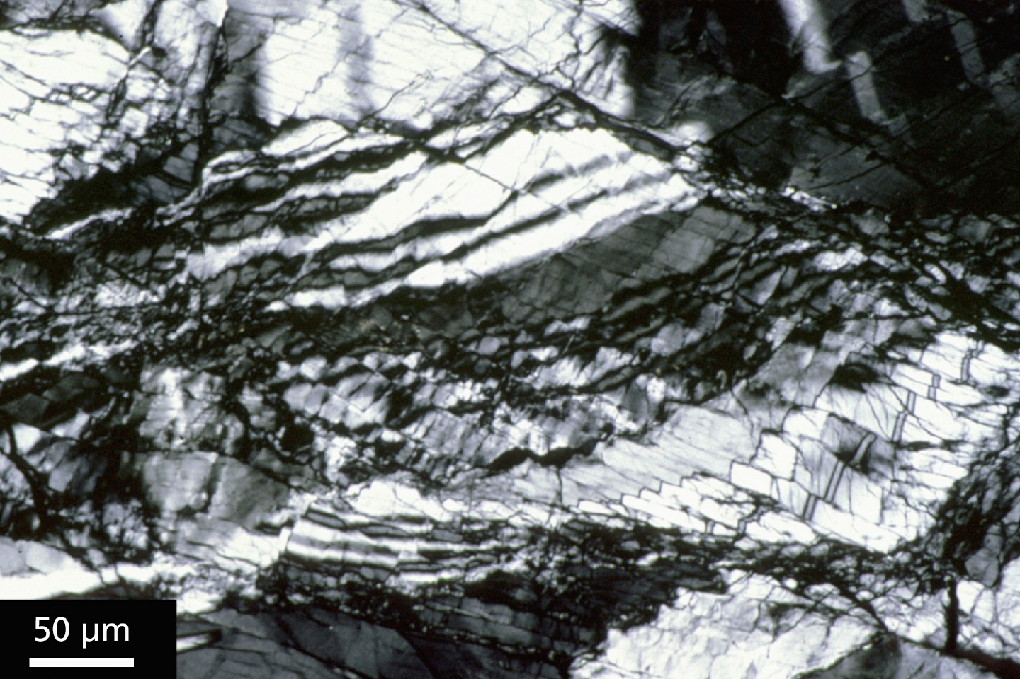
http://virtualexplorer.com.au/special/meansvolume/contribs/tullis/Slides/043.JPG
Microstructure(s):
Predominant deformation mechanism(s):

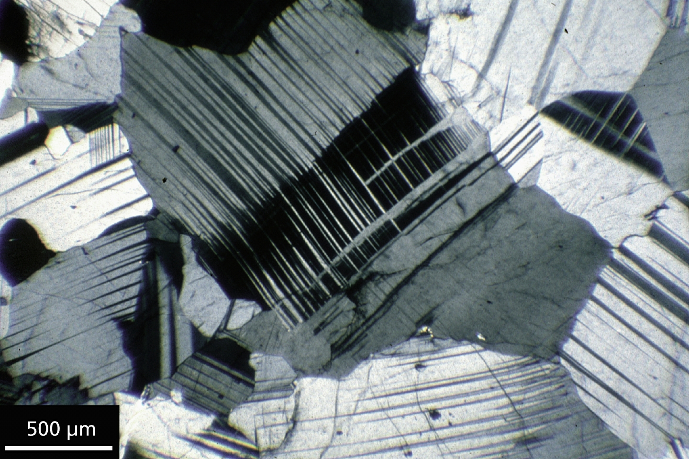
http://virtualexplorer.com.au/special/meansvolume/contribs/tullis/Slides/047.JPG
Microstructure(s):
Predominant deformation mechanism(s):
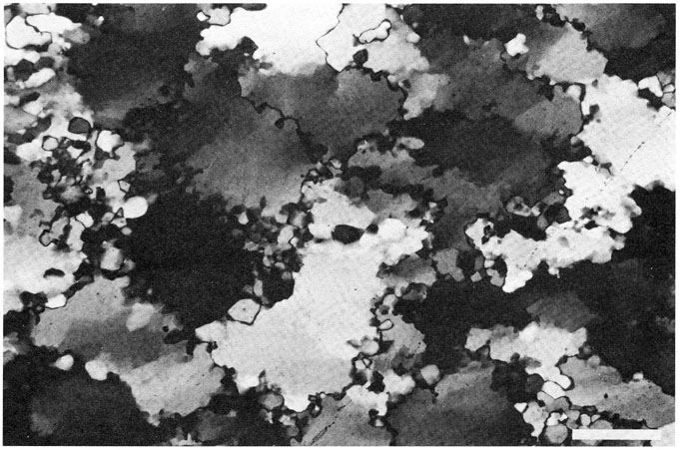
http://www.ged.rwth-aachen.de/Ww/projects/rexx/Urai+86Recrystallization/Urai+86Recrystallization5.htm
Microstructure(s):
Predominant deformation mechanism(s):

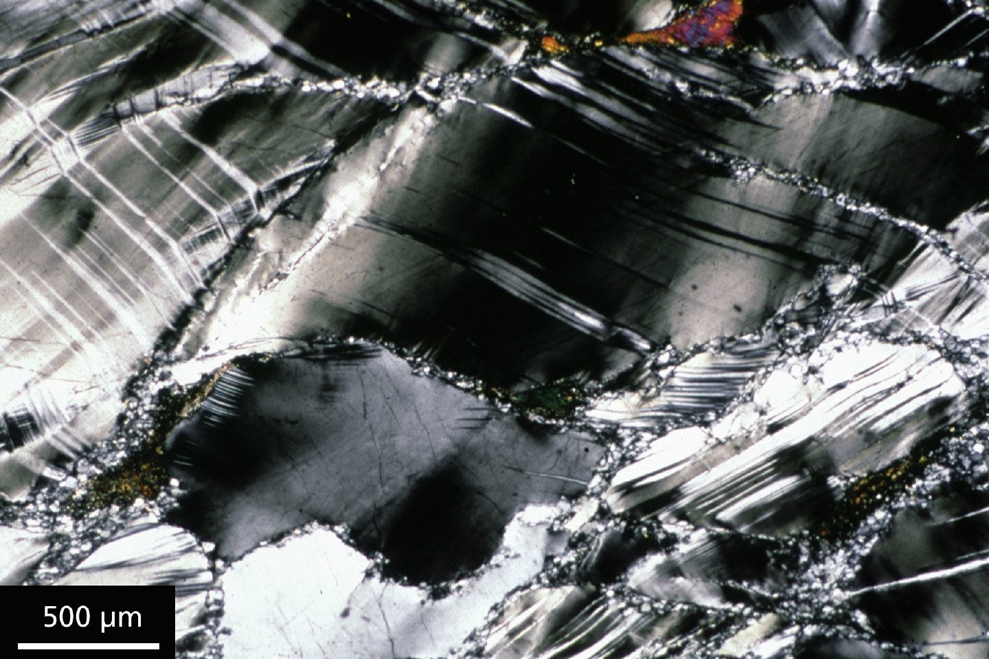
http://virtualexplorer.com.au/special/meansvolume/contribs/tullis/Slides/050.JPG
Microstructure(s):
Predominant deformation mechanism(s):
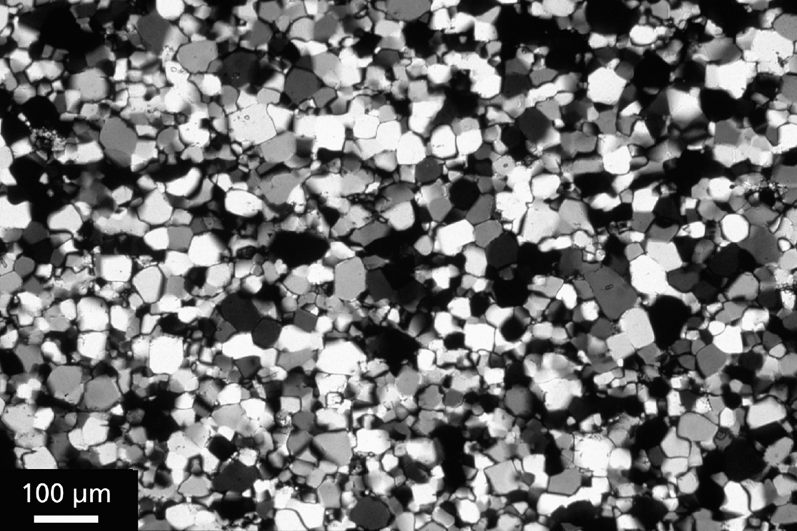
http://virtualexplorer.com.au/special/meansvolume/contribs/tullis/Slides/014.JPG
Microstructure(s):
Predominant deformation mechanism:
If you cut this rock perpendicular to this slice, would it look the same or different?

