Me·a·sure·ment: Uncertainty and Error in Lab Measurements

Measurement is at the heart of science. In order to do science, we must be able to measure quantities such as time, distance, and mass. As famous physicist William Thompson (Lord Kelvin) said, “when you cannot measure… your knowledge is of a meager and unsatisfactory kind”

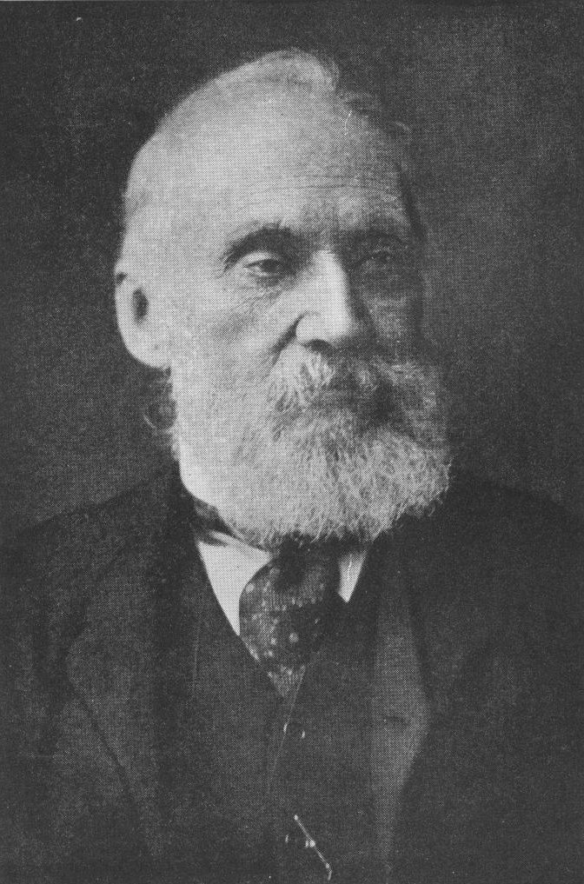
When we measure something, we are comparing a physical quantity we are interested in understanding to a known physical quantity. For example, when we measure the mass of a person, we are comparing their mass to a standard mass called the kilogram.
When you can measure what you are speaking about, and express it in numbers, you know something about it; but when you cannot measure it, when you cannot express it in numbers, your knowledge is of a meagre and unsatisfactory kind.

William Thompson, aka Lord Kelvin

(Lecture on "Electrical Units of Measurement" (3 May 1883), published in Popular Lectures Vol. I, p. 73)
(Image Credit: Arthur Shuster & Arthur E. Shipley: Britain's Heritage of Science. London, 1917. Note that this image is in the public domain)

Two issues must be confronted when performing measurement: the possibility of error during the measurement and some unavoidable uncertainty in the measurement. In this packet, we will learn about sources of measurement error, how to identify and avoid them. We’ll also learn about measurement uncertainty, a separate but related topic that is central to our success in science experiments and investigations. We’ll learn how to determine the amount of uncertainty in a measurement and how this uncertainty affects results of calculations using measured values.

In these first sections, we’ll define the terms error and uncertainty. Next, we will see how to determine the amount of uncertainty associated with measurements made with different measuring instruments.
In this packet, we’ll answer questions like this:
- What do scientists mean when they say error?
- How can we tell if our measurements have been affected by error?
- Are measurements ever exact?
- How can a measurement that is uncertain be useful?
- How can we use measurements that we know contain errors or uncertainty to make valid predictions or reach useful conclusions?
http://commons.wikimedia.org/wiki/File:Righello.jpg
http://commons.wikimedia.org/wiki/File:Fagus_wood.jpg

Section1: Error
1.1 Systematic Error
1.2 Random Error
Section 2: Uncertainty
2.1 Uncertainty in analog instruments
2.2 Uncertainty in digital instruments
2.3 Using the manufacturer’s specs to find uncertainty
2.4 Using significant figure notation to describe uncertainty
2.5 Uncertainty caused by random error
Section 3: Uncertainty Propagation During Calculations
3.1 Addition and Subtraction
3.2 Multiplication and Division
3.3 Raising to a power
3.4 Significant figures and absolute uncertainty

Each sub-section has a set of questions for review.

Section 1: Error
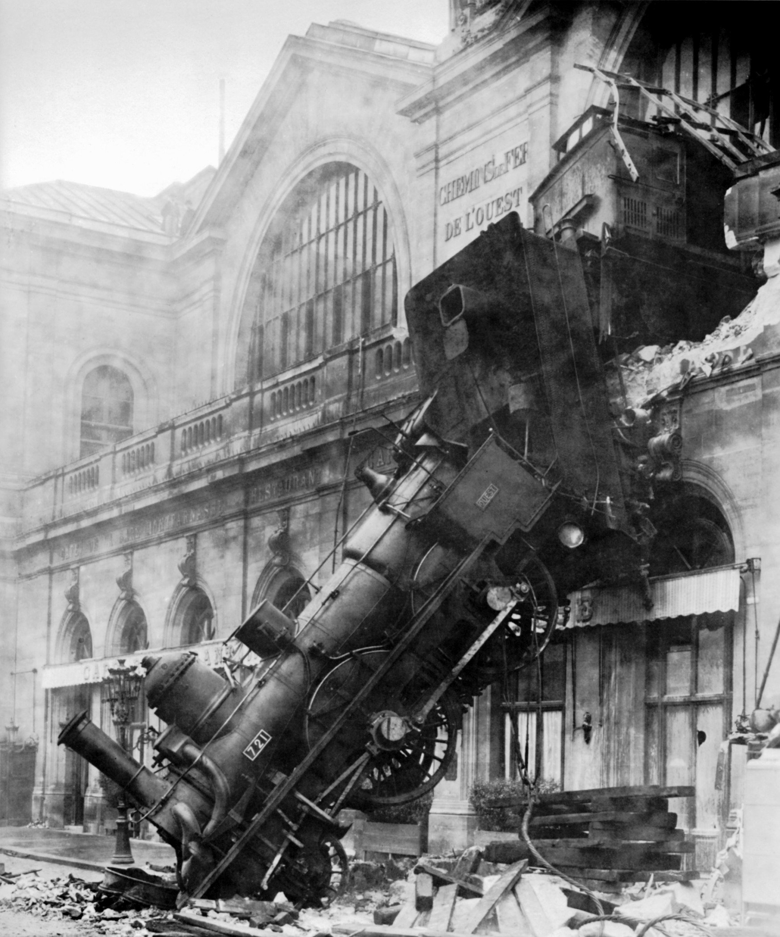
The word error is used to mean many different things and its use in science can sometimes be confusing. The term error can be used to mean mistake, or the difference between two values. Sometimes the words error and uncertainty are used interchangeably.

We’ll use the term error to mean the difference between a measured value and the true or actual value. Here’s an example. Let’s say you’d like to measure the number of people attending a concert, standing side by side in an auditorium. Imagine that you have no means of counting every person, so you come up with a clever idea. You notice that the floor is covered with large tiles and you see that each tile has about three people standing on it. You are able to see that the rectangular room is 20 tiles wide and 40 tiles long. So you multiply and find that there are 20 x 40 = 800 tiles. With three people standing on each tile, that means there are 2400 people in the room. Then, at the end of the concert you talk to the ticket sellers and they tell you that they have admitted 2450 people into the auditorium. Assuming they did not make any mistakes, your measurement is off by 50 people. This is an error – your number is not the same as the actual number of people in the room.
This accident was caused by an error. The term error is used in many different ways. We will define error as the difference between a measured value and a known value.

http://en.wikipedia.org/wiki/File:Train_wreck_at_Montparnasse_1895.jpg

Error can be expressed as the difference between a measurement and the actual value, called absolute error. Error is usually expressed as a positive value, so we use the absolute value of the difference:

In the case above, we’d say that the absolute error is:

Error can be expressed as a percent of the actual or real value, called relative error. Relative error is calculated like this:

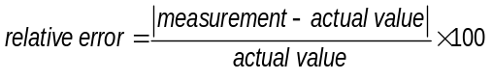

For this case, the relative error of our measurement is:
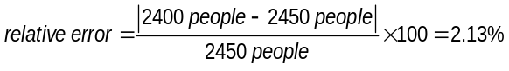

Note that the concept of error as we use it here makes sense only in cases where an actual value is known exactly, such as when we count the number of people in a room. For measured values, as we will see in the next section, there is no known value so we can’t use this method.

We’ll use the term accuracy to mean the amount of relative error in a measurement. The accuracy of a measurement is how close it is to the actual value. As we will see in the next section, there is no measured value for anything that is exactly correct. For example, there is no measured value for the speed of light that is exactly correct. There is a theoretically predicted value for the speed of light and the best measurements are very close to this value, but as with all measurements, there is some uncertainty associated with them.
Error: difference between a measurement and the actual or true value for that measurement.

We can use a similar method called percent difference to compare two measured values. For example, let’s say a student does an experiment to measure the speed of sound in air and measures the speed as 339 m/s. The in looking in a reference book, the student finds a published value of 342 m/s. Since both of these are measurements, and therefore have some uncertainty associated with them, we cannot be absolutely sure that either is exactly correct. None the less, we believe that there is less uncertainty in the published value, which represents the value that most scientists would agree is the closest measurement available. This is often called the accepted value. We compare the student’s measured value with the accepted value using this equation:

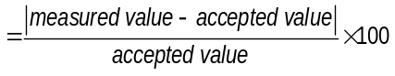
Percent difference between a measured value and an accepted value

Question Set 1.0: Error and Percent Difference
- An average chicken egg has a mass of 50 grams. You weigh a bag of eggs and find a mass of 1840 grams.
  - What is the most likely number of eggs in the bag?

  - Now you carefully count the eggs and find 39 eggs. What is the percent error of your predicted number of eggs?

- Greek philosopher/scientist Eratosthenes measured the circumference of the earth in the year 240 BC (1732 years before Columbus sailed). His equipment was: a hole in the ground, shadow made by sunlight, and very keen reasoning. His results were amazingly accurate. In his calculations, he used a unit of distance called a stadia. Since no one today is exactly sure how long the stadia is, there is some controversy about how accurate Eratosthenes’s results are.

  - If we assume that Eratosthenes used the most common unit for stadia, then his measurement for the earth’s circumference (converted to kilometers) is 46,620 km. An accepted value for the average circumference of the earth is 40,041.47 km. What is the percent difference between Eratosthenes’s measurement and the accepted value?

  - If we assume that he used a less common “Egyptian Stadium” as his unit for length, his result would be 39,690 km. What, in this case, would be the percent difference between Eratosthenes’s measurement and the accepted value?

1.1 Sources of measurement error: Systematic Error
One type of error that can affect measurements is called systematic error. Systematic errors are ones that consistently cause the measurement value to be either too large or too small. Systematic errors can be caused by faulty equipment such as mis-calibrated balances, or inaccurate meter sticks or stopwatches. For example, if a scale is calibrated so that it reads 5 grams when nothing is on the tray, then all the readings taken with that scale will be 5 grams higher than they should be. This is an example of a systematic error that always causes masses measured with that scale to be too high.

Other systematic errors occur when equipment is used incorrectly, like reading from the wrong end of the meter stick, or forgetting to subtract the weight of the container when finding the mass of a liquid, or converting units incorrectly.
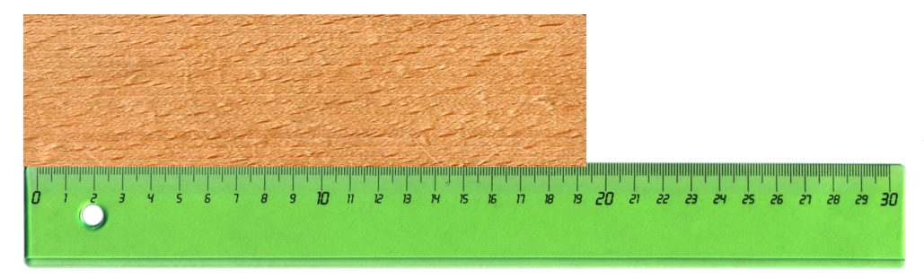
How long is the block of wood pictured at right?
Notice that the wood is lined up with the left end of the ruler, but the zero mark is not at the left end. All measurements done this way would yield measured values that are less than the true length. This is an example of systematic error.
http://commons.wikimedia.org/wiki/File:Righello.jpg
http://commons.wikimedia.org/wiki/File:Fagus_wood.jpg


An example of this kind of error is shown at above. Notice that the wood block being measured is lined up with the left edge of the ruler, but the zero reference line is not at the end. The part of the block to the left of the zero line is not included in the measurement. Unless we notice this mistake all measurements done this way will yield measured values lower than the actual length, no matter how many times we repeat this measurement. This is an example of a systematic error that will cause measured values to be lower than the actual value.

We must be clever and careful to think of sources of systematic error. Consider timing a running race where the person timing the race stands at the finish line, starting the watch when they hear the starting gun and stopping the watch when the runner crosses the finish line. Because it takes some time to react to the sound of the gun, the timer would start the watch about 0.3 seconds late. But at the finish line, the timer would watch as the runner approached the finish line and anticipate the runner’s motion so they can stop the watch very close to the instant the runner crossed the line. As a result, the time on the watch would always be shorter than the time the actual time for the race – a systematic error. Another example of systematic error in this measurement would be the delay for the sound to travel from the starting gun to the timer at the finish line. Unless the timer uses the flash of light or the smoke from the gun, this delay would cause the measured time to be even shorter than the actual time for the race.
For an official standing at the finish line, the use of stopwatches introduces systematic error into measured times for running races. First, there is a delay caused by the time it takes for sound to reach the ears of the timer who is standing at the finish line. Second, there is always more delay due to the official’s reaction time at the start of a race than at the finish, when they can use the runners’ motion to anticipate when to stop the watch.

http://images.google.com/imgres?imgurl=http://upload.wikimedia.org/wikipedia/commons/e/e6/Olympic_Development_%28Mens%29_100m_Dash.jpg&imgrefurl=http://commons.wikimedia.org/wiki/File:Olympic_Development_%28Mens%29_100m_Dash.jpg&usg=__hh_SpZ4HrqdFBx9LszgAE69yywk=&h=683&w=1024&sz=555&hl=en&start=1&um=1&tbnid=F2rkYC3ATkWRnM:&tbnh=100&tbnw=150&prev=/images%3Fq%3D100%2Bm%2Bdash%26as_st%3Dy%26as_rights%3D%28cc_publicdomain%257Ccc_attribute%257Ccc_sharealike%257Ccc_noncommercial%257Ccc_nonderived%29%26hl%3Den%26client%3Dfirefox-a%26rls%3Dorg.mozilla:en-US:official%26um%3D1

Often systematic errors can be eliminated if you know they exist. For example, if you discover that the balance you used in a lab showed a reading of 5 grams when the tray was empty, you could go back and subtract 5 grams from all your values to reduce error in your result. In the running race, we could do an experiment to measure the reaction time of the person timing and calculate the delay for sound to travel the distance of the race course and add these to the times they measured for the race to get a more certain measurement of the time for the race.
We can never be sure that our experiments are completely free from systematic errors. The best way to add confidence to our measurements is to devise an experiment to measure the same quantity by a completely different method that is unlikely to have the same error.
http://commons.wikimedia.org/wiki/File:Righello.jpg
http://commons.wikimedia.org/wiki/File:Fagus_wood.jpg

In some cases, it can be very difficult to identify systematic errors. In these cases, the errors often go undiscovered until another measurement is made using a different measuring technique.

We can never be sure that our experiments are completely free from systematic errors. The best way to add confidence to our measurements is to devise an experiment to measure the same quantity by a completely different method that is unlikely to have the same error. If our new technique produces different results, one or both experiments may suffer from unidentified systematic errors. . If measurements made with different measurement techniques agree, it suggests that there is no systematic error in either measurement.

1.2 Sources of error: Random Error
Let’s consider another source of error in the times recorded in the running race described above. No matter how careful the timer was, they would never be able to stop the watch at the exact instant the runner crossed the line. Sometimes they would stop the watch slightly before the runner reached the line, sometimes slightly after. This is an example of a source of random error. Random error is when variations in the measurements occur without a predictable pattern. If repeated measurements are made, random errors cause the measured value to vary, sometime above and below the actual measured value. Because of this, random error causes uncertainty in measurements.

Along with reaction time, another source of random errors comes from reading the scale on a measurement tool like a thermometer or meter stick. Since the actual value will usually fall in between two marks on the scale, the reader has to estimate the actual value. Sometimes their estimate will be too high and other times too low. This is another example of random error causing uncertainty.

We can determine how much random error our measurements have by repeating the measurements many times. If our results are identical or nearly the same, this indicates a small amount of random error. If, on the other hand, our results are different each time we measure the same thing, we must have random error affecting the results.

Random errors can be reduced, but never eliminated. Random error does not always prevent our measurements from being useful, but it does contribute to measurement uncertainty. In section 2.5, we will learn to use statistics to determine how much uncertainty random error contributes to a measurement.

Next, we’ll learn about the concept of measurement uncertainty, how to determine the amount of uncertainty in a measurement, and how to express uncertainty when doing calculations with numbers that are uncertain.

Question Set 1.2: Systematic and Random Error
- Consider an experiment to determine the average acceleration of a ball dropped from a height of 1 meter. Students stand a meter stick on a table top and use a stopwatch to measure the time for the ball to fall from the top of a meter stick to the table. One student drops the ball and another student watches and carefully starts the watch
  - Identify three possible sources of systematic error:

  - Identify three possible sources of random error:

- Make two suggestions for how the students could change their experiment to improve their results. State whether your suggestion would reduce systematic or random error
- In some cases, systematic error can be difficult or impossible to identify. For example, the balance you use in lab might be damaged in such as way that it causes all masses less than 100 grams to seem 50 grams lighter than they are. How, then, can you provide evidence that your measurements do not have systematic error?
- Random errors are often easy to identify, but impossible to eliminate. How can you determine whether your measurements contain random error?
Section 2 Uncertainty: An unavoidable result of all measurement

Whenever you or anyone else makes a measurement, we can never be certain that the result is exactly correct. There is always some difference between the measured value and the actual value, no matter how careful you are. No matter how exotic the equipment and how intelligent the operator, there is always some uncertainty associated with any measurement. What’s more, if we use a measured value to make a calculation, the results of the calculation will also not be exactly correct; they will also have some uncertainty associated with them. This is an unavoidable part of science.
Scientific knowledge is a body of statements of varying degrees of certainty — some most unsure, some nearly sure, but none absolutely certain.

Richard Feynman
"The Value of Science," address to the National Academy of Sciences (Autumn 1955)
http://commons.wikimedia.org/wiki/File:Feynman.jpg


Measurement uncertainty need not prevent measurements from being useful. If we can quantify the uncertainty for a measurement, that is, if we can determine the amount of uncertainty, we can still use the measurement with confidence. We can do this by specifying a range of values between which we are absolutely certain the true value of our measurement lies. For example, an engineer designing a cell phone receiver/transmitter does not need to know the exact frequency your cell phone transmits. They need to know a range within which they can be certain the transmission frequency lies.
Any measurement that you make without the knowledge of its uncertainty is completely meaningless.

Professor Walter Lewin
Lectures on Physics
http://ocw.mit.edu/OcwWeb/Physics/8-01Physics-IFall1999/VideoLectures/detail/embed01.htm

The term uncertainty implies lack of knowledge. But when we describe a measurement as a range of values, we are really saying that we are certain that the actual value of the measurement does lie within this range.

In this section, we’ll look at measurements and measurement uncertainty. We’ll learn how to determine how much uncertainty is associated with a measurement and how to uncertainty affects results of calculations we do using number we have measured.

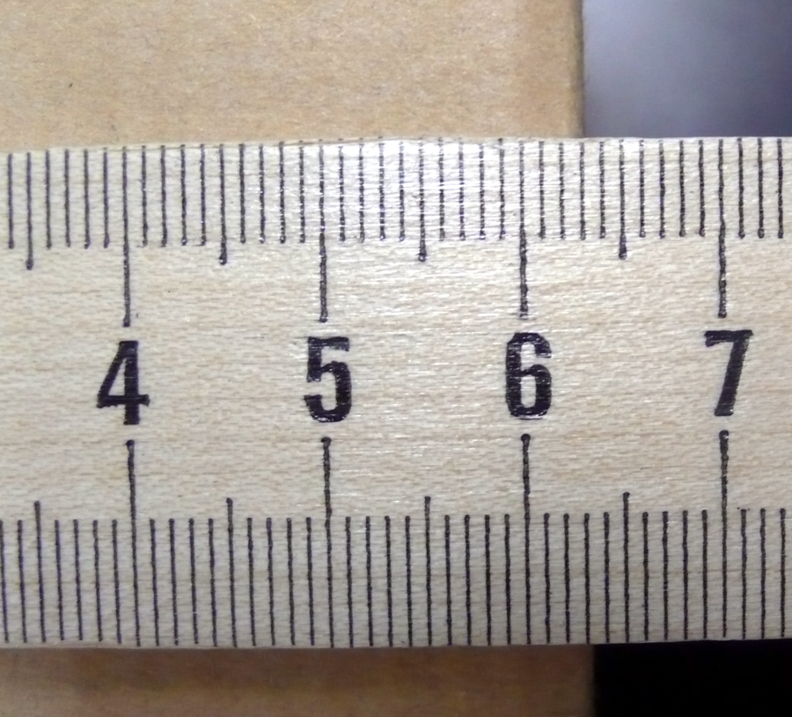
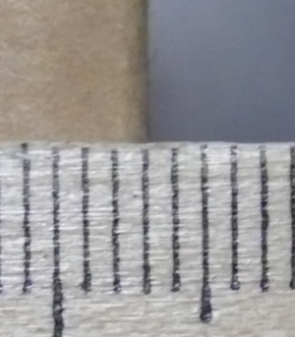
Let’s begin by seeing why all uncertainty is inherent in all measurment. Let’s look at two types of measurement devices: analog and digital measuring devices. All measuring devices fall into one of these categories. Analog devices, like the meter stick shown at left, have a printed scale with graduation lines and numbers printed next to them. Meter sticks, tape measures, spring scales used to measure forces, triple-beam balances and liquid thermometers are all examples of analog measuring instruments. Digital measuring instruments have an electronic display that shows numbers – digits. Digital clocks, digital volt meters, digital scales, and digital thermometers are all examples of digital instruments.
When using an analog measuring device, like a meter stick, the object we are measuring will always fall in between marks on the scale. The closer we look, the more clear it becomes that the object we are measuring will never align exactly with one of the graduation lines on the measuring scale. If we look close enough, we see that the graduation lines themselves have width, so even if the object is within the line, we still can’t determine the length exactly. This is a limitation of all analog measuring devices.

To see how uncertainty creeps into analog measurement, look at the photos of the meter stick at left. We see that the length of the object will always fall in between the graduation marks on the scale. The more carefully we look, the easier it is to tell that that the object we are measuring falls between the graduation lines. If we look even closer, we see that the graduation lines themselves have some width, so even if the object appears at a distance to be lined up with a graduation line, we still can’t tell exactly what part of the line. Since we can never see exactly where the object falls on the graduations on an analog measuring device, we will always have some uncertainty about the value of the measurement.

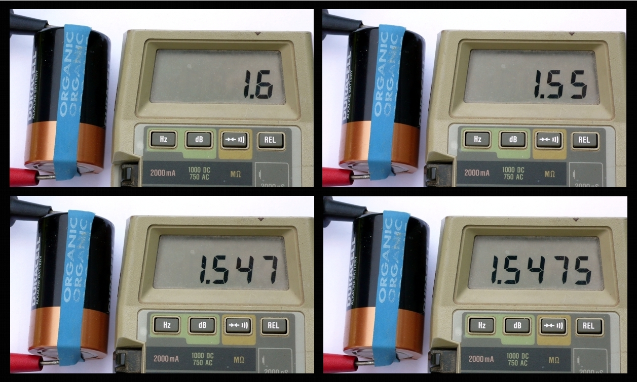
Things are no better if we use a digital measuring device. All digital measuring devices are limited to a certain resolution, a certain number of digits on the display. The device must round the measurement to the nearest decimal to display it. This rounding process introduces uncertainty, because when we read the device, we can’t tell what the numbers were before rounding. No matter how many decimal places on the display, the actual value is rounded to fit the number of decimal places on the display. Again, this leads to uncertainty about the actual value of the measurement.

Since all measuring devices are either analog or digital, all measurements fall prey to these problems. As a result, no one has ever succeeded in measuring the “real” speed of light, or the “actual” diameter of the earth, or the “exact” mass of an electron. Nor will we know if anyone ever does, since there is some uncertainty inherent in all measurement. To be able to use measurements effectively and confidently, we need to be able to express the amount of uncertainty in our measurements.
Four measurements of the voltage from a battery made using a digital voltmeter. Only the amount of rounding in the display is different. Do you think that 1.5475V is the exact value of the voltage?

How many more digits would have to be displayed to find the exact value?

Can you see that we’ll have the same problem with all digital measuring devices?

Note that we are not commenting on whether the measurement device is working correctly or not. We run into these same limitations even if the measurement device is perfect. We’ll talk about problems that arise when the measurement device is not working perfectly in a later section.

You may have noticed that while there is always some amount of uncertainty, the amount of uncertainty is not the same in each of these examples. In the case of the meter stick, the closer we look the more certain we are of the length, so we have less uncertainty of the actual scale reading. With the voltmeter, more digits on the display reduces the uncertainty of the scale reading. Even though looking closer or seeing more digits reduces uncertainty, there is no way to eliminate uncertainty. Instead, we must determine how much uncertainty is inherent in each measurement.

2.1 Determining the Amount of Uncertainty in a Analog Measurement
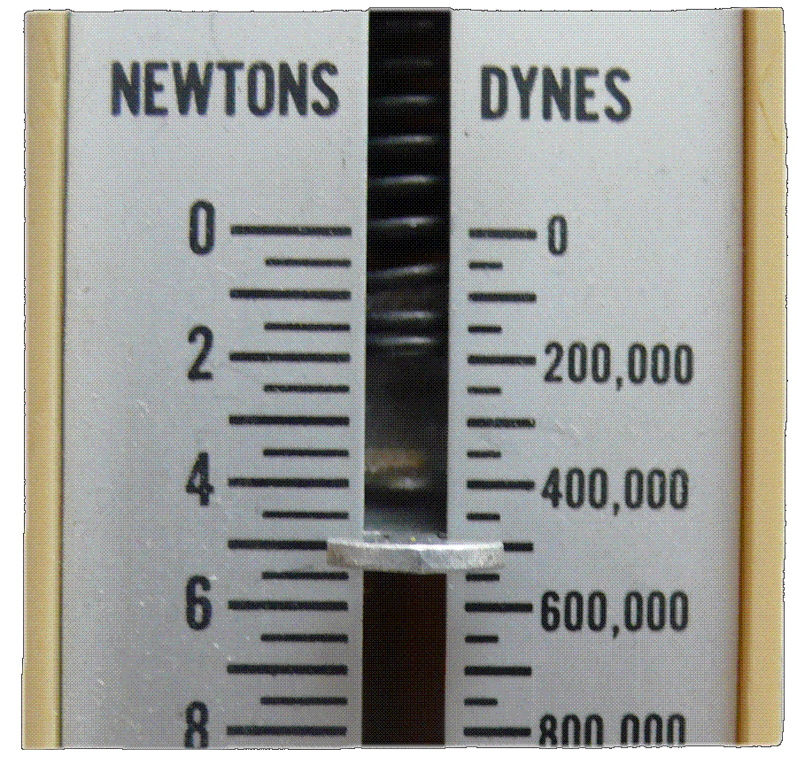
As we’ve seen in a previous section, we can never know the exact value of a measurement. But when we measure something, we can determine a range of values between which we are certain the true value of the measurement lies. In this section, we’ll learn a way to estimate the amount of uncertainty in a reading taken from an analog scale, such as a meter stick, spring scale, or triple-beam balance.

Look at the picture of the spring scale at left, which measures force in Newton (N). Notice that the small marks indicate 0.5 N. We can’t tell exactly what the scale reads, but we can see that there can be no question that scale reading is between 4.5 N and 5.5 N. We can say with absolute certainty that the scale reading is somewhere between these two values.
Although we can’t say exactly what this scale reads, we can be absolutely confident that the reading is between
4.5 and 5.5 N.

Let’s consider how can express this range of possible values for this measurement. First, we can display it on a number line using a confusingly named convention called error bars. In fact, they should more correctly be called uncertainty bars. The figure below shows a number line and a set of error bars expressing that the value of the scale reading is somewhere between 4.5N and 5.5N

4N
5N
6N
3N
7N

Here we are using a number line and error bars to describe the value of the reading on the scale, including uncertainty. Even though the term error bars is used commonly, a better name would be uncertainty bars.. Note that this does not say that the actual value of the scale reading is 5N.

When reading an analog instrument, the user must be the judge of what range he or she is confident the actual value of the measurement lies. There is no absolute rule that determines what range of certainty to use. It depends on the clarity of the printed scale and how clearly the user can see where the reading is on that scale.

Another way to express this rnage of values is to us the form:
4
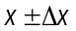
The measurement value
The absolute uncertainty

When writing the range in this form, x is the measured value and Δx is the absolute uncertainty or the amount of uncertainty of the measurement. Or, x is how much we think the measurement is and Δx is the maximum amount by which we think the measurement can be off.

Let’s see how to find the values x and Δx when we know the range of values between which the true value of our measurement lies. The measured, x, value falls at the midpoint of the range, that is, half way between the highest possible value and the lowest possible value. Similarly, Δx, is the mid-point of the range. So we can express a range of values in x±Δx form by finding the midpoint of the range, and finding half the width of the range:
The midpoint of the range
Half the width of the range

To find the midpoint (which is also the average) add highest and lowest possible values and divide by two.
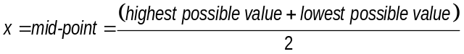

Using the example of the spring scale above you’d find x, the value of the measurement like this:
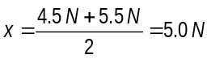

To find Δx, the uncertainty, you subtract the two values and divide by two.
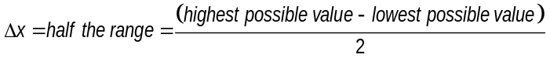

Again looking at the spring scale:
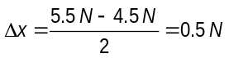

You’d express the measurement and uncertainty by saying that the force is 5.0 ±0.5N. Note that this expresses the same range of possible values that we described using the number line above.

But, is this range of values really the best we can do? Looking at the scale carefully, we can identify an even smaller range of possible values that we can be certain the scale reading falls between. We will always try to identify the narrowest range of possible values between which we are absolutely confident the reading falls. Exactly how much uncertainty will depend on the type of scale, how close the graduation lines are, and how clearly we can see the scale. There is no one set rule that tells exactly how much uncertainty we’ll get from an analog scale. Ultimately, the amount of uncertainty is determined by the confidence that you have when reading the instrument.

In this case, let’s say that a careful observer claims that the value of the scale reading definitely falls between 4.9N and 5.4N. Let’s use the same method to express this range in x±Δx form:
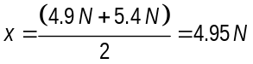

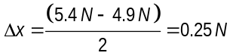

You’d express this measurement and uncertainty by saying that the length is 4.95 ±0.25N. Note that this is a different value for the measurement and less uncertainty than the previous reading. Which one is correct? We’ll always try for the smallest range that we can identify with a high degree of confidence. In this case, the second measurement is better because it has less uncertainty. The first one is not wrong; it just has a greater degree of uncertainty.

Relative Uncertainty
We can compare the amount of uncertainty in two measurements using a ratio called relative uncertainty. Relative uncertainty is the amount of uncertainty divided by the total amount of the measurement, that is:
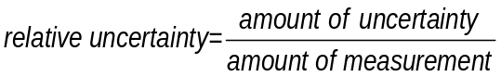

Or, using the variable names from the previous section:
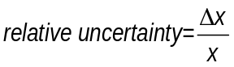

where x is the measured value, and Δx is the amount of uncertainty associated with x. Usually, we’ll express relative uncertainty as a percent:
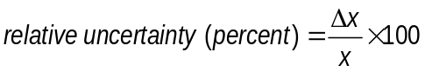

We’ll use the term precision to mean the amount of relative uncertainty in a measurement. Let’s compare the relative uncertainty of the two spring scale readings from the previous section. The first reading was 5.0 ±0.5N. The relative uncertainty expressed as a percentage is:
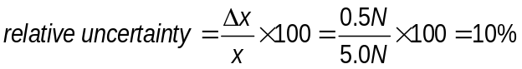

Notice that the measurement and the uncertainty always have the same units, which cancel when we find the ratio. The second reading was 4.95 ±0.25N
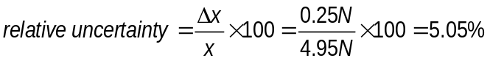

Notice that the relative uncertainty is lower for the second scale reading, because we more carefully stated the range of possible values.

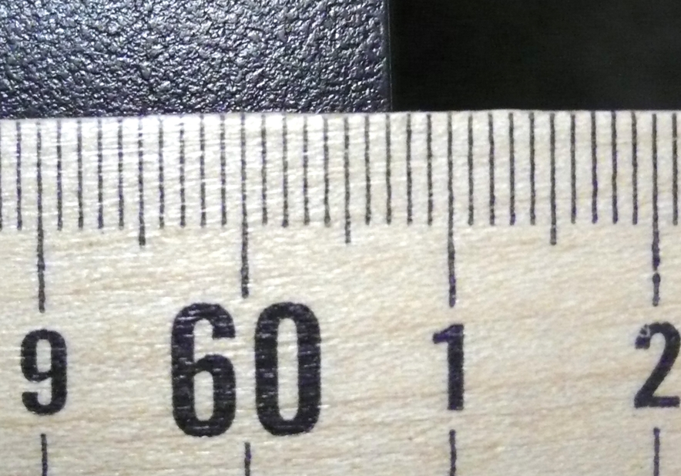
Here is another example of a measurement, this time using a meter stick to measure the width of a lab table. The width of the table appears to be between 60.7 cm and 60.8 cm. Using the same equations we did above we find:
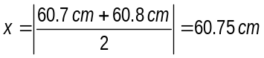

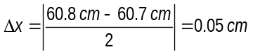

Here the scale reading is between
60.7cm and 60. 8 cm. The measurement with uncertainty is 60.75 ±0.05 cm

So the measurement with uncertainty would be 60.75±0.05 cm.

In the previous example, we have seen how to find the relative uncertainty when we know the absolute uncertainty. We can also use these relationships to find the absolute uncertainty of a measurement if we are given the relative uncertainty. For example, if we know that a speedometer reading could be off by 10%, and the speedometer reads 65 miles per hour, we can find the range of possible speeds like this:
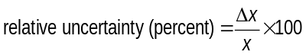
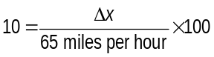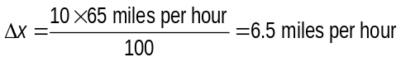

So the range of possible readings is 65 ±6.5 miles per hour.

Question Set 2.1: Uncertainty with Analog Scales
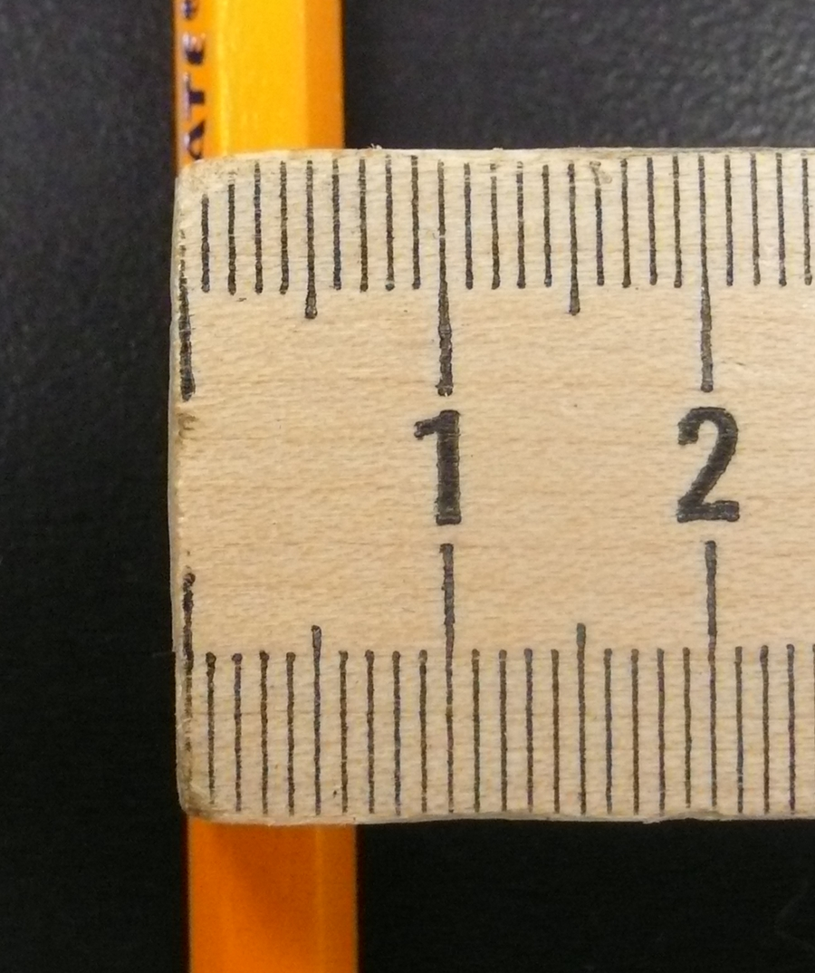
- Determine the width of the pencil at right, including uncertainty. The small graduation lines indicate millimeters. What is the relative uncertainty of your reading? (Remember, we will always express the relative uncertainty as a percentage)
- Let’s compare your results from question 1 to the from the measurement of the width of the lab table on page 13.
  - Which measurement has greater absolute uncertainty?

  - Which measurement has greater relative uncertainty?

  - Comment on why there is such a difference in relative uncertainty.

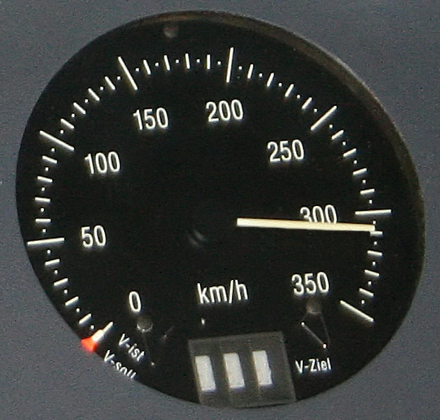
- Determine the reading on the speedometer at right, including uncertainty. What is the relative uncertainty of your reading? Draw a number line with error bars to describe this measurement.

http://upload.wikimedia.org/wikipedia/commons/a/a0/310kmh_Messfahrt.jpg

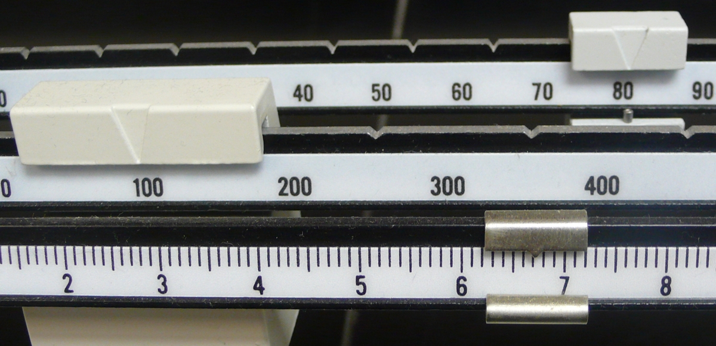
- Determine the reading on the beam balance at right, including uncertainty. What are the absolute and the relative uncertainty of your reading?

- The mass of a proton has been measured to be 1.67262171±29×10⁻²⁷ kg. What is the absolute uncertainty (in kg of this measurement)? What is the relative uncertainty (expressed as a percentage)?

- Cosmologists currently calculate the age of the universe as (13.73 ± 0.12) × 10⁹ years. What is the relative uncertainty of this measurement?

- Consider a person who is 1.7 meters tall. If the height of this person was known to the same relative uncertainty as the age of the universe, what would be the absolute uncertainty (in centimeters)?

2.2 Determining the amount of uncertainty in a digital instrument
Because the display on a digital instrument shows clearly the numbers of the measurement, it seem like they are less prone to uncertainty than analog measuring instruments. However, all digital instruments have inherent uncertainty due to a limited number of digits that can be shown on the instrument display. The smallest numerical gradation that can be shown on a digital display is called the resolution. The internal circuitry must round the measurement so that it fits the number of digits on the display. This rounding process introduces uncertainty because when we read the display, we can never know what the next digit would have been without rounding.

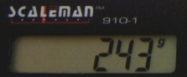
Here is an example. The display on the scale at right is rounded to the nearest gram. The actual unrounded value could be anywhere between 242.5 and 243.5 grams. We say that this digital scale has a resolution of 1 gram. This range of possible values is shown on the number line below.

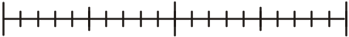
242.0
243.5
244.0
243.0
242.5
The value shown on the display is rounded to the nearest gram. Any value above 242.5 and below 243.5 would be rounded to 243. Here we are using a number line and error bars to describe the value of the reading on the scale, including uncertainty.

The scale reading is rounded to the nearest gram. The actual reading could be anywhere between 242.5 and 243.5 grams.
http://upload.wikimedia.org/wikipedia/commons/f/f9/Digi-keukenweegschaal1284.JPG

We can use the method from the previous section to find the mid-point and uncertainty, but there is a shortcut. We know by looking at the number line that 243, the actual scale reading, is the mid-point. In addition, we know that the maximum amount by which the scale reading could be off is half of the value of the last decimal place shown. If it were off by more than that, the reading would be rounded to show a different value. In this case, the last decimal place shown is the grams decimal place, so the maximum by which we could be off is half a gram, or 0.5 grams. So the scale reading is 243 ±0.5 grams.

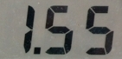
Here is another example. The reading on the digital volt meter at right is rounded to 1.55 V (V stands for Volts) to fit on the display. The value of the reading without rounding could be anywhere between 1.545 V and 1.555 V. Again, this is shown on the number line below.

1.540
1.555
1.560
1.550
1.545

This digital voltmeter shown here has rounded the measurement to fit on the display. We have no way to predict what the next digit could be; any value between 1.545 V and 1.555 V would round to 1.55 V
The value shown on the display is rounded to 1.55. Any value above 1.545 and below 1.555 would be rounded to 1.55. Here we are using a number line and error bars to describe the value of the reading on the scale, including uncertainty.

We know the mid-point is the same as the value shown on the display, and the uncertainty is half the value of the last decimal place shown. In this case, the last decimal place shown is the hundredths place, so the uncertainty is half a hundredth, or 5 thousandths. Of this case, the reading including uncertainty is 1.55±0.005 V.

2.3 Using the manufacturer’s specifications to determine uncertainty
In some cases the uncertainty of a measurement from a digital or analog measuring instrument can be greater than what we’d find using these methods. In many cases, the instrument’s resolution is better than its accuracy. That is, we can often read values from the display or scale that seem to have more certainty than the instrument can reliably provide.

Digital automobile speedometers are one example. The display often shows the car’s speed to the nearest mile per hour, that is the resolution is 1 mile per hour. However, the speed displayed may be off by greater than 1 mile per hour, because car speedometers are not very accurate. In some cases, we can consult the specification of the measurement device and see that the uncertainty of a measurement is greater than the uncertainty we’d assume by reading the display.

Let’s use the digital voltmeter above an example. Let’s say that when we consult the manufacturer’s specifications for the voltmeter, we read that the maximum error is 0.01 V. This means that any reading from this voltmeter could be as much as 0.01 V different from the actual value, so 0.01 V is the uncertainty of a measurement made with this device. We’d write the reading as 1.55 ±0.01 V. Note that this uncertainty is much greater than the uncertainty implied by the display that we saw in the previous section. With this instrument the amount of possible error is greater than we’d conclude simply by looking at the display. Beware that a display with high resolution (lots of decimal places) does not always indicate that we can have a high degree of confidence in the measured reading.

In the case above, the manufacturer provided us with the absolute uncertainty, that is, with an amount of possible error. Sometimes the manufacturer provides the relative uncertainty as a percent. Continuing to use the voltmeter from the previous section, let’s this time assume that the manufacturer specifies that the maximum error is 5%. If our reading is 1.55V, then we find the amount of uncertainty (the absolute uncertainty):

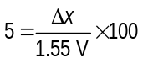

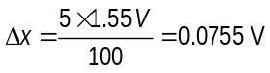

In this case, we’d report the reading from this voltmeter as
1.55±0.0755 Volts.

Question Set 2.3: Uncertainty with Digital Instruments
- The reading on a digital stopwatch is 0.76 seconds.
  - If the manufacturer’s specifications state a maximum error of 1%, determine the absolute and relative uncertainty.
  - If the manufacturer’s specifications state that the maximum error is 0.025 seconds, determine the absolute and relative uncertainty.
  - If the manufacturer’s specifications are not available, determine the absolute and relative uncertainty based on the certainty implied by the display
  - If we assume the person using the stopwatch adds an uncertainty of 0.25 seconds due to reaction-time, determine the absolute and relative uncertainty due to reaction time.

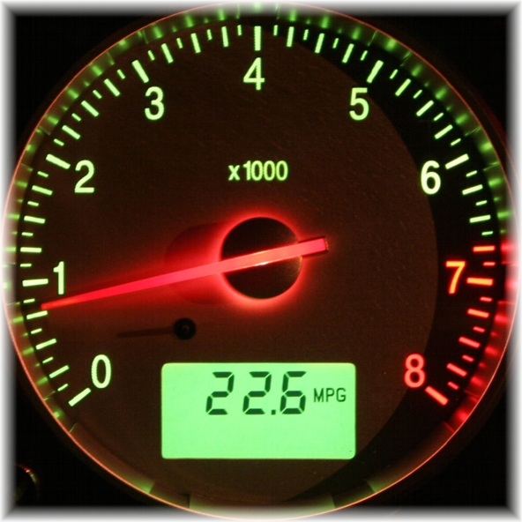
- The analog gauge at right measures the rate of engine rotation in rotations per minute (rpm) and the digital display shows fuel economy in miles per gallon (mpg). Express each reading in x±Δx form.
http://upload.wikimedia.org/wikipedia/commons/3/34/Ford_Mondeo_MK3_ST220_-_Tachometer_%28light%29.jpg

2.4 Significant Figures
Significant figures are another way to describe the uncertainty in a measured value. We will not review the rules for significant figures here, but let’s look how significant figures imply uncertainty. For example, consider the measured value for the mass of the Earth: 6380 km. We know that the last decimal place is the uncertain one. Much in the same way we did when reading a digital display, we must assume that this last digit may have been rounded and that the true value is between 6375 and 6385 km. We’d write this in x±Δx form as 6380 ± 5 km.
We can generalize this by saying that for a measurement expressed using significant figures, the uncertainty is half of the last decimal place.

Here’s another example. In chemistry, we use Avogadro’s number:
6.02 x 10²³. This number has three significant figures. The last decimal place is the hundredths, so this number and has an implied uncertainty of 0.005 x 10²³. In x±Δx form, we’d write 6.02±0.005 x 10²³ .

While significant figures are a convenient way to describe uncertainty, they also have limitations compared to other methods we’ve used here. One limitation is that the uncertainty of a measurement is limited to half a power of ten. That is, the uncertainty must be ±0.5 or ±0.05, or ±0.005… etc. Using significant figure notation, we can’t express a value and uncertainty as for example, 1±0.25.
To see why this is so, consider the measurement of the pencil at right. Looking carefully, we see that the width of the pencil is clearly between 0.6 and0.7 cm. or 0.65±0.05 cm. But we can’t write this number using significant digit notation. If we say that the width of the pencil is 0.6 cm. Using significant figures, this implies 0.6 ±0.05 or somewhere between 0.55 and 0.65 cm. But looking at the picture, we can clearly see that the pencil is wider than 0.6, closer to 0.65. If we use 0.65 cm as our width, we are implying 0.65±0.005, which is less uncertainty than we can honestly state.
The uncertainty in this measurement would be hard to describe using significant figures. We’d like to say that the measurement is 0.65 ±0.5, but we can’t write this using only significant figure notation.

Stating measurements in x±Δx form gives us the freedom to state the uncertainty at whatever size we think mostly closely matches the results of our measurement.

Question Set 2.4: Uncertainty with Significant Figures
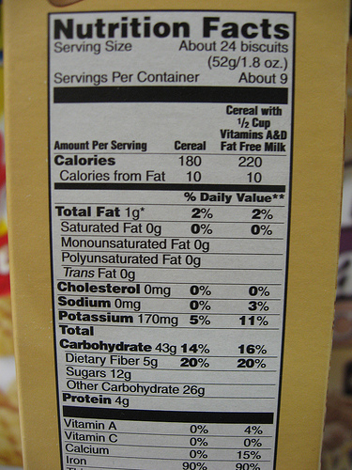
- When using significant figures to express uncertainty, the uncertainty is half of the last decimal place. Using this method, find the absolute and relative uncertainty of mass of Mercury, which is 3.3022 x 10²³ kg.
- Food manufacturers sometimes use significant figure rules to their advantage. For example, the manufacturer of this cereal claims “0 grams of trans fat per serving”.
  - Using the form x±Δx, state the range of possible values that “0 grams” implies. As a hint, consider how many significant digits “0 grams” has.
  - Based on your previous answer what is the maximum of trans fat per serving that this cereal could contain?
  - What is the maximum amount of trans fat as a percentage that could be in this cereal?
  - Since it is not possible for the cereal to contain a negative amount of trans fat, what would be a clearer way to describe the amount of trans fat per serving.

2.5 Determining uncertainty caused by random error
So far we have considered the uncertainty of single measurements made with digital and analog measuring devices. We have not considered what happens when we make repeated measurements. Remember that in section 1.2 we learned that sometimes repeated measurements of the same thing produce varying results. This is called random error. In this section we’ll learn how to use statistics to determine the amount of uncertainty in a set of measurements.

For example, let’s consider our lab procedure from Question Set 1.2, measuring the time to drop a ball a distance of 1 meter. We know that reaction time will play a role in adding uncertainty to our measurements. We also know that reaction time will cause random error – sometimes we stop the watch too soon, other times we stop it too late. Because of this, we know that the actual time is probably near the average of a group of repeated measurements. Our best measurement of the time will be an average of repeated measurements. But how can we determine the uncertainty of an average value? There are many statistical tools we can use, but the one we’ll use here is called average deviation. The average deviation of a group of measurements is the average amount that each measurement deviates from the average of all the measurements. To find the average deviation:

- Find the average of all your measurements
- Find the absolute value of the difference of each measurement from the average (deviations)
- Find the average of all the deviations by adding them up and dividing by the number of measurements.

For this method to work, you need to take enough measurements so that the average has some meaning. Here are two examples of data we can use to practice finding the average deviation. In both cases, students use a stop watch to measure the time for a ball to drop 1 meter.
 | Time for ball to fall 1 meter (Lab Group 1) |  |  |  | Time for ball to fall 1 meter (Lab Group 2)
 | trial | time (s) | deviation (s) |  | trial | time (s) | deviation (s)
 | 1 | 0.48 | 0.017 |  | 1 | 0.55 | 0.098
 | 2 | 0.41 | 0.053 |  | 2 | 0.33 | 0.133
 | 3 | 0.44 | 0.023 |  | 3 | 0.41 | 0.053
 | 4 | 0.51 | 0.047 |  | 4 | 0.54 | 0.077
 | 5 | 0.43 | 0.033 |  | 5 | 0.37 | 0.093
 | 6 | 0.51 | 0.047 |  | 6 | 0.41 | 0.047
 | average | 0.463 | 0.037 |  |  | 0.435 | 0.088
 | Time= 0.463 ± 0.037 seconds |  |  |  | Time= 0.435 ± 0.084 seconds

We can see that the measurements from Lab Group 1 have less average deviation, that is, they are more closely spaced than the measurements from Lab Group 2. We interpret this as reduced random error and less uncertainty in the average value. Let’s use a number line and error bars to look at the results for each group.
.

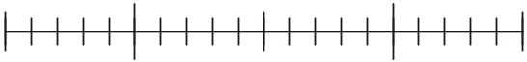
0.350
0.400
0.450
0.500
0.550

Here is the result from Group 1 showing a time of
0.463 ± 0.037 seconds. This means the time is between 0.426 s and 0.500 s.

0.350
0.400
0.450
0.500
0.550

Here is the result from Group 2 showing a time of
0.435 ± 0.084 seconds. This means the time is between 0.351 s and 0.519 s.

Note that the average values for both groups were close to each other, but the average deviation, and therefore the uncertainty, was much greater for the measurements made by group 2.

It turns out that if we don’t consider the effects of air friction, we can use physics to show that the ball should take 0.452 seconds to fall. We can calculate the percent difference for each group:

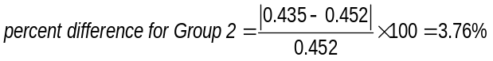

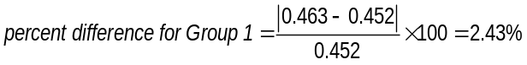

The average value for both groups of measurements is close to the theoretical value of 0.452s. But the measurements from Group 2 have more than twice as much as the uncertainty as the measurements from Group 1.

Question Set 2.5: Uncertainty and Average Deviation
- Complete the tables at left to find the average deviation for each set of measurements.
 | Time for ball to fall 1 meter (Lab Group 3) |  |  |  | Time for ball to fall 1 meter (Lab Group 4)
 | trial | time (s) | deviation (s) |  | trial | time (s) | deviation (s)
 | 1 | 0.42 |  |  | 1 | 0.70
 | 2 | 0.44 |  |  | 2 | 0.31
 | 3 | 0.46 |  |  | 3 | 0.41
 | 4 | 0.55 |  |  | 4 | 0.57
 | 5 | 0.43 |  |  | 5 | 0.33
 | 6 | 0.55 |  |  | 6 | 0.41
 | average |  | ± |  |  |  | ±
 | Time=______ ± _______ seconds |  |  |  | Time= _____ ± ______ seconds
- Draw the range of values on a number line using error bars to show the range of uncertainty.
- Bearing in mind the theoretical value for the time for the ball to drop is 0.452 seconds, describe in words the difference between the measurements performed by Groups 3 and those done by Group 4. Hint: use the terms accuracy (page 3) and precision (page 12).

Section 3 Uncertainty Propagation: Using uncertainty when making calculations
Often in labs we’ll produce results by doing calculations using values we have measured. Since the numbers we use to do the calculations have uncertainty associated with them, the result of the calculation must also have uncertainty. When you do calculations with values that have uncertainties, you will need to determine the uncertainty in the result. How uncertainty of a calculated result is affected by the uncertainty of the numbers used to make the calculation is called uncertainty propagation.

There are many mathematical techniques for uncertainty propagation, which depend on the statistical properties of your measurements. In this packet, we’ll use some of the simplest methods.

A simple way to estimate uncertainties this is to find the largest possible uncertainty the calculation could yield. This will always overestimate the uncertainty of your calculation, but an overestimate is better than none at all. In the following sections, we’ll learn how to express the uncertainty of the results of calculations made using numbers with uncertainty.

Addition and Subtraction
Suppose we measure the length of two tables using a meter stick. For the sake of this example, let’s say that our measurements have uncertainty of ±1 cm. Table 1 measures 165±1 cm long and Table 2 measures
155±1 cm long. Now suppose we put the two tables end to end. How long do we think the tables will be together?

Let’s assume a worst case situation and say that in both cases, we measured the tables shorter than they actually are, and that we were off by our stated maximum error of 1 cm. That is, Table 1 is really 164 cm and Table 2 is really 154 cm. If this were true, this would be the shortest possible length the tables together could have given our measurements:

Another possible worst case situation is that we really measured both tables longer than they actually are, again by the maximum amount of error. Now, the maximum possible length for the two tables together is


Table 1
Table 2
165±1cm
155±1cm
320±2cm
When adding measurements with uncertainty, we add the measurements to find the results, and add the uncertainties to find the uncertainty of the result. When subtracting, we also add the uncertainties to find the uncertainty of the result

Based on these worst case situations the two tables combined length could be any value between 318 cm and 322 cm. Let’s express this worst-case range in x±Δx form by finding the midpoint and half the width of the range using the equations in section 2.1:

Do you see that there is an easier way to reach the same answer? If we added the original measurements, we’d get the midpoint, 320 cm in this case. If we add the absolute uncertainties of the numbers we are adding, we’d get the combined absolute uncertainty, 2 cm in this case. We can generalize this like this, meaning we can write it in a form that we can use for many other cases. Let’s say we are adding two measurements x and y, each with uncertainty, Δx and Δy.

Adding numbers with uncertainty

We can use the same reasoning to see that if we subtract two measurements with uncertainty, we still add the uncertainties:

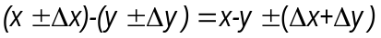
Subtracting numbers with uncertainty

We can summarize these two examples like this:

Sum and Difference Rule:
When adding or subtracting values with uncertainty, add absolute uncertainties of each value to find the absolute uncertainty of the result.

Multiplication and Division
Now suppose we’d like to multiply two measured values with uncertainty. For example, if we measured the width of Table 1 as 55 ±1 cm, in addition to the previous length measurement of 165±1 cm, we could multiply these two numbers to find the area of the table top. But what is the uncertainty of this area calculated using numbers with uncertainty? Let’s use the same approach and look at the worst case situation. If both numbers were actually smaller than the measured result by the maximum error, the area would be:

And if both measurements were too large by the maximum error the area would be:

This gives us a range of values of 8856 cm² to 9296 cm². Finding the mid-point of this range and finding half the width of the range gives:

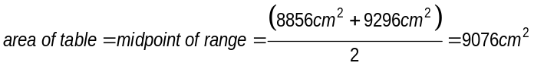

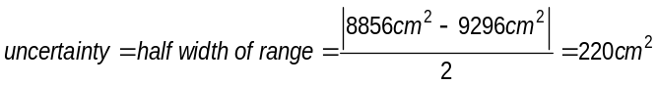

So the result of the multiplication including uncertainty is 9076±220 cm².

Again, there is an easier way to this result. To find the area, we’ll multiply the length and width measurements:

Note that the area we find is very close to the value we found above. Next, if we add the relative uncertainties of the length and width together, we get (very nearly) the relative uncertainty of the area. First, let’s find the relative uncertainty of the length and width:
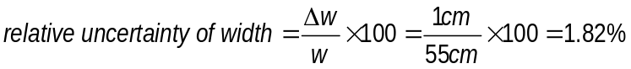

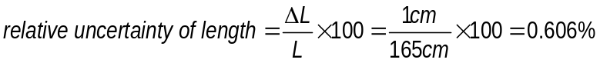

Now we add these relative uncertainties to find the relative uncertainty of the result:

Finally, since we know the relative uncertainty and the amount of the measurement, we find the absolute uncertainty:
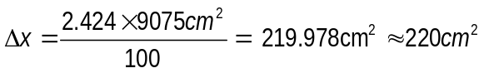

We can generalize this method (which works for division as well as multiplication) like this:

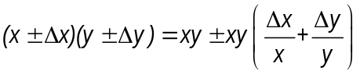

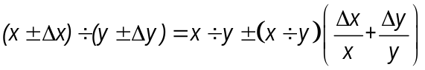

Product and Quotient Rule:
When multiplying or dividing values with uncertainty, add relative uncertainties of each value to find the relative uncertainty of the result.

Raising to a power
To see how to handle uncertainty when raising a measurement to a power, consider that squaring a value is the same as multiplying that value times itself:

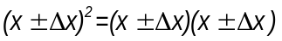

This means we can use the same approach as above when squaring a number. That is, we can add the relative uncertainties to get the relative uncertainty of the result. Since we are multiplying a number times itself, we have the same uncertainties twice:
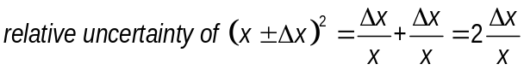

We can generalize this as well. When we raise a number with uncertainty to a power, the relative uncertainty of the result is the relative uncertainty of the original number times the power we raised it to:
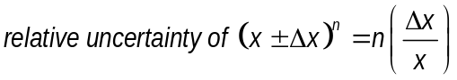

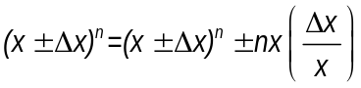

Raising to a Power:
When raising a number with uncertainty to a power, the relative uncertainty of the result is the relative uncertainty of the original number multiplied times the power. Note that this works for fractional powers as well.

As an example, let’s find the area of a square desktop with sides of length 55±1cm. First, find the relative uncertainty of the number we are squaring:
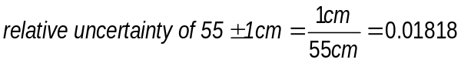

Note that we will not use percent uncertainty here. We can; doing so will not change our result but it will require first multiplying and then later dividing by 100.

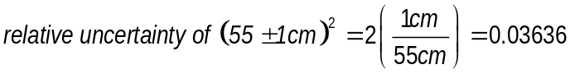

Next we square the number and find the absolute uncertainty of this number:
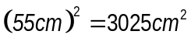

Our final answer for (55±1 cm)² is 3025±109.989 cm².

Significant Figures when expressing absolute uncertainty
Notice that we have left many significant figures on our values for uncertainty. Are these necessary or warranted? One way to see if these are useful is to remember that the uncertainty helps us identify a range of possible values for the result. It does not make sense to describe the range of possible values for our result from the previous example as 3025±109.989. To see why, let’s see what range we have specified using these numbers.

Hopefully it is clear that the added precision implied by all these decimal places implies confidence that we cannot have. Remember that our uncertainty in the original measurements was ±1cm. We can’t have certainty in our result of one thousandth of a cm². This would be like saying, “I’ll be home sometime between 12 o’clock and 1.762 seconds and 12:30 and 2.345 seconds.” The extra decimal places in our times imply greater certainty than the wide range allows.

As a general rule, we round absolute uncertainty to one additional decimal place than the amount of the measurement. For example, we’d express

10.5±0.2456 as 10.5±0.25

0.25±0.0926 rounds to 0.25±0.093

3025±109.989 would be expressed as 3025±110.0

Again, there are other more sophisticated techniques that can give better estimates of uncertainty in some cases. The methods presented here are easy to follow and will give a conservative (overestimated) value for the uncertainty of your results. Most importantly, they show that we must continue to consider the uncertainty of a measurement when using the measurement for calculations.

Finally, remember that these techniques help you estimate the random uncertainty that always occurs in measurements. They will not help account for systematic errors, mistakes, or poor measurement procedures. Careful and thoughtful measurements are essential to produce quality data.
Problems
- Students measuring the dimensions of a table top use a meter stick. They determine that the width of the table is between 78.4 cm and 78.3 cm.
- Express the measurement and uncertainty in the form: 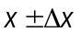.
- What is the absolute uncertainty of the width measurement?
- What is the relative uncertainty of the width measurement?
- Using the same meter stick to measure the thickness of the table, the students determine that the thickness is between 3.5 cm and 3.6 cm.
- Express the measurement and uncertainty in the form: .
- What is the absolute uncertainty of the thickness measurement?
- What is the relative uncertainty of the thickness measurement?
- Compare the relative uncertainties of the width and thickness. Why are they so different if the same meter stick was used for each measurement?
- Consider the following results for different experiments. Determine if they agree with the accepted or predicted result listed to the right. Also calculate the percent difference for each result.
a) measured value for g = 10.4 ± 1.1 m/s2 (accepted value for g = 9.8 m/s2)
b) measured value for T = 1.5 ± 0.1 sec ( predicted value for T = 1.1 sec)
c) measured value for k = 1368 ± 45 N/m (predicted value for k = 1300 ± 50 N/m)

- Each member of your lab group weighs an empty box and two metal bars twice. The following table shows this data.
trial | Box (g) | deviation | Bar 1 (g) | deviation | Bar 2 (g) | deviation
1 | 201.3 |  | 98.7 |  | 95.6
2 | 201.5 |  | 98.8 |  | 95.3
3 | 202.3 |  | 96.9 |  | 96.4
4 | 202.1 |  | 97.1 |  | 96.2
5 | 199.8 |  | 98.4 |  | 95.8
6 | 200.0 |  | 98.6 |  | 95.6
average |  | ± |  | ± |  | ±
  - Estimate the uncertainty of each data set by finding the average deviations.
  - Calculate the total mass of the box with Bar 1. Use rules for uncertainty propagation.
  - Calculate the mass of the box with Bar 2. Use rules for uncertainty propagation.
  - Calculate the mass of the box with both bars. Use rules for uncertainty propagation.

- The area of a rectangular metal plate was found by measuring its length and its width. The length was found to be 5.37±0.05 cm. The width was found to be 3.42±0.02 cm.
  - What are the relative uncertainties of each measurement?
What is the area, including the uncertainty? (Use the method of adding relative uncertainties.)

Discussion Questions
- How is the word uncertainty used differently in everyday speech than in science?
- Does a greater degree of uncertainty affect your confidence in the results?
- A scientist makes a prediction and claims that they are completely certain of the outcome. How does this affect your confidence in the outcome?
- What is the difference between uncertainty and error?
- Students just starting science often attribute results that they think are incorrect to “human error”. More advanced science students recognize that this is not a sufficient description of potential problems in lab work. Why?
- What is the difference between the scientific use of the word uncertainty and the everyday use?
- Does the knowledge that the results of a scientific prediction have uncertainty increase or decrease your confidence in the prediction?
- What would be your reaction to a scientific prediction that is 100% certain, that is, a prediction that has no uncertainty?
- You are measuring the time it takes for a student to run a 100-meter race. Describe a method you could use to determine the uncertainty of the time.
- What does it mean to be absolutely certain? What things can we be absolutely certain about?
Sample Quiz Questions
- Students are trying to identify an unknown liquid by determining its density and comparing it to a table of densities of known liquids. They begin by finding the mass of a graduated cylinder, which they determine to be 54.55 ± 0.05 grams. What is the relative uncertainty of this measurement?
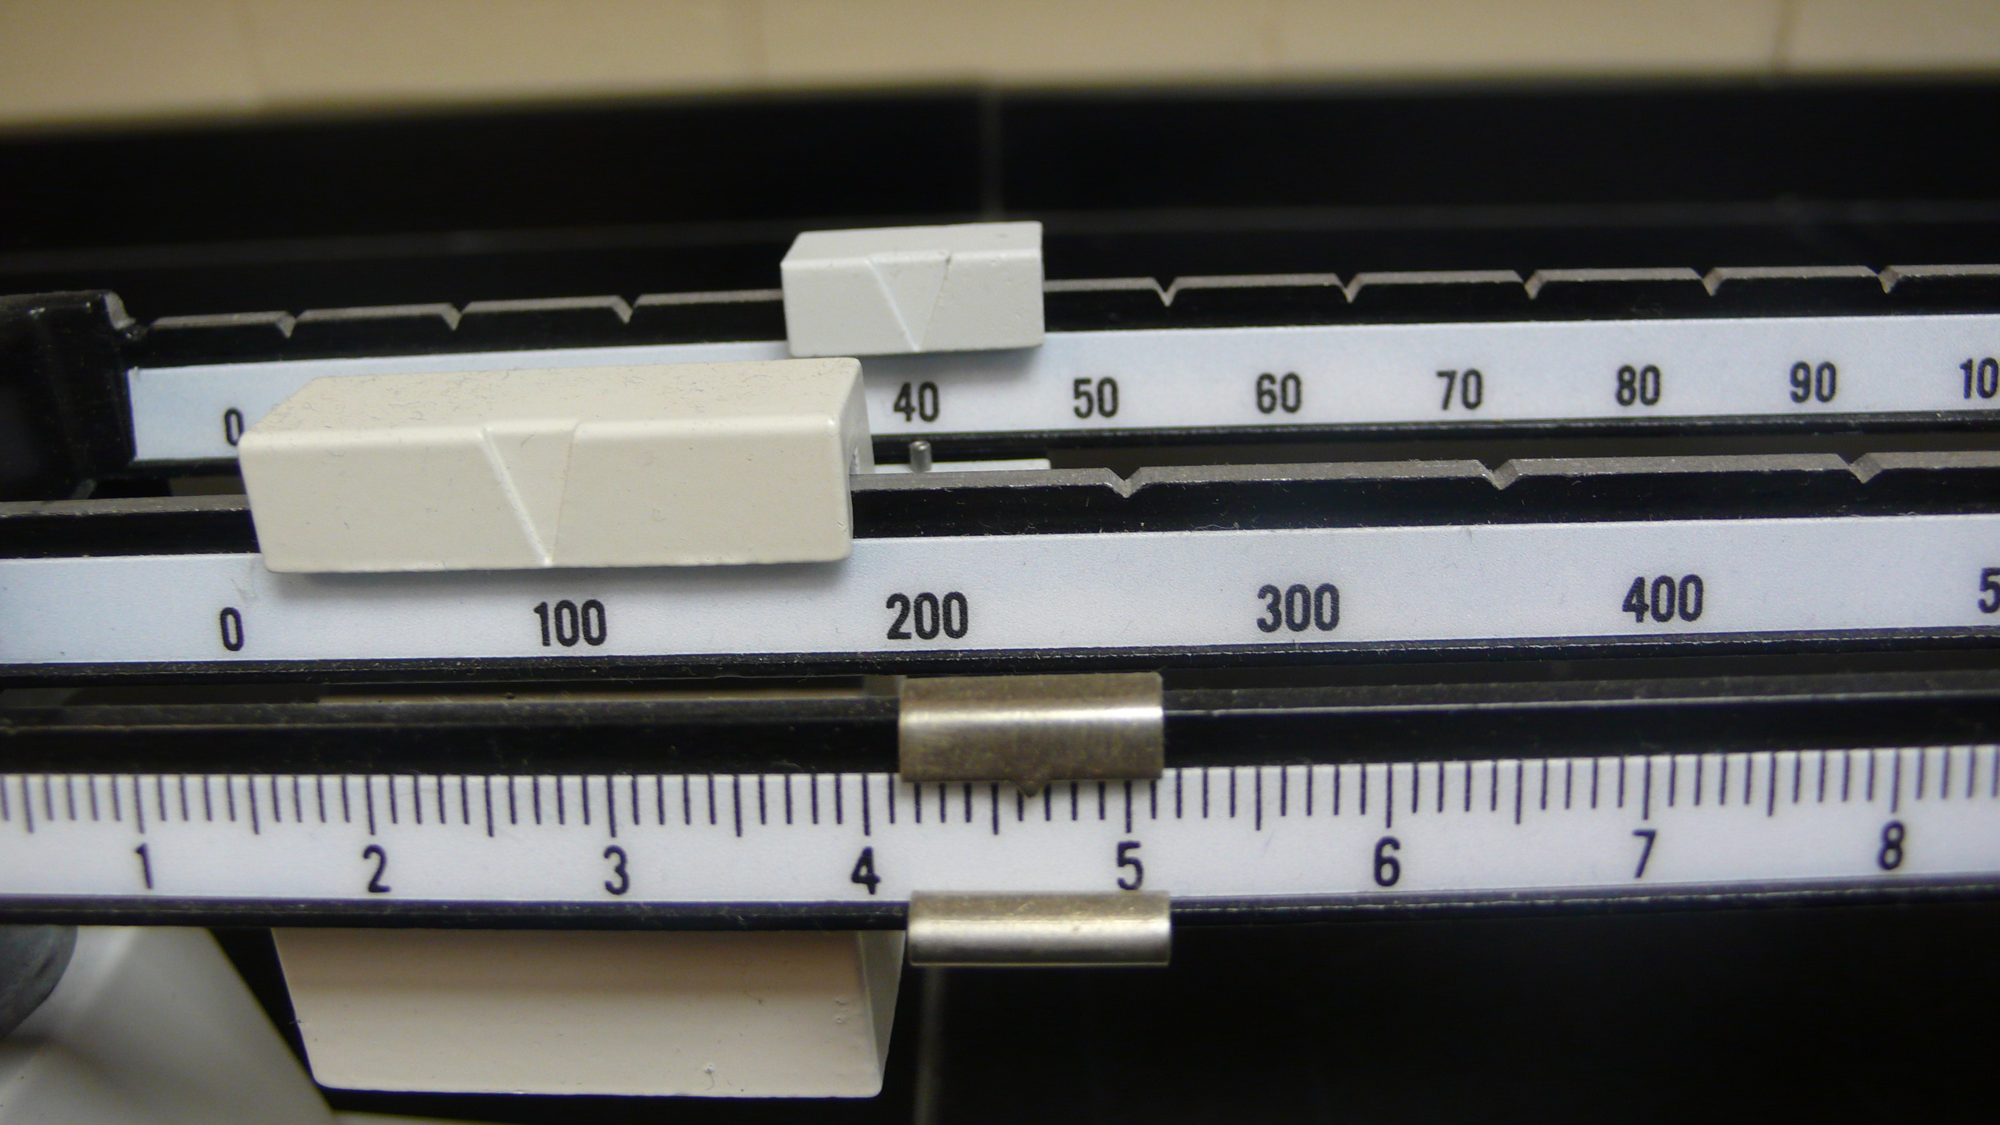
- The scale at right shows the mass of the graduated cylinder from problem 2 filled with some of the unknown liquid. Determine the reading on the beam balance at right, including absolute uncertainty. What is the relative uncertainty of the measurement?
- What is the mass of the liquid in the graduated cylinder, including uncertainty? What is the relative uncertainty of this measurement?
- By reading the graduated cylinder, the students determine that the volume of liquid is 114 ± 2 ml. What is the density of the unknown liquid, including uncertainty? (note: use the method of adding relative uncertainties)
- Shown at right is a table of densities of various alcohols. What conclusions can the students reach about the identity of the unknown liquid based on this table and the results of their density calculations?
Compound | Density (g/ml)
Methanol | 0.791
Ethanol | 0.789
Isopropanol | 0.785
- Identify one plausible source of systematic error in this procedure and describe how to correct it.
- Identify one source of random error in this procedure and describe how to correct it.

