The Moon by Mary Barrett

The Moon is really just one size The light grows larger every day
It always stays the same, Exactly as it ought'er,
But here on Earth before our eyes, But logic tells us we must say
We see it wax and wane. What looks like half is quarter.

The new moon we don't see at all, And then there's gibbous on its way
But then there is a sliver, To full, the brightest face,
The crescent moon is what we call Then swiftly it begins to wane
This slice that makes us quiver. 'Til gone without a trace.

These changes happen every night;
Each month we see each phase

The moon intrigues us with its light
It truly does amaze.

Dear God,
It is great the way you always get the stars in the right place. Why can't you do that with the moon?
Jeff (a young child)

Organization of the Moon Project (Worth a total of 150 points)
Part of Project | Point Value | Specific Requirements are on…
Observations and Graphs | 30 points | MP–2 through MP–3
Teaching of the Lesson | 10 points | MP–4
Written Reflection on the Lesson | 20 points | MP–4 through MP–5
Explanations of Concepts (your topic) | 60 points | MP–6 through MP–10
Completed Lab Activities (all topics) | 30 points | MP–10

Information, Tables, Graphs, Rubrics and Lab Activities | Where to find them
Grading Rubric for the Explanations of Concepts | MP–11
Tables in which to record your observations | MP–13 through MP–18
Graphs for you to complete | MP–19 through MP–22
Tables of Moon Facts | MP–23 through MP–34
Lab Activities for all Four Topics | C–73 through C–98

Purpose: This assignment is designed to give you the opportunity to…
• become intimately familiar with the various changes that the moon goes through each month and season.
• conduct a genuine scientific research project: to make systematic accurate observations and to use those observations to derive scientific conclusions WITHOUT “looking it up” somewhere.
• teach a lesson that guides others to discover scientific concepts for themselves.
• reflect on your teaching efforts, documenting successes, problems and ideas for improvement.
• write clear, complete, well-illustrated explanations of scientific concepts.

Questions to Answer for Topic #1
1. We all know that the sun rises in the east and sets in the west. But what does the moon do? Does it rise in the east and set in the west (like the sun does)? Or, since we know that the moon revolves around Earth from west to east, does the moon rise in the west and set in the east (the opposite of what the sun does)? Prove your answers using your observations. Explain WHY the moon rises where it does and sets where it does.
2. The sun always rises in the morning and sets in the evening. The moon, on the other hand, rises and sets at any and all times of the day or night. Why? Is there any pattern to the changes in the times of moon rise and set? What is that pattern? Why does that pattern exist?
3. Is there any correlation between the times of moonrise/moonset and the phases of the moon? If so, clearly explain that correlation and explain and illustrate WHY this correlation exists.

Observations to Make for Topic #1
Where to Make Your Observations: The best place to make each observation is in a large open area (a sports field or large parking lot, for example).
Required Number of Observations: You must observe the moon on at least 20 different dates. On 10 of these days, you will observe the moon twice on its journey across the sky. At least 7 of these observations must be made during the waning phases of the moon. BEGIN YOUR OBSERVATIONS IMMEDIATELY. If you have trouble at first, keep trying; it gets easier.
Suggested Times of Observations: Be sure to make each observation when the moon is actually out. The time period when the moon is out varies from day to day. Use the moonrise and moonset times in the “Moon Facts” tables to figure out when the moon will be out. For your double observations, plan ahead to determine good dates and times for making two observations at least four hours apart. For example, on Saturday, February 7th, you will be able to see the moon most of the afternoon and evening. You could observe it at 5:00 p.m. and then again at 11:00 p.m.

The longer the time lapse between your observations, the better, but it is sometimes hard to find the moon in the middle of the day. So watch for opportunities to make two observations in the dark. For example, on Thursday, February 12th, you could observe the moon at 11:00 p.m. and then a second time when you wake up Friday morning (February 13th) at 7:00 a.m.

Note that both observations may or may not be on the same calendar date. That doesn't matter as long as both observations are made on a single “moon day” (between a single moonrise and the next moonset).

Data to Record: Record your data in the given tables.
1. Record the time of each observation. Be sure to include a.m. or p.m. as appropriate.
2. Under “Sketch of Moon,” sketch the moon the way you see it in the sky by blackening the part of the moon that you can NOT see; leave the visible part of the moon white. Be sure to clearly show how the visible portion is “tilted” relative to the horizon (On the data table, imagine the horizon as a horizontal line on the bottom of the page.).
3. Note the compass direction of the moon (is it in the NE, E, SE, S, SW, W or NW part of the sky?). To assure accuracy, use a compass and/or refer to a map.
WARNING: In Chico, the streets are “crooked;” they are NOT lined up with N, S, E and W.
4. On at least 10 days (or nights), observe the moon twice on the same “moon day,” at least four hours apart. In other words, after a given moon rise, observe the moon twice before it sets again. Each time, draw the moon exactly as you see it, record the position of the moon in the sky (relative to N, S, E, W and “up”) and make a sketch of the trees and houses in the foreground.
5. If it is cloudy out or if you forget to look, make a note of that, but do not sketch the moon unless you actually observe it and do not record any observations that you have not personally made of the real sky (the internet is NOT the real sky). The worst sin that a scientist can commit is to falsify data. Do not commit this sin! Don't laugh–students try it every semester and end up being very disappointed in their moon project grades.
6. Record your observations as neatly as possible. But neatness is much less important than honesty, thoroughness, accuracy and usefulness. For an example of an observation table made by the great scientist, Galileo, see Figure 21.15 on p. 609 in your textbook (Earth Science, 12th edition, by Tarbuck and Lutgens).

What to Graph
The “Moon Facts” tables list times of moonrise and moonset for each date this year. Use the data on these tables to complete the graphs, depicting the time when the moon is out for much of this semester. If you are confused as to how to complete this graph, see the example graph, which plots data from a previous year.

A word to the wise: Complete your graph as early as possible and have your lab instructor check it. You already have all of the data you need to complete the graph. The completed graph will help you understand your topic better.
Due Date: The observations and graphs will be due in the middle of the semester, BEFORE the rest of the moon project is due. See your syllabus for the exact date.
What to Hand In: For this part of the moon project, hand in your original completed moon observation tables and your completed graph(s).
Teaching the Lesson: Requirements
- You will return to your original lab table group and teach the concepts of your topic to your table mates. You will meet with others to brainstorm and plan, but you will teach individually.
- The lesson is constructivist and discovery-based. Facilitate your classmates' progress throughout the activities. Keep them actively engaged, and thinking hard about the concept. Let them get their hands on the materials. Don’t do it for them.
- Let the students construct for themselves the concept that you are trying to teach. Ask them lots of questions; don’t give many answers. Explain things only when students are truly stuck; give them only enough information to help them get unstuck and continue on their own. Do not “give away” the answers; help students discover them.
- The emphasis is on important concepts—“big ideas,” not trivia.
- Explore the concepts in depth; do not just give them a superficial treatment.
- Make efficient use of your classmates' time. Do not require them to do “busy work” such as cutting, pasting, or doing simple repetitive calculations.
- Make use of the graphs that you constructed for your moon project. The students are not asked to go through the tedium of making a graph, but to interpret the meaning of a completed graph.
- Build on (i.e. do not repeat) what the students have already learned in prior labs in this class.
- Understand the concept well enough that you can answer unexpected questions from students.
- Conclude the lesson by having the students clearly answer the questions for your topic, either orally or in writing.
- Practice! Practice! Practice! Try the lesson on your roommates, family and friends.
- Your lesson must be 40-45 minutes long; no more, no less.

Written Reflection on the Lesson: Requirements
- Record your perception of how well the students came to understand the concept. Provide evidence to support your perception (quotes of what they said, quotes from what they wrote on their evaluation sheets, etc.). Describe what they did not come to understand as well as what they did come to understand.
- Evaluate how effective the lesson was in helping students learn the concept. Describe any changes you would make next time you taught the same lesson.
- Describe any misconceptions that surfaced among the students as they worked through the lesson.
- Discuss, in detail, any insights you had on the concept as a result of trying to teach it. Remember: The best way to learn something is to teach it!
Example of a Teacher’s Reflection on Her Lesson
(This is a reflection I wrote about a lesson on the moon's phases and eclipses)
This was a fun lesson (lots of “aha!” moments), especially during Activity #2, but toward the end of lab, some students began to feel confused and frustrated by the three-dimensional visualization required for this lab activity. We don’t ask students to visualize in 3-D often enough.
Activity #1 elicited the usual “shadow of the Earth” misconception about the phases of the moon. A few students had had Spatial Concepts already and vaguely remembered what they had learned in that class. There were some heated arguments but many students had no clue and were content to believe their classmates. Many groups forgot to address the issue of eclipses.
Activity #2 worked very well, except when students accidentally held the ball too low, inside the shadows of their heads. Next time, I’ll be sure to tell the students to hold the balls a foot or so above their heads. Another problem that came up in Activity #2 is that students skipped over the instructions to draw the Earth, moon and sun as viewed from the ceiling of the room; many tried to draw a view from the side and then had trouble showing the third dimension. In the future, I will be sure to point out how important perspective is when drawing three-dimensional situations on paper.
Activity #3 was a challenge for some students. For most, it was a first encounter with the method of making and then testing predictions. Quite a few students didn't have their moon projects with them or their tables contained too little data, slowing a few groups down. But, after some scrambling, each group had enough actual moon data to complete the activity. In the future, I will remind students a week or so ahead that they will need to bring their moon observations to lab on the day we cover the moon's phases and eclipses.
In the original version of this lesson, Activity #4 was part of Activity #3. Students tried to complete the pop-up, moon diagram before they had figured out which way the moon revolved around Earth. So, naturally, they had no idea which phases were waning and which were waxing. So, in my rewrite of the lesson, I separated the old Activity #3 into two activities. Also, the original version of the pop-up moon activity didn’t have the table at the bottom of page C–21 (I just referred the students to the same table on page C–1). But students either didn’t have page C–1 or they missed the reference so they got confused about terminology. In my rewrite, I included the table in this lab so it’s right there where students can find it.
When I taught the lesson, I spontaneously decided to do Activity #5 as a whole class. It took a long time to convince some students that the moon really does rotate. It took several repetitions of the demonstration with the two people. It's hard for the human brain to see a perspective other than its own. In the future, I will just plan to do the activity with the whole class.
Activities #6 and 7 were pretty easy and a nice break after several difficult ones.
The End-of-Lab questions were difficult for some students, especially question #2. Many students had a hard time REALLY seeing that the moon rises and sets because Earth rotates. Some students had trouble shaking the misconception that the moon goes all the way around the Earth every day, causing different phases in different parts of the world. In the future, I will take more time to help students see how Earth’s rotation causes the sun and the moon (and the stars and planets too!) to rise and set.
Explanations of Concepts (Your Topic): Requirements
- Use a question-and-answer format. The questions are your “Questions to Answer” for your topic (p. MP-2). Answer all of these questions fully, assuming that your reader understands no more than the basic astronomy concepts covered by the lab activities, lectures, and homework assignments that we did in this class before we did the moon project.
- Write clearly, using proper grammar and spelling. Use proper methods for citing sources of ideas and information. Put a page number on each page.
- Include lots of well-labeled well-designed diagrams and specifically refer to these diagrams in your text. You may draw your own diagrams and/or modify the diagrams included in the activities you used to teach the lesson.
- The “Grading Rubric for the Explanations of the Concepts” should be the first page of your paper.
- Submit your explanations on ordinary paper, stapled together. Simplicity (and conservation of natural resources) is best.
- All text must be typed. Hand-drawn diagrams and graphs are, however, perfectly acceptable.

Example Explanations of Concepts
(These are the answers to questions that you explored in the lab on the Moon's Phases and Eclipses)

Question #1: What causes the phases of the moon?

Answer: Contrary to popular belief, the phases of the moon are NOT caused by Earth's shadow; lunar eclipses are (see below). Except during a lunar eclipse, the entire half of the moon that faces the sun is always fully illuminated by the sun. From Earth, we can only see the entire lit portion of the moon when Earth is directly between the moon and the sun; this is a full moon.
When the moon is directly between Earth and the sun, we on Earth can see none of the lit portion of the moon; this is a new moon.
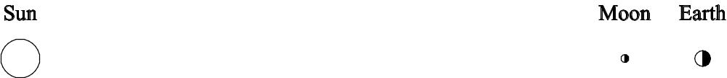
All of the other phases of the moon are partial views of the lit portion of the moon, i.e. we on Earth are viewing the lit portion of the moon more or less “from the side” as the moon revolves around Earth. See, for example, the depiction below of the 1st quarter moon.
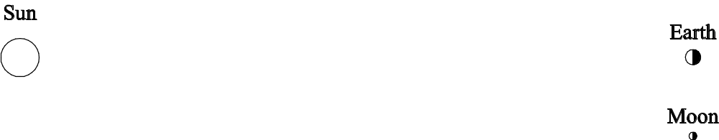

Question #2: Which way does the moon revolve around Earth?

Answer: The moon revolves around Earth from west to east (counterclockwise when viewed from above the North Pole). We know this because, in the northern hemisphere, if we observe the moon each day for a month, we see that the right half of the moon is lit during the waxing phases of the moon and the left half of the moon is lit during the waning phases of the moon. If the moon revolved clockwise around Earth, we would see the opposite: we would see the left side of the moon lit during the waxing phases and the right side lit during the waning phases.

The diagram below shows a view from space above Earth’s North Pole. The sun is far away on the right. If the moon revolved around Earth in a clockwise direction, it would head toward the Quarter Moon B position after leaving the New Moon position. If you turn this page upside down to get the view of the moon as seen from Earth’s northern hemisphere, you see that Quarter Moon B is lit on the left.

What really happens is that the moon revolves around Earth in a counterclockwise direction, heading toward the Quarter Moon A position after leaving the New Moon position. That is why we see that a waxing moon is lit on the right (in the northern hemisphere, anyway).

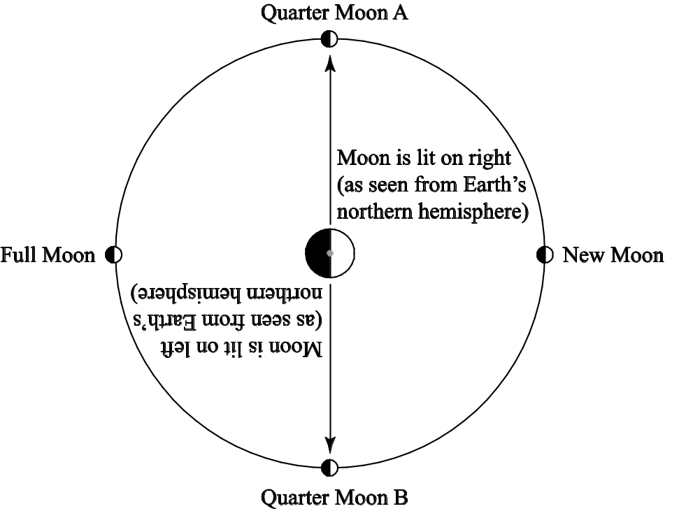

You can model this, using a white polystyrene ball-on-a-pencil to represent the moon, your head to represent Earth, and a single light bulb to represent the sun. The diagram on the top of the next page shows what you see when you put the moon in the Quarter Moon A position.
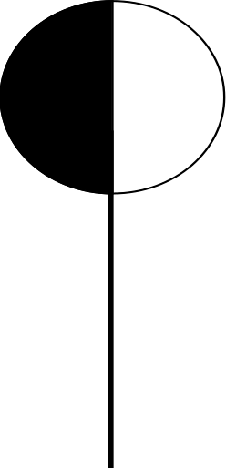

Question #3: Does the moon rotate? If so, how long does one rotation of the moon take?
Answer: No matter what phase the moon is in, the same side of the moon always faces Earth. This is because the moon rotates exactly once every time it revolves around Earth. The easiest way to visualize this is with a partner. Study the drawing on the left. Imagine that the man in the cowboy hat is Earth and the woman is the moon. Imagine that, as this couple dances, the woman is always facing the man, no matter how much they spin around the room. To accomplish this, she must rotate each time she revolve around her partner. As they dance, she keeps facing different sides of the room, but she keeps facing her partner. If she didn’t rotate as she revolved, she would end up facing away from her partner and he would see the back of her head (see the photograph on the right).
A “moon” (woman) that rotates A “moon” (woman) that doesn’t rotate
every time she revolves: as she revolves

http://library.thinkquest.org/TQ0313103/squared.jpg www.debandtomdance.com

Question #4: Why don’t we get solar and lunar eclipses every month?
Answer: A lunar eclipse occurs when the moon passes through Earth's shadow. This can happen only during a full moon. Because Earth is much bigger than the moon, the entire moon can fit within Earth's shadow; thus everyone on the side of Earth facing the moon can see a lunar eclipse.
When Earth passes through the moon's shadow, we have a solar eclipse; this can only happen during a new moon. Because the moon is much smaller than Earth, the moon's shadow only falls on a small portion of Earth's surface; therefore, only the people located in just the right spot will be able to see a solar eclipse.

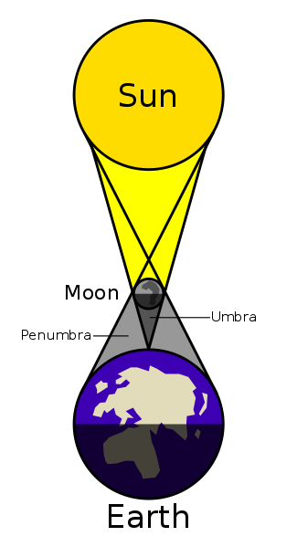 | 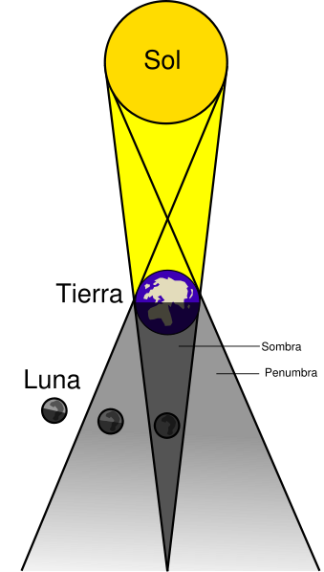
Solar Eclipse | Lunar Eclipse (Pardon my French!)
http://commons.wikimedia.org/wiki/Image:Eclipse_lunar.svg | http://commons.wikimedia.org/wiki/Image:Lunar_eclipse-es.svg
Either type of eclipse occurs when the moon, Earth and sun are in perfect precise alignment with each other. Such an alignment is rare and short-lived because these objects are very far apart. No drawing of the sun, moon and Earth during an eclipses is ever to scale. Why? Well, here is a true scale drawing:
Sun Earth and Moon
Earth and the moon show up as two tiny dots which should, in fact, be a lot smaller, but printers can’t print dots any smaller than this. I hope this drawing makes it clear how miraculous it is that the sun, moon and Earth ever line up exactly.
The final reason why we don’t get eclipses every month is this: The moon's revolution around Earth is not in exactly the same plane as Earth's revolution around the sun; it is 5° off. As a result, Earth and the moon can pass through each other's shadows only twice each year; the rest of the time, they “miss” each other’s shadows by quite a bit.

Completed Lab Activities (All Topics): Requirements
- Fully and neatly answer all of the questions in lab activities about the four different moon projects (pages C–73 through C–98). If you messed up on any of the pages that you completed in lab, you may download and print the one ones posted on the course web site.
- Take extra care to correctly answer the questions for your moon project topic. These will carry most of the points.

Student Name _______________________________________________ | Grading Rubric for the Explanations of the Concepts | Points |  |  |  |  | Multiply raw score by this number to calculate the points earned.
Student Name _______________________________________________ | Grading Rubric for the Explanations of the Concepts | Excellent (5) | All questions fully answered. Explanations are clear, correct and complete. The logic is sound and easy to follow. The level is appropriate for the assigned audience. | Diagrams accurately portray all concepts. Captions, labels, and/ or written explanations clearly reveal what diagrams are showing. Diagrams neat and uncluttered. | The writing is elegant and original; creative analogies clarify concepts. Free of errors. Formatted according to instructions. All ideas, info and figures properly credited. | Total Points (out of 60):
Student Name _______________________________________________ | Grading Rubric for the Explanations of the Concepts | Good (4) | Explanations are correct but a little unclear or incomplete. A few gaps in logic. The writer assumes a bit too much or too little prior knowledge in the reader. | Most key concepts are illustrated. Diagrams contain minor errors or are a bit unclear. Captions, labels or written explanations are incomplete. | Text is a bit too wordy or is so concise as to be unclear. Some wording is awkward or contains grammar or spelling errors. Minor formatting errors. | Total Points (out of 60):
Student Name _______________________________________________ | Grading Rubric for the Explanations of the Concepts | Fair (3) | Explanations are mostly correct. Gaps in logic or invalid logic make the explanations hard to follow. The writer assumes too much prior knowledge in the reader. | Most key concepts illustrated, but some not. Diagrams contain errors or are unclear. Captions, labels or written explanations are poor or missing. | Text is quite wordy or unclear. Spelling or grammar errors partially obscure the meaning of the text. Ideas, info and figures only partially credited. | Total Points (out of 60):
Student Name _______________________________________________ | Grading Rubric for the Explanations of the Concepts | Unacceptable (0-2) | Several questions not answered. Explanations are incorrect and full of gaps. The logic is invalid and impossible to follow. The writer assumes far too much prior knowledge in reader. | Diagrams are missing altogether or are useless because they don’t actually illustrate the concepts. | Poorly worded. Meaning unclear. Full of errors. Formatted incorrectly. Material obtained from outside sources is presented as the writer’s own. | Total Points (out of 60):
Student Name _______________________________________________ | Grading Rubric for the Explanations of the Concepts | Weight¹ | 6 | 4 | 2 | Total Points (out of 60):
Student Name _______________________________________________ | Grading Rubric for the Explanations of the Concepts | Component | Explanations | Diagrams | Grammar, spelling, formatting, citations, etc. | Total Points (out of 60):

Location of Moon  (sketch showing moon, objects in foreground and compass directions) |  |  |  |  |  | Shade in the portion of the moon you CANNOT see. Leave the visible portion white
Sketch of Moon | 
Date and Time of 2nd Observation (Include am/pm)
Location of Moon
(sketch showing moon, objects in foreground and compass directions)
Sketch of Moon
Date and Time of 2nd Observation (Include am/pm)
 | 1 | 2 | 3 | 4 | 5

Location of Moon  (sketch showing moon, objects in foreground and compass directions) |  |  |  |  |  | Shade in the portion of the moon you CANNOT see. Leave the visible portion white
Sketch of Moon
Date and Time of 2nd Observation (Include am/pm)
Location of Moon
(sketch showing moon, objects in foreground and compass directions)
Sketch of Moon
Date and Time of 2nd Observation (Include am/pm)
 | 1 | 2 | 3 | 4 | 5

Location of Moon  (sketch showing moon, objects in foreground and compass directions) |  |  |  |  |  | Shade in the portion of the moon you CANNOT see. Leave the visible portion white
Sketch of Moon
Date and Time of 2nd Observation (Include am/pm)
Location of Moon
(sketch showing moon, objects in foreground and compass directions)
Sketch of Moon
Date and Time of 2nd Observation (Include am/pm)
 | 1 | 2 | 3 | 4 | 5

Location of Moon  (sketch showing moon, objects in foreground and compass directions) |  |  |  |  |  | Shade in the portion of the moon you CANNOT see. Leave the visible portion white
Sketch of Moon
Date and Time of 2nd Observation (Include am/pm)
Location of Moon
(sketch showing moon, objects in foreground and compass directions)
Sketch of Moon
Date and Time of 2nd Observation (Include am/pm)
 | 1 | 2 | 3 | 4 | 5

Location of Moon  (sketch showing moon, objects in foreground and compass directions) |  |  |  |  |  | Shade in the portion of the moon you CANNOT see. Leave the visible portion white
Sketch of Moon
Date and Time of 2nd Observation (Include am/pm)
Location of Moon
(sketch showing moon, objects in foreground and compass directions)
Sketch of Moon
Date and Time of 2nd Observation (Include am/pm)
 | 1 | 2 | 3 | 4 | 5

Location of Moon  (sketch showing moon, objects in foreground and compass directions) |  |  |  |  |  | Shade in the portion of the moon you CANNOT see. Leave the visible portion white
Sketch of Moon
Date and Time of 2nd Observation (Include am/pm)
Location of Moon
(sketch showing moon, objects in foreground and compass directions)
Sketch of Moon
Date and Time of 2nd Observation (Include am/pm)
 | 1 | 2 | 3 | 4 | 5

Example Graph for Topic #1

The example graph is on the next page; the data used for this graph are listed below. They are from January and February of 2002. Note especially the method for handling those dates when the moon does not rise or does not set.

Date | Time of Moonset | Time of Moonrise
1-Jan | 9:34 AM | 7:48 PM
2-Jan | 10:17 AM | 9:01 PM
3-Jan | 10:54 AM | 10:13 PM
4-Jan | 11:27 AM | 11:22 PM
5-Jan | 11:57 AM | ∗
Date | Time of Moonrise | Time of Moonset
6-Jan | 12:31 AM | 12:27 PM
7-Jan | 1:38 AM | 12:58 PM
8-Jan | 2:45 AM | 1:32 PM
9-Jan | 3:51 AM | 2:08 PM
10-Jan | 4:56 AM | 2:50 PM
11-Jan | 5:58 AM | 3:38 PM
12-Jan | 6:54 AM | 4:31 PM
13-Jan | 7:45 AM | 5:27 PM
14-Jan | 8:28 AM | 6:26 PM
15-Jan | 9:05 AM | 7:25 PM
16-Jan | 9:37 AM | 8:24 PM
17-Jan | 10:06 AM | 9:21 PM
18-Jan | 10:32 AM | 10:18 PM
19-Jan | 10:56 AM | 11:14 PM
20-Jan | 11:21 AM | **
Date | Time of Moonset | Time of Moonrise
21-Jan | 12:12 AM | 11:47 AM
22-Jan | 1:10 AM | 12:15 PM
23-Jan | 2:12 AM | 12:48 PM
24-Jan | 3:15 AM | 1:26 PM
25-Jan | 4:21 AM | 2:12 PM
26-Jan | 5:25 AM | 3:08 PM
27-Jan | 6:26 AM | 4:13 PM

Date | Time of Moonset | Time of Moonrise
28-Jan | 7:21 AM | 5:24 PM
29-Jan | 8:09 AM | 6:39 PM
30-Jan | 8:50 AM | 7:55 PM
31-Jan | 9:25 AM | 9:08 PM
1-Feb | 9:58 AM | 10:20 PM
2-Feb | 10:29 AM | 11:29 PM
3-Feb | 11:00 AM | *
Date | Time of Moonrise | Time of Moonset
4-Feb | 12:38 AM | 11:33 AM
5-Feb | 1:45 AM | 12:09 PM
6-Feb | 2:50 AM | 12:49 PM
7-Feb | 3:52 AM | 1:34 PM
8-Feb | 4:50 AM | 2:25 PM
9-Feb | 5:41 AM | 3:20 PM
10-Feb | 6:26 AM | 4:18 PM
11-Feb | 7:05 AM | 5:17 PM
12-Feb | 7:38 AM | 6:15 PM
13-Feb | 8:08 AM | 7:13 PM
14-Feb | 8:34 AM | 8:10 PM
15-Feb | 8:59 AM | 9:07 PM
16-Feb | 9:24 AM | 10:03 PM
17-Feb | 9:49 AM | 11:01 PM
18-Feb | 10:15 AM | **
Date | Time of Moonset | Time of Moonrise
19-Feb | 12:00 AM | 10:45 AM
20-Feb | 1:01 AM | 11:20 AM
21-Feb | 2:04 AM | 12:01 PM
22-Feb | 3:07 AM | 12:50 PM
23-Feb | 4:08 AM | 1:49 PM
24-Feb | 5:05 AM | 2:56 PM

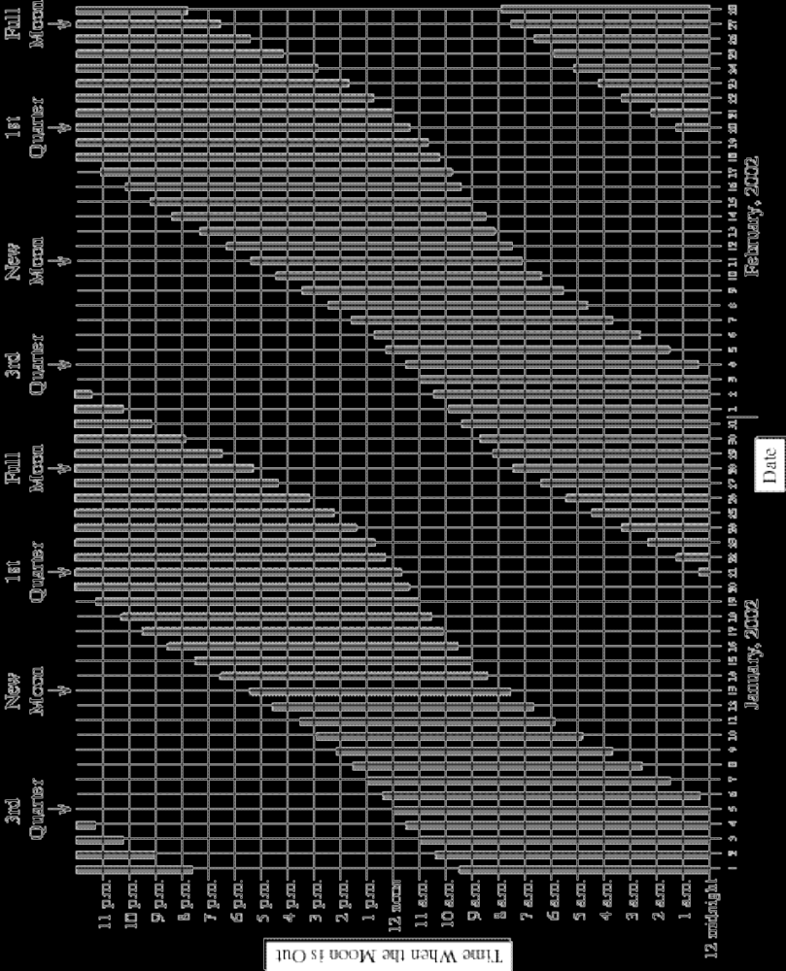

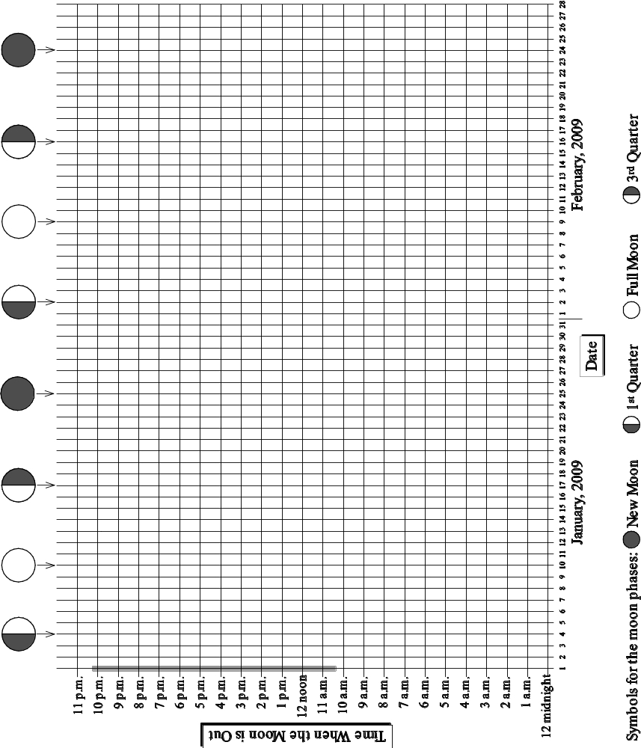

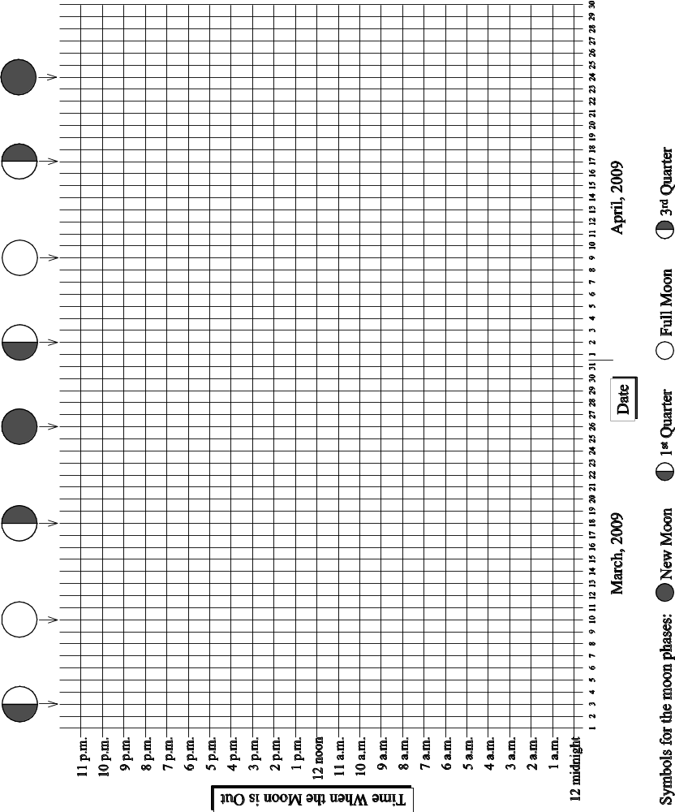

Moon Facts for January, 2009

Date | Time of Moonrise | Time of Moonset | Length of Moon “Day” (# of hours the moon is out) | Astronomical Place of the moon
1-Jan | 10:19 AM | 10:10 PM | 11:51 | Aquarius
2-Jan | 10:42 AM | 11:13 PM | 12:31 | Pisces
3-Jan | 11:05 AM | ∗∗ | ∗∗∗ | Pisces
Date | Time of Moonset | Time of Moonrise | Length of Moon “Day” (# of hours the moon is out) | Astronomical Place of the moon
4-Jan | 12:18 AM | 11:30 AM | 13:13  | Pisces
5-Jan | 1:27 AM | 11:59 AM | 13:57 | Pisces
6-Jan | 2:40 AM | 12:35 PM | 14:41 | Aries
7-Jan | 3:55 AM | 1:20 PM | 15:20 | Aries
8-Jan | 5:09 AM | 2:17 PM | 15:49 | Taurus
9-Jan | 6:17 AM | 3:26 PM | 16:00 | Taurus
10-Jan | 7:15 AM | 4:44 PM | 15:49  | Gemini
11-Jan | 8:01 AM | 6:04 PM | 15:17 | Gemini
12-Jan | 8:39 AM | 7:22 PM | 14:35 | Cancer
13-Jan | 9:09 AM | 8:36 PM | 13:47 | Leo
14-Jan | 9:36 AM | 9:46 PM | 13:00 | Leo
15-Jan | 10:01 AM | 10:54 PM | 12:15 | Leo
16-Jan | 10:25 AM | 11:59 PM | 11:31 | Virgo
17-Jan | 10:50 AM | ∗ | 10:51  | Virgo
Date | Time of Moonrise | Time of Moonset | Length of Moon “Day” (# of hours the moon is out) | Astronomical Place of the moon
18-Jan | 1:04 AM | 11:18 AM | 10:14 | Virgo
19-Jan | 2:07 AM | 11:49 AM | 9:42 | Libra
20-Jan | 3:09 AM | 12:26 PM | 9:17 | Libra
21-Jan | 4:08 AM | 1:09 PM | 9:01 | Scorpius
22-Jan | 5:02 AM | 1:58 PM | 8:56 | Ophiuchus
23-Jan | 5:49 AM | 2:54 PM | 9:05 | Sagittarius
24-Jan | 6:30 AM | 3:54 PM | 9:24 | Sagittarius
25-Jan | 7:05 AM | 4:56 PM | 9:51  | Sagittarius
26-Jan | 7:35 AM | 5:58 PM | 10:23 | Capricornus
27-Jan | 8:01 AM | 7:01 PM | 11:00 | Aquarius
28-Jan | 8:25 AM | 8:03 PM | 11:38 | Aquarius
29-Jan | 8:47 AM | 9:06 PM | 12:19 | Aquarius
30-Jan | 9:10 AM | 10:10 PM | 13:00 | Pisces
31-Jan | 9:34 AM | 11:17 PM | 13:43 | Pisces
∗ The moon does not rise on this date. It rises early the next day.
∗∗ The moon does not set on this date. It sets early the next day.
∗∗∗ This date is “skipped” on the graphs for topics 3 and 4 because the moon does not set on this date.
Moon Facts for February, 2009

Date | Time of Moonrise | Time of Moonset | Length of Moon “Day” (# of hours the moon is out) | Astronomical Place of the moon
1-Feb | 10:01 AM | ∗∗ | ∗∗∗ | Pisces
Date | Time of Moonset | Time of Moonrise | Length of Moon “Day” (# of hours the moon is out) | Astronomical Place of the moon
2-Feb | 12:26 AM | 10:33 AM | 14:25 | Aries
3-Feb | 1:38 AM | 11:13 AM | 15:05 | Aries
4-Feb | 2:51 AM | 12:02 PM | 15:38 | Taurus
5-Feb | 3:59 AM | 1:04 PM | 15:57 | Taurus
6-Feb | 5:00 AM | 2:15 PM | 15:56 | Gemini
7-Feb | 5:50 AM | 3:33 PM | 15:35 | Gemini
8-Feb | 6:31 AM | 4:52 PM | 14:58 | Cancer
9-Feb | 7:05 AM | 6:08 PM | 14:13 | Cancer
10-Feb | 7:34 AM | 7:22 PM | 13:26 | Leo
11-Feb | 8:00 AM | 8:32 PM | 12:38 | Leo
12-Feb | 8:25 AM | 9:41 PM | 11:53 | Virgo
13-Feb | 8:50 AM | 10:48 PM | 11:09 | Virgo
14-Feb | 9:18 AM | 11:53 PM | 10:30 | Virgo
15-Feb | 9:48 AM | ∗ | 9:55 | Libra
Date | Time of Moonrise | Time of Moonset | Length of Moon “Day” (# of hours the moon is out) | Astronomical Place of the moon
16-Feb | 12:57 AM | 10:23 AM | 9:26 | Libra
17-Feb | 1:58 AM | 11:04 AM | 9:06 | Scorpius
18-Feb | 2:55 AM | 11:51 AM | 8:56 | Ophiuchus
19-Feb | 3:45 AM | 12:45 PM | 9:00 | Sagittarius
20-Feb | 4:28 AM | 1:43 PM | 9:15 | Sagittarius
21-Feb | 5:05 AM | 2:45 PM | 9:40 | Sagittarius
22-Feb | 5:37 AM | 3:47 PM | 10:10 | Capricornus
23-Feb | 6:04 AM | 4:50 PM | 10:46 | Capricornus
24-Feb | 6:29 AM | 5:54 PM | 11:25 | Aquarius
25-Feb | 6:52 AM | 6:57 PM | 12:05 | Aquarius
26-Feb | 7:15 AM | 8:02 PM | 12:47 | Pisces
27-Feb | 7:39 AM | 9:09 PM | 13:30 | Pisces
28-Feb | 8:05 AM | 10:18 PM | 14:13 | Pisces
∗ The moon does not rise on this date. It rises early the next day.
∗∗ The moon does not set on this date. It sets early the next day.
∗∗∗ This date is “skipped” on the graphs for topics 3 and 4 because the moon does not set on this date.
Moon Facts for March, 2009

Date | Time of Moonrise | Time of Moonset | Length of Moon “Day” (# of hours the moon is out) | Astronomical Place of the moon
1-Mar | 8:36 AM | 11:29 PM | 14:53 | Aries
2-Mar | 9:13 AM | ∗∗ | ∗∗∗ | Aries
Date | Time of Moonset | Time of Moonrise | Length of Moon “Day” (# of hours the moon is out) | Astronomical Place of the moon
3-Mar | 12:40 AM | 9:58 AM | 15:27 | Taurus
4-Mar | 1:49 AM | 10:54 AM | 15:51 | Taurus
5-Mar | 2:51 AM | 12:00 PM | 15:57 | Taurus
6-Mar | 3:43 AM | 1:13 PM | 15:43 | Gemini
7-Mar | 4:26 AM | 2:29 PM | 15:13 | Gemini
8-Mar | 6:02 AM | 4:44 PM | 14:33 | Cancer
9-Mar | 6:32 AM | 5:58 PM | 13:48 | Leo
10-Mar | 6:59 AM | 7:09 PM | 13:01 | Leo
11-Mar | 7:25 AM | 8:19 PM | 12:16 | Leo
12-Mar | 7:50 AM | 9:27 PM | 11:31 | Virgo
13-Mar | 8:17 AM | 10:34 PM | 10:50 | Virgo
14-Mar | 8:46 AM | 11:41 PM | 10:12 | Virgo
15-Mar | 9:20 AM | ∗ | 9:39 | Libra
Date | Time of Moonrise | Time of Moonset | Length of Moon “Day” (# of hours the moon is out) | Astronomical Place of the moon
16-Mar | 12:44 AM | 9:59 AM | 9:15 | Libra
17-Mar | 1:43 AM | 10:44 AM | 9:01 | Scorpius
18-Mar | 2:37 AM | 11:36 AM | 8:59 | Ophiuchus
19-Mar | 3:23 AM | 12:32 PM | 9:09 | Sagittarius
20-Mar | 4:03 AM | 1:32 PM | 9:29 | Sagittarius
21-Mar | 4:36 AM | 2:34 PM | 9:58 | Capricornus
22-Mar | 5:05 AM | 3:37 PM | 10:32 | Capricornus
23-Mar | 5:31 AM | 4:40 PM | 11:09 | Capricornus
24-Mar | 5:55 AM | 5:43 PM | 11:48 | Aquarius
25-Mar | 6:18 AM | 6:48 PM | 12:30 | Pisces
26-Mar | 6:42 AM | 7:55 PM | 13:13 | Pisces
27-Mar | 7:08 AM | 9:05 PM | 13:57 | Pisces
28-Mar | 7:38 AM | 10:17 PM | 14:39 | Pisces
29-Mar | 8:13 AM | 11:30 PM | 15:17 | Aries
30-Mar | 8:57 AM | ∗∗ | ∗∗∗ | Taurus
Date | Time of Moonset | Time of Moonrise | Length of Moon “Day” (# of hours the moon is out) | Astronomical Place of the moon
31-Mar | 12:41 AM | 9:50 AM | 15:44 | Taurus

∗ The moon does not rise on this date. It rises early the next day.
∗∗ The moon does not set on this date. It sets early the next day.
∗∗∗ This date is “skipped” on the graphs for topics 3 and 4 because the moon does not set on this date.
Moon Facts for April, 2009

Date | Time of Moonset | Time of Moonrise | Length of Moon “Day” (# of hours the moon is out) | Astronomical Place of the moon
1-Apr | 1:45 AM | 10:53 AM | 15:55 | Taurus
2-Apr | 2:40 AM | 12:03 PM | 15:47 | Gemini
3-Apr | 3:25 AM | 1:17 PM | 15:22 | Gemini
4-Apr | 4:02 AM | 2:30 PM | 14:45 | Cancer
5-Apr | 4:33 AM | 3:42 PM | 14:03 | Leo
6-Apr | 5:01 AM | 4:52 PM | 13:19 | Leo
7-Apr | 5:26 AM | 6:01 PM | 12:34 | Leo
8-Apr | 5:51 AM | 7:09 PM | 11:50 | Virgo
9-Apr | 6:17 AM | 8:16 PM | 11:08 | Virgo
10-Apr | 6:45 AM | 9:23 PM | 10:29 | Virgo
11-Apr | 7:17 AM | 10:28 PM | 9:54 | Libra
12-Apr | 7:54 AM | 11:30 PM | 9:26 | Libra
13-Apr | 8:37 AM | ∗ | 9:07 | Scorpius
Date | Time of Moonrise | Time of Moonset | Length of Moon “Day” (# of hours the moon is out) | Astronomical Place of the moon
14-Apr | 12:26 AM | 9:27 AM | 9:01 | Ophiuchus
15-Apr | 1:16 AM | 10:22 AM | 9:06 | Sagittarius
16-Apr | 1:58 AM | 11:20 AM | 9:22 | Sagittarius
17-Apr | 2:34 AM | 12:21 PM | 9:47 | Sagittarius
18-Apr | 3:04 AM | 1:23 PM | 10:19 | Capricornus
19-Apr | 3:31 AM | 2:25 PM | 10:54 | Aquarius
20-Apr | 3:56 AM | 3:27 PM | 11:31 | Aquarius
21-Apr | 4:19 AM | 4:31 PM | 12:12 | Aquarius
22-Apr | 4:43 AM | 5:37 PM | 12:54 | Pisces
23-Apr | 5:08 AM | 6:46 PM | 13:38 | Pisces
24-Apr | 5:37 AM | 7:58 PM | 14:21 | Pisces
25-Apr | 6:10 AM | 9:13 PM | 15:03 | Aries
26-Apr | 6:52 AM | 10:27 PM | 15:35 | Aries
27-Apr | 7:43 AM | 11:35 PM | 15:52 | Taurus
28-Apr | 8:44 AM | ∗∗ | ∗∗∗ | Taurus
Date | Time of Moonset | Time of Moonrise | Length of Moon “Day” (# of hours the moon is out) | Astronomical Place of the moon
29-Apr | 12:35 AM | 9:54 AM | 15:51 | Gemini
30-Apr | 1:24 AM | 11:08 AM | 15:30 | Gemini

∗ The moon does not rise on this date. It rises early the next day.
∗∗ The moon does not set on this date. It sets early the next day.
∗∗∗ This date is “skipped” on the graphs for topics 3 and 4 because the moon does not set on this date.
Moon Facts for May, 2009

Date | Time of Moonset | Time of Moonrise | Length of Moon “Day” (# of hours the moon is out) | Astronomical Place of the moon
1-May | 2:03 AM | 12:22 PM | 14:55 | Cancer
2-May | 2:36 AM | 1:34 PM | 14:14 | Leo
3-May | 3:04 AM | 2:43 PM | 13:30 | Leo
4-May | 3:30 AM | 3:51 PM | 12:47 | Leo
5-May | 3:54 AM | 4:57 PM | 12:03 | Virgo
6-May | 4:19 AM | 6:03 PM | 11:22 | Virgo
7-May | 4:46 AM | 7:09 PM | 10:43 | Virgo
8-May | 5:17 AM | 8:15 PM | 10:08 | Virgo
9-May | 5:52 AM | 9:18 PM | 9:37 | Libra
10-May | 6:32 AM | 10:16 PM | 9:14 | Scorpius
11-May | 7:20 AM | 11:08 PM | 9:04 | Ophiuchus
12-May | 8:13 AM | 11:53 PM | 9:05 | Sagittarius
13-May | 9:10 AM | ∗ | 9:17 | Sagittarius
Date | Time of Moonrise | Time of Moonset | Length of Moon “Day” (# of hours the moon is out) | Astronomical Place of the moon
14-May | 12:32 AM | 10:10 AM | 9:38 | Sagittarius
15-May | 1:04 AM | 11:11 AM | 10:07 | Capricornus
16-May | 1:32 AM | 12:12 PM | 10:40 | Capricornus
17-May | 1:57 AM | 1:13 PM | 11:16 | Capricornus
18-May | 2:20 AM | 2:15 PM | 11:55 | Aquarius
19-May | 2:43 AM | 3:18 PM | 12:35 | Pisces
20-May | 3:07 AM | 4:25 PM | 13:18 | Pisces
21-May | 3:34 AM | 5:35 PM | 14:01 | Pisces
22-May | 4:05 AM | 6:48 PM | 14:43 | Aries
23-May | 4:43 AM | 8:04 PM | 15:21 | Aries
24-May | 5:30 AM | 9:17 PM | 15:47 | Taurus
25-May | 6:29 AM | 10:22 PM | 15:53 | Taurus
26-May | 7:38 AM | 11:17 PM | 15:39 | Gemini
27-May | 8:53 AM | ∗∗ | ∗∗∗ | Gemini
Date | Time of Moonset | Time of Moonrise | Length of Moon “Day” (# of hours the moon is out) | Astronomical Place of the moon
28-May | 12:01 AM | 10:09 AM | 15:08 | Cancer
29-May | 12:37 AM | 11:24 AM | 14:28 | Cancer
30-May | 1:07 AM | 12:35 PM | 13:43 | Leo
31-May | 1:34 AM | 1:44 PM | 12:59 | Leo
∗ The moon does not rise on this date. It rises early the next day.
∗∗ The moon does not set on this date. It sets early the next day.
∗∗∗ This date is “skipped” on the graphs for topics 3 and 4 because the moon does not set on this date.
Moon Facts for June, 2009

Date | Time of Moonset | Time of Moonrise | Length of Moon “Day” (# of hours the moon is out) | Astronomical Place of the moon
1-Jun | 1:58 AM | 2:50 PM | 12:14 | Virgo
2-Jun | 2:23 AM | 3:56 PM | 11:33 | Virgo
3-Jun | 2:49 AM | 5:01 PM | 10:53 | Virgo
4-Jun | 3:18 AM | 6:06 PM | 10:17 | Virgo
5-Jun | 3:51 AM | 7:09 PM | 9:45 | Libra
6-Jun | 4:30 AM | 8:08 PM | 9:21 | Scorpius
7-Jun | 5:15 AM | 9:03 PM | 9:07 | Scorpius
8-Jun | 6:06 AM | 9:50 PM | 9:03 | Ophiuchus
9-Jun | 7:02 AM | 10:30 PM | 9:12 | Sagittarius
10-Jun | 8:01 AM | 11:04 PM | 9:31 | Sagittarius
11-Jun | 9:02 AM | 11:33 PM | 9:58 | Capricornus
12-Jun | 10:03 AM | 11:59 PM | 10:30 | Capricornus
13-Jun | 11:03 AM | ∗ | 11:04 | Capricornus
Date | Time of Moonrise | Time of Moonset | Length of Moon “Day” (# of hours the moon is out) | Astronomical Place of the moon
14-Jun | 12:22 AM | 12:03 PM | 11:41 | Aquarius
15-Jun | 12:45 AM | 1:04 PM | 12:19 | Pisces
16-Jun | 1:08 AM | 2:08 PM | 13:00 | Pisces
17-Jun | 1:32 AM | 3:14 PM | 13:42 | Pisces
18-Jun | 2:01 AM | 4:24 PM | 14:23 | Pisces
19-Jun | 2:34 AM | 5:38 PM | 15:04 | Aries
20-Jun | 3:16 AM | 6:52 PM | 15:36 | Aries
21-Jun | 4:09 AM | 8:02 PM | 15:53 | Taurus
22-Jun | 5:14 AM | 9:03 PM | 15:49 | Taurus
23-Jun | 6:28 AM | 9:53 PM | 15:25 | Gemini
24-Jun | 7:47 AM | 10:34 PM | 14:47 | Gemini
25-Jun | 9:05 AM | 11:07 PM | 14:02 | Cancer
26-Jun | 10:21 AM | 11:36 PM | 13:15 | Leo
27-Jun | 11:32 AM | ∗∗ | ∗∗∗ | Leo
Date | Time of Moonset | Time of Moonrise | Length of Moon “Day” (# of hours the moon is out) | Astronomical Place of the moon
28-Jun | 12:02 AM | 12:41 PM | 12:30 | Leo
29-Jun | 12:27 AM | 1:48 PM | 11:46 | Virgo
30-Jun | 12:53 AM | 2:54 PM | 11:05 | Virgo

∗ The moon does not rise on this date. It rises early the next day.
∗∗ The moon does not set on this date. It sets early the next day.
∗∗∗ This date is “skipped” on the graphs for topics 3 and 4 because the moon does not set on this date.
Moon Facts for July, 2009

Date | Time of Moonset | Time of Moonrise | Length of Moon “Day” (# of hours the moon is out) | Astronomical Place of the moon
1-Jul | 1:21 AM | 3:59 PM | 10:27 | Virgo
2-Jul | 1:53 AM | 5:02 PM | 9:54 | Libra
3-Jul | 2:29 AM | 6:03 PM | 9:27 | Libra
4-Jul | 3:12 AM | 6:58 PM | 9:09 | Scorpius
5-Jul | 4:01 AM | 7:48 PM | 9:03 | Ophiuchus
6-Jul | 4:55 AM | 8:30 PM | 9:07 | Sagittarius
7-Jul | 5:54 AM | 9:06 PM | 9:24 | Sagittarius
8-Jul | 6:54 AM | 9:37 PM | 9:48 | Sagittarius
9-Jul | 7:55 AM | 10:03 PM | 10:18 | Capricornus
10-Jul | 8:56 AM | 10:27 PM | 10:53 | Capricornus
11-Jul | 9:56 AM | 10:49 PM | 11:29 | Aquarius
12-Jul | 10:56 AM | 11:12 PM | 12:07 | Pisces
13-Jul | 11:57 AM | 11:35 PM | 12:45 | Pisces
14-Jul | 1:01 PM | ∗ | 13:26 | Pisces
Date | Time of Moonrise | Time of Moonset | Length of Moon “Day” (# of hours the moon is out) | Astronomical Place of the moon
15-Jul | 12:01 AM | 2:07 PM | 14:06 | Pisces
16-Jul | 12:31 AM | 3:17 PM | 14:46 | Aries
17-Jul | 1:07 AM | 4:29 PM | 15:22 | Aries
18-Jul | 1:53 AM | 5:40 PM | 15:47 | Taurus
19-Jul | 2:51 AM | 6:45 PM | 15:54 | Taurus
20-Jul | 4:00 AM | 7:40 PM | 15:40 | Gemini
21-Jul | 5:17 AM | 8:25 PM | 15:08 | Gemini
22-Jul | 6:38 AM | 9:03 PM | 14:25 | Cancer
23-Jul | 7:56 AM | 9:34 PM | 13:38 | Leo
24-Jul | 9:12 AM | 10:02 PM | 12:50 | Leo
25-Jul | 10:24 AM | 10:29 PM | 12:05 | Leo
26-Jul | 11:34 AM | 10:55 PM | 11:21 | Virgo
27-Jul | 12:42 PM | 11:23 PM | 10:41 | Virgo
28-Jul | 1:49 PM | 11:54 PM | 10:05 | Virgo
29-Jul | 2:54 PM | ∗∗ | ∗∗∗ | Libra
Date | Time of Moonset | Time of Moonrise | Length of Moon “Day” (# of hours the moon is out) | Astronomical Place of the moon
30-Jul | 12:29 AM | 3:56 PM | 9:35 | Libra
31-Jul | 1:10 AM | 4:54 PM | 9:14 | Scorpius
∗ The moon does not rise on this date. It rises early the next day.
∗∗ The moon does not set on this date. It sets early the next day.
∗∗∗ This date is “skipped” on the graphs for topics 3 and 4 because the moon does not set on this date.
Moon Facts for August, 2009

Date | Time of Moonset | Time of Moonrise | Length of Moon “Day” (# of hours the moon is out) | Astronomical Place of the moon
1-Aug | 1:57 AM | 5:45 PM | 9:03 | Ophiuchus
2-Aug | 2:50 AM | 6:30 PM | 9:05 | Sagittarius
3-Aug | 3:47 AM | 7:07 PM | 9:17 | Sagittarius
4-Aug | 4:47 AM | 7:40 PM | 9:40 | Sagittarius
5-Aug | 5:48 AM | 8:07 PM | 10:08 | Capricornus
6-Aug | 6:49 AM | 8:32 PM | 10:42 | Aquarius
7-Aug | 7:49 AM | 8:55 PM | 11:17 | Aquarius
8-Aug | 8:49 AM | 9:17 PM | 11:54 | Aquarius
9-Aug | 9:50 AM | 9:40 PM | 12:33 | Pisces
10-Aug | 10:53 AM | 10:05 PM | 13:13 | Pisces
11-Aug | 11:57 AM | 10:33 PM | 13:52 | Pisces
12-Aug | 1:05 PM | 11:06 PM | 14:32 | Aries
13-Aug | 2:14 PM | 11:46 PM | 15:08 | Aries
14-Aug | 3:23 PM | ∗ | 15:37 | Taurus
Date | Time of Moonrise | Time of Moonset | Length of Moon “Day” (# of hours the moon is out) | Astronomical Place of the moon
15-Aug | 12:37 AM | 4:29 PM | 15:52 | Taurus
16-Aug | 1:39 AM | 5:27 PM | 15:48 | Taurus
17-Aug | 2:51 AM | 6:16 PM | 15:25 | Gemini
18-Aug | 4:08 AM | 6:56 PM | 14:48 | Gemini
19-Aug | 5:27 AM | 7:30 PM | 14:03 | Cancer
20-Aug | 6:45 AM | 8:00 PM | 13:15 | Leo
21-Aug | 8:00 AM | 8:28 PM | 12:28 | Leo
22-Aug | 9:13 AM | 8:55 PM | 11:42 | Virgo
23-Aug | 10:24 AM | 9:23 PM | 10:59 | Virgo
24-Aug | 11:33 AM | 9:53 PM | 10:20 | Virgo
25-Aug | 12:41 PM | 10:27 PM | 9:46 | Virgo
26-Aug | 1:46 PM | 11:07 PM | 9:21 | Libra
27-Aug | 2:46 PM | 11:52 PM | 9:06 | Scorpius
28-Aug | 3:40 PM | ∗∗ | ∗∗∗ | Ophiuchus
Date | Time of Moonset | Time of Moonrise | Length of Moon “Day” (# of hours the moon is out) | Astronomical Place of the moon
29-Aug | 12:43 AM | 4:27 PM | 9:03 | Sagittarius
30-Aug | 1:39 AM | 5:07 PM | 9:12 | Sagittarius
31-Aug | 2:39 AM | 5:41 PM | 9:32 | Sagittarius
∗ The moon does not rise on this date. It rises early the next day.
∗∗ The moon does not set on this date. It sets early the next day.
∗∗∗ This date is “skipped” on the graphs for topics 3 and 4 because the moon does not set on this date.
Moon Facts for September, 2009

Date | Time of Moonset | Time of Moonrise | Length of Moon “Day” (# of hours the moon is out) | Astronomical Place of the moon
1-Sep | 3:39 AM | 6:11 PM | 9:58 | Capricornus
2-Sep | 4:40 AM | 6:36 PM | 10:29 | Capricornus
3-Sep | 5:41 AM | 7:00 PM | 11:05 | Capricornus
4-Sep | 6:42 AM | 7:23 PM | 11:42 | Aquarius
5-Sep | 7:43 AM | 7:46 PM | 12:20 | Pisces
6-Sep | 8:45 AM | 8:10 PM | 12:59 | Pisces
7-Sep | 9:50 AM | 8:37 PM | 13:40 | Pisces
8-Sep | 10:56 AM | 9:08 PM | 14:19 | Pisces
9-Sep | 12:05 PM | 9:46 PM | 14:57 | Aries
10-Sep | 1:13 PM | 10:33 PM | 15:27 | Taurus
11-Sep | 2:19 PM | 11:29 PM | 15:46 | Taurus
12-Sep | 3:18 PM | * | 15:49 | Taurus
Date | Time of Moonrise | Time of Moonset | Length of Moon “Day” (# of hours the moon is out) | Astronomical Place of the moon
13-Sep | 12:35 AM | 4:08 PM | 15:33 | Gemini
14-Sep | 1:48 AM | 4:51 PM | 15:03 | Gemini
15-Sep | 3:04 AM | 5:27 PM | 14:23 | Cancer
16-Sep | 4:20 AM | 5:58 PM | 13:38 | Leo
17-Sep | 5:35 AM | 6:26 PM | 12:51 | Leo
18-Sep | 6:48 AM | 6:53 PM | 12:05 | Leo
19-Sep | 8:00 AM | 7:21 PM | 11:21 | Virgo
20-Sep | 9:11 AM | 7:51 PM | 10:40 | Virgo
21-Sep | 10:21 AM | 8:24 PM | 10:03 | Virgo
22-Sep | 11:29 AM | 9:02 PM | 9:33 | Libra
23-Sep | 12:33 PM | 9:46 PM | 9:13 | Libra
24-Sep | 1:30 PM | 10:36 PM | 9:06 | Scorpius
25-Sep | 2:21 PM | 11:30 PM | 9:09 | Ophiuchus
26-Sep | 3:04 PM | ∗∗ | ∗∗∗ | Sagittarius
Date | Time of Moonset | Time of Moonrise | Length of Moon “Day” (# of hours the moon is out) | Astronomical Place of the moon
27-Sep | 12:29 AM | 3:40 PM | 9:25 | Sagittarius
28-Sep | 1:29 AM | 4:11 PM | 9:49 | Sagittarius
29-Sep | 2:29 AM | 4:38 PM | 10:18 | Capricornus
30-Sep | 3:30 AM | 5:03 PM | 10:52 | Capricornus

∗ The moon does not rise on this date. It rises early the next day.
∗∗ The moon does not set on this date. It sets early the next day.
∗∗∗ This date is “skipped” on the graphs for topics 3 and 4 because the moon does not set on this date.

Moon Facts for October, 2009

Date | Time of Moonset | Time of Moonrise | Length of Moon “Day” (# of hours the moon is out) | Astronomical Place of the moon
1-Oct | 4:31 AM | 5:26 PM | 11:28 | Aquarius
2-Oct | 5:32 AM | 5:49 PM | 12:06 | Pisces
3-Oct | 6:35 AM | 6:14 PM | 12:46 | Pisces
4-Oct | 7:39 AM | 6:40 PM | 13:25 | Pisces
5-Oct | 8:46 AM | 7:11 PM | 14:06 | Pisces
6-Oct | 9:55 AM | 7:47 PM | 14:44 | Aries
7-Oct | 11:05 AM | 8:31 PM | 15:18 | Aries
8-Oct | 12:11 PM | 9:25 PM | 15:40 | Taurus
9-Oct | 1:12 PM | 10:28 PM | 15:47 | Taurus
10-Oct | 2:05 PM | 11:38 PM | 15:37 | Gemini
11-Oct | 2:49 PM | ∗ | 15:11 | Gemini
Date | Time of Moonrise | Time of Moonset | Length of Moon “Day” (# of hours the moon is out) | Astronomical Place of the moon
12-Oct | 12:51 AM | 3:26 PM | 14:35 | Cancer
13-Oct | 2:05 AM | 3:58 PM | 13:53 | Cancer
14-Oct | 3:17 AM | 4:26 PM | 13:09 | Leo
15-Oct | 4:29 AM | 4:53 PM | 12:24 | Leo
16-Oct | 5:40 AM | 5:20 PM | 11:40 | Virgo
17-Oct | 6:50 AM | 5:49 PM | 10:59 | Virgo
18-Oct | 8:00 AM | 6:21 PM | 10:21 | Virgo
19-Oct | 9:09 AM | 6:57 PM | 9:48 | Libra
20-Oct | 10:16 AM | 7:39 PM | 9:23 | Libra
21-Oct | 11:17 AM | 8:27 PM | 9:10 | Scorpius
22-Oct | 12:11 PM | 9:20 PM | 9:09 | Ophiuchus
23-Oct | 12:58 PM | 10:18 PM | 9:20 | Sagittarius
24-Oct | 1:37 PM | 11:17 PM | 9:40 | Sagittarius
25-Oct | 2:10 PM | ∗∗ | ∗∗∗ | Sagittarius
Date | Time of Moonset | Time of Moonrise | Length of Moon “Day” (# of hours the moon is out) | Astronomical Place of the moon
26-Oct | 12:17 AM | 2:39 PM | 10:07 | Capricornus
27-Oct | 1:18 AM | 3:04 PM | 10:39 | Aquarius
28-Oct | 2:18 AM | 3:28 PM | 11:14 | Aquarius
29-Oct | 3:18 AM | 3:51 PM | 11:50 | Aquarius
30-Oct | 4:20 AM | 4:15 PM | 12:29 | Pisces
31-Oct | 5:23 AM | 4:40 PM | 13:08 | Pisces

∗ The moon does not rise on this date. It rises early the next day.
∗∗ The moon does not set on this date. It sets early the next day.
∗∗∗ This date is “skipped” on the graphs for topics 3 and 4 because the moon does not set on this date.
Moon Facts for November, 2009

Date | Time of Moonset | Time of Moonrise | Length of Moon “Day” (# of hours the moon is out) | Astronomical Place of the moon
1-Nov | 5:30 AM | 4:10 PM | 13:50 | Pisces
2-Nov | 6:39 AM | 4:44 PM | 14:29 | Aries
3-Nov | 7:50 AM | 5:27 PM | 15:06 | Aries
4-Nov | 9:00 AM | 6:19 PM | 15:33 | Taurus
5-Nov | 10:05 AM | 7:20 PM | 15:46 | Taurus
6-Nov | 11:01 AM | 8:29 PM | 15:41 | Gemini
7-Nov | 11:48 AM | 9:42 PM | 15:19 | Gemini
8-Nov | 12:27 PM | 10:56 PM | 14:45 | Cancer
9-Nov | 1:00 PM | ∗ | 14:04 | Cancer
Date | Time of Moonrise | Time of Moonset | Length of Moon “Day” (# of hours the moon is out) | Astronomical Place of the moon
10-Nov | 12:08 AM | 1:29 PM | 13:21 | Leo
11-Nov | 1:18 AM | 1:56 PM | 12:38 | Leo
12-Nov | 2:27 AM | 2:22 PM | 11:55 | Leo
13-Nov | 3:36 AM | 2:49 PM | 11:13 | Virgo
14-Nov | 4:45 AM | 3:19 PM | 10:34 | Virgo
15-Nov | 5:53 AM | 3:53 PM | 10:00 | Virgo
16-Nov | 7:00 AM | 4:32 PM | 9:32 | Libra
17-Nov | 8:03 AM | 5:18 PM | 9:15 | Scorpius
18-Nov | 9:00 AM | 6:10 PM | 9:10 | Scorpius
19-Nov | 9:50 AM | 7:06 PM | 9:16 | Sagittarius
20-Nov | 10:33 AM | 8:05 PM | 9:32 | Sagittarius
21-Nov | 11:08 AM | 9:06 PM | 9:58 | Sagittarius
22-Nov | 11:38 AM | 10:06 PM | 10:28 | Capricornus
23-Nov | 12:05 PM | 11:05 PM | 11:00 | Capricornus
24-Nov | 12:29 PM | ∗∗ | ∗∗∗ | Capricornus
Date | Time of Moonset | Time of Moonrise | Length of Moon “Day” (# of hours the moon is out) | Astronomical Place of the moon
25-Nov | 12:04 AM | 12:52 PM | 11:35 | Aquarius
26-Nov | 1:04 AM | 1:15 PM | 12:12 | Pisces
27-Nov | 2:06 AM | 1:39 PM | 12:51 | Pisces
28-Nov | 3:10 AM | 2:06 PM | 13:31 | Pisces
29-Nov | 4:17 AM | 2:38 PM | 14:11 | Pisces
30-Nov | 5:28 AM | 3:17 PM | 14:50 | Aries

∗ The moon does not rise on this date. It rises early the next day.
∗∗ The moon does not set on this date. It sets early the next day.
∗∗∗ This date is “skipped” on the graphs for topics 3 and 4 because the moon does not set on this date.
Moon Facts for December, 2009

Date | Time of Moonset | Time of Moonrise | Length of Moon “Day” (# of hours the moon is out) | Astronomical Place of the moon
1-Dec | 6:38 AM | 4:08 PM | 15:21 | Taurus
2-Dec | 7:47 AM | 5:07 PM | 15:39 | Taurus
3-Dec | 8:49 AM | 6:16 PM | 15:42 | Taurus
4-Dec | 9:42 AM | 7:32 PM | 15:26 | Gemini
5-Dec | 10:26 AM | 8:47 PM | 14:54 | Gemini
6-Dec | 11:03 AM | 10:00 PM | 14:16 | Cancer
7-Dec | 11:33 AM | 11:13 PM | 13:33 | Leo
8-Dec | 12:02 PM | ∗ | 12:49 | Leo
Date | Time of Moonrise | Time of Moonset | Length of Moon “Day” (# of hours the moon is out) | Astronomical Place of the moon
9-Dec | 12:23 AM | 12:28 PM | 12:05 | Leo
10-Dec | 1:30 AM | 12:56 PM | 11:26 | Virgo
11-Dec | 2:38 AM | 1:23 PM | 10:45 | Virgo
12-Dec | 3:44 AM | 1:56 PM | 10:12 | Virgo
13-Dec | 4:49 AM | 2:34 PM | 9:45 | Libra
14-Dec | 5:52 AM | 3:15 PM | 9:23 | Libra
15-Dec | 6:50 AM | 4:04 PM | 9:14 | Scorpius
16-Dec | 7:43 AM | 4:59 PM | 9:16 | Ophiuchus
17-Dec | 8:28 AM | 5:56 PM | 9:28 | Sagittarius
18-Dec | 9:07 AM | 6:59 PM | 9:52 | Sagittarius
19-Dec | 9:40 AM | 7:58 PM | 10:18 | Sagittarius
20-Dec | 10:07 AM | 8:56 PM | 10:49 | Capricornus
21-Dec | 10:33 AM | 9:57 PM | 11:24 | Capricornus
22-Dec | 10:57 AM | 10:54 PM | 11:57 | Aquarius
23-Dec | 11:18 AM | 11:54 PM | 12:36 | Pisces
24-Dec | 11:42 AM | ∗∗ | ∗∗∗ | Pisces
Date | Time of Moonset | Time of Moonrise | Length of Moon “Day” (# of hours the moon is out) | Astronomical Place of the moon
25-Dec | 12:54 AM | 12:06 PM | 13:12 | Pisces
26-Dec | 1:59 AM | 12:36 PM | 13:53 | Pisces
27-Dec | 3:05 AM | 1:11 PM | 14:29 | Aries
28-Dec | 4:14 AM | 1:52 PM | 15:03 | Aries
29-Dec | 5:23 AM | 2:46 PM | 15:31 | Taurus
30-Dec | 6:29 AM | 3:51 PM | 15:43 | Taurus
31-Dec | 7:27 AM | 5:04 PM | 15:36 | Gemini

∗ The moon does not rise on this date. It rises early the next day.
∗∗ The moon does not set on this date. It sets early the next day.
∗∗∗ This date is “skipped” on the graphs for topics 3 and 4 because the moon does not set on this date.

Mary Barrett is a school teacher in Berkeley, CA. This poem appeared in the Fall/Winter 1999 GEMS Network News. If you plan to teach elementary or junior high school, check out all the wonderful GEMS (Great Explorations in Math and Science) K–8 teacher’s guides in math and science at http://www.lhs.berkeley.edu/gems/gems.html.
See p. C–1 of your course packet for the definition of a waning moon. Word to the wise: the waning moon is easiest to see in the early morning; and it doesn't have to be dark--you can even see it during the day.
 ∗ The moon does not set on this date. It sets early the next day.
** The moon does not rise on this date. It rises early the next day.

