Sample Discount Rate Follow-On Discussion Assignment Tied to Economics of Climate Change
Examine these excerpts from the report “The Economics of Global Climate Change” from Tufts University and answer the following questions.
(http://www.ase.tufts.edu/gdae/education_materials/modules/The_Economics_of_Global_Climate_Change.pdf)
If we do not change our current emissions of greenhouse gases, Table 3 gives the estimated annual damage to the US economy at different future years.
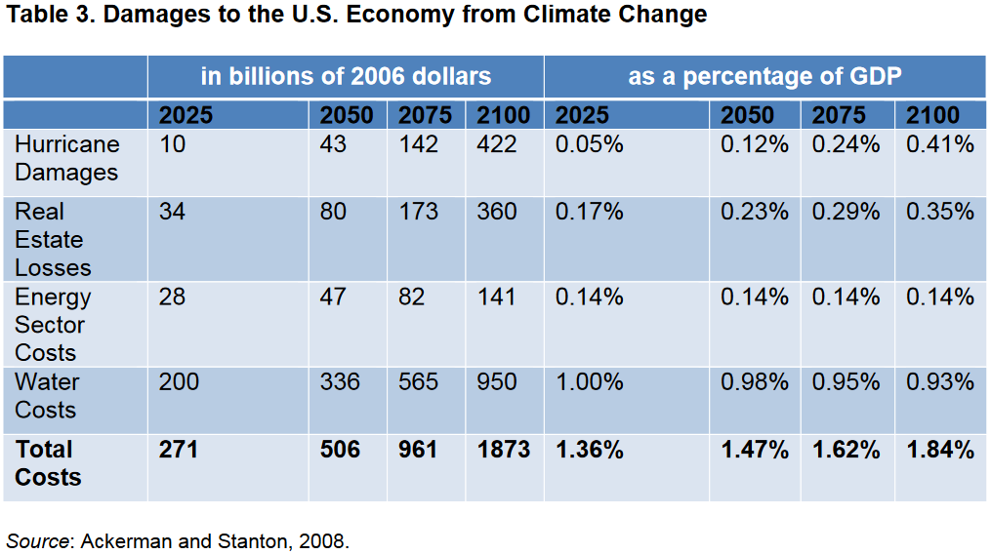
- What trends do you see in Table 3? What is interesting about Table 3?

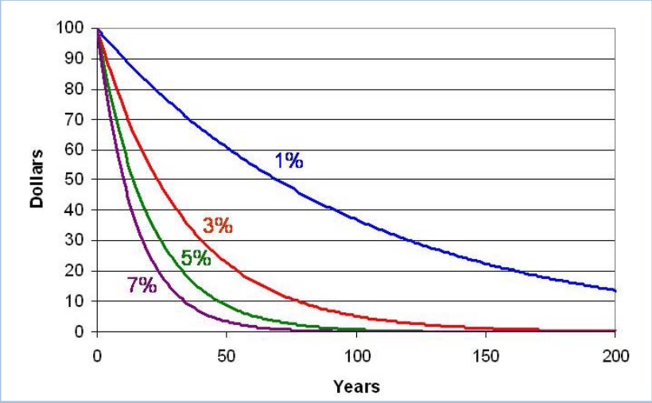
- What does Figure 9 show about present value of future costs or benefits 50, 100 or 150 years from now at different discount rates?

- Why would Figure 9 be important when we are using the information from Table 3?

Table 4. Regional-scale impacts of climate change by 2080
(millions of people)
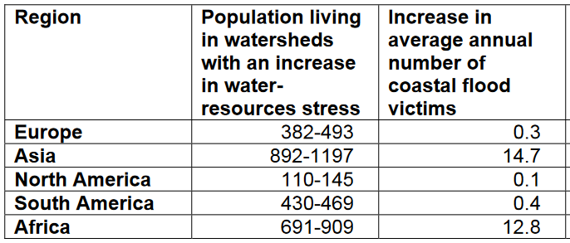
- What does Table 4 show about the impacts of climate change in 2080 if we do nothing to change current trends?

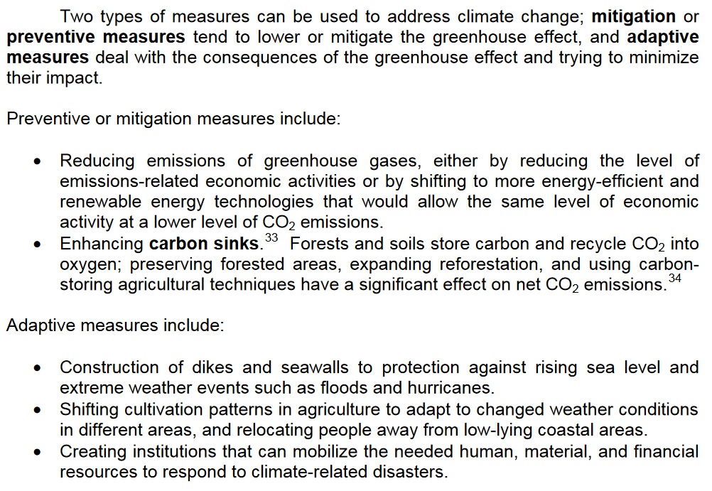
- Who in the economy might like a preventive approach to climate change and who would prefer an adaptive approach?

- What are some difficulties in using cost-benefit comparisons to determine the appropriate response to global climate change?

