Weathering
Physical Weathering – Frost Wedging
Before you begin a discussion or lecture about physical weathering, post a photo on the screen or put one on a sheet of paper and give it to the students. Here is an example for frost wedging:
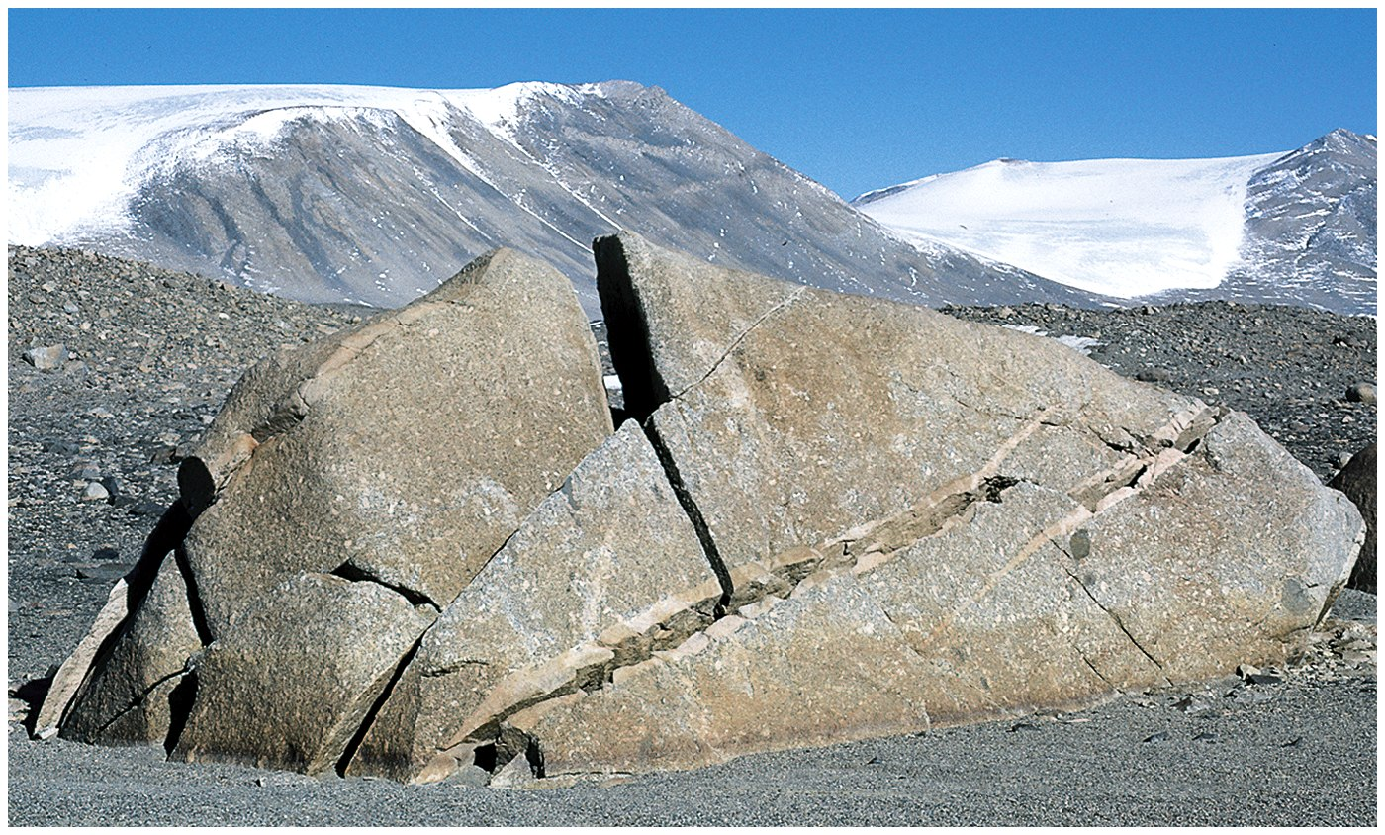
(http://teach.albion.edu/jjn10/files/2010/10/frost-wedging-example3.jpg)

Ask students to think to themselves and come up with ideas of why the rock is cracked. What happened to make it that way. In order to make sure all students participate, ask them to write down their answer and turn it in when they are done. It will give you a chance to read their answers so you know where they are coming from as you begin talking about physical weathering. You may also ask them about the climate, the rock type, or anything else you think relevant. It gives you and the students a chance to see what they have learned.

How Frost Wedging Brings Down Mountains
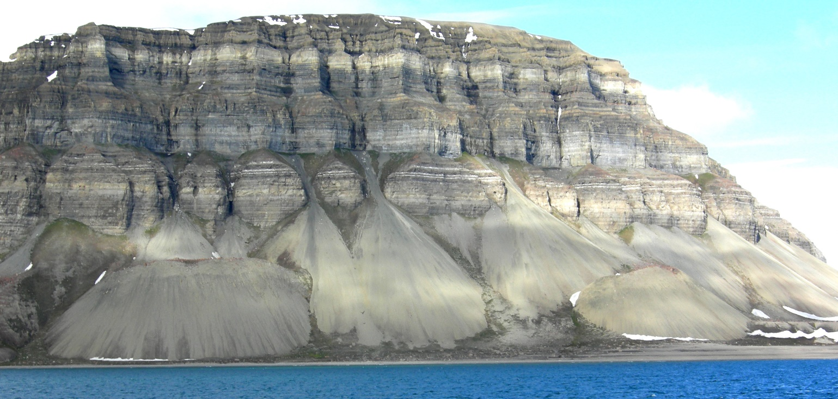
(https://upload.wikimedia.org/wikipedia/commons/d/d5/TalusConesIsfjorden.jpg)

With this image, you can ask them to sketch and describe what they see. During the discussion, get them to notice the fractures, the talus slopes, even the rock type. Focus them in on the way the piles are collecting under fractures to illustrate the fact that fractures often determine where weathering occurs.

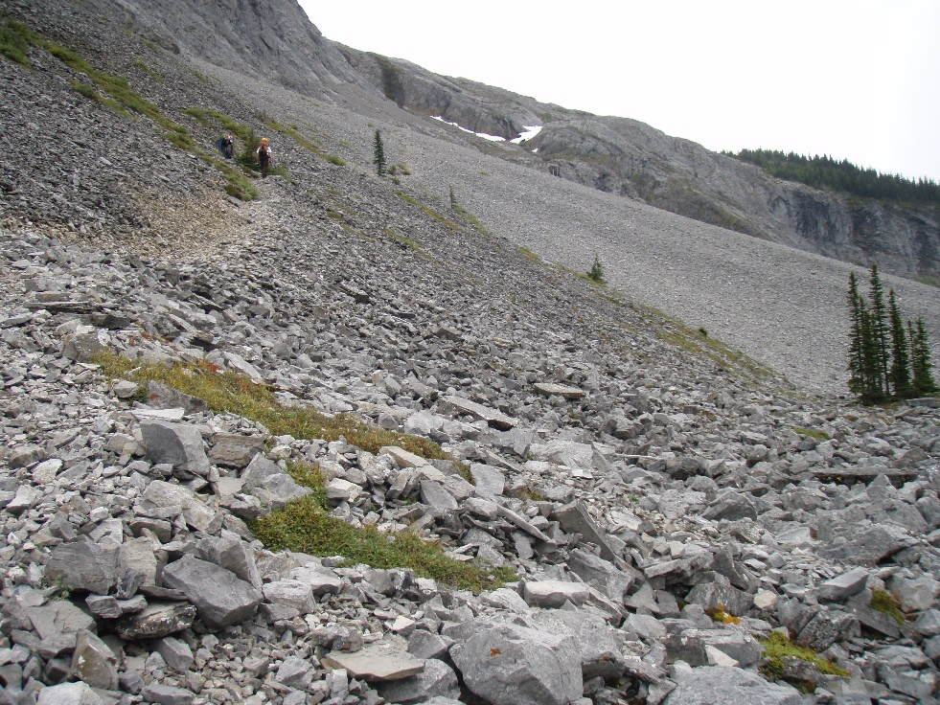
(http://pics.obtuse.com/aster08/P9060050.JPG)
Zoom in on a talus slope so that the students can see the size of the rocks and that they are very angular. Get them to relate the angularity to distance from source area and mode of transportation.

Physical Weathering – Pressure Release
Show the following exfoliation domes (or others as you see fit) and ask the students to make a quick sketch and description of each. Give them about 2 minutes for each photo. You may wish to guide them to look only at the rock. They may work together to come up with observations.

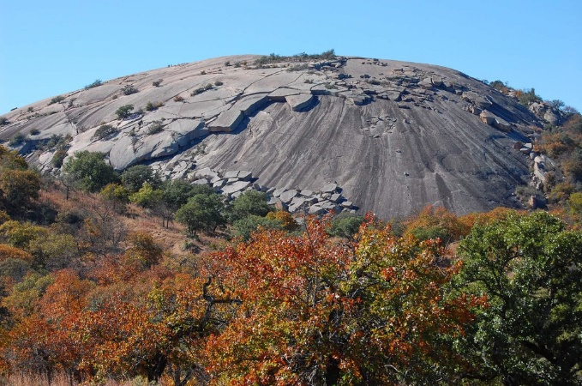
Enchanted Rock, TX Half Dome
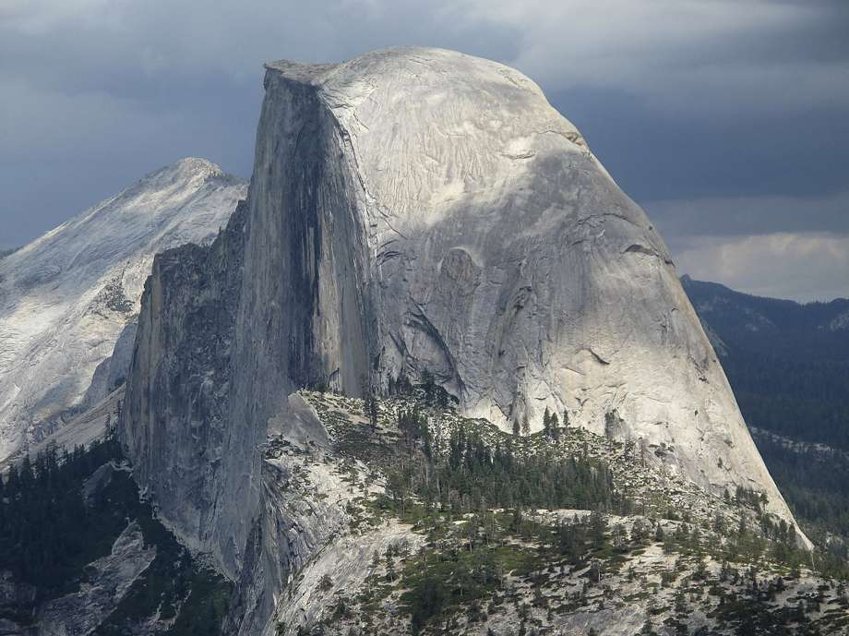

(https://www.summitpost.org/broken-slabs/681373/c-151788) (https://s.hdnux.com/photos/73/40/05/15597904/5/920x920.jpg)

Stone Mountain, GA
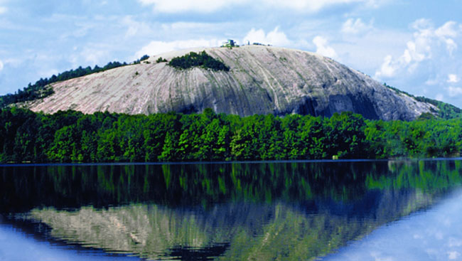
https://cdnblog.rentcafe.com/blog/wp-content/uploads/2011/10/Stone-Mountain.jpg

Stone Mountain, NC
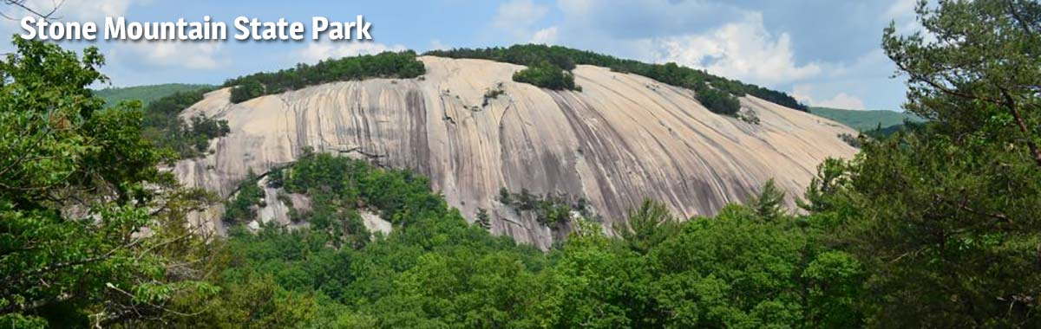
https://files.nc.gov/ncparks/park-images/stmo-view-of_0.jpg
Once they have sketched and described the domes, ask them what they noticed that each has in common. Then, go back to the Enchanted Rock image. Ask them what they see that is different from the other locations. Hopefully, they will notice the slabs of sheet jointed rock on the top. Get them to describe the appearance of that broken rock. Hopefully, they will say it is a layer or a cap or something like that. If not, guide them to see it that way.

Next show this image:
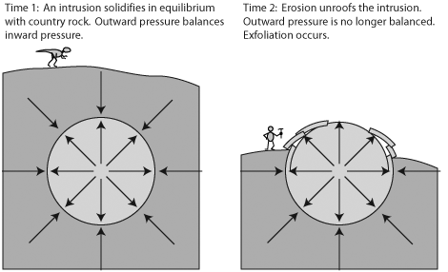
https://planetgeogblog.files.wordpress.com/2014/09/exfoliation.gif?w=656

Focus them on the fact that the rock is originally deep. Ask them to identify the type of stress if you have done metamorphic rocks already. Discuss how the rock will expand and fracture. Go back to the Enchanted Rock image and see if they can see the exfoliation sheets.

Dissolution Weathering:
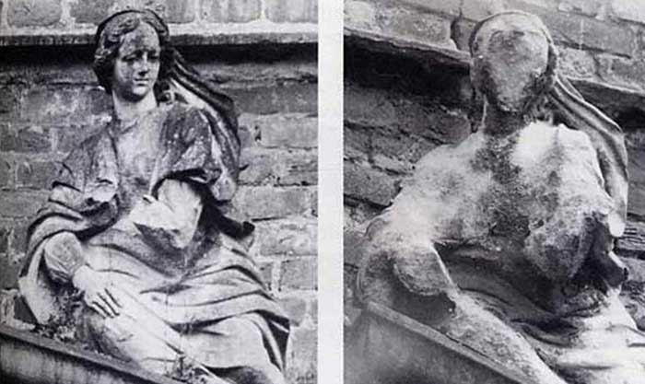
https://www.zenithcrusher.com.ph/d/file/news/2016-07-11/7f72f3821c00d55fff010d158c68fcdb.jpg
This image is taken of a figure over the portal of a castle in Westphalia, Germany. The left photo was taken in 1908 and the right photo was taken in 1968. The castle was built in 1702 (Photos courtesy of herr Schmidt-Thomsen)

Ask the students to describe the difference they see in the two images. Ask them what happened and why the statue didn’t change much in nearly 200 years and then greatly in 60 years.

The castle is located in the heavily industrialized Ruhr region of Germany.

