Lone Star College – Tomball
Physical Geology – GEOL 1403
Exploration of Faults and Folds

For this activity, you will need three tubs of Play Doh, a plastic knife, and a length of dental floss (approx. 24 inches long).

At plate boundaries, rocks are put under significant stress. Stressed rocks will first behave elastically and then they will deform in either a brittle or a ductile manner, In this lab, you will explore faults and folds

FAULTS
There are two kinds of faults
- Dip Slip – slip along the dip of the fault, either up or down as illustrated below

- Strike Slip – slip along the strike of the fault to either the right or the left as shown below.

With your Play Doh, roll out the three colors to no less than a half-inch thick each. Stack the three colors. Then, cut through the layers from top to bottom at an angle. After that, hold the two halves next to each other and try to create normal and reverse faults by pulling the two apart (tension) or pushing them together (compression) sliding along the fault. Determine which fault, normal or thrust, is the result of tension and which is the result of compression. Sketch your results below. Include arrow indicating tension and compression

Normal Fault:

Thrust Fault:

FOLDS
There are two geometries of folds, anticlines where the limbs of the folds are folded down so that the fold resembles the letter A and synclines where the limbs of the fold are folded up so that the fold resembles the letter U. These folds are formed through compression and are illustrated below:
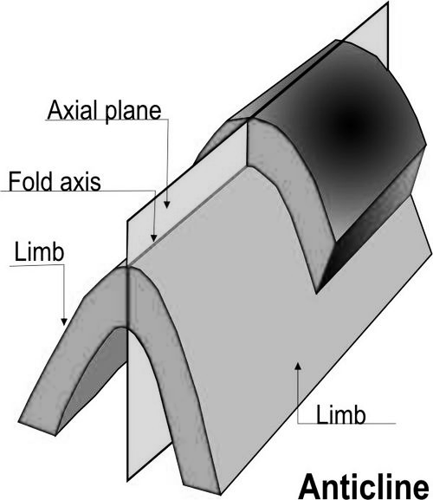
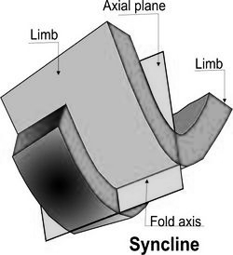

(Hinge line)

(Hinge line)

Anticline
Once again, roll out the three colors of Play Doh and stack them one on top of the other. Write the order of colors in the figure below:

Using the Law of Superposition, number the colors from oldest (1) to youngest (3)

Now, create an anticline. Sketch your anticline in the box below labeling the colors and numbering them from oldest (1) to youngest (3).

Note, where are the youngest beds, in the inside of the fold or the outside of the fold? _____________ Where are the oldest beds? _________________
Next, we will simulate erosion of that anticline. Take the dental floss and wrap it around the outside of the anticline, crisscross the ends of the dental floss and pull. This action will cut the top off the anticline as though it had been eroded deeply, exposing the interior of the anticline. The top of the anticline should now have stripes of color visible.

- Sketch the order of colors on the top of your “eroded” anticline in the box below.
- On that sketch, label the beds as you did before oldest (1) and youngest (3).

Eroded anticline (map view)

Add the following to your “map”
- Hinge line (fold axis)
- Strike and dip symbols on each layer
- Number the layers from oldest (1) to youngest (3)

Syncline
Follow the same procedure but this time make a syncline. First, indicate the order of colors and the ages (oldest [1] to youngest [3]) using the Law of Superposition.

Fold the limbs up to make the syncline and sketch your model in the box below labeling the colors and numbering them from oldest (1) to youngest (3).

Note, where are the youngest beds, in the inside of the fold or the outside of the fold? _____________ Where are the oldest beds? _________________

Next, we will simulate erosion of that syncline. Take the dental floss and wrap it around the outside of the syncline, crisscross the ends of the dental floss and pull. This action will cut the top off the syncline as though it had been eroded deeply, exposing the interior of the syncline. The top of the syncline should now have stripes of color visible.

- Sketch the order of colors on the top of your “eroded” syncline in the box below.
- On that sketch, label the beds as you did before oldest (1) and youngest (3).

Eroded Syncline (map view)

Add the following to your “map”

- Hinge line (fold axis)
- Strike and dip symbols on each layer
- Number the layers from oldest (1) to youngest (3)

Questions:
- Is it possible to identify an anticline or a syncline from the age pattern alone? ______________
If so, how? If not, why?

- Is it possible to identify an anticline or a syncline form the strike and dip symbols alone? ______
If so, how? If not, why?

Now for a puzzle. Your instructor will make a sketch on the board of some tilted layers. Reproduce that sketch in the box below.

- Label the hinge line on the sketch
- Identify the folds on the sketch
- Indicate their ages using numbers with 1 being the oldest.

Now, project those folds into the subsurface. Sketch the folds, as they would look from the side, in the box below. Remember that this is an eroded surface so some of the fold will be missing.
On your cross-section, label the layers from oldest to youngest with 1 being the oldest.

Note that when folds are in series, they will share a limb between them. In the drawing below, the syncline shares each of its limbs with an adjacent anticline. In nature, it is common for anticlines and synclines to be in series.

