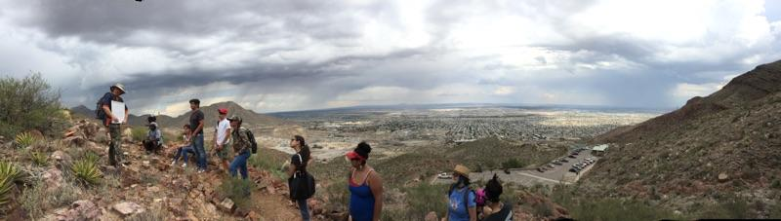

**Research Experience for Community College Students!**

**Program Overview:**

* **4 week research experience in El Paso followed by continued data analysis at home institution in July**
* **Research involves field and/or laboratory setting**
* **One-on-one mentoring by faculty and undergraduate mentors**
* **Opportunities for virtual and face-to-face research presentations**

**Award includes:**

* **$4500 stipend for 9 weeks**
* **Housing in shared apartments**
* **Travel reimbursement up to $600**

**Requirements:**

* **U.S. citizen or permanent resident**
* **2.5 minimum GPA**
* **Full-time student in spring 2018**
* **Completion of 2 introductory geology courses**
* **Expected graduation date (associate’s degree) beyond June 2018**

**UTEP-ROCCS**

**RESEARCH EXPERIENCE FOR COMMUNITY COLLEGE STUDENTS IN GEOLOGICAL SCIENCES**

**Summer 2018**

**(June 4-29 in El Paso)**

**(June 30-Aug. 4 at home institution)**

**Application deadline:**

**January 31, 2018**

**For more information visit:**

[**http://science.utep.edu/utep-roccs**](http://science.utep.edu/utep-roccs)

**or contact us at:**

[**utep-roccs@utep.edu**](mailto:utep-roccs@utep.edu)

**This program is funded by the**



**National Science Foundation**