Question 1 1 pts
R is a(n) _______________-based programming system.

- Image
- Object
- Science

Question 2 1 pts
What is the assignment operator? For example, used to assign a vector.
- <-
- ?
- ~

Question 3 1 pts
In an R script, what symbol placed before characters or text makes it a note to yourself rather than code that will be run?
- &
- c()
- #

Question 1 1 pts
Which set of commands created this plot? 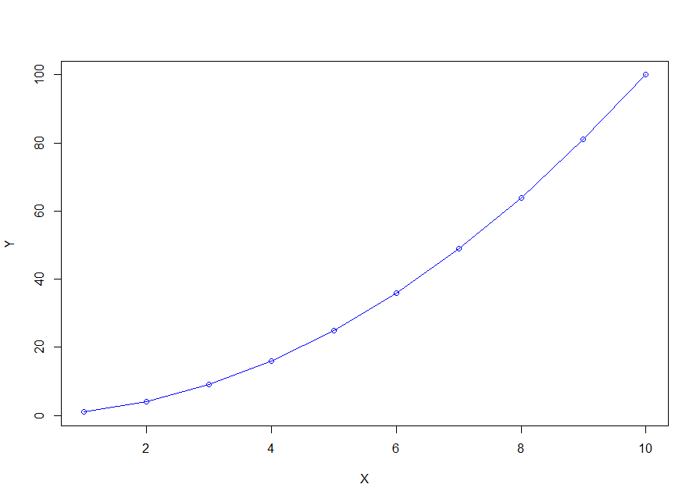
- X=1:10
Y=X
plot(X, Y, type = "o", col = "blue")

- X=1:10
Y=X^2
plot(X, Y, type = "o", col = "blue")

- X=1:10
Y=X^2
plot(Y, X, type = "o", col = "blue")

Question 1 1 pts
What kind of circulation is shown in the figure?
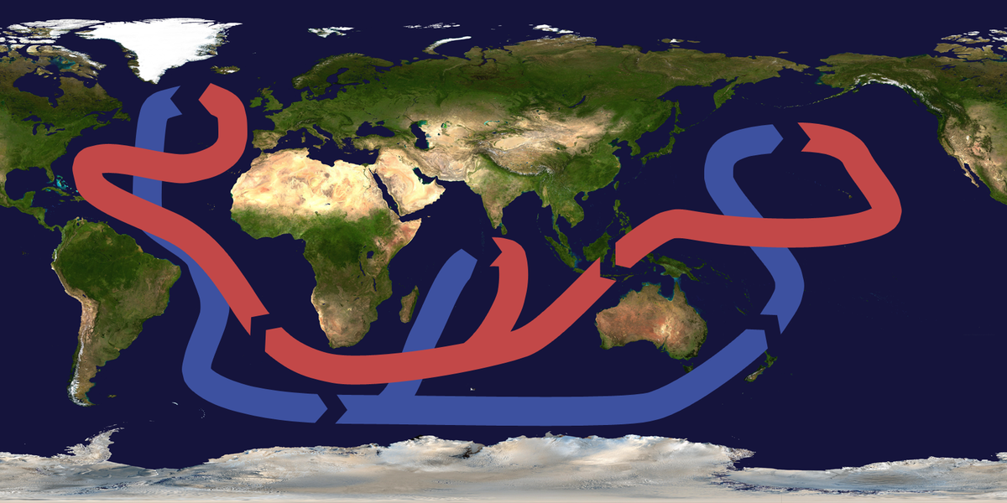
(https://upload.wikimedia.org/wikipedia/commons/b/b0/Thermohaline_circulation.png;
Brisbane [CC BY-SA 3.0 (http://creativecommons.org/licenses/by-sa/3.0/)])

- Ekman Circulation
- Thermohaline Circulation
- Tidal Circulation
- Atmospheric Circulation

Question 2 1 pts
What kind of chemical bonding is being shown?
- Hydrogen Bonding
- Oxygen Bonding
- Covalent Bonding
- Ionic Bonding

Question 1 1 pts
Inspect the Table.
Is the Antarctic described by Column A or Column B?

Feature | A | B
Shelf | Broad with two narrow openings | Narrow and open to all oceans
River Input | Several | None
Nutrients in Photic Zone | Seasonally depleted | High year-round
Icebergs | Small, irregular, not in basin | Abundant, large, tabular
Pack ice (sea ice) averages
Maximum Area | 15 * 10^6 km2 | 18 * 10^6 km2
Minimum Area | 7 * 10^6 km2 | 3 * 10^6 km2
Age | Mostly multiyear | Mostly 1 year
Thickness | 3.5 m | 1.5 m
Trend in Total Amount (1979 – 2008) | 4.1% decrease/decade | 0.9% increase/decade
Snow thickness (over ice) | Relatively thin | Relatively thick

- A
- B

Question 1 1 pts
What does this graph show?

(https://nsidc.org/arcticseaicenews/charctic-interactive-sea-ice-graph/;
Credit: National Snow and Ice Data Center)

- On average, the areal extent of Arctic Sea Ice is lower in June, than in September.
- On average, the areal extent of Arctic Sea Ice is lower in September than in June due to climate change.
- The areal extent of Arctic Sea-Ice was lower in 2012, than the average areal extent of Arctic Sea Ice.
- There is no difference between the average climatological areal extent of Arctic Sea Ice and the areal extent of Arctic Sea Ice in 2007.
Question 1 1 pts
Refer to the diagram. What do Antarctic krill eat?

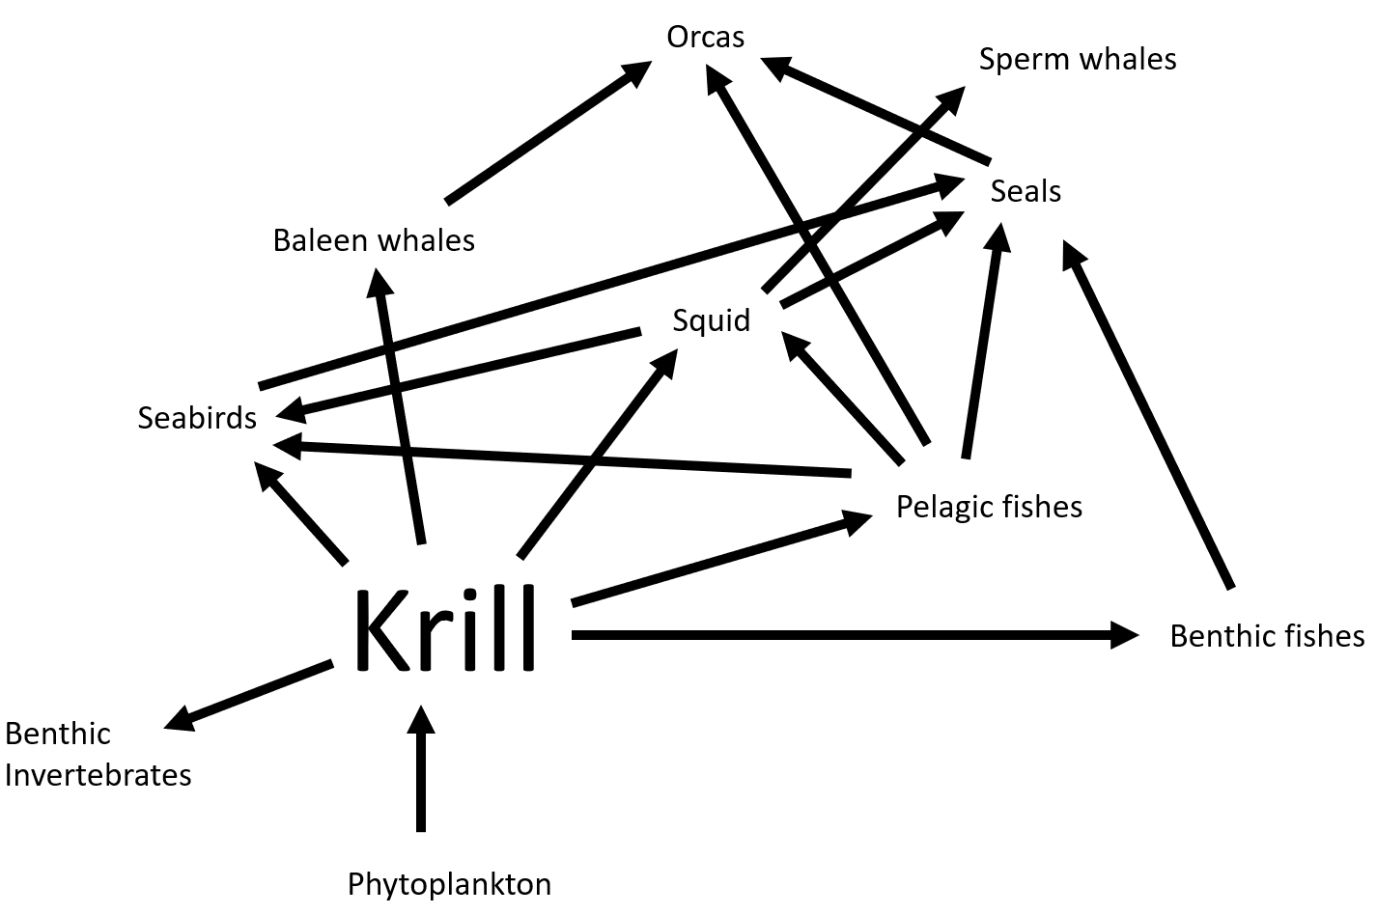
- Seabirds
- Phytoplankton
- Benthic Invertebrates
- All of these

Question 1 1 pts
Which penguin species is declining in the West Antarctic Peninsula?

- Adélie Penguin
- Chinstrap Penguin
- Cape Penguin
- Gentoo Penguin

Question 1 1 pts
The phytoplankton in the image are:
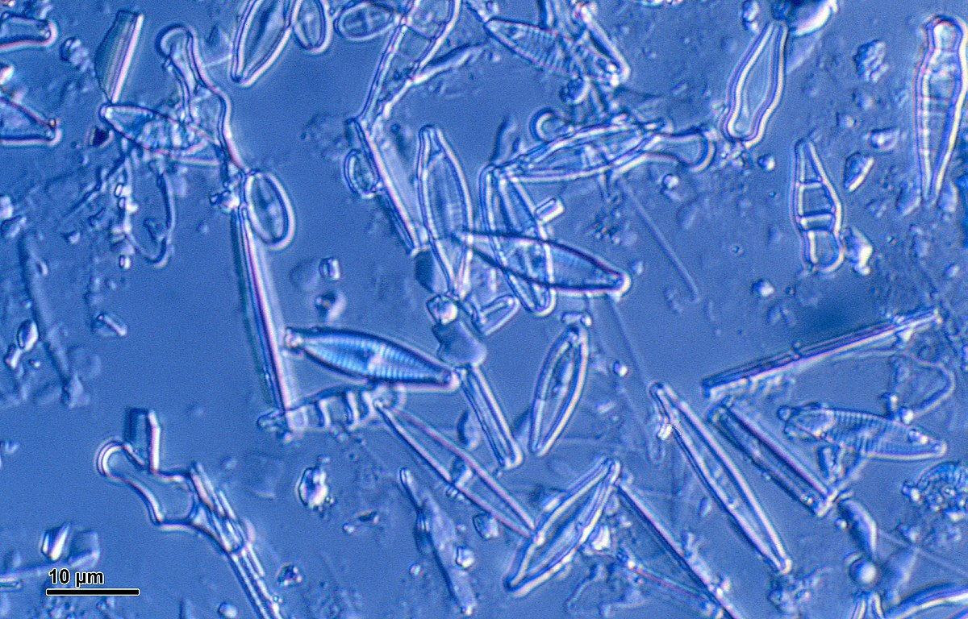
(https://upload.wikimedia.org/wikipedia/commons/c/c1/Diatoms_%28248_05%29_Various_diatoms.jpg; Doc. RNDr. Josef Reischig, CSc. [CC BY-SA 3.0 (https://creativecommons.org/licenses/by-sa/3.0)])

- Diatoms
- Dinoflagellates
- Coccolithophores
- Zooplankton

Question 2 1 pts
Why is highest population size of a predator often lagged behind that of the prey?

- Prey swim away from the predator.
- It takes time for the predator population to respond to the increased food availability.
- Predators only like to eat declining prey populations.
- Prey are more nutritious when their populations are declining.

Question 1 3 pts
What aspects of a bird's behavior does the bill give information into?

- Mating
- Food Source
- Predator Avoidance
- Volume of noises they make

Question 1 2 pts
Which polar region has phylogenetically older groups and more endemic species?
- Antarctic
- Arctic

Question 2 2 pts
What is the brown material in this ice?
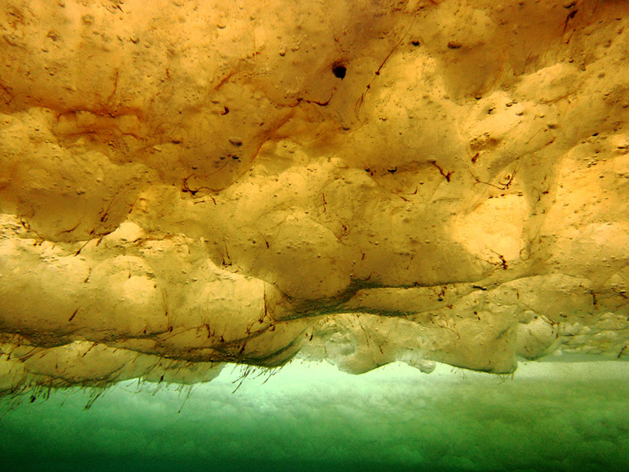
(https://upload.wikimedia.org/wikipedia/commons/0/0a/Thurber_algae.jpg; Andrew Thurber [CC BY-SA 4.0 (https://creativecommons.org/licenses/by-sa/4.0)])

- Sediment
- Phytoplankton
- Ice algae

Question 1 1 pts
Pollution is any material discharged into waters that has measurable adverse effect on natural systems and can be:

- A point source
- A nonpoint source
- Both point and nonpoint source
- None of the above

Question 1 1 pts
True or False: The Murphy article in Nunatsiaq Online paper suggests that eating ringed seal liver is unhealthy for Inuit women.
- True
- False

Question 1 2 pts
An example of "fishing down the food web" is:
- Krill harvesting in Antarctica
- Salmon harvesting in British Columbia
- Oyster aquaculture in New Zealand

Question 1 2 pts
The common body characteristics of marine mammals include:
- Viviparity
- Body Hair
- Mammary Glands
- Large Teeth
- Echolocation
- All the above
- None of the above
- Viviparity, Body Hair, Mammary Glands

