Instructions:
This assessment will be taken today, and again at the end of the course. It is NOT part of your course grade. It is for instructors to assess the effectiveness of teaching pedagogies in marine science courses. Please answer each question to the best of your abilities.

Student Name/Number: __________________________

1. Solar energy is not actually reduced as the sun moves away from the equator, but the area over which the sun shines at the equator:
A) is much larger than the area over which it shines at the poles.
B) is much denser than the area over which it shines at the poles.
C) is much less predictable than the area over which it shines at the poles.
D) is much smaller than the area over which it shines at the poles.

2. The main source of water vapor in the air is from:
A) snow melting.
B) water evaporating from the sea.
C) water evaporating from large lakes.
D) sea ice melting.

3. Which of the following describes a gyre that rotates in a clockwise direction in the Northern Hemisphere?
A) Cyclonic
B) Anticyclonic
C) Easterly
D) Westerly

4. Which of the following statements about water is not true?
A) Water is the solvent of life.
B) Most of the water on earth is in a liquid form.
C) Most of the water on earth is in a solid form.
D) Water is a polar molecule.

5. Which of the following statements best describes the function of greenhouse gases?
A) They trap cool air near the surface of the Earth to maintain cooler temperatures.
B) They trap poisonous gases in the upper atmosphere.
C) They trap heat near the Earth’s surface to maintain temperatures above freezing.
D) None of these is correct.

6. What happens to seawater as density increases?
A) It sinks.
B) It floats.
C) It freezes.
D) It evaporates.

7. Which of the following best defines the term phytoplankton?
A) Drifting prokaryotes
B) Drifting animals
C) Drifting autotrophs
D) Benthic macroalgae

8. Which of the following statements is not true concerning zooplankton?
A) Zooplankton are non-photosynthetic.
B) Zooplankton drift with the currents.
C) Zooplankton have no swimming capabilities whatsoever.
D) Zooplankton are larger than the majority of phytoplankton.

9. The majority of marine primary productivity is accomplished by:
A) macroalgae.
B) phytoplankton.
C) mangals.
D) anthophytes.

10. A substance that can serve as a check on population growth is called:
A) photoinhibition.
B) the critical depth.
C) a limiting factor.
D) the compensation depth.

11. Which of the following type of estuary has restricted water circulation with the open ocean?
A) Fjord
B) Salt-wedge estuary
C) Vertically mixed estuary
D) Slightly stratified estuary

12. Which of the following is an example of a complete endotherm?
A) Marine bird
B) Whale shark
C) Tuna
D) Sea anemone

13. Sources of pollutants in the ocean include all of the following except:
A) erosion.
B) pesticides.
C) paints.
D) oil spills.
14. The largest living penguins are the:
A) chinstrap penguins.
B) adelie penguins.
C) emperor penguins.
D) tufted penguins.

15. Which of the following is not an important feature of penguins?
A) They inhabit the Northern Hemisphere.
B) They have lost the ability to fly.
C) They are fast swimmers.
D) They are clumsy on land.

16. Why must polar bear and pinniped pups be born on land?
A) They cannot swim upon birth.
B) They are too small to float.
C) Their parents abandon them immediately.
D) Their food source is on land.

17. Which of the following is the most numerous and widespread group of holoplankton species?
A) Jellyfishes
B) Siphonophores
C) Larvaceans
D) Crustaceans

18. Which of the following groups of animals is not known to occur in the Arctic?
A) Penguins
B) Baleen whales
C) Mussels
D) Phylogenetically young fish families

19. Which of the following best describes sea ice algae?
A) Algae that lives just below the sea ice
B) Algae that blooms when the sea ice melts
C) Dinoflagellates that make the ice glow at night
D) Algae living embedded in the sea ice

20. Which of the following is a unifying feature for all marine mammals that are truly residents of polar seas?
A) They are ice breeders.
B) They do not rely on the ice for survival, but occasionally use the ice for feeding or breeding.
C) They are long distance migrators.
D) They rely on krill.

21. Which of the following statements describes a major difference between the Arctic and Antarctic?
A) The Antarctic is a frozen ocean surrounded by continents.
B) The Arctic has no seawater below it to warm the nearby land.
C) The average air temperature in the Antarctic is much lower than in the Arctic.
D) Only the Arctic has seasonal phytoplankton blooms.

22. Which of the following is not true about phytoplankton blooms in polar seas?
A) They occur year round in both the Arctic and Antarctic.
B) They are often prompted by sea ice that is released from melting ice.
C) They are in decline in the Arctic.
D) They are limited by light.

23. Which of the following is not true concerning pack ice in the Arctic and Antarctic?
A) The maximum area is higher in the Antarctic.
B) It is usually multiyear in the Antarctic.
C) It is thicker in the Arctic.
D) Snow thickness is high in the Antarctic.

24. Which of the following is false concerning climate change?
A) It is a recent phenomenon, just discovered in the year 2000.
B) Man is contributing to this phenomenon.
C) It may occur naturally to some level.
D) It has been observed and measured by scientists.

25. Which of the following is a primary reason to argue for the need to increase the amount of seafood that is available for human consumption?
A) The human population has increased drastically.
B) Other protein sources like chicken and beef are in low supply.
C) Developed nations are lacking protein sources.
D) Fish populations are exploding and must be kept in check.

26. The plot below depicts phytoplankton and zooplankton cycles in tropical, temperate, and polar regions. What regions correspond to each color: brown, green, blue?
A) polar, temperate, tropical
B) tropical, temperate, polar
C) temperate, polar, tropical
D) temperate, tropical, polar

27. The image below depicts global patterns of krill distribution. According to this graphic, Euphausia diomedeae is found in the _____________ region?
A) polar
B) subpolar
C) temperate
D) tropical

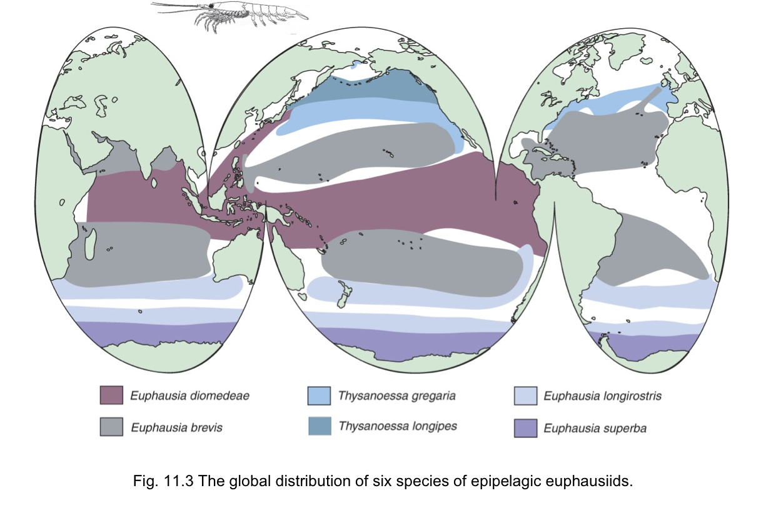
(http://webhost.lclark.edu/clifton//marbio/lectures/Lecture%2019.htm)

