Module 3: Human Dimensions in the Poles

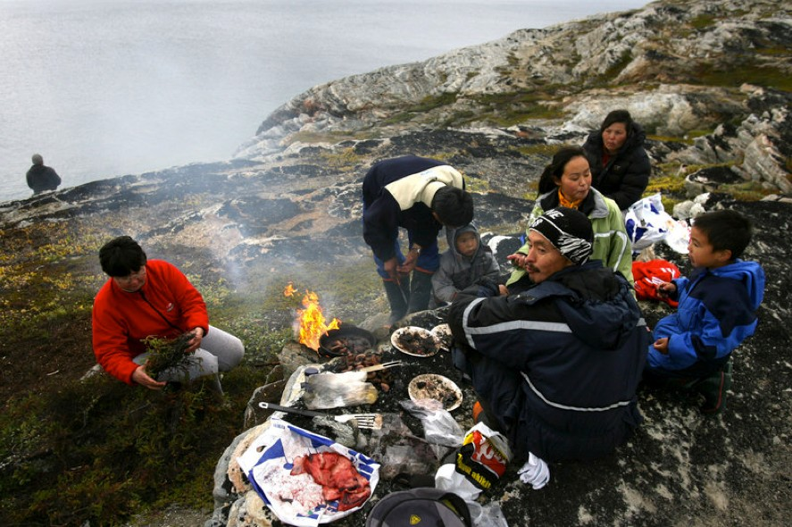Arctic ecosystems are highly productive, and support diverse marine mammal taxa. Inuit people inhabit the high Arctic of North America, Greenland, and Siberia. With little arable land, Inuit peoples have a diet centered on the hunting of these mammals. Marine mammals in the arctic are long-lived, and therefore can accumulate or magnify dilute contaminants over their lifespan. As heavy metals from industrialized nations are transported by winds and rivers to Arctic regions, they are taken up by phytoplankton, passed through the food web and to marine mammals. These metals are then consumed by expecting mothers, bringing harm to the unborn child. The Canadian government has recommended levels of heavy metal consumption that are exceeded by the Inuit

Fig: Arne Lange, a 39-year-old Inuit fisherman, and his family barbecue seal meat on an island near the village of Ilimanaq, Greenland in 2007. From:(http://www.npr.org/sections/thesalt/2015
/09/17/441169188/the-secret-to-the-inuit-high- fat-diet-may-be-good-genes)
diet. Changing these diets risks abandoning culturally important food sources.

With the projected loss of Arctic sea ice, the interaction between the Inuit and the marine mammals they hunt could change. They may need to rely more on land mammals than marine mammals. Additionally, the loss of sea ice and reorganization of marine food webs could change contaminant concentration in the food sources they currently consume. These challenges were raised in an article published by Nunatsiaq Online, Nunavut's territorial newspaper in
the Nunavut and Nunavik regions of the eastern Canadian Arctic.

Information Sources and Data
- Morrissey et al. Intro to the Biology of Marine Life (Chapters 5.2, 8.3, 8.4, 9.5, 15)
- Murphy, D. “High mercury levels prompt health advisory in Nunavut” Nuntatsiaq Online, June 29, 2012 (http://www.nunatsiaqonline.ca/stories/article/65674high_mercury_levels_prompt_health
_advisory_in_nunavut/)
- Data: Chan et al., 1995. Assessment of Dietary Exposure to Trace Metals in Baffin Inuit Food, Environmental Health Perspectives, 103 (7-8) pp 740-746. (https://www.ncbi.nlm.nih.gov/pmc/articles/PMC1522199/pdf/envhper00356-0109.pdf)

Questions to consider

- Is Ringed Seal liver packed with mercury?

- Does almost half the mercury in women of child-bearing age come from eating ringed seal liver?

- Does cutting out ringed seal liver dramatically lower the risk of mercury intake according to the PTWI?

- Is Ringed Seal meat a healthy alternative for women? If not, what would you recommend?

- What about the diets of men and children, what would you do to get them below the PTWI for mercury?

- Does mercury accumulate in marine mammals?

- Does less sea ice cover lead to increased mercury in seals and Polar Bears?

- Can you find another media claim to which your analysis would be informative?

