Module 1: Sea Ice as indicator of climate change

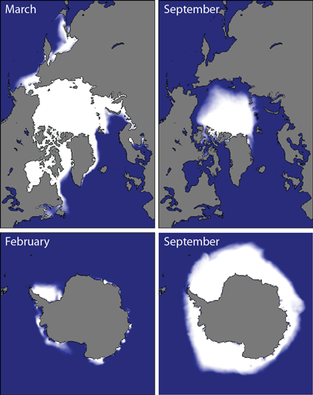
While the Arctic and Antarctic share many attributes as polar systems, they have several fundamental differences in their particular climate and oceanography which cascade into differences in the seasonal cycles of ice. An obvious difference is in the timing of maxima and minima in ice cover, as depicted in the figure to the right. Perhaps less obvious is the amount of sea ice that remains in each region year after year (that is, multiyear ice); while sea ice extent is larger in the Antarctic, there is more multiyear ice in the Arctic.

Superimposed on these cycles are effects of global climate change. As a result, considerable scientific and media attention has been paid to ice cover in polar regions and how it has changed over the past half century. One of the conundrums resulting from this is how to interpret long term changes in sea ice extent in Arctic and Antarctic polar regions, because these trends appear to differ with Arctic sea ice decreasing and Antarctic sea ice increasing, despite a warming planet. This was raised in an article published a few years ago in The Guardian. How do we reconcile this, and decide whether sea ice is a good parameter to be using for assessing global change in the first place? Does more recent data provide any additional insight?
Sea ice climatologies: Arctic and Antarctic sea ice concentration climatology from 1981-2010, at the approximate seasonal maximum and minimum levels based on passive microwave satellite data. Image provided by National Snow and Ice Data Center, University of Colorado, Boulder. http://nsidc.org/cryosphere/sotc/sea_ice.html

Information Sources and Data
- Morrissey et al. Intro to the Biology of Marine Life (Ch. 2, Ch. 14.0 and 14.1)
- Mathiesen, K. “Why is Antarctic sea ice at record levels despite global warming?” The Guardian, October 9, 2014.
- NOAA/NSIDC; Sea Ice Concentration and Sea Ice Index
  - Meier, W., F. Fetterer, M. Savoie, S. Mallory, R. Duerr, and J. Stroeve. 2013, updated 2015. NOAA/NSIDC Climate Data Record of Passive Microwave Sea Ice Concentration, Version 2. Boulder, Colorado USA. NSIDC: National Snow and Ice Data Center. doi: http://dx.doi.org/10.7265/N55M63M1.
  - Fetterer, F., K. Knowles, W. Meier, and M. Savoie. 2002, updated daily. Sea Ice Index, Version 1. Boulder, Colorado USA. NSIDC: National Snow and Ice Data Center. doi: http://dx.doi.org/10.7265/N5QJ7F7W.

Questions to consider

- Was Mathiesen’s claim supported by the data in 2014?

- Does the claim need to change given the additional data available since then?

- Does the claim depend on what month is analyzed?

- Are the trends (rates) constant for the Arctic and Antarctic? Is one greater than the other?

- What emerges from considering global sea ice extent? Does this approach make sense?

- Does sea ice data alone provide enough evidence for a warming planet? Justify your response using your analysis of the data.

- Can you find another media claim to which your analysis would be informative?

