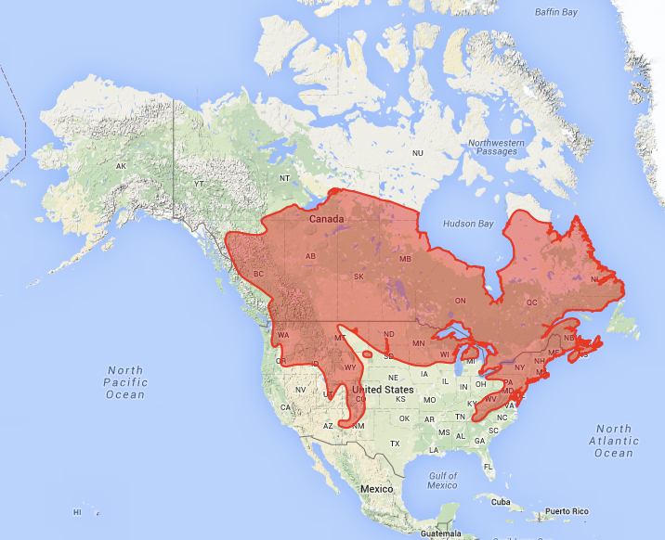
Red Back Vole, Myodes gapperi (Vigors, 1830)
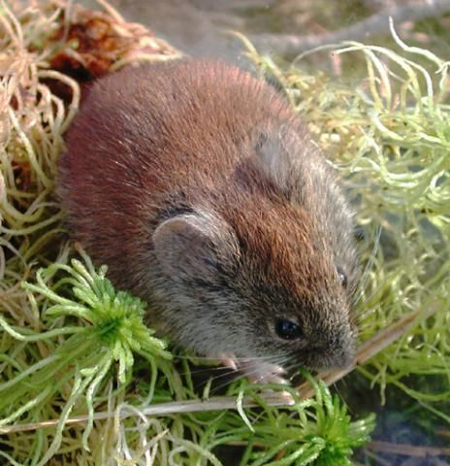
Modern distribution of M. gapperi (from Neotoma database)

Red Back Vole (Photo by Phil Myers, Museum of Zoology,
University of Michigan on Animal Diversity Web)

Rodentia (Rodents)
Family: Cricetidae (Lemmings and Voles)
Body Size: Length Range, 146-222 mm, including 30-50 mm tail (5.75-8.75 in); Weight Range, 6-42 g (0.013-0.093 lbs).

Physical Description: As suggested by its name, the pelt of this vole’s back (dorsal surface) is brownish-red from forehead to rump. The eyes are large and the ears easily visible.

Distribution: The modern range of the Red Back Vole stretches from Newfoundland Canada to the Chesapeake Bay in the east, southwest down the Appalachia Mountains to the Smoky Mountains of northern Georgia, north to the Great Lakes area and north-central Montana, down the Rocky Mountains as far as south-central Arizona and New Mexico, west to the Cascade Mountains, and east from north-central British Columbia to Hudson Bay.

Habitat: The Red Back Vole is a characteristic resident of the boreal forest biome, occupying mesic and exeric cool, mossy, and rocky areas of the boreal forest. It prefers coniferous forests, but may also occupy the tundra, bogs, and mixed deciduous/coniferous forests. In much of the Canadian boreal forest, this vole may be found in muskegs, spruce and fir bogs, sedge marshes, levees with abundant willows, wet prairies, and tundra. In the southern parts of its range, this vole is restricted to alpine settings with stands of ponderosa pine, hemlock, red and white spruce, mesic meadows, sedge and grass areas, and rocky slopes. In the upper Midwest, it is found in a variety of mixed deciduous-coniferous forests, usually with a heavy brush understory. In all areas it requires an abundant litter of rotting trees, stumps, branches, leaves, etc.

Diet: Red Back Voles are omnivorous dietary generalists, switching foods according to abundance and availability. Plant foods include berries, mosses, lichens, ferns, seeds, nuts, roots, bark, and fungi. Insects may be eaten regularly, but form only a small part of their overall diet. This vole has particularly high water requirements, a significant factor in habitat selection.

Behavior: Red Back Voles, while more active at night (nocturnal), will be active at other times depending on the season and latitude. They tend to be more nocturnal in the winter and in more northern habitats. They are not social and do not form colonies. This vole is quite agile – they are good climbers and hoppers. They are known to be rather nervous and sensitive to disturbance. The timing and severity of the first freezes in the fall, severity of the mid-winter, and timing of the spring thaw may be critical to Red Back Vole populations. Early freezes before food can be cached, a harsh winter, and late thaw may combine to significantly increase mortality and reduce local populations. Major predators include a variety of Mustelids, particularly the Short-Tailed Weasel (Mustela erminae), and a variety of owls and hawks.

Paleoecological Implications: The Red Back Voles’ affinity for coniferous forests, abundant leaf litter, and high daily water requirements suggests that their presence in the fossil record is a good indicator for cool and wet coniferous or mixed coniferous/deciduous forests.

Web Resources:
http://animaldiversity.org/accounts/Myodes_gapperi/
http://zipcodezoo.com/index.php/Myodes_gapperi
http://explorer.natureserve.org/
http://www.biokids.umich.edu/critters/Myodes_gapperi/

References:
Merritt, J.F. 1981. Clethrionomys gapperi. Mammalian Species, 146: 1 - 9. American Society of Mammalogists.

