Module 3: Understanding Climate Patterns in North America
James S. Oliver III and Russell W. Graham

- Understanding the broad patterns of global climate helps in understanding more specific North American climate patterns. Understanding these climate patterns is necessary to understand the modern and past distributions of plants and animals in North America.

Weather and Climate: Weather is the atmospheric conditions (temperature, precipitation, humidity, atmospheric pressure, wind speed, etc.) that are experienced day to day and year to year. Climate is the average weather conditions over multiple years of time. Paleoclimate is the climate that occurred before written records were maintained.

For terrestrial organisms, especially vegetation, temperature, precipitation, and effective moisture are some of the most important climate limiting factors. Furthermore, seasonal extremes (hot summers, cold winters, etc.) are more important in controlling the distribution of terrestrial organisms than annual mean temperature or annual mean precipitation.

In North America, temperature gradients follow a latitudinal (N-S) pattern. For example, in Figure 1 temperature decreases towards the north. This is a direct function of the amount of solar radiation that reaches the surface of the Earth. In the western part of North America the correlation between temperature and latitude is not as direct as it is in the region east of the Rocky Mountains. The reason for this discrepancy is that temperature is also a function of elevation. The higher the elevation the lower the temperature.

Moisture generally shows a strong correlation with longitude (E-W) (Fig. 2). Again, this is complicated by elevation with drier conditions at the base of mountains and moister and cooler conditions at their peaks. However, the E-W trend of moisture is not disrupted as much by the Rocky Mountains as is the temperature gradient.

Temperature and moisture are interrelated through effective moisture:

Effective Moisture = Precipitation minus Evaporation

Hence, if two areas receive the same amount of precipitation but one area has a cooler climate, then effective moisture will be greater in the cooler climate because evaporation is less. Moist plants are controlled effective moisture rather than annual precipitation.

Maps showing climate conditions can be used with the modern distributions of organisms to get a general idea of the climate factors limiting the organism.

Temperature and Precipitation Gradients of North America

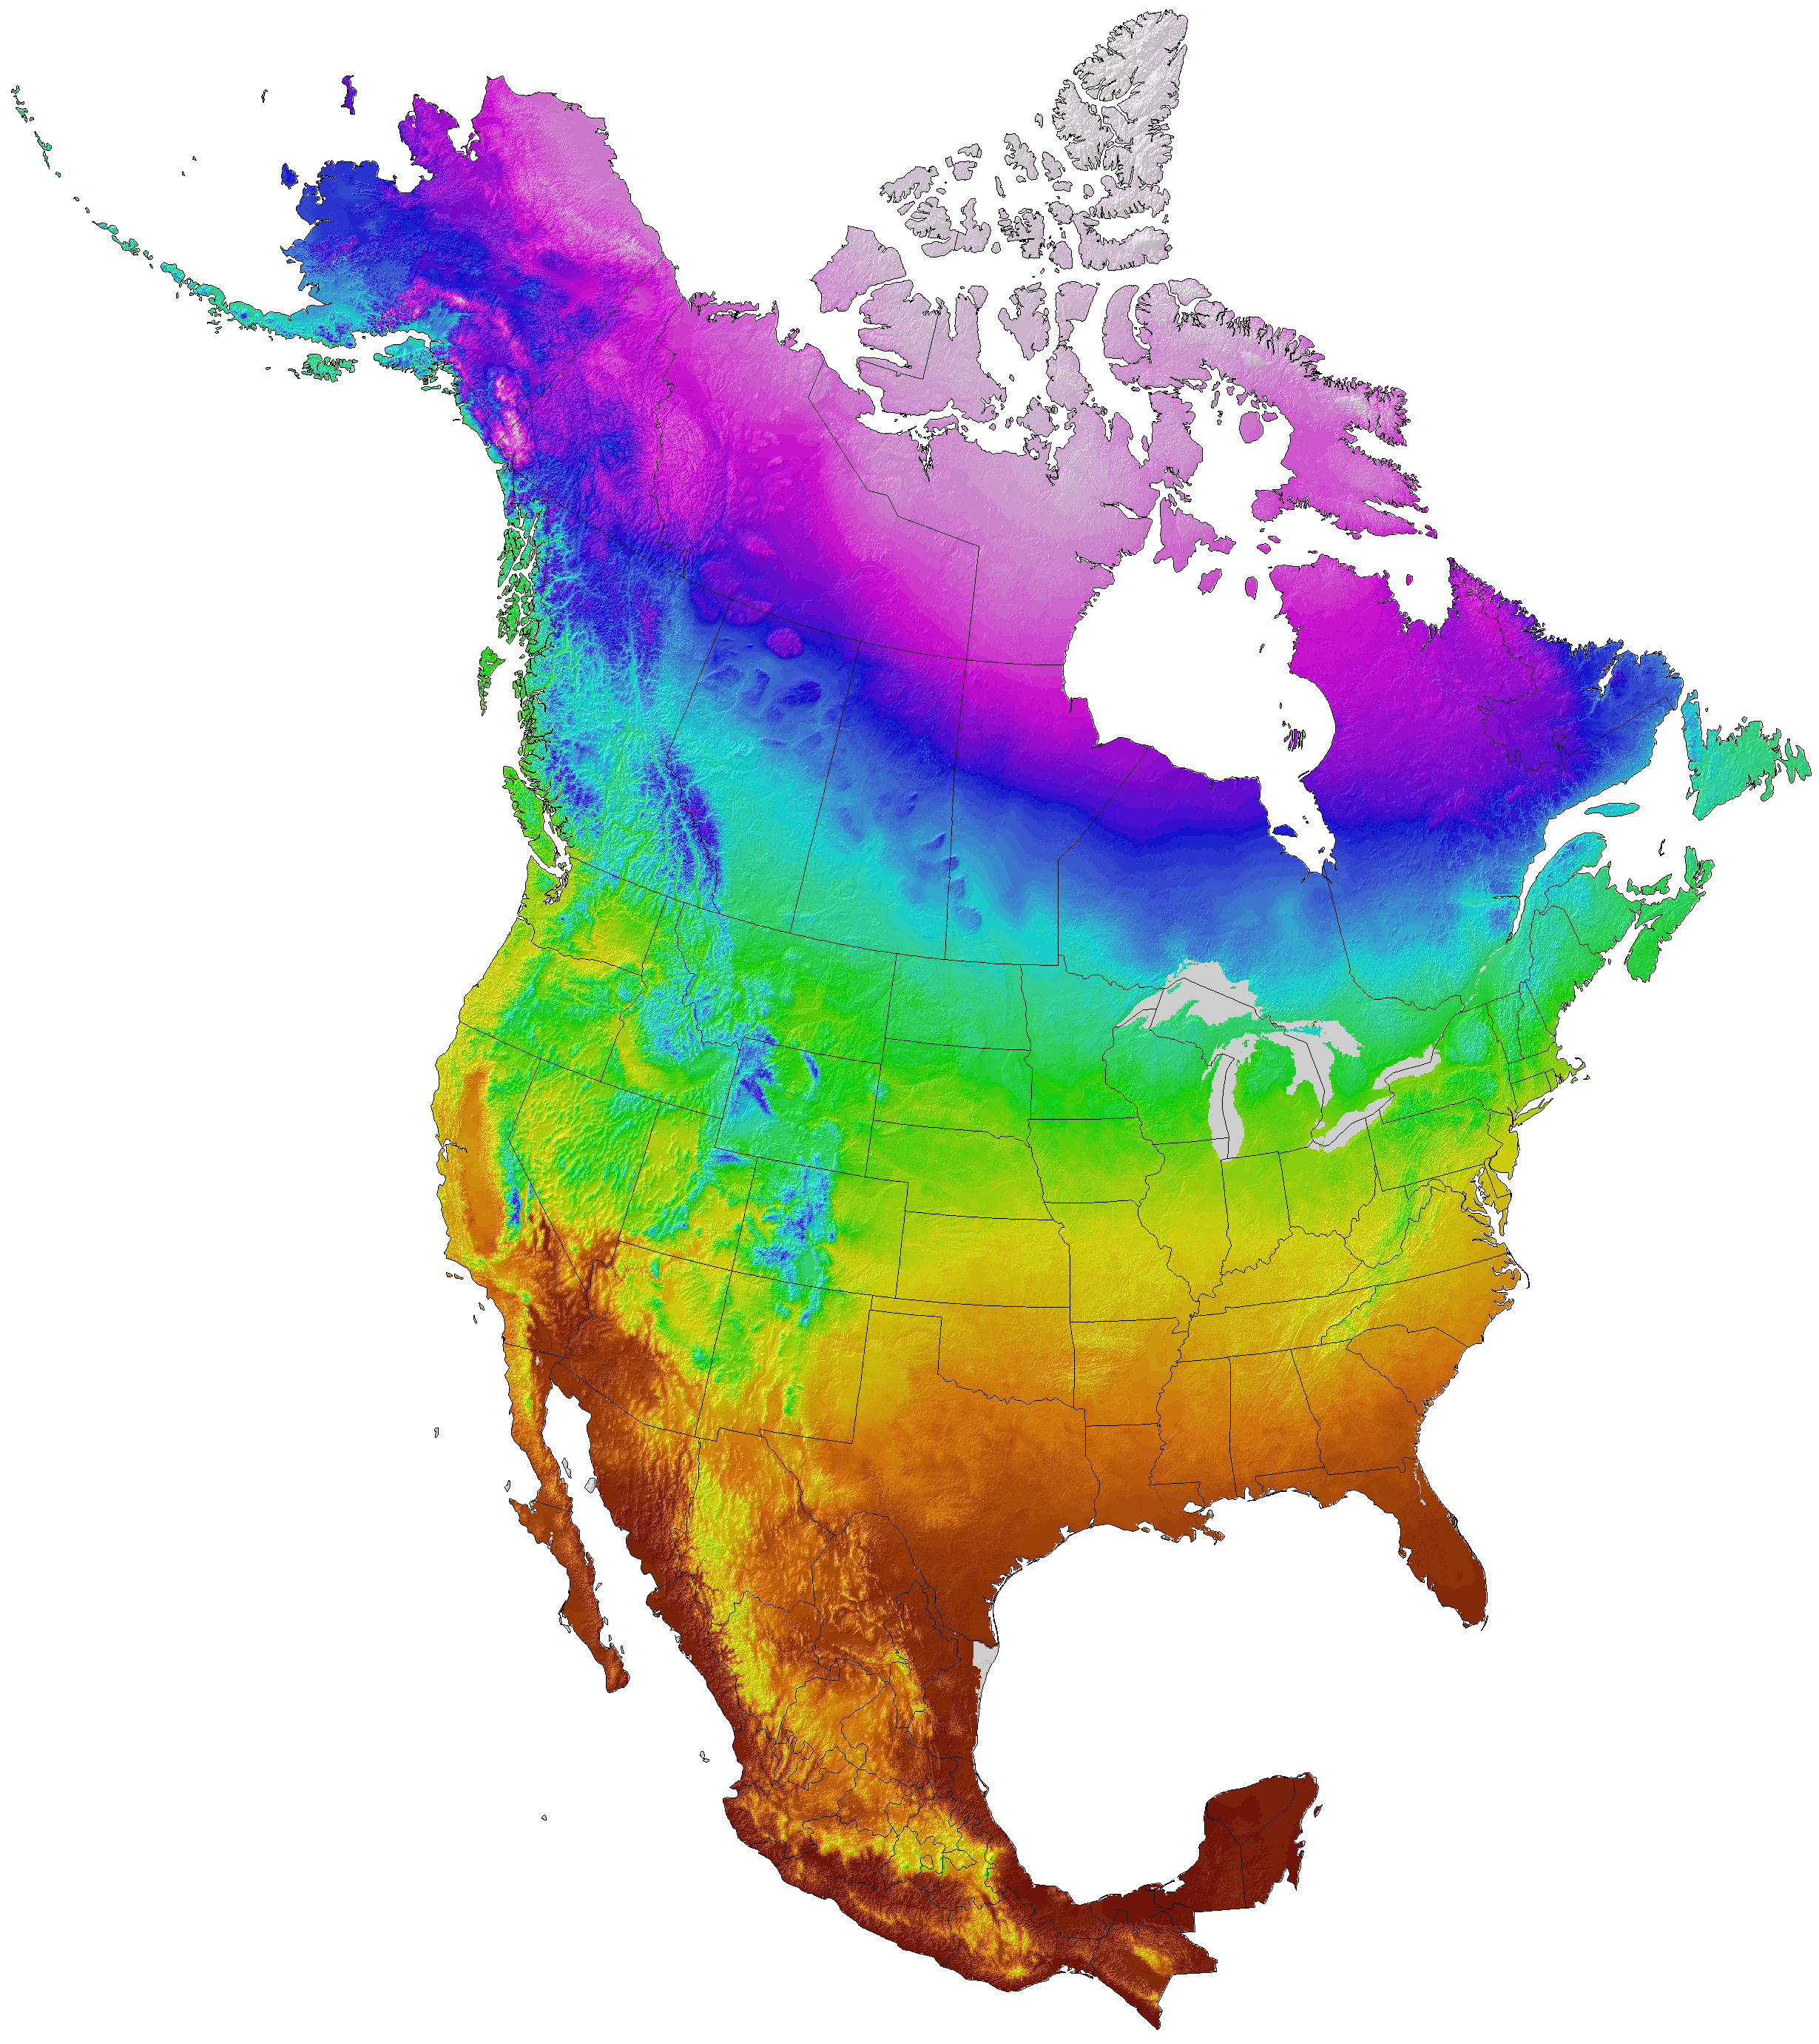
Fig. 1. The North American temperature gradient – Browns are the warmest temperatures and Blues and Purple are the coldest. Like other places in the Northern hemisphere, temperatures tend to get colder as you approach the pole and warmer towards the equator. Note however, how the mountains of the west and the Appalachian Mountains disrupt this overall pattern. https://adaptwest.databasin.org/pages/adaptwest-climatena

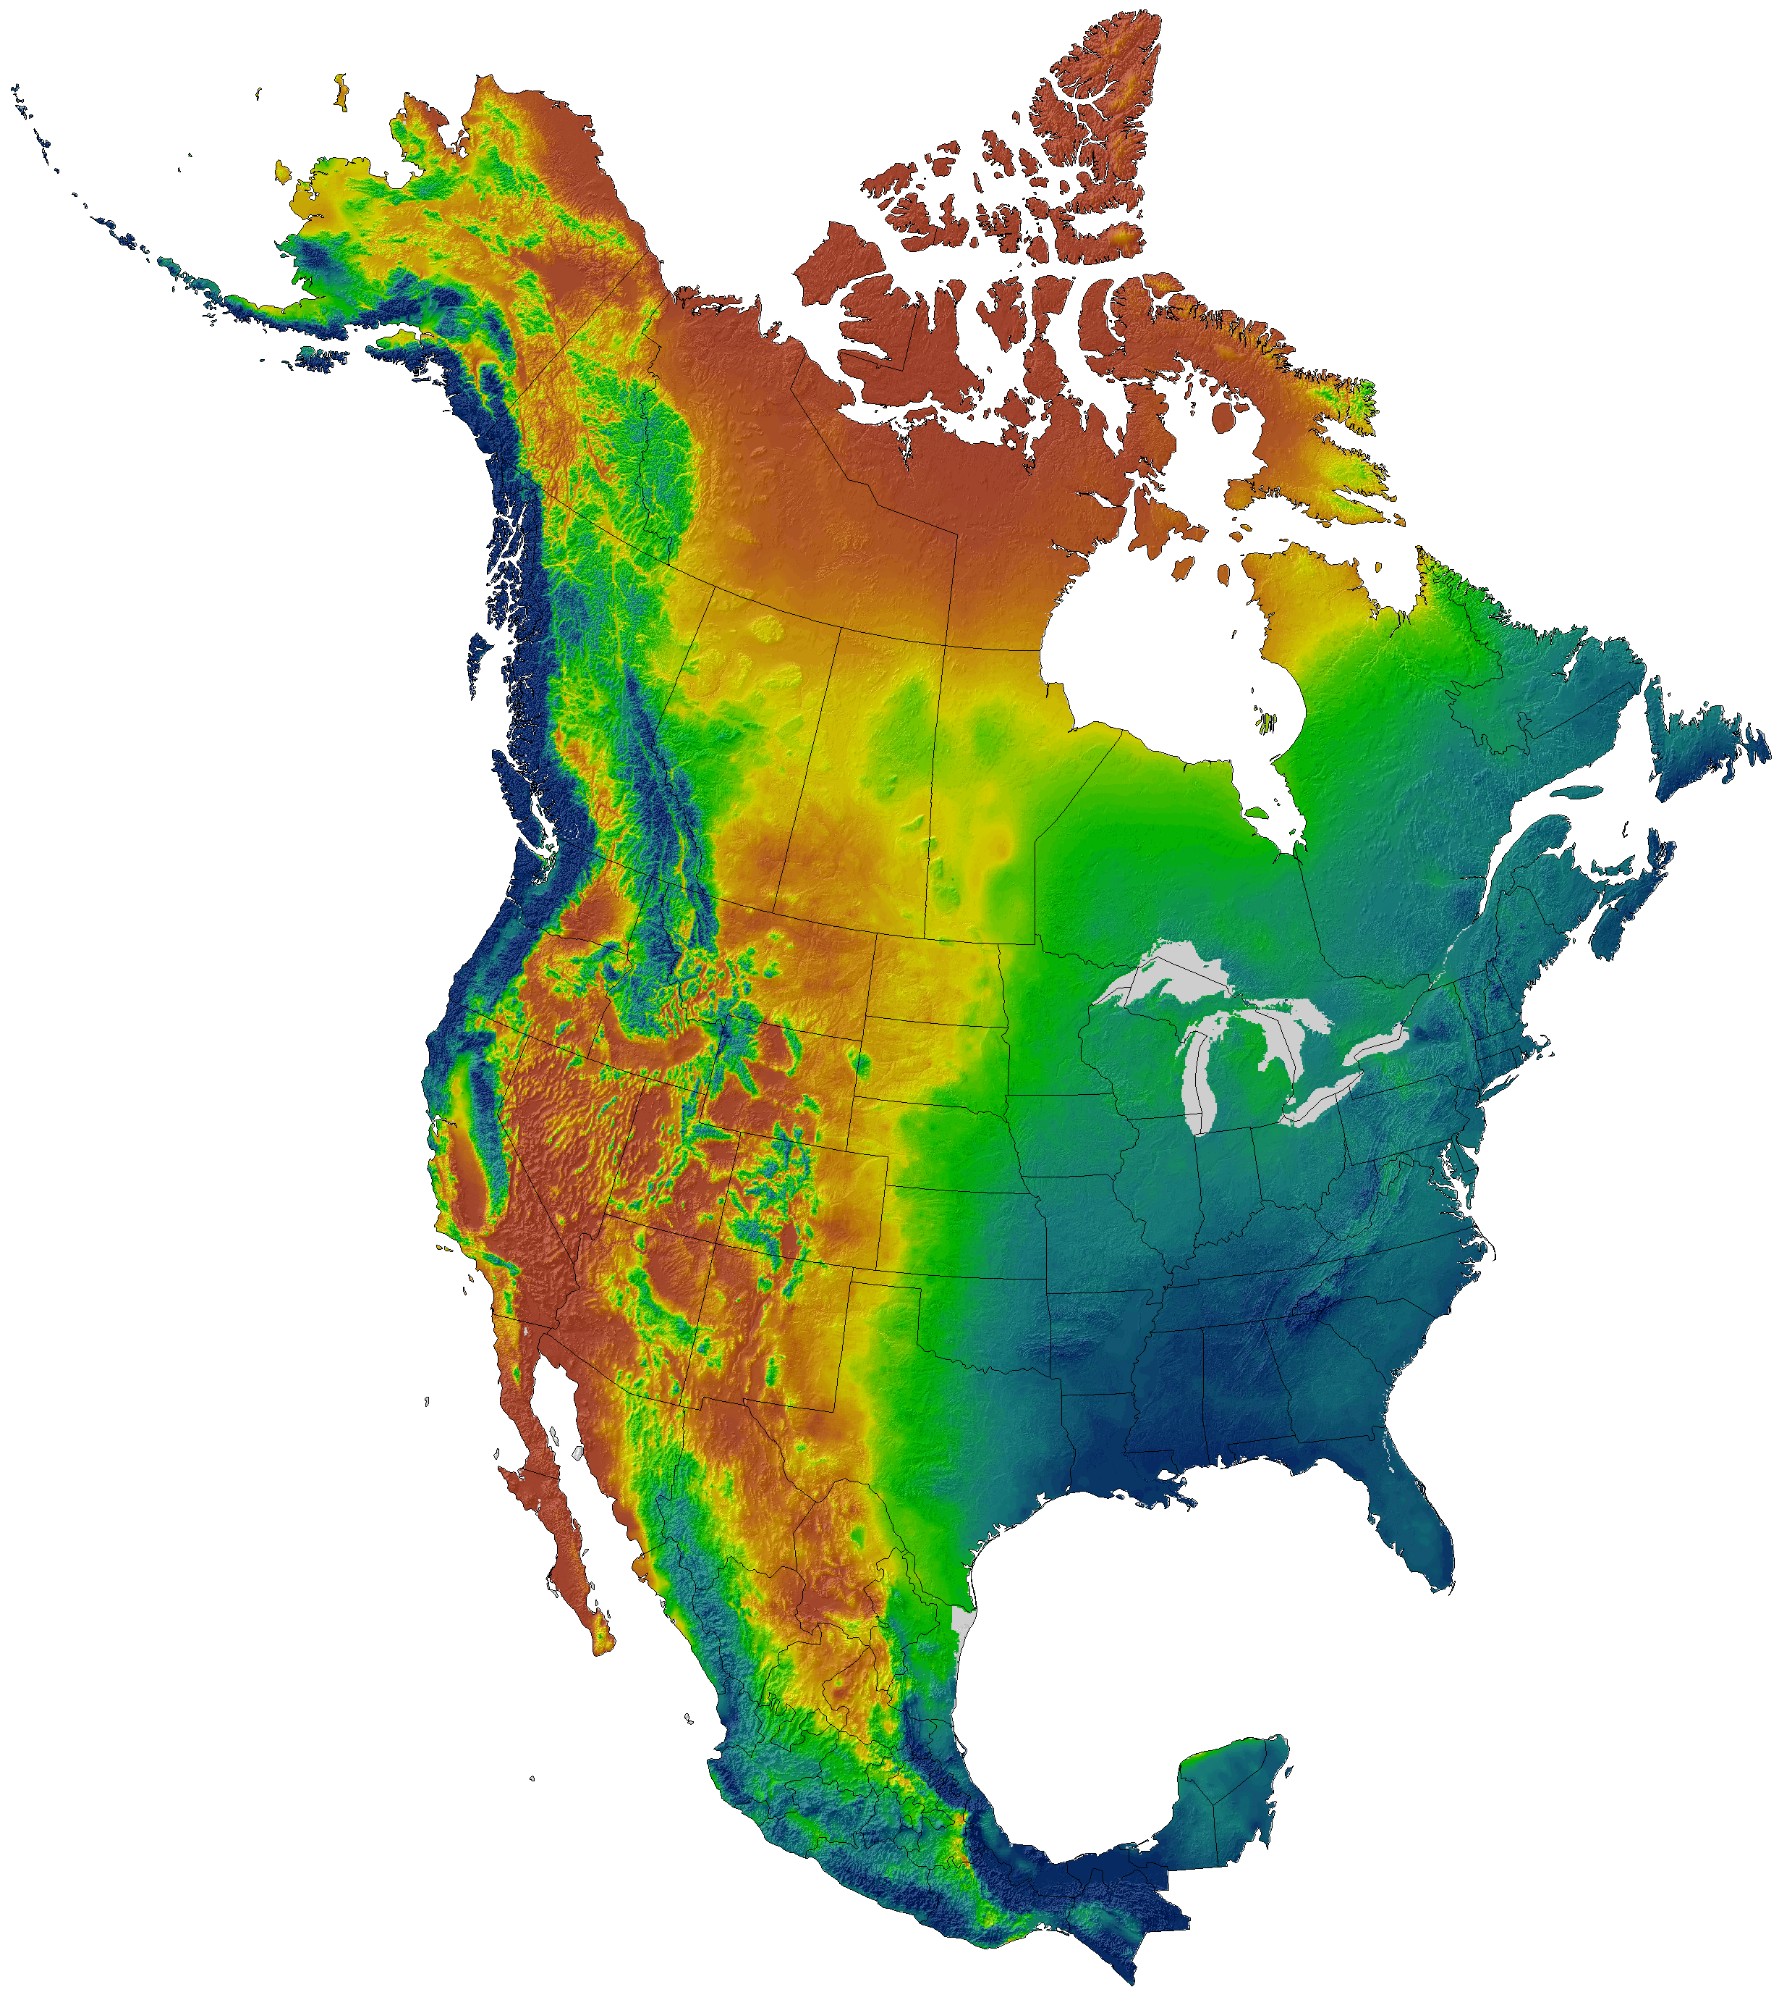
Fig. 2. North American precipitation gradient – Blues are the highest precipitation and Brown the driest. The mountains of the west and the Appalachian Mountains disrupt this overall pattern but not as much as they disturb temperature – compare Figs. 1 and 2. Also, observe the sharp boundary (yellow line between green and brown in the central part of the continent) at the base of the Rocky Mountains. https://adaptwest.databasin.org/pages/adaptwest-climatena

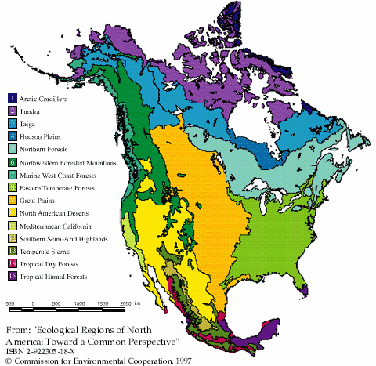
Fig. 3. Ecological regions (biomes) of North America. Note the relationships between the locations of the biomes and the temperature (Fig. 1) and precipitation (Fig. 2) maps. For instance, the light green area is the eastern deciduous forest. Its northern boundary is controlled by temperature but its western boundary is a response to moisture. Contrast this pattern to the elongated gold area in the center of the map. Its eastern and western boundaries are controlled by moisture but is has a long north-south axis so organisms in this region can tolerate a wide range of temperatures, although the northern boundary is abrupt. https://archive.bigelow.org/virtual/index_weather.html
EXERCISES
- Examine the above temperature and precipitation maps for North America, and answer the following questions:

- Draw a schematic (representative but not precise) graph showing changes in temperature from the tip of Texas straight north to the northern edge of the North American continent. Label the Y-axis from bottom to top as low temp to high temp. The X-axis will be south at the left and north at the right.
- In what direction do temperatures increase? Decrease?
- Examining the map, where does it appear that altitude causes temperatures to be colder than surrounding areas?
- Draw a schematic (representative but not precise) graph showing changes in precipitation from the bulge (at the northern boundary of North Carolina) along the East Coast straight west to the southern California. Label the Y-axis from top to bottom as high precip to low precip. The X-axis will be west at the left and east at the right.
- Generally, does more precipitation fall in eastern or western North America?
- What two areas of the USA receive the most precipitation?
  - Explain how the ocean currents and wind directions in each area cause so much precipitation. Pay particular attention to the Atlantic and Gulf coasts.
- If global mean annual temperatures cooled, how might this temperature gradient change? Draw another schematic line on your temperature graph and label it cooling.
  - Along what two geographic features (one in the west and one in the east) would the temperature change project furthest south? Why?
- If global climate becomes warmer, how would the temperature gradient map change? Draw another schematic line on your temperature graph and label it cooling.
- Using Google Earth examine mean annual temperatures for the periods 1901-1930, 1931-1960, and 1961-1990 (go to http://serc.carleton.edu/eslabs/weather/4b.html and download World Temperature Observations 1901-1990.kmz).
  - What broad changes do you see in the northern boundary of some temperature bands, particularly those between 10 and 015°C?

