Module 1: An Ecology/Climate Scenario
James S. Oliver III and Russell W. Graham

Scenario 1: “Gotta find a better place to fish….”
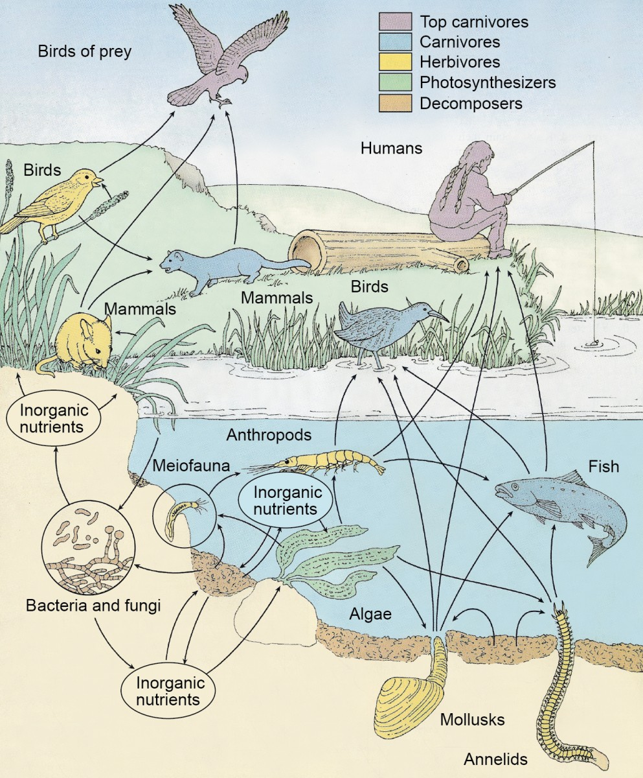
“Too hot to be sweating like this in the spring...” You approach a spot in the open woodlands near a stream emerging from a rock-strewn canyon onto a flat area a few hundred meters below the nearby Rocky Mountains. You have been coming here for years to fish after school in the spring. As you become seated you notice that the stream level is even lower than last year and you have to move further down the bank closer to the stream. The ground seems drier – the floodplain lacks the muddy spots and their associated clouds of insects. The vegetation does not seem as lush. Even more trees have died over the winter and the afternoon sun washes over the forest floor. You see a hawk taking flight from a narrow leaf cottonwood tree branch and swoop down into the adjacent field. It arises moments later with a mouse in its talons. Nearby a muskrat is busy excavating a new burrow lower on the bank. At your side you notice a flower you remember from growing up on further east on the plains, but have never seen here before. Glancing up, you see a mule deer covered in the Buffalo burs that seem to have taken over a once lush floodplain further downstream. The marmot you had seen for several springs, but whose burrow was abandoned last year, is now occupied by a red fox. The beaver dam built here last year is dried out and the beavers are nowhere to be seen. Hours pass, but not even a nibble. Even last year you caught a couple of small Mountain Whitefish - you haven’t seen Rainbow trout here for four years. You will have to find a larger stream to fish next week.
Fig. 1. Ecological Relationships: The Food Web

Ecology and Palaeoecology are the relationships between organisms and their physical environment and each other. Ecology deals with modern conditions; whereas, palaeocology focuses on past ecosystems. For more information on these topics see the web sites below.

Introduction to Ecology Websites
https://www.ck12.org/life-science/Principles-of-Ecology-in-Life-Science/lesson/Introduction-to-Ecology/?referrer=concept_details

The following exercises are based on observations from the above scenario. Scientists may start with a similar scenario and then develop hypotheses to explain their observations. Then they would go to the “field” to collect data (in the following exercises you will be using the Neotoma Paleoecological Database that contains data scientists have collected in the field) to see if they can refute the hypothesis. If they refute it, then they need to develop a new hypothesis. If it is not refuted, it is still a viable hypothesis until it may be refuted in the future.

EXERCISES
- Why in the above scenario do you think the stream level is lower than in previous years?
- What changes in animal and plant life at your fishing spot suggest environmental change?
- Explain how a predator population might be related to the population of its prey.
- How might the decline in fish populations in your stream impact mammals like raccoon and bear?
- What might the preferred habitat of Mountain Whitefish and Rainbow Trout tell you about recent changes in the stream? Do a Google search to find out about the preferred habitats of these two fish.

