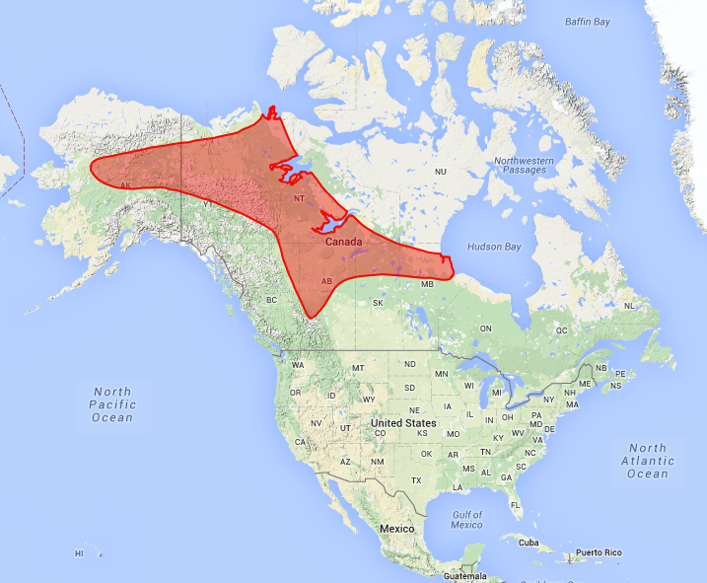
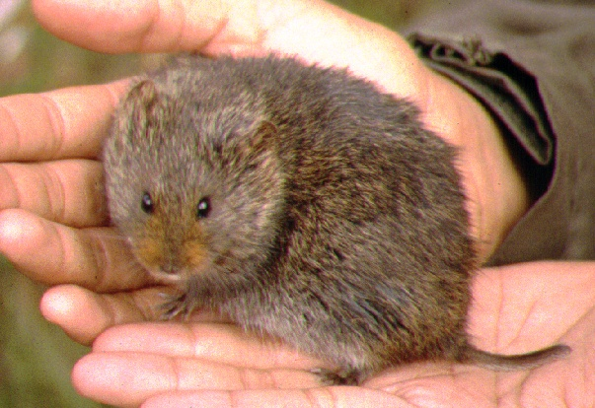
Yellow Cheeked (Taiga) Vole, Microtus xanthognathus (Leach, 1815)
Yellow Cheeked Vole (credit unknown)

Modern distribution of M. xanthognathus (from Neotoma database)
Rodentia (Rodents)
Family: Cricetidae (Lemmings and Voles)
Body Size: Length Range, 186–226 mm (7.3–8.9 in); Weight Range, 140–170 g (0.306–0.375 lbs).

Physical Description: The Taiga vole is the largest of the Microtus genera. The distinctive rust-yellow markings on its cheeks are present in adults.

Distribution: Today this vole is found primarily in the western parts of the boreal forest biome west of Hudson Bay to central Alaska.

Habitat: This vole occupies much of the boreal forest biome west of Hudson Bay and a small part of the tundra biome in Canada. It strongly prefers wet areas with productive plants such those in riparian settings, dense spruce forests, and those that grow in early successional forests after a disturbance (e.g., fire, recent glacial retreat, etc.). In all habitats the Yellow Cheeked Vole requires a heavy ground cover with mosses, loose, organic-rich soils with abundant rhizomes (which are a major food in winter), and close proximity to water.

Diet: This vole’s diet consists mainly of sedges, grasses, berries, and rhizomes. Equisetum and epilobium rhizomes are cached and comprise the bulk of the winter diet in some areas.

Behavior: The Yellow Cheeked Vole seems to be somewhat social. Winter nests may contain up to 10 individuals, not all of who are related. Nests are either underground or wholly within the leaf/vegetation litter. Food caches for the winter are built near the main nest. The American Marten (Martes Americana), ermine (Mustela erminea), least weasel (Mustela rixosa), wolf (Canis lupus), red fox (Vulpes vulpes), lynx (Lynx canadensis) and a variety of hawks and owls found in the boreal forest and tundra are this vole’s main predators.

Paleoecological Implications: Because the modern Yellow Cheeked Vole lives in northern North American latitudes with cold conditions and prefers wet areas in coniferous forests with abundant understory growth that includes rhizome plants, grasses, sedges, and Willowherb, its presence in a fossil assemblage likely indicates a cold and moist boreal environment.

Web Resources:
http://animaldiversity.org/accounts/Microtus_xanthognathus/
http://zipcodezoo.com/index.php/Microtus_xanthognathus
http://explorer.natureserve.org/

References:
Conroy, C., Cook, J. 1999. Microtus xanthognathus. Mammalian Species 627: 1-5.

