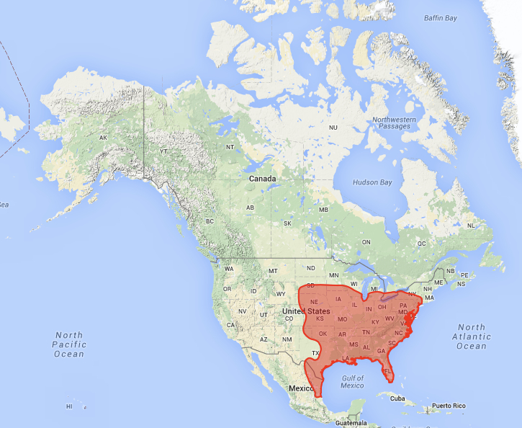
Least Shrew, Cryptotis parva (Say, 1823)
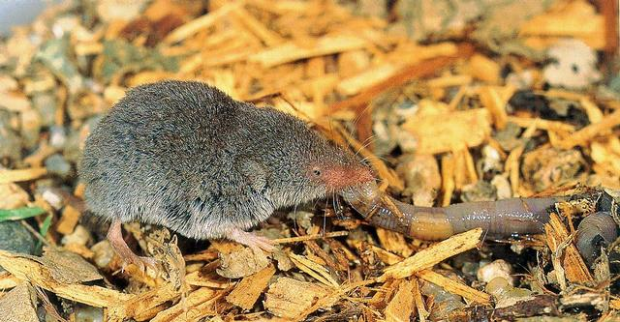
Least Shrew feeding on an earthworm (© Copyright The Smithsonian Book of North American Mammals, edited by Don E. Wilson & Sue Ruff, 1999.)

Modern distribution of C. parva (from Neotoma database)
Order: Insectivora (Insectivores)
Family: Soricidae (Shrews)
Body Size: Length Range, 61-89mm (2.5-3.5in); Weight Range, 3-10 g (0.007-0.022 lbs).

Physical Description: This grey-brown to reddish-brown shrew has a long, pointy snout, small eyes, and almost invisible ears. It is one of the world’s smallest mammals.

Distribution: The modern range of the Least Shrew extends from central South Dakota to western Massachusetts in the north, along the Atlantic seaboard to Florida in the east, along the Gulf of Mexico to northeast Mexico in the south, and to northwestern Wyoming in the west.

Habitat: Although the Least Shrew prefers moist (mesic), open grasslands, marshes, and meadows with dense herbaceous vegetation, leaf-litter and loose soil, it can be found in uplands where vegetation and ground cover ensure adequate insects for feeding. Nests are located under fallen logs or branches, under flat rocks, and in shallow burrows. Forests seem to be avoided unless located near an open area.

Diet: The Least Shrew diet consists mainly of small insects, earthworms, centipedes, slugs, sow bugs, and larvae, which it normally eats whole. It will also feed on carrion (dead animals) and occasionally on seeds and fruits. It has been known to live in beehives, feeding on the larvae. Because of it’s very high energy needs (it has a very high metabolism that consumes a lot of energy), the Least Shrew eats 60-100% of its body weight daily and requires a constant access to high quality foods.

Behavior: This small insectivore is mainly nocturnal, but may be active throughout the day. Its small eyes and ears give it very poor eyesight and hearing. As one might expect of an animal with a large snout, the Least Shrew hunts primarily by smell. Touch (feeling the vibrations created by nearby prey) is also important in locating prey. Its venomous saliva will paralyze prey somewhat larger than itself, and consequently, its bite is painful to humans. Food is cached. In contrast to most other shrews, the Least Shrew is quite social, sharing food, cooperating in digging burrows, and sharing sleeping space. Colonies of upwards of 5-25 individuals are not uncommon. Although often found in open spaces or brushy areas, the Least Shrew requires adequate leaf/vegetation litter for both insect foods and hiding themselves from predators. Various species of owls, hawks, skunks, and snakes are their major predators in the wild. In urban areas, house cats are an important predator.

Paleoecological Implications: The Least Shrew’s preference for moist, open habitats with adequate litter suggests that its Late Pleistocene occurrence in Dry Cave, NM and Upper Sloth Cave TX, well west of its modern westernmost distribution, indicates more moist conditions in west Texas and southern New Mexico than exist there today.

Web Resources:
http://animaldiversity.org/accounts/Cryptotis_parva/
http://zipcodezoo.com/index.php/Cryptotis_parva
http://explorer.natureserve.org/
http://www.biokids.umich.edu/critters/Cryptotis_parva/

References:
Hamilton, W. J. 1944. The biology of the little short-tailed shrew, Cryptotis parva. Journal of Mammalogy, 25: 1-7.
Whitaker, J.O., Jr. 1974. Cryptotis parva. Mammalian Species, 43: 1-8.

