Names: ____________________________
Asperity Model Date:

- Obtain 15 pieces of spaghetti (mix of whole wheat and regular spaghetti), 1 model, 1 clamp

- With 1 piece of spaghetti, apply stress to the spaghetti until you notice deformation. Draw a picture below of the spaghetti before and after you applied stress. Label where you see evidence of deformation.
BEFORE: AFTER:

- With the same piece of spaghetti, model elastic and brittle deformation.
  - What happens to the spaghetti during elastic deformation? Does it return to the same shape?

  - What happens to the spaghetti during brittle deformation? Does it return to the same shape?

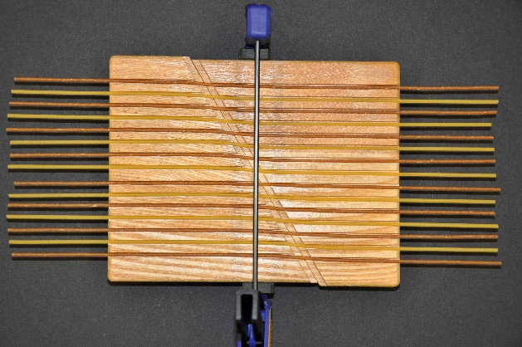
- Using the model, insert the spaghetti in the rivets of the wood board. Alternate wheat and regular spaghetti. Attach the clamp as is shown in the picture. Note: You may need to repeat the steps below a few times because it’s easy to put too much stress on the clamp.
- SLOWLY apply continuous stress to the clamp handle until you see deformation. Draw what the spaghetti looks like:

- Resume applying stress and observe the pattern of brittle deformation. STOP applying stress when several pieces of spaghetti break. Release your grip on the clamp.

- Did all the spaghetti break at once? Describe…

- Did and spaghetti break after you released your grip on the clamp?

5) What is an asperity?
An asperity is an area on a fault that is stuck or locked. In the Earth, tectonic earthquakes are caused by slip along a fault plane, where two rock bodies are in rigid contact. The friction along the fault plane is not uniform in strength, so overall movement involves slip on one or more asperities, or “stuck patches” where the friction is highest. Most of the energy that is released by earthquakes comes from the patches that become “unstuck.”
Models are used when it is difficult to make direct observations of a phenomena. The model we used here is attempting to reproduce an asperity. What do the following parts of the model correspond to in the Earth?
  - Wood:

  - Spaghetti bending:

  - Spaghetti breaking:

  - Clamp:

  - How is the model not like the Earth?

6) Challenge question: In diagram A the arrows indicate amount of movement of GPS stations on either side of a fault before a big earthquake. Draw arrows in diagram B to indicate what the arrows would look like during an earthquake. THINK and discuss – it may not be obvious at first glance.

A. Before Earthquake B. During Earthquake

