Sea Level and Facies Changes: Large Classroom and/or Interactive Demonstration
K.S. Pound, Earth & Atmospheric Sciences, St. Cloud State University, MN
kspound@stcloudstate.edu http://web.stcloudstate.edu/kspound/

Objectives
Participants will be able to visualize and predict how changes in sea level can control the lateral and vertical facies distribution within and adjacent to a marine sedimentary basin. They will also critique the model and identify shortcomings and assumptions that the model makes. Participants will be able to draw a sea-level curve for Paleozoic rocks of the Central Midwest.

Materials
See-through tubes: I ordered mine from http://www.mcmaster.com/ “clear cast acrylic hollow rod” part # 8486K326 and cut each in half on the table saw. Mine are far too wide (6” diameter - expensive to buy materials to fill them); they crack easily too... I’d suggest 4” diameter at the widest.
Colored Objects: I did a volume/cost determination and decided on “porcupine balls” from Oriental Trading (www.orientaltrading.com) item # 39/983, 144 per bag, $5.95/bag. They were still really pricey (I have 25 bags of them).
Bags to keep sorted porcupine balls in: Extra-large ziplock garment bags
Measurer: Cut down plastic milk cartons
Something to form ‘basement’ at bottom of tube: old material, foam rubber…….
Sea-level marker: meter stick
Digital Camera to take pictures

Background Information
I introduce a simplified series of depositional settings (Figure 1), which are: Stream, Beach, Shelf & Continental Slope, and Ocean Basin (siliciclastic) and Ocean Basin (carbonate). Coarser sediment is deposited closer to source (fluvial), finer sediment deposited farther from source. Farthest from source, where essentially no siliciclastic terriginous material is available carbonate sediment is deposited. The ‘position’ that it is easiest to track is the transition between the stream sediments and the fluvial sediments; this transition is assumed to mark the position of sea level. I do NOT use a horizontal line to mark sea level because it gets into so many problems; firstly there is no slope to the basement surface (I deliberately set it up like this; I want them to see Walther’s Law in action; it also gives them something to critique about the model). Students need to grasp the fact that the sedimentary settings will ‘move’ with sea-level, and that the settings in Figure 1 shift as sea level position changes, and the sediments deposited consequently change too (i.e. we are seeing Walther’s Law in action).

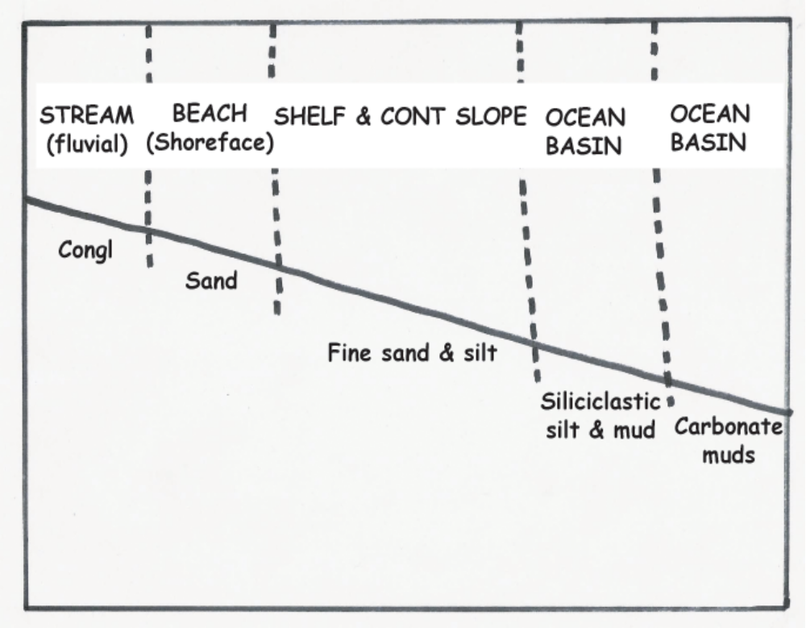

Figure 1. Depositional settings and sediment characteristics used for ocean basin at a passive continental margin

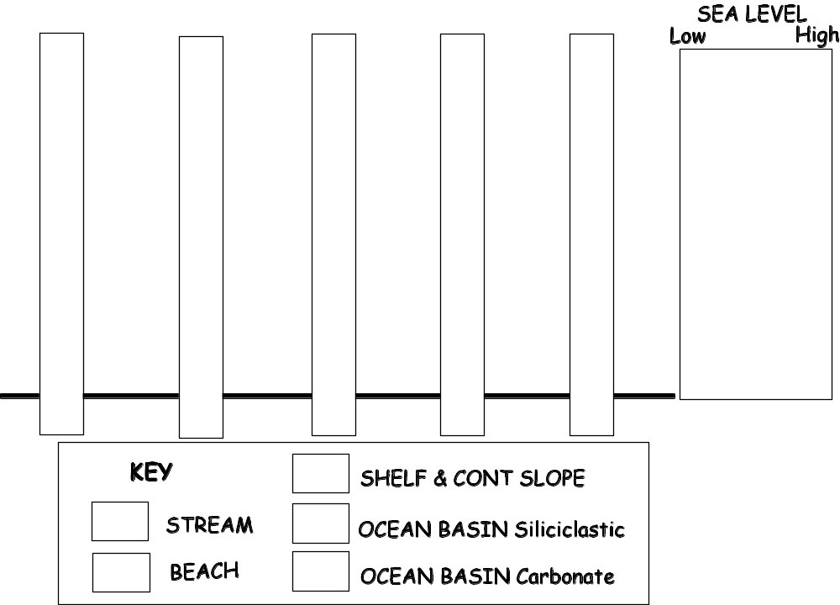

Figure 2. Each position on the continental margin starts out as one of the depositional settings, and is represented by a stratigraphic column or ‘tube’
Doing the Demonstration
I like to do this as an interactive demonstration in the center of a 20-40 student class, but it can also be used in a large lecture class. For the interactive demonstration I spread the tubes in a line across the middle of the room. I assign one person to each sedimentary setting and give them a bag of porcupine balls and a scoop. I assign one other person to be the sea-level (fluvial/beach transition) marker; I give them the meter stick. I review which color each environment is represented by, and which direction is landward, and which is basinward. Depending on the scenario I want to produce, I then just read out “sea level rises one increment” or “sea level lowers one increment” or “sea level remains at same position”. The model tubes are not tall enough (and porcupine balls were too expensive) to develop a longer sea-level history, but essential elements can be captured. I often give the students a worksheet they need to complete.
Some of the sequences I like to demonstrate are:
(i) Two rises followed by 3 falls (transgression followed by regression)
(ii) Three falls followed by two rises (regression followed by transgression)
At this point I usually get the students to make a prediction about what the sequence will look like with a given sea-level history – or I give them a sequence they need to interpret the sea-level history for; students invariably want to model some extreme event of their own devising.

Completing the Learning Cycle
Depending on the class group, I may or may not use the worksheet.
Regardless, I ask students “What assumptions did we make in our use of this model?”
(constant supply/sedimentation rates, carbonates only form in deeper water, no subsidence, no erosion, sea level is the only independent variable). I follow up by giving students a series of simple questions such as “What IS the depositional rate for….?”, “What is the morphology/slope of a passive continental margin?” “What other problems are there with this model?” I then get the students to complete the portion of the worksheet that focuses on the application of these principles to the Paleozoic sedimentary sequence in SE Minnesota. I use diagrams from Dr. Tony Runkel and the Minnesota Geological Survey ‘Minnesota at a Glance’ Series, in which I white-out the sea-level curve from the original diagram, and ask them to draw it and explain how they came to their conclusions regarding sea-level position.

Add-on Activities
This activity can be augmented (or initiated)
- By a field trip,
- Through use of sediment instead of porcupine balls
- Through the use of real (or ‘made-up’) cores
- Through use of data available online from the NCED Jurassic Tank mini-basin (http://www.nced.umn.edu/Rapid_and_slow_level_changes_XES_96Prototype_basin.html).

