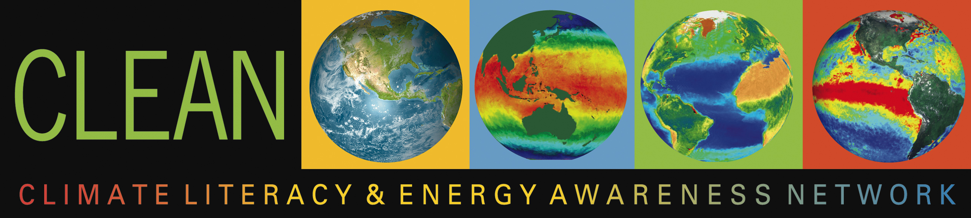

Fostering Climate Literacy & Energy Awareness in the US & Abroad

The Climate Literacy and Energy Awareness Network (CLEAN) provides 1) peer-reviewed, online, free educational resources on climate and energy; 2) scaffolding to support teaching these topics; and 3) a professionally diverse community to foster climate literacy and energy awareness, enabling responsible decision making.

CLEAN (Climate Literacy and Energy Awareness Network), http://cleanet.org, launched in November 2010 and funded by NSF, NOAA, and the Department of Energy, is led by the science education and science expertise of TERC, the Cooperative Institute for Research in Environmental Science (CIRES), NOAA, and the Science Education Resource Center (SERC). It supports educators in many contexts -including formal and informal settings in teaching and learning about climate and energy topics.

The activities of CLEAN include:
1. CLEAN Collection – http://cleanet.org/clean/educational_resources - The CLEAN search engine directs you to annotations and links for 580+ vetted, online activities, videos, and visualizations on climate and energy for grades 6 - 16. These resources have been hand-picked and peer-reviewed by scientists for accuracy and by teachers for classroom effectiveness. Learn how resources are selected by CLEAN (http://cleanet.org/clean/community/reviewprocessabout.html).

2. Teaching Climate and Energy Science pages – http://cleanet.org/clean/literacy – These pages offer background information on the big ideas in climate and energy that are drawn from the original Climate and Energy Literacy frameworks. They provide summaries of each principle, possible challenges for educators, suggested pedagogic approaches for each grade level, and point to relevant teaching materials from the CLEAN collection.
3. CLEAN Community – http://cleanet.org/clean/community – The CLEAN Community includes educators and learners, resource developers, project partners, and the CLEAN Network (formerly the Climate Literacy Network). The CLEAN Network includes professionals and citizens who are stakeholders in improving climate and energy literacy. Announcements of CLEAN activities appear on the CLEAN Facebook page, the CLEAN Network listserv and teleconferences, and the CLEAN announcements listserv for educators.

http://cleanet.org

The CLEAN Collection has 580+ resources that include teaching activities, visualizations, videos, and short demonstrations that have been reviewed by practicing educators and scientists. Each resource is annotated with information from our reviewers, such as information about the science and pedagogy, technical quality, and teaching tips. Each is aligned with a) the Climate Literacy: Essential Principles of Climate Science and the Energy Literacy: Essential Principles of and Fundamental Concepts of Energy Education frameworks; b) the AAAS Project 2061 Benchmarks for Science Literacy; c) the National Science Education Standards (to be replaced with the Next Generation Science Standards); d) the NAAEE Excellence in Environmental Education Guidelines for Learning; and e) a climate and energy topic vocabulary.

There are multiple search options that include an open text search and a faceted search that enables searching by climate and energy topic, resource type, grade level, regional focus, and by climate and energy literacy principles and standards.

The Collection also includes an interactive browse tool of maps of climate and energy concepts (http://cleanet.org/clean/literacy/concept_maps.html, based on the AAAS Project 2061 Benchmarks, which help teachers connect climate and energy concepts, standards and the CLEAN educational resources. The maps illustrate connections between concepts and depict how concepts build upon one another across grade levels.

The CLEAN Community provides an avenue for climate and energy literacy stakeholders to share information, communicate, and contribute. The CLEAN Network (http://cleanet.org/clean/community/cln) enables ongoing conversation of all interested stakeholders through an active listserv and weekly-recorded teleconferences and webinars (Tuesdays 1pm ET). CLEAN communicates with the broader community through the CLEAN Facebook page (http://www.facebook.com/CLEANET). CLEAN Educators can receive information about CLEAN events through a CLEAN Announcements listserv. CLEAN Resource Developers can identify where to focus their efforts in the creation of new materials through the use of the “Gaps and Thin Spots Analysis” of the CLEAN Collection, and can submit their resources to the CLEAN review process to be considered for inclusion in the Collection. CLEAN Partners can bring CLEAN resources to their own web pages through the use of the CLEAN Widget, and can engage the CLEAN review process for resources on climate and energy topics important to their communities and partners.

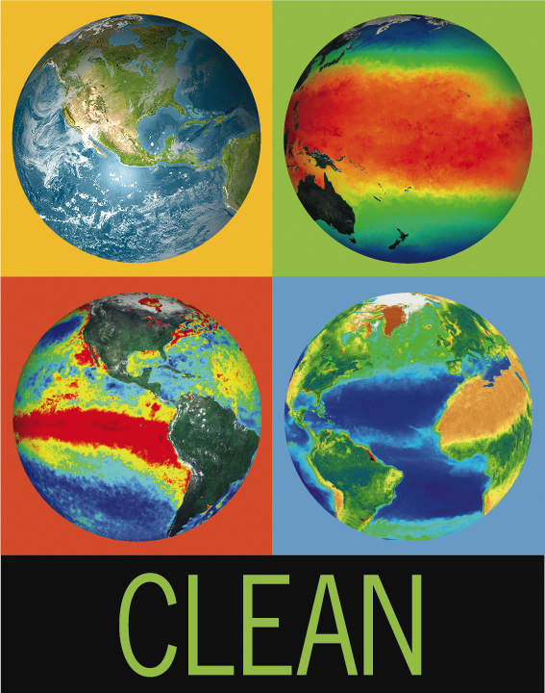
The CLEAN Portal can be accessed at: http://cleanet.org

For more information, contact

Tamara Shapiro Ledley
Email: Tamara_Ledley@terc.edu
Phone: 617-873-9658

