Location Map for 4 Seismic Lines Used in the Seismic Jigsaw Lab:
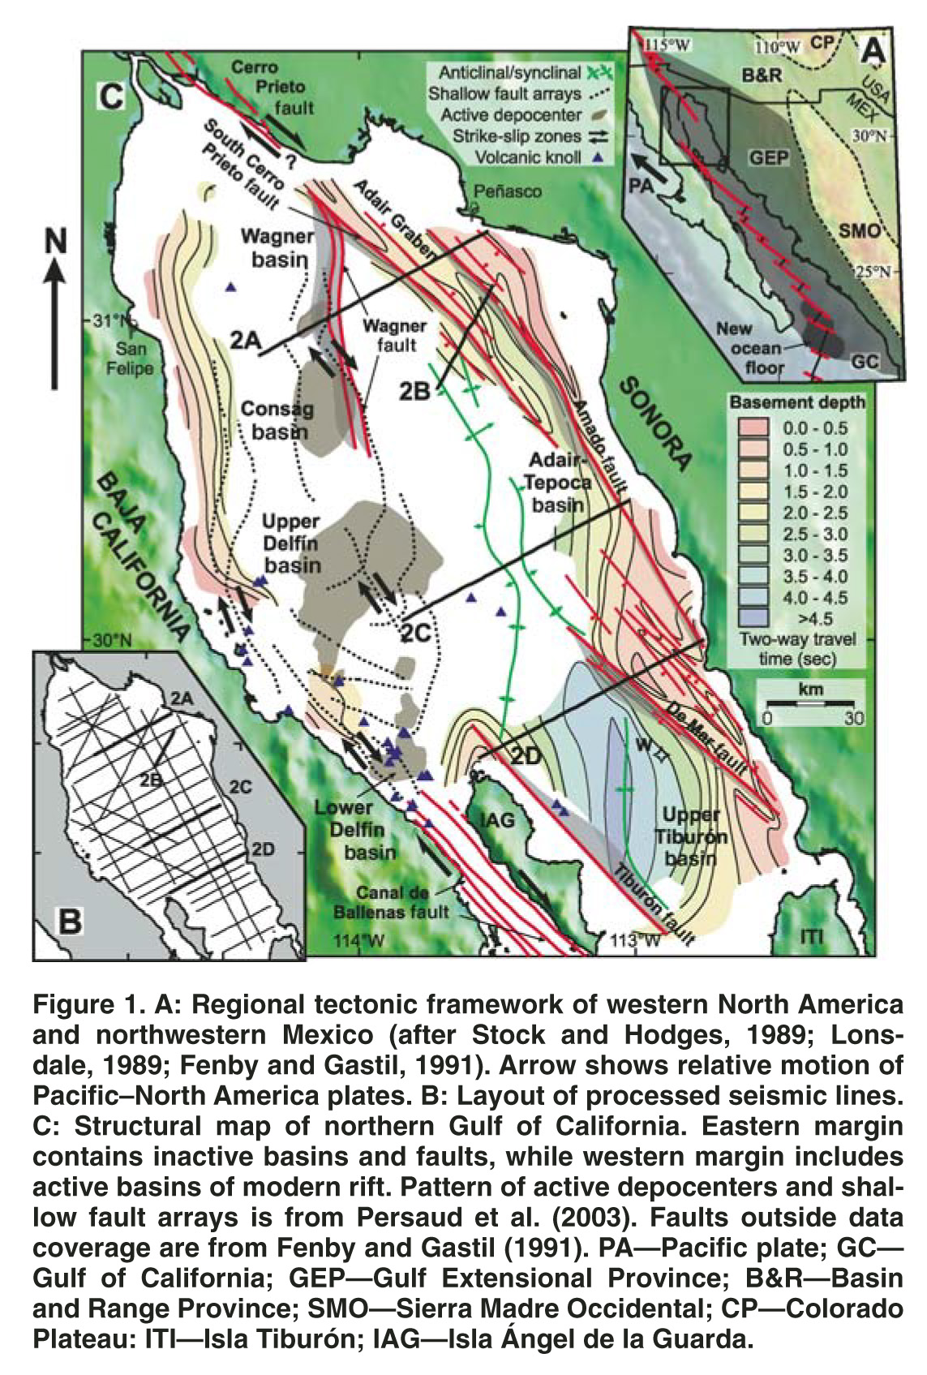
Aragon-Arreola, M and Martin-Barajas, A., 2007, Westward migration of extension in the northern Gulf of California, Mexico: Geology, v. 7. 35; no. 6; p. 571–574; doi: 10.1130/G23360A.1; 3 fi gures; Data Repository item 2007130

