Using lavas of the Central American volcanic arc (CAVA) to teach about petrogenesis of igneous rocks in subduction zones

INTRODUCTION

It is challenging to understand the processes that form arc lavas, because these processes and their products - the rocks - vary over so many scales. The subduction zone associated with any convergent plate margin extends hundreds of kilometers into Earth’s interior and the overlying arc-trench system that it engenders can be traced for hundreds to thousands of km along strike. Subduction is responsible for some of most dangerous natural hazards: earthquakes, tsunamis and explosive volcanism. Subduction zone magmatism also benefits humanity by producing ore deposits and geothermal energy. Even though subduction has been recognized as a central part of plate tectonics for almost fifty years, we still have much to learn about the operation of this gigantic solid Earth system, which we also call the “Subduction Factory” (Fig. 1). The Subduction Factory recycles raw materials from the seafloor and underlying mantle to create distinctive melts, which ultimately make up the continental crust where most of us live. The huge extent and deeply buried nature of the global Subduction Factory makes it very difficult to study, so most large-scale research projects focused on subduction processes such as MARGINS and GeoPRIMS involve interdisciplinary teams that include geophysicists, geochemists, petrologists, marine geologists, volcanologists, geodynamic modelers, and experimentalists.

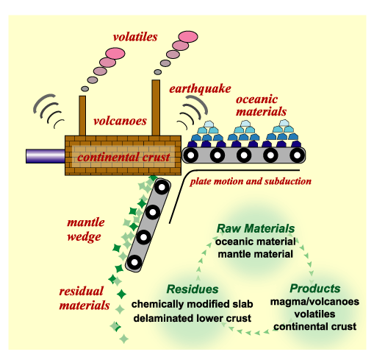
Figure 1. Diagrammatic representation of major processes and products of the Subduction Factory [http://www.jamstec.go.jp/jamstec-e/IFREE/ifree2/ifree2image/fig2_e.gif]. Courtesy of Y. Tatsumi, JAMSTEC

Igneous rocks are one of the most important products of the Subduction Factory, and include extrusive (volcanic) and intrusive (plutonic) varieties. Arc igneous rocks are compositionally more diverse than igneous rocks produced at most other tectonic settings, with the possible exception of continental rifts (Fig. 2). For example, mid-ocean ridges erupt pillow basalts on the seafloor that are underlain by diabase dikes that are further underlain by gabbros. Basalt, diabase, and gabbro are textural variations of the same mafic magma, caused by fast cooling to yield small or no crystals (basalt), moderate cooling to produce medium-size crystals (diabase), or slow cooling to form large crystals (gabbro). The bulk composition of these three rocks is not much different, mostly reflecting the composition of partially melted shallow mantle. This is also true for the composition of most hotspot igneous rocks (Fig. 2). In contrast, the chemical compositions of arc magmas show much larger variations, most importantly with regard to the concentration of silicon dioxide (given as weight percent SiO₂). While mafic rocks like basalts are also common in arcs, intermediate (e.g. andesite) and felsic (e.g. rhyolite) rocks that contain more silica are volumetrically the fundamental constituents of most arcs (Fig. 2).

In this exercise we will examine the petrology of arc lavas from two well-studied volcanoes in Central America as our natural laboratory: Cerro Negro in Nicaragua (Fig. 3a), and Ilopango in El Salvador (Fig. 3b). Initially we will focus on representative lavas from representative volcanoes of a representative convergent margin magmatic system – the Central American volcanic arc (CAVA) - to explore the processes that can produce the wide range of rock types typical of volcanic arcs. You will first get familiar with some representative CAVA lavas. You will learn about the location and tectonic setting of CAVA and a little about the nations of the region. Then you will explore two examples of individual volcanoes and their lavas, beginning with the basaltic lavas of Cerro Negro in Nicaragua (Fig. 3A). Cerro Negro is relatively small, young volcano, which is a surface expression of an immature magmatic system where mantle-derived magmas arrive at the surface without much modification in the crust. Next you will learn about Ilopango in El Salvador, an old, broad volcano with a well-developed caldera that has erupted large volumes of felsic tephra and smaller lava domes (Fig. 3B). Ilopango felsic magma is produced in a mature magmatic system where mantle-derived magmas stalled in the crust long enough to produce felsic magmas either by crystal fractionation or by melting the surrounding crust. The genetic relationship between mantle-derived melts (basalts in Fig. 2) and melts similar in composition to the continental crust (dacite/granodiorite and rhyolite/granite in Fig. 2) is one of the fundamental questions that scientists are still trying to answer. We will use the different lavas of these volcanoes to explore the relationship between the physical appearance of lavas – particularly their modal mineralogy, or mode – with the chemical composition of these lavas as expressed by major element compositions and the ideal mineralogy calculated from this composition – their normative mineralogy or norm.

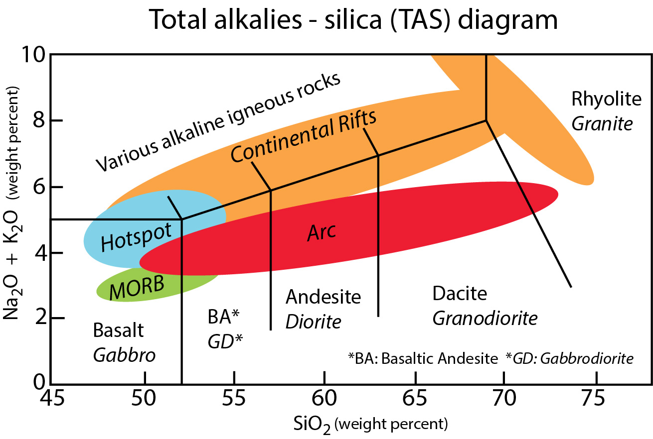
Figure 2: A portion of the “Total alkalies – silica” (TAS) diagram showing typical compositional ranges for igneous rocks from the four great petrotectonic environments: mid-ocean spreading ridges (MORB); hotspots, continental rifts, and convergent plate margins (arcs). Both volcanic and plutonic (italics) rock names are given (modified from LeMaitre et al., 2002).

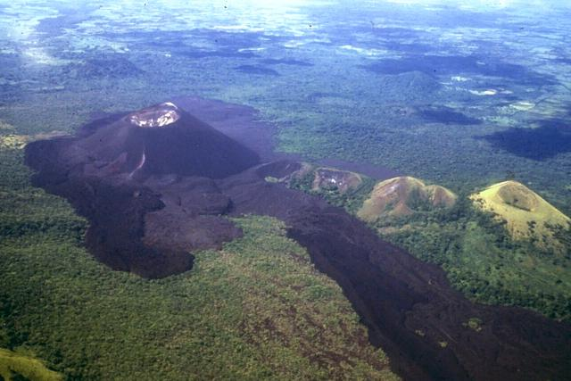 | 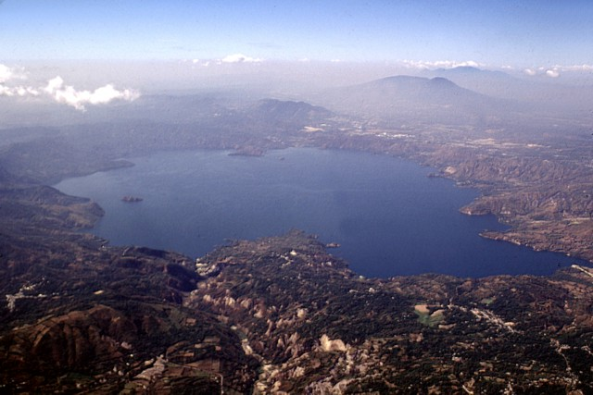
Figure 3: Two example volcanoes from CAVA. A. Cerro Negro volcano in Nicaragua comprises a 250 m high cinder cone and lava flows that have all formed since its first eruption in 1850; it is Central America’s youngest volcano. B. Ilopango volcano in El Salvador comprises a lake-filled caldera that is 8 x 11 km, which is one of the largest lakes in El Salvador. While the last large eruption happened in the 5th century A.D., small lava domes where formed beneath the lake waters as recently as 1880. Both images are courtesy of the Global Volcanism Program.
(Left Photo by Jaime Incer http://www.volcano.si.edu/Photos/small/041017.jpg, Right Photo Wikipedia)

PLATE TECTONIC SETTING

The Central American volcanic arc (CAVA) is located at the convergent plate boundary where the eastern part of the Cocos plate (2,900,000 km², the 14th largest tectonic plate) subducts beneath the western margin of the Caribbean plate (3,300,000 km², the 13th largest tectonic plate). The surface expression of this subduction zone is marked by a ~1100 km long “necklace” of CAVA volcanoes marking the western margin of the Caribbean plate (Fig. 4). The Cocos plate is subducted at ~6 cm/year beneath Central America, and is produced by seafloor spreading at the Galapagos Ridge to the south and the East Pacific Rise to the west. The oceanic lithosphere of the Cocos plate is only 15 to 20 million years old (Ma) when it begins to subduct along the well-defined Central American Trench, which makes it much younger than the oceanic lithosphere that is being subducted around the western edge of the Pacific Ocean, which typically 100-180 Ma in age. Consequently Central America is a relatively “hot” subduction zone in comparison to western Pacific subduction zones such as the Marianas volcanic arc.

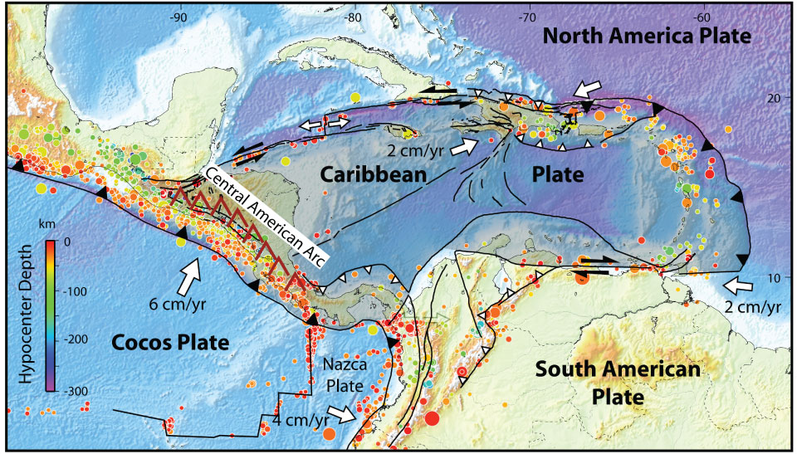
Figure 4: Tectonic setting of the Central American volcanic arc on the western margin of the Caribbean plate. Earthquake epicenters are color coded for depth; those on the western margin of the Caribbean plate define the Central American subduction zone. (Courtesy of Eric Calais, UMR CNRS http://web.ics.purdue.edu/~ecalais/haiti/context/)

A schematic cross-section of the Central American subduction zone shows that the trajectory of the subducting Cocos plate is demarcated by earthquakes (Fig. 5). The concept of the volcanic front is important for understanding all arc igneous activity, including CAVA. The volcanic front marks where subduction-related igneous activity is concentrated and also separates regions underlain by colder mantle (beneath the forearc, closer to the trench) from warmer mantle that underlies the arc farther away from the trench. The volcanic fronts of all arcs worldwide lie ~100-150 km above the underlying subducted plate – sometimes called the ‘slab’. The altered oceanic crust and sediments on the subducting Cocos plate are progressively squeezed and baked, releasing hydrous fluids (at shallow depths) and sediment melts (deeper) that rise up into the overlying mantle and cause chemical changes (metasomatism) within it. Mantle beneath the forearc is cold enough that the addition of hydrous fluids causes it to be serpentinized (to learn more about subduction-related serpentinization, see SERC mini-lesson “Serpentinite in Subduction Zones: How do we find it, and how common is it?”). However, the volcanic front lies above the circulating asthenosphere (Fig. 3), which is hot enough – perhaps ~1300°C – that addition of hydrous fluids and sediment melts from the subducted Cocos plate causes this mantle to melt (to learn more about how subducted altered oceanic crust and sediments affect the composition of arc magmas, see SERC mini-lesson “Chemical Inputs and Outputs at Subduction Zones”; to learn more about how arc magmas are produced, see SERC mini-lesson “What goes into making volcanic arc magmas, and how do we know it?”). The volcanic front is where most of the active volcanoes in CAVA are found and it is where all historic volcanic activity has occurred (Carr et al., 2003). The CAVA volcanic front lies 165 to 190 km east of the Middle America Trench, 100-150 km above top of the subducting Cocos plate (Syracuse et al., 2006) (to learn more about how the geometry of subducted plates affects the location of arc volcanoes, see SERC mini-lesson “How slab dip affects the location of volcanoes”).

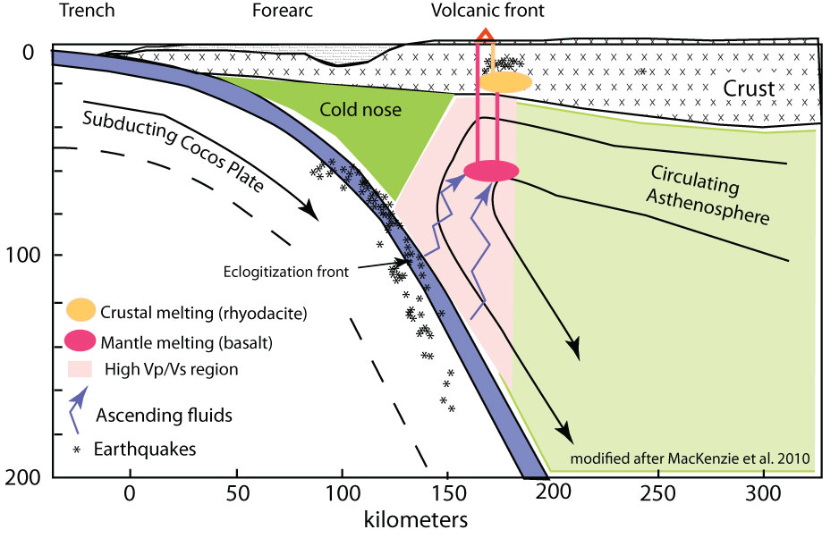
Figure 5: Simplified cross-section through northern Nicaragua and the Central American subduction zone based on geophysical profile of MacKenzie et al. (2010). Pinkish area shows regions of low Vp/Vs, signaling areas that are richer in fluids and melts than circulating asthenosphere beneath the backarc region. Note two distinct regions of melting, deeper region ~60 km deep where mantle melting generates basalt (like those erupted at Cerro Negro) and shallower region in crust ~20 km deep, where felsic melts (like those of Ilopango) are generated.

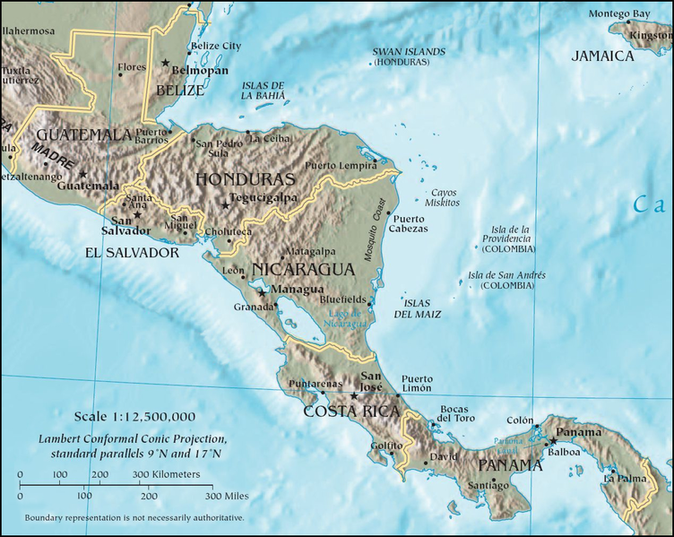
Figure 6: Political geography of Central America showing country boundaries, capital cities (stars), and other major cities. (Source Wikipedia)

CULTURAL SETTING

The ~1100 km length of CAVA is about the distance from New York City to Chicago, and it spans six Central American nations (from N to S: Guatemala, El Salvador, Honduras, Nicaragua, Costa Rica, Panama; Fig. 6). These countries are relatively small in area: for example Nicaragua is about the size of the U.S. state of Arkansas. Costa Rica is about the size of the U.S. states of Vermont and New Hampshire combined. Many of the ~40 million people of these nations live near volcanoes, including those who live in four of these nations’ capitols: San Jose (Costa Rica) near Irazu volcano, Guatemala City at the foot of Pacaya volcano, San Salvador at the foot of Boquerôn volcano, and Managua (Nicaragua) at the foot of Masaya volcano. Honduras and Belize are also in Central America but they lack active arc volcanoes.

The people living in Central America have origins that derive from a mixture of indigenous cultures (Mayan predominantly) and predominantly Spanish European settlers. The most frequently spoken common language is Spanish, and many of the economies are based on agriculture and tourism, which are both strongly influenced by the presence of CAVA.
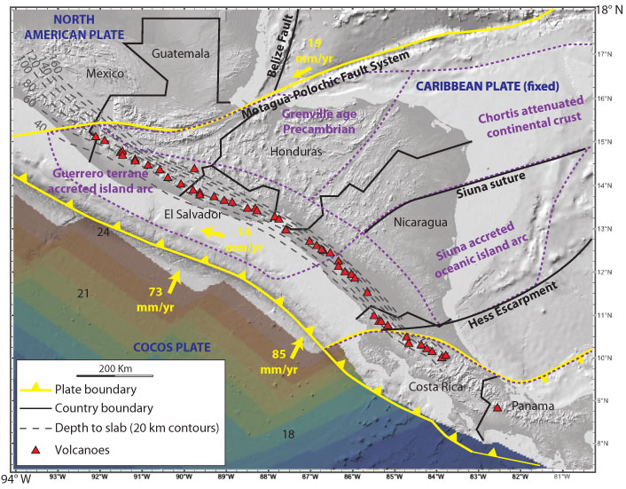

Figure 7: Simplified tectonic map of the Central American convergent plate boundary. Red triangles mark CAVA volcanoes. Colors of Cocos plate seafloor correspond to ages, from 24 Ma (brown) to 18 Ma (greenish blue). Yellow lines mark plate boundaries and yellow arrows show relative plate motions. Dashed lines show approximate depths to the top of the subducted Cocos plate, after Syracuse and Abers (2006). Dashed purple lines define subterranes; note that continental crust underlies NW Central America (Chortis Terrane) but Late Cretaceous oceanic plateau of the Caribbean Large Igneous Province underlies Nicaragua and Costa Rica.

CENTRAL AMERICAN VOLCANIC ARC (CAVA)

The ~1100 km long CAVA begins near the Mexico-Guatemala border, at the western extension of the Motogua-Polochic fault. This gigantic fault marks a Cretaceous suture zone that has been reactivated as a left-lateral transform fault that now separates the North American and Caribbean plates (Fig. 7). The Cocos plate is also subducted beneath southernmost Mexico, so why does not the volcanic front continue farther NW into Mexico? We do not know. Why CAVA ends in the very NW corner of Panama is also mysterious. The Cocos plate is subducted underneath much of Panama, but CAVA just stops. The SE termination is even more surprising than the NW termination, because the volcanoes at this end – Barbra, Irazú, and Turralba – are the largest of all CAVA volcanoes. The SE termination is not associated with a major fault like the Motogua-Polochic fault. Why does CAVA end in the SE? We do not yet know.

The crust upon which CAVA was built varies from NW to SE. Continental crust of Paleozoic and older age of the Chortis terrane underlies NW Central America (Guatemala, Honduras, and possibly El Salvador) but the crust beneath SE Central America (Nicaragua, Costa Rica, and Panama) is Late Cretaceous oceanic plateau of the Caribbean Large Igneous Province. It is not yet clear whether or not the more continental nature of crust in the NW as opposed to the more oceanic nature of the crust in the SE has any effect on the composition of lavas erupted by CAVA volcanoes.

The CAVA volcanic front is a chain, made of right-stepping, linear segments, each 100 to 300 km long (to learn more about the offset, segmented alignments of CAVA volcanoes, see SERC minilesson ““Volcanoes of Central America”). CAVA volcanoes are clustered into 39 distinct centers, each center comprising multiple volcanic vents, ranging from maars to calderas, and including cinder cones, composite cones, domes, and shield volcanoes. Each center is separated by about 27 km from its neighbors (Carr et al., 2003). The interested student can learn about each of these volcanic centers by downloading <CAVolcfront.xls> from Prof. Mike Carr’s website (http://rci.rutgers.edu/~carr/), then looking up individual volcanoes on the Smithsonian Global Volcanism webpage (http://www.volcano.si.edu/index.cfm). Not all 72 of the volcanoes listed in Carr’s table have information listed in the Smithsonian compilation, only those classified as active, which in this context refers to those erupting in the last 10,000 years or so.

CAVA is made up of distinctive landforms that are clearly visible at many scales, so a good way to explore CAVA is to use GeoMapApp. GeoMapApp is an Earth science exploration and visualization tool that is freely available on the internet and easy to use (http://www.geomapapp.org/). Another good way to explore CAVA is with Google Earth, which is another application that is free and easy to use (earth.google.com). As an example of how one can use Google Earth to study CAVA, open Google Earth on your computer and in the upper left “search box”, type in “Cerro Negro”; you will be transported there immediately. (Cerro Negro is one of the volcanoes that we will study in Handout Part 2, below). Note on the Google Earth image there are many icons (little blue squares) where people have posted their ground photos. You can take your own field trip by clicking on one icon after another!

References

MacKenzie, Laura S., et al. "Imaging a steeply dipping subducting slab in Southern Central America." Earth and Planetary Science Letters 296.3 (2010): 459-468

Syracuse, E. M., and G. A. Abers (2006), Global compilation of variations in slab depth beneath arc volcanoes and implications, Geochem. Geophys. Geosyst., 7, Q05017, doi:10.1029/2005GC001045

