***Investigation & Experimentation:***

* A. *Students will* select and use appropriate tools and technology to perform tests, collect data, analyze relationships, and display data.
* B. *Students will* analyze situations and solve problems that require combining and applying concepts from more than one area of science.

**Background:**

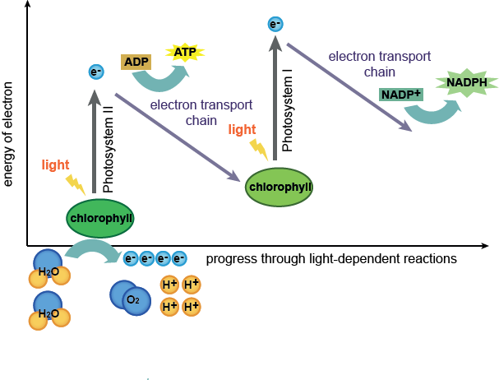A solar cell is a light sensitive material that can collect solar energy and convert it into electrical/chemical energy. In this lab you will create a solar cell that mimics the architecture used in natural photosynthesis. The solar cell that you will create will be made of readily available materials: TiO2 paste (essentially white pigment, that absorbs little light), anthocyanin dye (from blackberry juice), electrolyte (I2 – iodine and KI – potassium iodide solution), and conductive glass (it is transparent, but acts like a metal).

A solar cell works similarly to a leaf on a plant. The chlorophyll dye (chlorophyll a) in a leaf absorbs solar energy and converts it into chemical energy (sugar); a solar cell takes solar energy and converts it into electrical energy, but creates no net chemicals and thus is termed regenerative. Leaves store net chemical energy and are termed photosynthetic.

Blackberries contain a strongly light-absorbing dye molecule called anthocyanin, which occurs in many types of fruits and berries. It is the compound that gives blackberries, raspberries, blueberries, and pomegranates their color. These dyes can be extracted and used in a dye-sensitized TiO2 solar cell to absorb light and convert the light’s energy into electricity.

**Anthocyanin (Blackberry Dye)**

Chemical Formula: C15H10O6

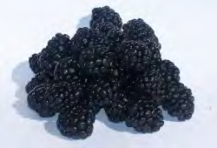Brian O’Regan and Michael Grätzel at the École Polytechnique Fédérale De Lausanne in Switzerland made the first efficient DSSC. The approach used in DSSCs has many advantages over other solar energy conversion technologies because of its simple device construction and inexpensive TiO2 particles and dyes that can be fine-tuned to increase their light-absorbing properties. Although there is still much room for improvement, state-of-the-art DSSCs converts solar energy into electricity with efficiencies over 10%, rivaling some silicon-based technologies (commercial silicon is typically around 10 – 15%). These devices use specially prepared dyes that absorb a great deal more sunlight than the anthocyanin dyes extracted from the blackberries.

**Materials and Supplies:**

Per group of students

• 2 Transparent Conductive Glass Plates

• 1 Pipette*

• 1 Tweezer* or tong

• 1 Graphite pencil*

**Preparing TiO2 Electrode** *(See* [*http://www.youtube.com/watch?v=RYO09FdCN5I for a demonstration)*:](http://www.youtube.com/watch?v=RYO09FdCN5I%24for%24a%24demonstration)%3A%2B)

1. Split the students up into groups of two, for up to 30 students in total.

2. Take the larger, 2.5 cm x 2 cm, conductive glass electrode and ensure that the conductive side is facing up; do this by using the multimeter probes to measure resistance across two points on the glass surface. Share the multimeters between groups. Ensure that the multimeter is **set to resistance mode (Ω)** on any setting. (*Carefully handle the sides of the glass electrodes and avoid touching the faces of the electrodes.*) If no resistance is measured turn the electrode over and measure again. Typical resistances should be around 10 – 30 ohms.

3. Tape the electrode down to a clean, sturdy surface so that the tape masks off ~1.5 cm (bigger is better) down along the length of the electrode (Figure 1a). This will create a lane down the center of the electrode where the TiO2 paste will be spread.

4. Using a pipette, drip a few (~10 – 20) drops of the TiO2 solution halfway down the center of the plate and immediately squeegee the solution down and up once with the paste spreader. The tape should act a bumper, allowing for an even coating of the center lane (Figure 1b, c). If a TiO2 film does not coat the entire exposed surface (Figure 1c), quickly drip a few more drops of TiO2 on the exposed areas and re4squeegee the entire film. Allow the electrodes to dry, undisturbed, for a few minutes. During this time, rinse the pipette with water to remove the leftover TiO2 paste.

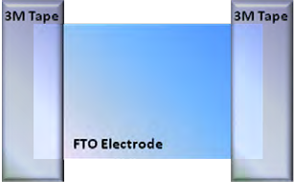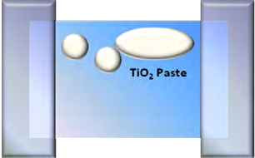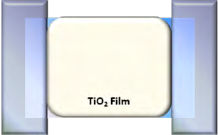

***Figure 1( (a, b, c).*** *Steps for depositing TiO2 paste and “doctor blading.” The middle lane should be almost as wide as you can make it. Only put paste near one edge and pressing with little force, squeegee down and back up each once; you should not need to repeat the process.*

5. Remove the 3MTM Scotch® tape from the dried TiO2 electrode. Carefully wipe any remaining white paste off the bottom of the glass using a moist paper towel.

6. *Note about hot plates: You can place the electrodes onto a* ***cold*** *hot plate so you do not burn the fingers. Then turn the hot plate on. It will take extra time to heat up. The teacher can monitor the hot plate, and turn it off at the end of the day. Then, the hot plate will be cool to the touch for the next class with no fear of students burning their fingers*.

Using tweezers or tongs, carefully place the TiO2 electrode onto a hot plate. The electrode is ready, i.e. fully sintered, after it darkens in color and then turns bright white (~30 min). Use tweezers or tongs to remove the electrode from the hot plate, handling it only on the edges. Allow the electrode to cool for 15 minutes by setting it on a designated tray. (Caution: Cooling too quickly can cause the glass electrode to fracture.)

*Classroom management tip: Make a diagram of the layout of students’ electrodes, and place them on the hot plate in that order. That way, students will know they are working with the electrode they made.*

**START HERE**

**7. Take the other smaller, 2.5 cm x 1 cm, piece of conductive glass—this will be the *counter electrode*. Use a multimeter to find the conductive side (see step 1). Use a golf pencil to coat the entire surface with graphite (pencil lead).**

**Dyeing the TiO2 Electrode and Assembling the DSSC:**

1. Prepare the dye by thoroughly crushing 1 – 2 blackberries in a baggie by squeezing the outside of the baggie or in a centrifuge tube with a straight utensil.

2. Take the cooled electrode and place it into the blackberry solution in the baggie or centrifuge tube for ~5 minutes. (*Use tweezers or tongs to handle the electrode.*) Ensure that the electrode is fully submerged (add more water if necessary). The white TiO2 paste should turn purple throughout so there is no white left. Continue with the next step while you wait.

3. Using a beaker to catch your waste fluid, rinse the dyed TiO2 electrode with the bottle of distilled water. Then thoroughly rinse again with isopropanol or ethanol into the same waste beaker. Allow the dyed electrode to dry for 5 – 10 minutes.

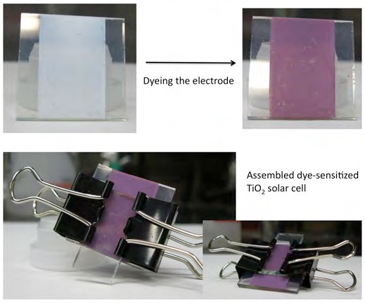

4. Assemble the dyed TiO2 electrode with the counter electrode (the one with graphite) using 2 binder clips to form a sandwich thin film cell. Follow the picture to the right, and make sure the graphite coating is touching the purple dyed TiO2 surface and avoid overlapping the bare glass electrodes (the sides). The thinner graphite coated electrode should line up with the TiO2 line but is offset so that an alligator clip can be attached to each individual electrode.

5. Using a p20 pipette, fill the space between the two electrodes with the iodide/triiodide (I-/I3-) electrolyte solution. Allow the solution to wick up between the electrodes by capillary action. Alternate removing/reattaching each binder clip, one at a time, to facilitate this action. The space between the glass electrodes should turn slightly yellow and be entirely wetted by the solution.

6. To test your solar cell, clip the positive terminus (red) of the multimeter probe to the graphite

electrode and negative terminus (black) to the TiO2 electrode using alligator clips.

1. Measure the voltage obtained in room light, under the light source and outside in the sunshine with the dye sensitized electrode facing the light source. Record your results in the data table. To measure voltage, switch the indicator to DCV (Direct Current Voltage) (*upper left on the* *Cen-Tech Multimeter*) to the lowest setting, **200m**. If it reads a 1, the voltage is too large for that setting and you must switch to the next level, **2000m**, by turning it clockwise. Continue this process until you observe a reading other than 1.
2. To measure current, switch the indicator to DCA (*upper right on the Cen-Tech Multimeter)* to the lowest setting, 200μ. Again, if you see 1 one the display, switch the indicator clockwise to the next setting and repeat until a meaningful value is obtained.

|  |  |  |
| --- | --- | --- |
| Group # | Voltage (unit) | Current (unit) |
| 1 |  |  |
| 2 |  |  |
| 3 |  |  |
| 4 |  |  |
| 5 |  |  |
| 6 |  |  |
| 7 |  |  |
| 8 |  |  |

The figure below shows that dye becomes excited (i.e., dye*) after electrons in dye absorb light energy. Dye* gives off electrons, leaving dye in a non-excited, oxidized state (i.e., dye+). Electrons in iodine replenish the electrons of dye+, restoring itback to regular dye.

On the TiO2 electrode (anode): TiO2–Dye + photon TiO2–Dye*  e- in TiO2 and Dye+

In the electrolyte solution: Dye+ + 2 I-  {possible&intermediate}  Dye + I2- ;

2 I2- I- + I3-

On the graphite-coated counter electrode (cathode) I3- + 2 e- 🡪 3 I-

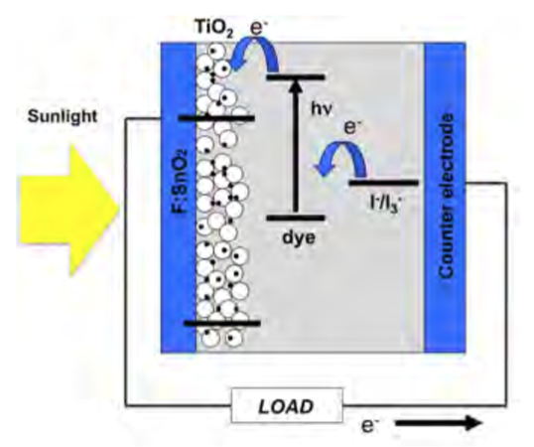

Compare the energy harvesting mechanism in DSSC vs. the photosynthesis (see the figure in p.1).

|  |  |  |  |  |
| --- | --- | --- | --- | --- |
| **Component in the photosynthesis** | **Corresponding component in DSSC** | **The function in Photosynthesis vs. function in DSSC** | **Appropriateness of the analogy (1-10) where 1=not at all 10=very appropriate** | **Notes** |
| Water | I-/I3- | PS: The water is used to replenish the electrons that were being excited from the chlorophyll  DSSC: The I-/I3- was used to replenish the electrons that were being excited from the blackberry dye | 10 | The comparison was appropriate because these two analogous component was used to accomplish the same purpose—replenishing electrons |
|  |  | PS:  DSSC: |  |  |
| **Component in the photosynthesis** | **Corresponding component in DSSC** | **The function in Photosynthesis vs. function in DSSC** | **Appropriateness of the analogy (1-10) where 1=not at all 10=very appropriate** | **Notes** |
|  |  | PS:  DSSC: |  |  |
|  |  | PS:  DSSC: |  |  |
|  |  | PS:  DSSC: |  |  |
|  |  | PS:  DSSC: |  |  |
|  |  | PS:  DSSC: |  |  |