Web-based Interactive Landform Simulation Model -- Grand Canyon (WILSIM-GC) Parameters

1. Subsidence Rate Along Grand Wash Fault

Variable Description
WILSIM-GC models the Grand Wash fault and can be found on the westernmost part of the simulated topography. The Grand Wash fault is a normal fault system consisting of two separating blocks along the fault line with a hanging wall and a foot wall. The hanging wall in a normal fault system subsides and decreases in elevation relative to the foot wall as illustrated below.
The subsidence rate within the model determines the rate or speed at which the hanging wall subsides in relevance to foot wall.

How to use the Model
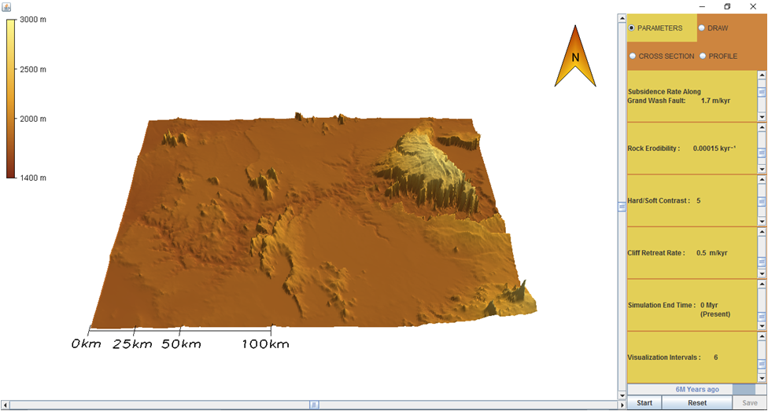
- To change the parameter values, move the Scroll Bar or click on the Arrows next to the parameters.
- Notice there are four tabs in the upper right corner labeled Parameters, Draw, Cross Section, and Profile. Click the DRAW tab. You can create a cross section line across the fault by clicking and dragging your cursor to form an arrow at that location. To remove a cross section line, select Clear.
- Click on the PARAMETERS tab and then hit the Start button to run the simulation.
- To pause the simulation, click Pause; to continue simulation, click Continue (the button toggles between Pause and Continue upon clicking).
- When the simulation is finished, view the resulting 3-D topography in the PARAMETERS tab. Click on the CROSS SECTION tab and view the topographic changes along the cross section line you created. Similarly, you can click on the PROFILE tab to view the topographic changes along the river. Horizontal and/or vertical grid lines can be viewed on the Cross Section and Profile graphs by selecting the empty boxes beneath the tabs. The default values of the model creates a topographic line for every passing million years resulting in a total of six lines.
- In the lower right corner next to the Start/Pause and Reset buttons is a Save button. The Save button provides an option to save the data from the current simulation and can be viewed in Microsoft Excel.
- To start a different simulation, click the Reset button and then click Start to begin the simulation.

Exercise
Draw a cross-section line across the fault line similar to the image below by selecting the DRAW tab. Then click and drag your mouse across the fault line and release the mouse to create an arrow.
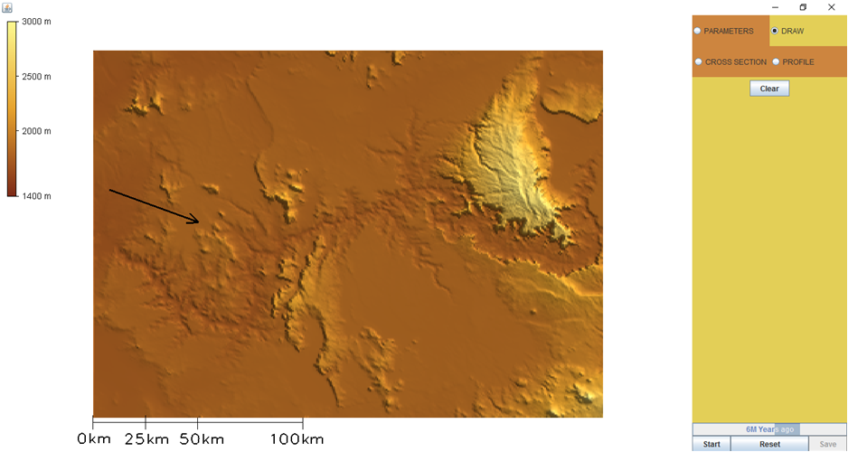
Run the simulation using the default parameters as shown below.

Subsidence Rate Along Grand Wash Fault: 1.7 m/kyr
Rock Erodibility: 0.00015 kyr⁻¹
Hard/Soft Contrast: 5
Cliff Retreat Rate: 0.5 m/kyr
Simulation End Time: 0 Myr (Present)
Visualization Interval: 6 equal interval saves

- How has the landscape and the topography along the fault line (far left) changed (click the CROSS SECTION tab to view the topographic changes along the transect line)?
- Hypothesize how the landscape would change if you increased the subsidence rate along the Grand Wash Fault, and explain your predictions.
- Now change the subsidence rate value to 0.90 m/kyr. How is the shape of this landscape along the fault line different than the default landscape (click the CROSS SECTION tab to view the topographic changes along the transect line)? Were there any changes to the landscape that you didn't predict? If so, what were they and why did they occur?
- Now change the subsidence rate value to 2.51 m/kyr. How is the shape of this landscape along the fault line different than the default landscape (click the CROSS SECTION tab to view the topographic changes along the transect line)? Were there any changes to the landscape that you didn't predict? If so, what were they and why did they occur?
- How would you generalize the relationship between the subsidence rate variable and the topography along the fault line? For example, “as the subsidence rate value increases, the elevation between the top of the hanging wall and the top of the foot wall ________ (decreases/increases).”
- How does the subsidence rate variable relate to geological properties and processes? That is, how would you extrapolate from these simulation results to real-world landscape evolution?

