Exploring the Grand Canyon Using WILSIM-GC:
Changing multiple parameters simultaneously
Introduction
In this module, you will explore the effects of changing multiple parameters simultaneously. When you have successfully completed this exercise, you will understand how the physical model parameters interact with each other and will be able to describe how those interactions affect the landscape that develops.
Learning Goals
After completing this exercise, you will be able to:
- Understand how multiple geological forces interact with one another to create landforms such as the Grand Canyon
- Explain the effects of decreased and increased erosion rates
- Recognize that similar shaped landforms can develop in different ways
Exercise 1: Interactions Between Pairs of Parameters
Now we will dive into changing two variables for each simulation. Pay attention to both the process as the Grand Canyon evolves over time and the resultant landform. Think about the geological meaning of increasing or decreasing the value for each parameter. For example, when you increase the hard/soft contrast, what does that represent, geologically? In addition, when you change two variables, think about whether the variables will tend to amplify each other or counteract each other. For example, when the rock erodibility parameter is increased, erosion increases in the simulation. If you also increase the cliff retreat rate value in the same simulation, you should see a greater overall increase of erosion in the simulation results. In this example, these variable changes amplify each other and cause greater erosion together than they would separately. The images below illustrate this principle.

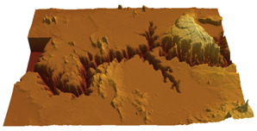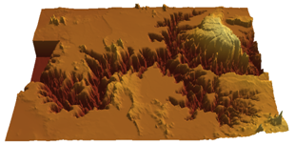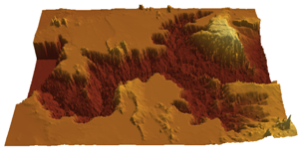
Default values Increased rock erodibility Increased rock erodibility
& cliff retreat rate

- Design a simulation by changing two variables (other than the combination of rock erodibility and cliff retreat rate) to increase overall erosion in the model. Describe whether the variables you chose amplify or counteract one another. Check your design by clicking on the Parameters, Cross Section, and Profile to view the 3D topography, cross-sectional graph, and long profile graph. Save or print out one or more images to prove that you were successful, and write the parameter values you used on the images.

- Design a simulation by changing two variables to decrease overall erosion. Describe whether the variables you chose amplify or counteract one another. Check your design by clicking on the Parameters, Cross Section, and Profile to view the 3D topography, cross-sectional graph, and long profile graph. Save or print out one or more images to prove that you were successful, and write the parameter values you used on the images.

- Design a simulation by changing two variables to have relatively no net change in erosion. Describe whether the variables you chose amplify or counteract one another. Check your design by clicking on the Parameters, Cross Section, and Profile to view the 3D topography, cross-sectional graph, and long profile graph. Save or print out one or more images to prove that you were successful, and write the parameter values you used on the images.

Exercise 2: Maxima
- What would it mean, geologically, if all four of the model parameters were at the maximum values allowed within the simulation?

- What do you think would happen if all four model parameters were set to their maximum values? That is, what would the canyon look like at the end of the simulation?

- Test your hypothesis. How did your prediction compare to the result of your simulation?

Exercise 3: Minima
- What would it mean, geologically, if all four of the model parameters were at the minimum values allowed within the simulation?

- What do you think would happen if all four model parameters were set to their minimum values? That is, what would the canyon look like at the end of the simulation?

- Test your hypothesis. How did your prediction compare to the result of your simulation?

Exercise 4: Reproducing the Grand Canyon
The default values for WILSIM-GC were chosen for two reasons:
- They approximate the values of the geologic properties they are simulating, and
- The simulated canyon that develops with these values is a close approximation of the Grand Canyon.
However, as you have seen, the model parameters interact with each other in ways that amplify or counteract each other's effects.
Can you create a landscape similar to the Grand Canyon, using values significantly different than the default values of the model? Aim to produce a simulation that has an output or result similar to the simulation output of the default values. Play around with the parameters to see how close you can get to producing a similar landscape with different values. Save or print out the results from your best approximation and write the parameter values you used on the images.

Open-ended Exploration:
Explore the model at your own rate. Set the parameter values to your choosing, make a hypothesis, and run the model. Change the end time of the simulation to see what could happen in the future. Discover the power of using a simulation to understand landscape evolution.

