Exploring the Grand Canyon Using WILSIM-GC:
Interpreting simulated landforms, cross-sections and profiles
Introduction
In the previous exercise, you learned how each variable affects the end result of the model. In this module, you will apply what you learned in prior exercises to interpret simulated landforms, cross-sections, and profiles.
Learning Goals
When you have successfully completed this exercise, you will be able to understand how each of the four physical parameters (subsidence rate, rock erodibility, hard/soft contrast, and cliff retreat rate) affects the resulting topography by viewing the 3D topography, cross-section graphs, and long profile graphs.

Exercise 1: Interpreting (Simulated) Landscapes
The following page shows landscape images of the Grand Canyon from four pairs of simulations. In each simulation, one variable was changed from the default value (shown in the left image) to its maximum possible value in WILSIM-GC (shown in the right image). The subsidence rate, rock erodibility, hard/soft contrast, and cliff retreat rate are the only variables used in the below scenarios.
- Describe the changes you see in each scenario (1-4) below.

- Based on your prior experience with WILSIM-GC, make an educated guess about which variable was changed in each of the scenarios. Write your guesses beside each pair of diagrams.

- What characteristics do you see in each image (on the right) that led you to suggest that variable has changed?

- Now run several simulations in WILSIM-GC, by changing one variable to its maximum value in each simulation (with the rest of the variables set to their default values) and compare the simulation results to the Grand Canyon topography images below. Were your educated guesses correct? If not, explain what information you misinterpreted, and how you will be able to make a correct interpretation in the future.

Simulated Landscapes
Scenario 1
Scenario 2
Scenario 3

Scenario 4

Exercise 2: Interpreting (Simulated) Cross-sections

The following page shows cross-sectional graphs of the Grand Canyon from four pairs of simulations. In each simulation, one variable was changed from the default value (shown in the left image) to its maximum possible value in WILSIM-GC (shown in the right image). The subsidence rate, rock erodibility, hard/soft contrast, and cliff retreat rate are the only variables used in the below scenarios. The image below shows where the cross-section line was drawn to create the images in scenarios A-D. Use the information from the image below and the graphs in each scenario to answer the following questions.
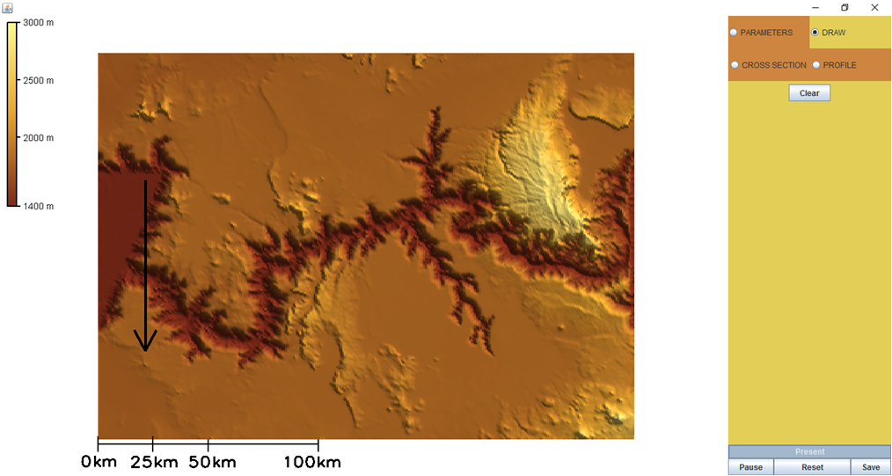

- Describe the changes you see in each scenario (A-D) below. The following image displays where the cross-section line was drawn to obtain the graphs in scenarios A-D. Use this information to determine which variable was changed.

- Based on your prior experience with WILSIM-GC, make an educated guess about which variable was changed in each of the scenarios. Write your guesses beside each pair of diagrams.

- What characteristics do you see in each image (on the right) that led you to suggest that variable has changed?

- Now run several simulations by changing one variable to its maximum value in each simulation (with the rest of the variables set to their default values) and compare the simulation results to the cross-section graphs below. Were your educated guesses correct? If not, explain what information you misinterpreted, and how you will be able to make a correct interpretation in the future.

Simulated Cross-Sections
---5.0 Myr Ago ---4.0 Myr Ago ---3.0 Myr Ago ---2.0 Myr Ago ---1.0 Myr Ago ---Present
Scenario A
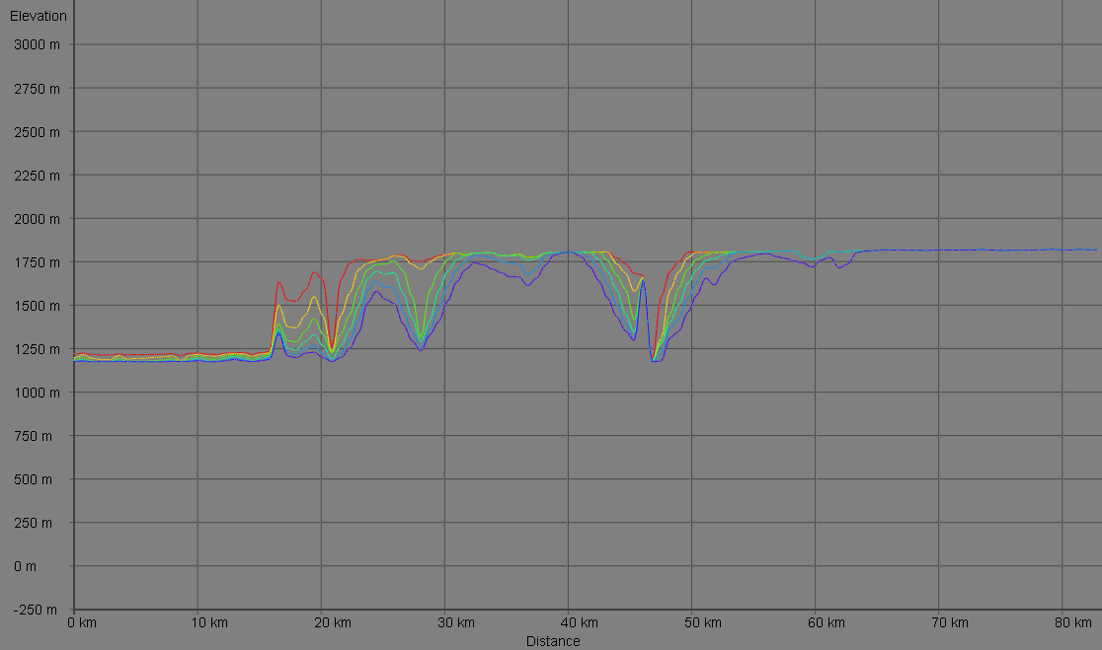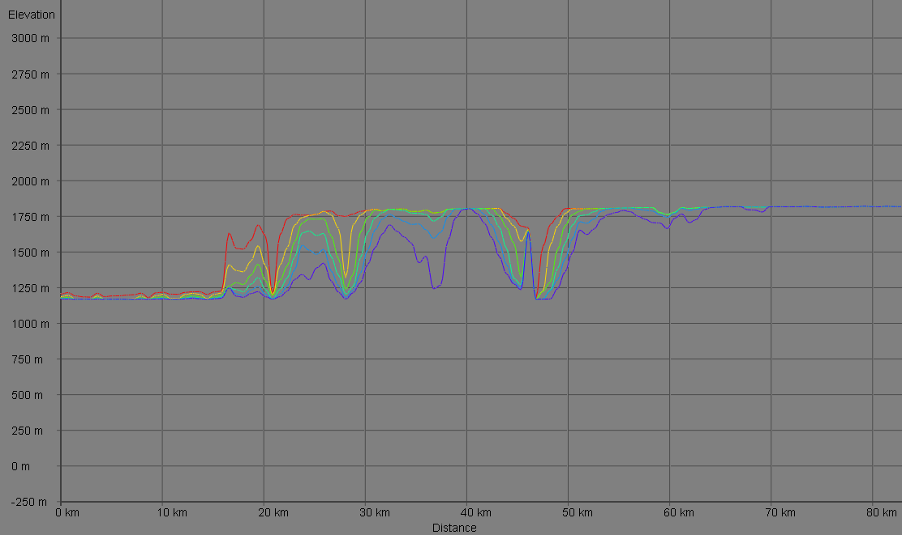
Scenario B
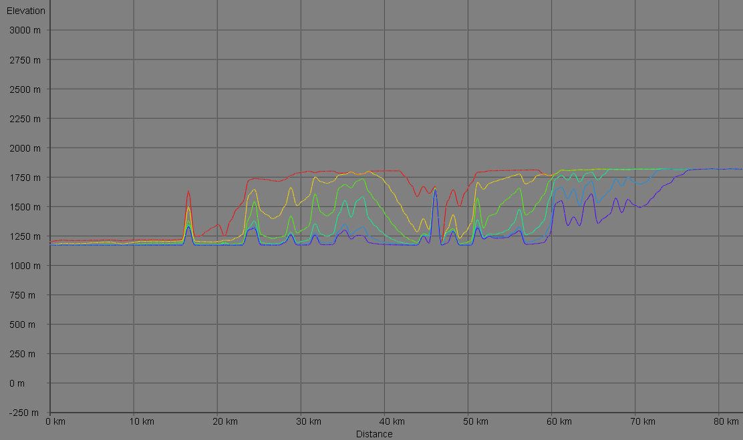
Scenario C
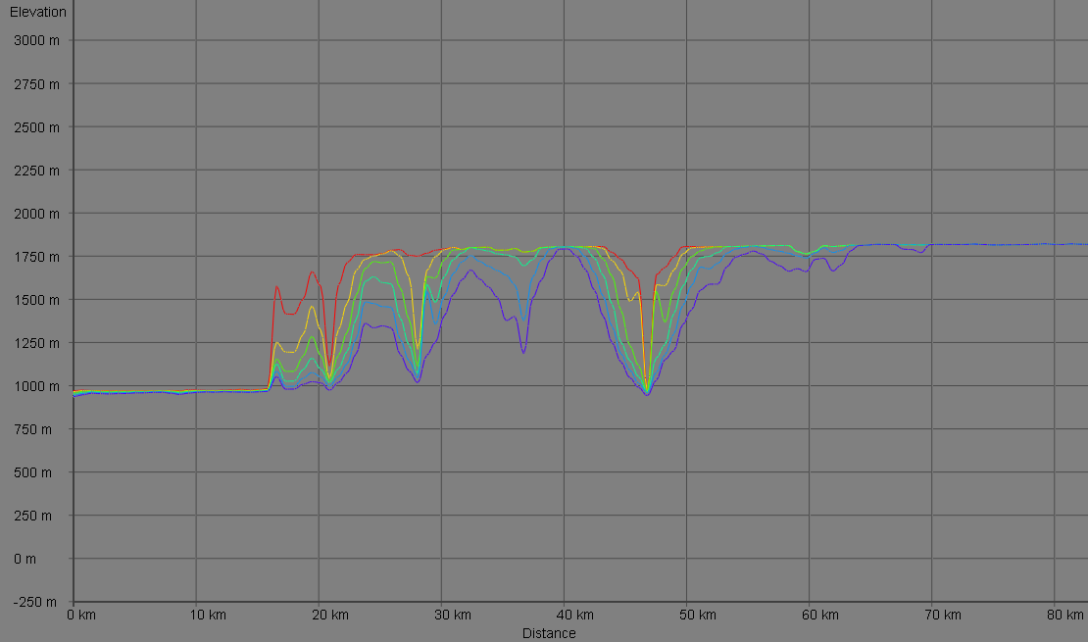

Scenario D
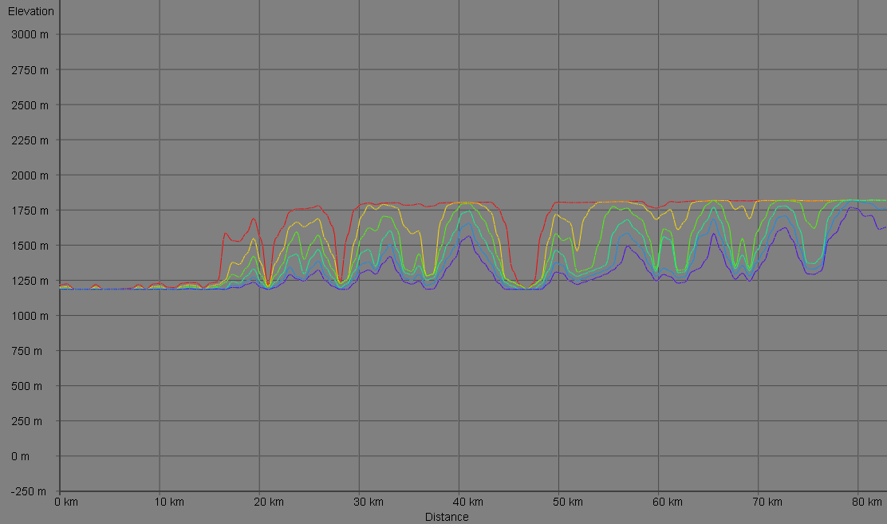

Exercise 3: Interpreting (Simulated) Long Profiles

The following page shows long profile graphs of the Grand Canyon from four pairs of simulations. In each simulation, one variable was changed from the default value (shown in the left image) to its maximum possible value in WILSIM-GC (shown in the right image). The subsidence rate, rock erodibility, hard/soft contrast, and cliff retreat rate are the only variables used in the below scenarios.
- Describe the changes you see in each scenario (I-IV) below.

- Based on your prior experience with WILSIM-GC, make an educated guess about which variable was changed in each of the scenarios. Write your guesses beside each pair of diagrams.

- What characteristics do you see in each image (on the right) that led you to suggest that variable has changed?

- Now run several simulations by changing one variable to its maximum value in each simulation (with the rest of the variables set to their default values) and compare the simulation results to the profile graphs below. Were your educated guesses correct? If not, explain what information you misinterpreted, and how you will be able to make a correct interpretation in the future.

Simulated Profiles
---5.0 Myr Ago ---4.0 Myr Ago ---3.0 Myr Ago ---2.0 Myr Ago ---1.0 Myr Ago ---Present
Scenario I
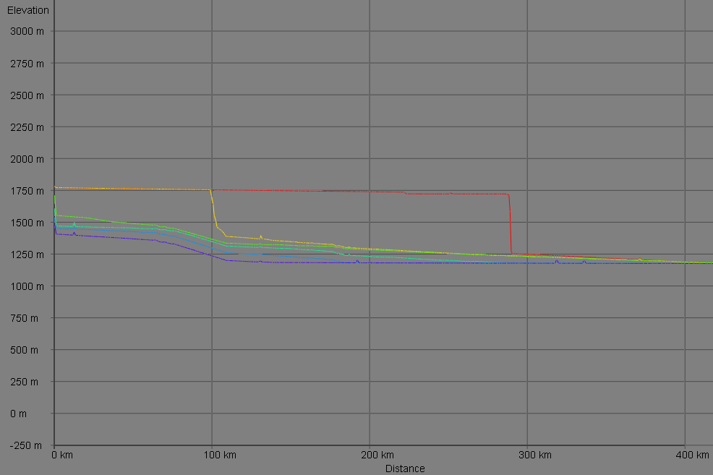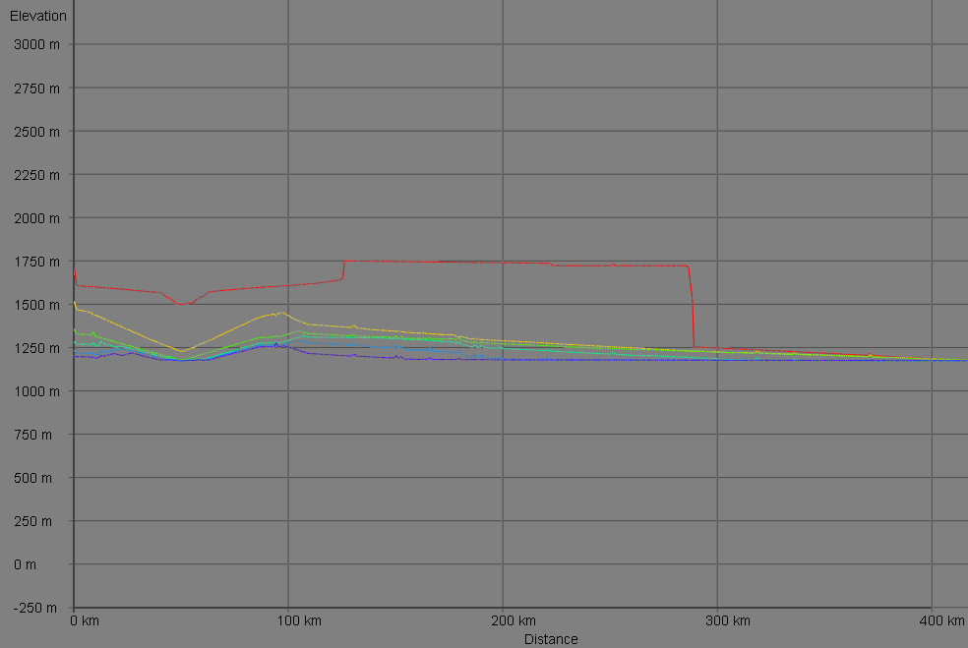
Scenario II
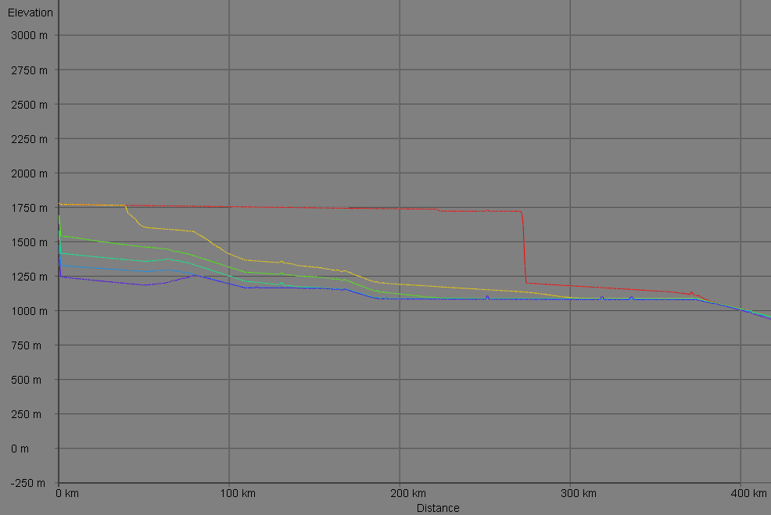

Scenario III
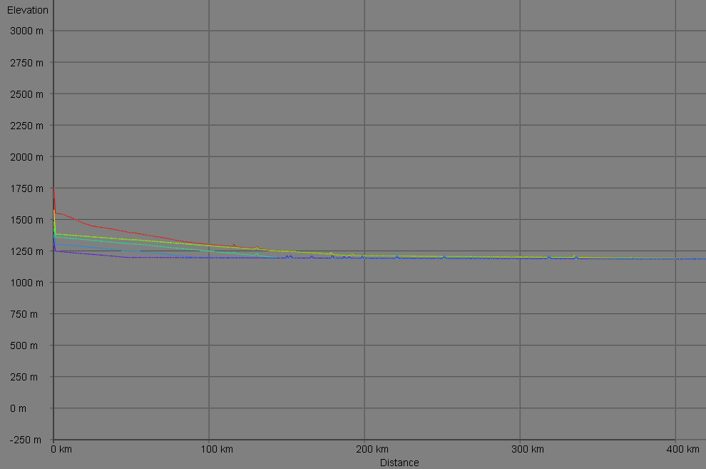
Scenario IV
