The Grand Canyon:
How Stratigraphy and Fluvial Processes Affect Its Development

- Introduction
The Grand Canyon is one of the most spectacular landforms on Earth. Have you ever wondered how it formed? The Web-based Interactive Landform Simulation Model – Grand Canyon (WILSIM-GC) is a computer simulation designed to help you understand and visualize the geologic processes that interacted to form the Grand Canyon over the past 6 million years. Before we get into the modeling, this exercise will give you some background information.
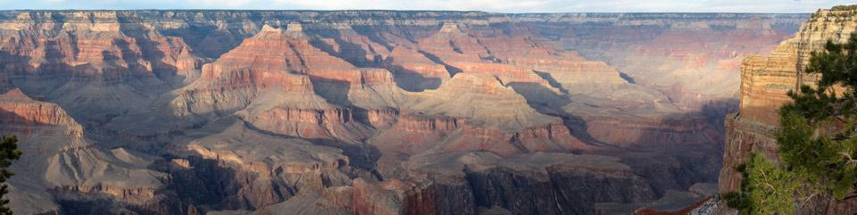
Figure 1: Grand Canyon National Park at sunset, from the south rim. Photo courtesy of the National Park Service.

Landforms, such as mountains and valleys, are created by the interactions of several geologic processes, including plate tectonics, weathering, and erosion. These processes operate over long geologic time scales and thus it is virtually impossible to observe the evolution of most landforms during a human lifetime (occasionally, a catastrophic event, such as a landslide, will dramatically alter the landscape in a very short period of time). Computer simulations such as WILSIM-GC, make it easier to understand and visualize landform evolution by simulating these processes.

- Learning Goals
In this exercise, you will learn about how landforms are created and changed over time, what weathering or erosional variables influence landform evolution, and how a landform simulation model specifically focusing on the Grand Canyon is effective in demonstrating the processes that control landform evolution. When you have successfully completed this exercise, you should be able to:

- Define relief, cliff retreat, knickpoint, and knickpoint migration

- Explain the roles of faulting, weathering, gravity, cliff retreat, and fluvial erosion in the development of the Grand Canyon

- Describe how the types of rocks that form the walls of the Grand Canyon influence the shape of the canyon

- Origin of the Grand Canyon
Most scientists believe that a steep-walled and deeply incised canyon began to form, where the Grand Canyon is now, approximately 16 million years ago (Ma). At that time, movement on the Grand Wash-Wheeler Fault system (see Figure 2), at the downstream end of the Grand Canyon, created topographic relief (the amount of topographic change within a particular area, measured by the difference in elevation between the highest point and the lowest point in a given area). However, this was well before the Colorado River flowed in this region. Between about 16 Ma and 6 Ma, a canyon was forming slowly, driven by a relatively small river (not the Colorado River) draining a local area. Sometime between 6 Ma and 5 Ma, the Colorado River started flowing over the "step" created by the Grand Wash-Wheeler Fault system. At that time, the erosion that formed the Grand Canyon really accelerated. It is uncertain whether the relief produced along the Grand Wash-Wheeler Fault was created by uplift of the Colorado Plateau or the subsidence of the adjacent Grand Wash-Wheeler Trough. Either way, the difference in elevation from one side of the fault to the other gave the river the power to erode the bedrock on the high side, thus beginning the process of carving out the Grand Canyon.

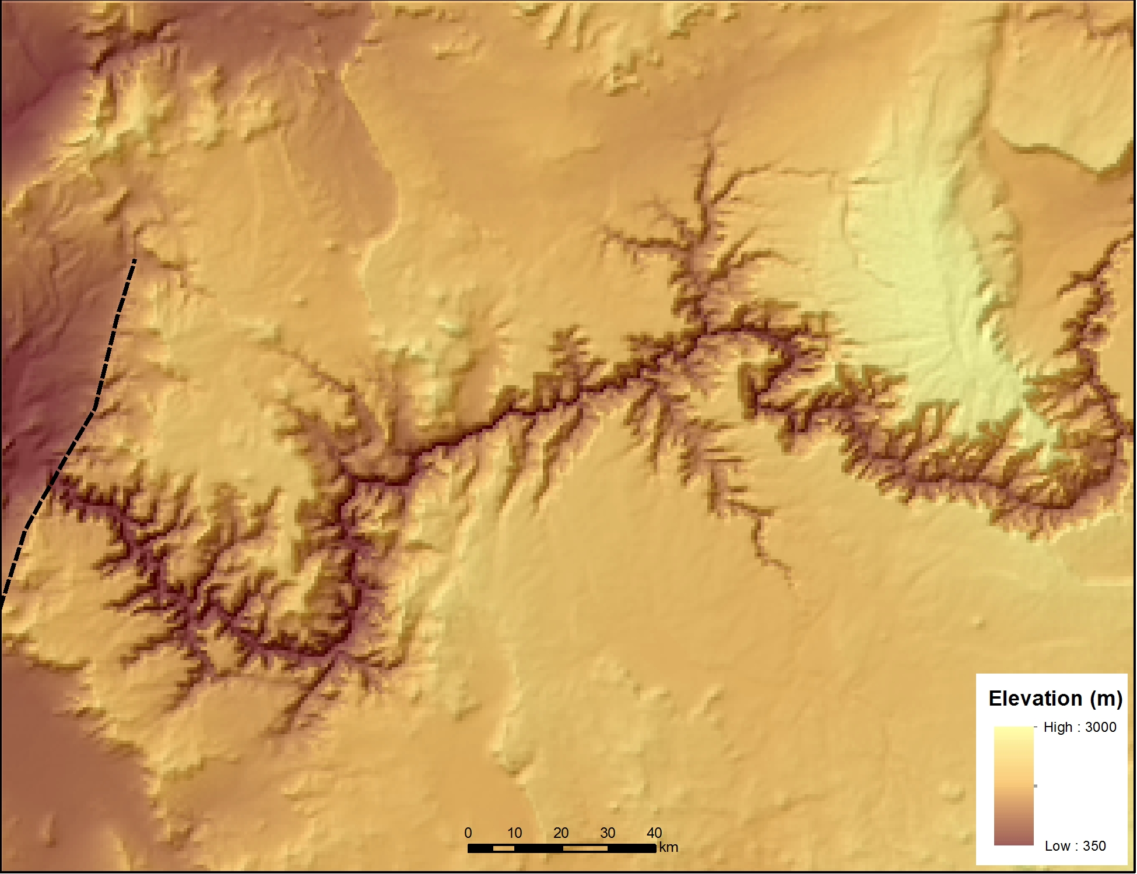
Grand Wash-Wheeler Fault
Figure 2: Shaded relief map of the Grand Canyon at present time. Dashed black line shows the approximate location of Grand Wash-Wheeler Fault. Note the relief created by the fault.

- Development of the Grand Canyon
As the Grand Canyon developed, the Colorado River carved its way down through the rock layers that now make up the walls of the canyon. These layers can be seen in Figure 3, below.

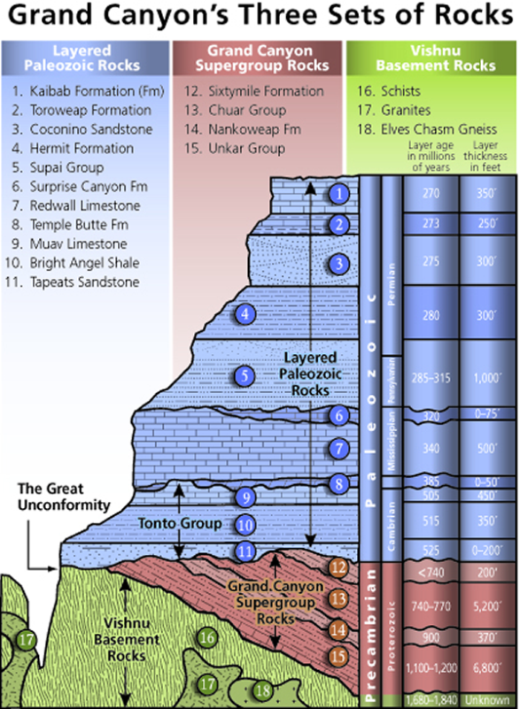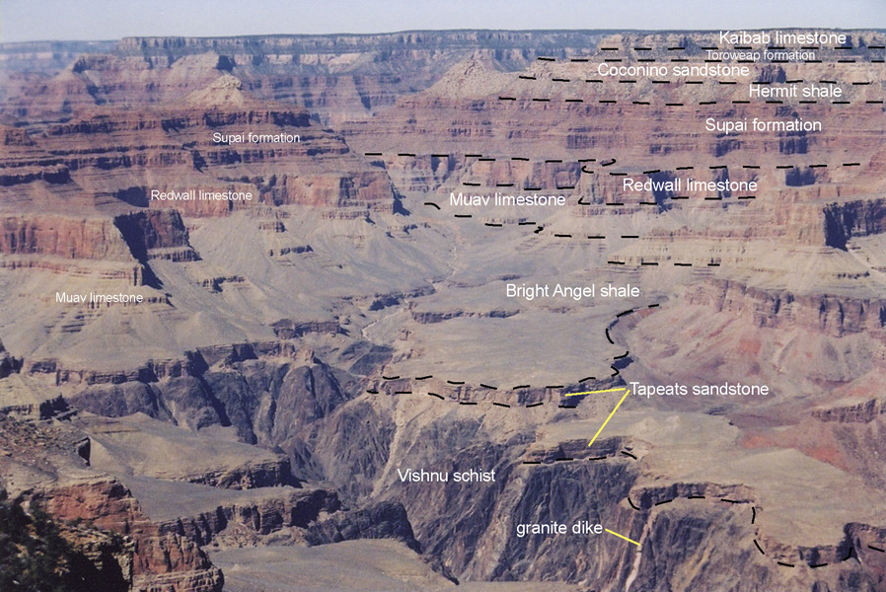
Figure 3: The rocks that form the walls of the Grand Canyon.
Paleozoic sedimentary rocks sit on top of Precambrian igneous and metamorphic rocks.
Images courtesy of the National Park Service (left) and the University of Arizona Geology Department (right).

As you can see from this diagram (as well as in the photo), some of the rock layers form steep cliff walls, while others form more gentle slopes.

Use the two images above in Figure 3 to answer questions 1-3.

Q1: Which rock units form cliffs? For those units that include a rock type in the unit name, what types of rocks are those units composed of? Fill the table below. Be as specific as you can (i.e., be more specific than igneous, sedimentary, or metamorphic). One example is filled for you.

Q2: Which rock units form gentle slopes? For those units that include a rock type in the unit name, what types of rocks are those units composed of? Fill the table below. Be as specific as you can (i.e., be more specific than igneous, sedimentary, or metamorphic).

Cliff |  |  | Gentle slope
Unit # | Unit name | Rock type  (if indicated) | Unit # | Unit name | Rock type  (if indicated)
1 | Kaibab Formation | Limestone

Q3: Based on the table you filled above, which kind(s) of sedimentary rock in this area form cliffs? Which kind(s) of sedimentary rocks form gentle slopes?

Landforms created by running water (such as the Grand Canyon, carved by the Colorado River) are called fluvial landforms and the processes involved are called fluvial processes. You might wonder how a river carves a canyon through bedrock. Several processes are involved here. Weathering processes (both chemical weathering such as dissolution and physical weathering such as frost wedging) weakens and breaks down the bedrock and produces sediment to be transported downhill, pulled by gravity. Sediments carried by running water mechanically erode the bedrock through abrasion (the grinding and wear on rocks due to friction applied by sediments and water). The force of gravity continually causes more water and sediments to flow downhill into eroding channels that lead to further mechanical erosion to deepen, widen, and lengthen channels. This positive feedback mechanism turns the small rills into gullies, and gullies into rivers and eventually canyons.

It is a general principle that harder rocks (those more resistant to erosion) form cliffs, while softer rocks (those more easily eroded) form gentle slopes.

Q4: Considering your answer to question 3: which types of sedimentary rock in the walls of the Grand Canyon are relatively hard? Which are relatively soft?

Rivers flow downhill, creating their own paths as they go. Rivers carry lots of sediment, especially during high-flows, which allows large amounts of moving boulders and sand to abrade the bedrock beneath the water, driving bedrock erosion. Rivers also respond to the rocks and forces surrounding them. The mechanical strength (“hardness”) of rock is affected by weathering and fractures. Rocks with little weathering and few fractures are strong and hard to erode and vice versa. Stronger and harder rock layers are more resistant to river erosion than weaker and softer rock layers. River gradient or slope is defined as the change in elevation of the river bottom over some horizontal distance. It is a dimensionless quantity (i.e. a length divided by a length). Several factors affect river slope, but only rock strength is considered in this exercise. Differences in rock strength often lead to rapid changes in gradient along the river channel, as softer layers are easily eroded away, forming gentler slopes and harder rocks forming steeper slopes. Such rapid change in slope along a river channel is called a knickpoint (Figure 4A). Regardless of how a knickpoint forms, continued erosion over time will usually cause the knickpoints location to move upstream. This is called knickpoint migration (Figure 4A). Knickpoints and knickpoint migration occur in tributary streams as the main river increases erosion rate (Figure 4B). An extreme example of a knickpoint is the near vertical step found at a waterfall. The knickpoint found in the Colorado River in Grand Canyon is less dramatic than a waterfall, but nonetheless represents rapid changes in gradient (Note the scale in the diagram; Figure 5). One possible explanation for the knickpoint above Grand Canyon is differences in rock strength. You will see knickpoint migration in the channels, as well as headward erosion of hillslopes and cliffs in WILSIM-GC as the Colorado River carves through rock layers of varying hardness.

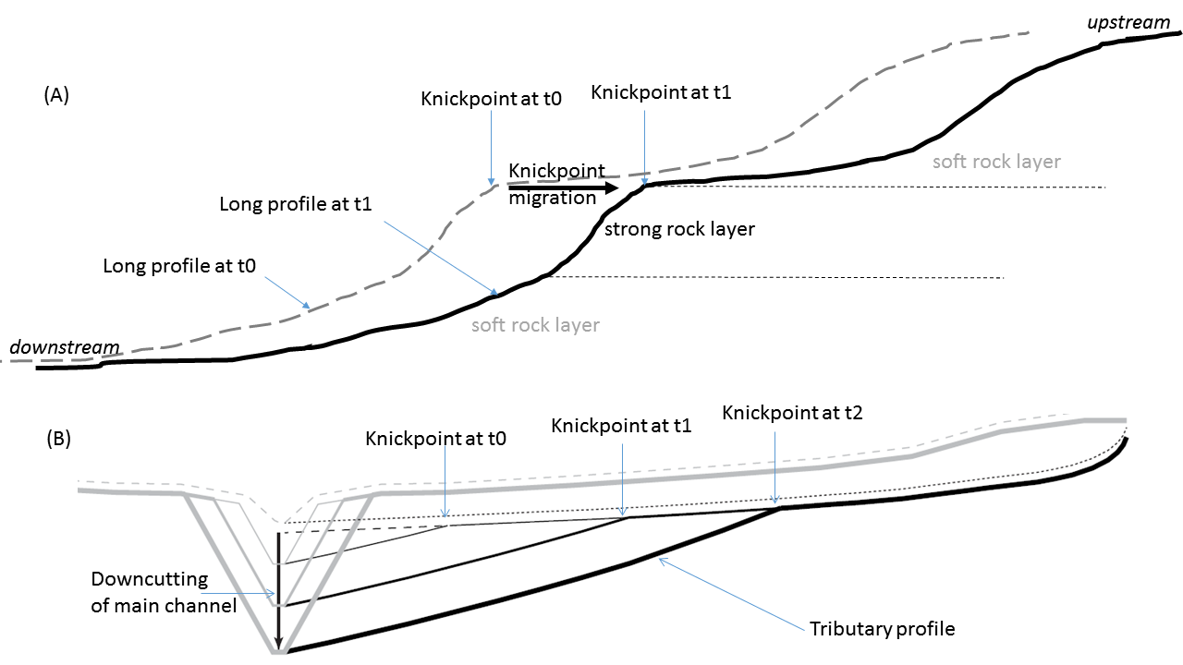

Figure 4. (A) A schematic diagram showing knickpoint and knickpoint migration in relation to resistance (or erodibility) of rock layers. (B) A schematic diagram illustrating knickpoint formation and migration in tributary streams as a result of rapid downcutting in main channel. [Diagram in (B) courtesy of AndrewDarling, Arizona State University].

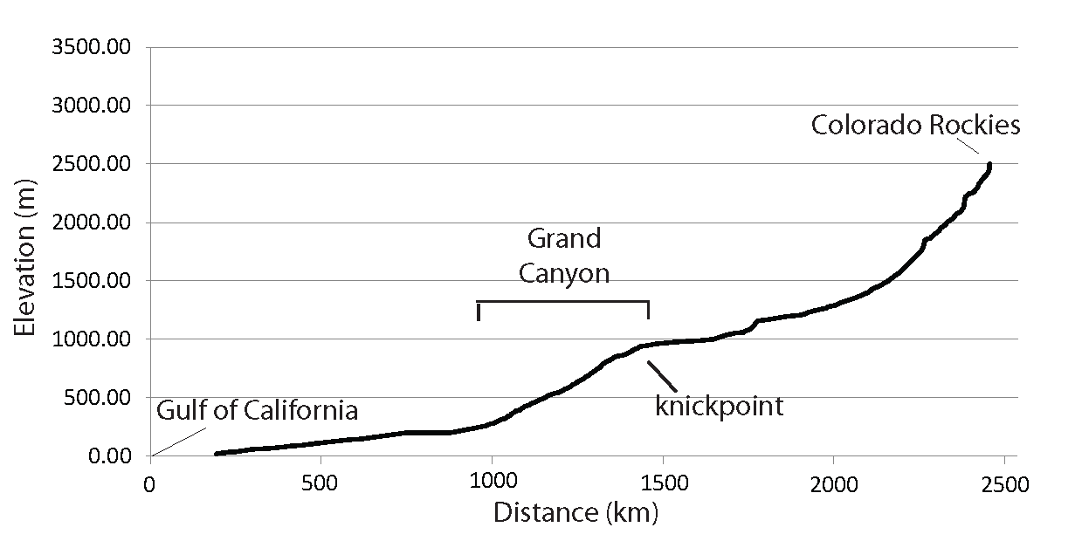

Figure 5. Long profile of Colorado River derived from USGS topographic maps. [Courtesy of Karl Karlstrom Research Group, University of New Mexico].

