**Connect Four PowerPoint Game Instructions**

Susan M. Moncada, Ph.D., CPA

Indiana State University

Susan.moncada@indstate.edu

March 30, 2012

This game has been designed to include 49 multiple choice questions that have three response options. Each numbered slot hyperlinks to a question. Each question hyperlinks to standardized positive and negative feedback slide.

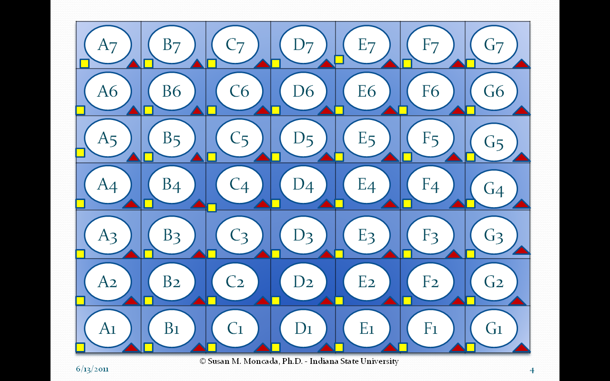**Purpose:** The first team to arrange 4 chips in consecutive sequence horizontally, vertically, or diagonally wins the game.

**Game Playing Overview for Students:**

1. Students are assigned to two teams, Yellow & Red. Either team can go first. Assume Yellow goes first.
2. Student from Yellow Team selects any game oval in row 1. (To simulate the actual Connect Four game, the slots are to be filled from the bottom up.)
3. The oval hyperlinks to a multiple choice question.
4. Yellow Team student selects a response. If the response is correct, the Yellow Team wins the slot. Upon returning to the game board, the moderator click on the yellow square associated with the question answered. If the Yellow Team’s answer is incorrect, the cell is forfeited and upon returning to the game board, play switches to the Red Team. Play progress with teams alternating turns until 4 chips are arranged consecutively.

**Game Operation Instructions**

* **Important!** Game operators may only click on designated shapes, otherwise the game will not function properly.

A1

* Clicking on any white shape slot on the game board hyperlinks to a game question.

To simulate the Connect Four game, the game slots questions should be filled from the bottom up.

* Clicking on the small yellow rectangle to the left of the game slot causes the yellow chip to be dropped into the slot. **The mouse pointer must change to a little hand before the mouse is clicked.**
* Clicking on the small red triangle to the right of the game slot causes the red chip to drop into the slot. **The mouse pointer must change to a little hand before the mouse is clicked.**

**Please note:**

1. Once a red chip is selected, the yellow chip cannot be displayed in the same slot.
2. However, if the yellow chip is displayed and then the red triangle is selected, the red chip will cover up the yellow chip, so be careful.

* Clicking on the Home action button returns play to the game board, so that the winner’s chip can be dropped into the appropriate game board slot.
* Clicking on the Return Action button returns play to the game board from the incorrect response feedback slide.
* Clicking on the bevel shape that stores the question response hyperlinks to the appropriate feedback slide.

Notes for Instructors:

* **Do NOT** delete any title on any of the slides. Having titles on slides is critical for hyperlinking to be maintained should slides be inserted or deleted.
* Once questions have been added to the question templates, the slide titles can be hidden behind other shapes. They have been included so that instructors can see which question slide corresponds to which game board slot.
* The beveled response shapes have the location for the correct response identified, so that instructors know where to put it. Once all responses have been entered, instructors may alter the location of the responses by merely, dragging them into a different location. As a result the hyperlinks will not be affected.
* You may add additional feedback slides after the Game Board template to provide question specific feedback. The links from the game slots to the questions should remain unaffected. However, the links from the question responses to the question specific feedback slides will have to be reset.