Price Control Exercises - Key

Question 1
The weekly demand and supply for corn is given by the following equations where P is the price (in cents) per ear of corn, and Q is the number of ears of corn in thousands.
Demand: Q = 140-10P
Supply: Q = -10 + 5P
- Since corn can be used for ethanol production, the government wishes to stimulate corn production. Thus, it sets a price floor of 12 cents per ear of corn.
  - How will this regulation affect the quantity of corn traded?
By substituting 12 cents in for the price into the demand and supply equations, we can solve to find the quantity demanded and quantity supplied, respectively.
Q_{D} = 140 - 10(12) = 20
Q_{S} = -10 + 5(12) = 50
Since the quantity supplied exceeds the quantity demanded, there is a surplus of corn – specifically, 30 thousand ears with only 20 thousand ears traded.
If the market were allowed to reach equilibrium, then the quantity supplied would equal the quantity demanded.
Q_{D} = Q_{S}
140 – 10P* = -10 +5P*
10 = P*
By substituting the equilibrium price into either the demand or supply equations, we will find the equilibrium quantity.
Q* = 140 – 10(10) = 40
Thus, there are 20 thousand fewer ears of corn traded as a result of the price control.
  - How will the regulation affect the efficiency of the corn market? Be sure to provide a diagram to help illustrate your answer.
The price floor will reduce the efficiency in the market. The left diagram (below) shows the consumer and producer surpluses in equilibrium while the right diagram shows the consumer and producer surpluses as well as the deadweight loss (DWL) with the price control.
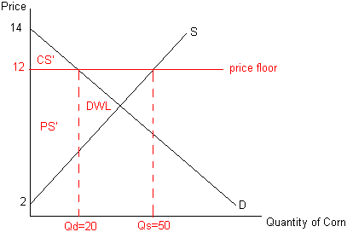
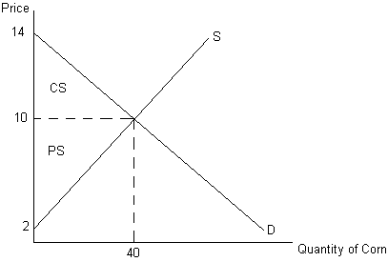
Compared to the total surplus in equilibrium, the total surplus when the price floor is instituted is less by $600. The difference in total surplus in equilibrium, and total surplus with the price control is the area of DWL. This is a triangle, and its area can be found by calculating ½ base * height. The base is the difference in equilibrium quantity and the quantity exchanged with the price control (40-20). The height is the difference between the price control and the price that would generate a Q_{S} of 20: Q_{S}= -10 + 5P so… 20= -10 + 5P… 30=5P… thus the P that generates a Q_{s} of 20 is $6. The height of the DWL loss triangle is 12-6=6. Thus, the area of DWL = ½ base*height = ½ (20)(6)= 60 cents then taking into account Q expressed as thousands translates this in total to $600 (60 cents *1000).
  - Are consumers helped or hurt by this program? Explain with the aid of your diagram.
Consumers are hurt by the program. Consumer surplus is $600 less with the price floor than in equilibrium. (Again, note the translation by units of thousands here… and below.)
  - Are producers helped or hurt by this program? Explain with the aid of your diagram.
In aggregate, producers are neither helped nor hurt by the program. Producer surplus is $1600 both with the price floor and in equilibrium. However, it is still possible that some producers are helped and some are worse off. Since the total quantity traded falls by half, it isn’t clear which producers are still able to sell corn and which are not.
- Suppose instead, that the government wishes to encourage corn consumption by making it more affordable for consumers. Thus, it sets a price ceiling of 5 cents per ear of corn.
  - How will this regulation affect the quantity of corn traded?
By substituting 5 cents in for the price into the demand and supply equations, we can solve to find the quantity demanded and quantity supplied, respectively.
Q_{D} = 140 - 10(5) = 90
Q_{S} = -10 + 5(5) = 15
Since the quantity demanded exceeds the quantity supplied, there is a shortage of corn – specifically, 75 thousand ears with only 15 thousand ears traded.
Recall (from part (a)) that the equilibrium quantity is 40 thousand ears. Thus, the quantity of corn traded falls by 25 thousand ears.
  - How will the regulation affect the efficiency of the corn market? Be sure to provide a diagram to help illustrate your answer.
The price ceiling will reduce the efficiency in the market. Compared to the total surplus in equilibrium, the total surplus when the price ceiling is instituted is less by $937.50. The diagram shows the consumer and producer surpluses as well as the deadweight loss (DWL) with the price control.
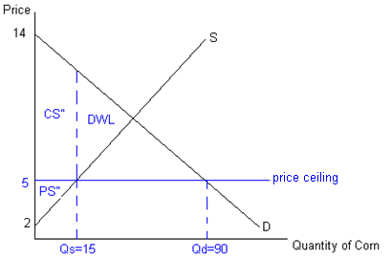
  - Are consumers helped or hurt by this program? Explain with the aid of your diagram.
In aggregate, consumers are helped. Consumer surplus increases from $800 to $1237.50. However, it is not the case that all consumers are better off. Some consumers who were able to purchase corn in equilibrium are no longer able to acquire corn with the price ceiling. Consumers, however, who are able to purchase corn at the lower price are better off.
  - Are producers helped or hurt by this program? Explain with the aid of your diagram.
Producers are worse off. Producer surplus falls from $1600 to $225.

Question 2
Rising fuel oil prices (in excess of $125 per barrel) lead consumer lobbyists to pressure the government to provide some relief to the consumer. The government has two courses of action, and seeks your economic expertise in evaluating the consequences and choosing the best course of action. For each course of action you should evaluate the market impact by including in your answer: a description (using economic terminology) of how the action impacts the market, a clearly labeled graphical depiction showing initial and final equilibrium points, a description of any associated market adjustment, and demonstrate whether the market is efficient.
- The first course of action is for the government to release some of the fuel oil they have stored in the Strategic Petroleum Reserves (an emergency fuel store of oil maintained by the US Department of Energy).
By releasing some fuel from the Strategic Petroleum Reserves, the supply of fuel oil will increase. The increase in the supply of fuel oil will cause the equilibrium price of fuel oil to fall and the equilibrium quantity of fuel oil to increase.
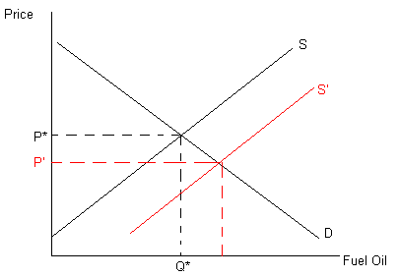
- The second course of action is for the government to set a maximum price of $90.00 a barrel for fuel oil.
A maximum price – or a price ceiling – will result in a shortage of gasoline. The price ceiling causes a deadweight loss in the market.
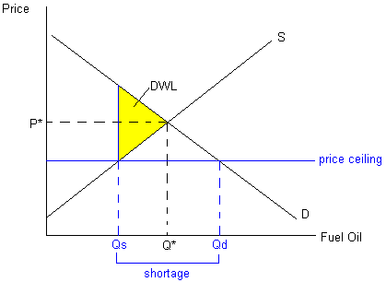
- Which course of action would you recommend and why? Be sure to link your evaluation to both the underlying reason for the course of action and the concept of efficiency.
I would recommend that fuel oil be released from the Strategic Petroleum Reserve. This course of action will not result in a market inefficiency since it does not restrict the price mechanism. Further, it will achieve the objective of making more fuel available at a lower price.
- Now suppose that the market for gasoline is characterized by the following demand and supply curves.
Demand: Q = 3 – 0.25P
Supply: Q = 0.5 + P
where P is the price per gallon and Q is thousands of gallons per week. The government imposes a maximum price of $1.50 per gallon of gasoline.
- Is this a price control referred to as a price ceiling or a price floor?
A legal maximum price is a price ceiling.
- Would the regulation result in excess demand or excess supply of gasoline in the market?
Binding price ceilings will always result in shortages of the product. The price ceiling in question will result in a shortage of gasoline of 0.625 thousand (i.e. 625) gallons of gasoline.
- How is the efficiency of the gasoline market affected by the price control?
The price ceiling will reduce the efficiency of the gasoline market. Price ceilings lead to under investment in the product and other forms (non-price) rationing. There is a deadweight loss associated with the price ceiling of $625. See the diagram below.
