Price Control Exercise - Key

Question 1
The weekly demand and supply for corn is given by the following equations where P is the price (in cents) per ear of corn, and Q is the number of ears of corn in thousands.
Demand: Q = 140-10P
Supply: Q = -10 + 5P
- Since corn can be used for ethanol production, the government wishes to stimulate corn production. Thus, it sets a price floor of 12 cents per ear of corn.
  - How will this regulation affect the quantity of corn traded?
By substituting 12 cents in for the price into the demand and supply equations, we can solve to find the quantity demanded and quantity supplied, respectively.
Q_{D} = 140 - 10(12) = 20
Q_{S} = -10 + 5(12) = 50
Since the quantity supplied exceeds the quantity demanded, there is a surplus of corn – specifically, 30 thousand ears with only 20 thousand ears traded.
If the market were allowed to reach equilibrium, then the quantity supplied would equal the quantity demanded.
Q_{D} = Q_{S}
140 – 10P* = -10 +5P*
10 = P*
By substituting the equilibrium price into either the demand or supply equations, we will find the equilibrium quantity.
Q* = 140 – 10(10) = 40
Thus, there are 20 thousand fewer ears of corn traded as a result of the price control.
  - How will the regulation affect the efficiency of the corn market? Be sure to provide a diagram to help illustrate your answer.
The price floor will reduce the efficiency in the market. The left diagram (below) shows the consumer and producer surpluses in equilibrium while the right diagram shows the consumer and producer surpluses as well as the deadweight loss (DWL) with the price control.
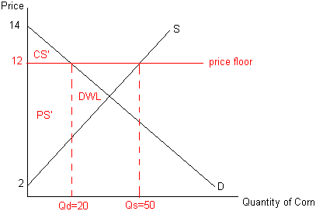
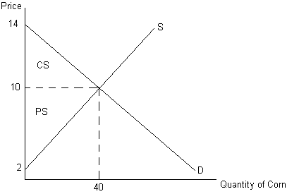
Compared to the total surplus in equilibrium, the total surplus when the price floor is instituted is less by $600. The difference in total surplus in equilibrium, and total surplus with the price control is the area of DWL. This is a triangle, and its area can be found by calculating ½ base * height. The base is the difference in equilibrium quantity and the quantity exchanged with the price control (40-20). The height is the difference between the price control and the price that would generate a Q_{S} of 20: Q_{S}= -10 + 5P so… 20= -10 + 5P… 30=5P… thus the P that generates a Q_{s} of 20 is $6. The height of the DWL loss triangle is 12-6=6. Thus, the area of DWL = ½ base*height = ½ (20)(6)= 60 cents then taking into account Q expressed as thousands translates this in total to $600 (60 cents *1000).
  - Are consumers helped or hurt by this program? Explain with the aid of your diagram.
Consumers are hurt by the program. Consumer surplus is $600 less with the price floor than in equilibrium. (Again, note the translation by units of thousands here… and below.)
  - Are producers helped or hurt by this program? Explain with the aid of your diagram.
In aggregate, producers are neither helped nor hurt by the program. Producer surplus is $1600 both with the price floor and in equilibrium. However, it is still possible that some producers are helped and some are worse off. Since the total quantity traded falls by half, it isn’t clear which producers are still able to sell corn and which are not.
- Suppose instead, that the government wishes to encourage corn consumption by making it more affordable for consumers. Thus, it sets a price ceiling of 5 cents per ear of corn.
  - How will this regulation affect the quantity of corn traded?
By substituting 5 cents in for the price into the demand and supply equations, we can solve to find the quantity demanded and quantity supplied, respectively.
Q_{D} = 140 - 10(5) = 90
Q_{S} = -10 + 5(5) = 15
Since the quantity demanded exceeds the quantity supplied, there is a shortage of corn – specifically, 75 thousand ears with only 15 thousand ears traded.
Recall (from part (a)) that the equilibrium quantity is 40 thousand ears. Thus, the quantity of corn traded falls by 25 thousand ears.
  - How will the regulation affect the efficiency of the corn market? Be sure to provide a diagram to help illustrate your answer.
The price ceiling will reduce the efficiency in the market. Compared to the total surplus in equilibrium, the total surplus when the price ceiling is instituted is less by $937.50. The diagram shows the consumer and producer surpluses as well as the deadweight loss (DWL) with the price control.
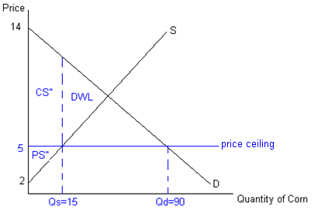
  - Are consumers helped or hurt by this program? Explain with the aid of your diagram.
In aggregate, consumers are helped. Consumer surplus increases from $800 to $1237.50. However, it is not the case that all consumers are better off. Some consumers who were able to purchase corn in equilibrium are no longer able to acquire corn with the price ceiling. Consumers, however, who are able to purchase corn at the lower price are better off.
  - Are producers helped or hurt by this program? Explain with the aid of your diagram.
Producers are worse off. Producer surplus falls from $1600 to $225.

