GEO 1030

ASSIGNMENT 4

HOW MANY M 5.0 OR LARGER EARTHQUAKES OCCUR WORLDWIDE?

POINTS: 50

Every week, numerous potentially damaging earthquakes occur around the world. To demonstrate the frequency of these earthquakes, you will use U.S. GEOLOGICAL SURVEY’s Earthquake Tracker, an online resource, to list the locations / facts of all the magnitude 4.5 or higher earthquakes for the 4-day period: February 19 – 22, 2015. The dates should be based on coordinated universal time (UTC or GMT), not local time at the epicenters. You will record information about the earthquakes (e.g., magnitude, date/time, depth, nearest city) in a word processing document and save as a pdf. Once you have completed this assignment, you will save your file and submit it as an attachment under Assignment 4 in WSU Online.

How many magnitude 4.5+ earthquakes will you record? Only time will tell!

INSTRUCTIONS

** You will need internet access on a computer to complete this assignment.

(U.S. GEOLOGICAL SURVEY EARTHQUAKE CENTER – WORLDWIDE EARTHQUAKES WEBSITE)

You will go to the following USGS Real-Time Earthquake tracker website and modify the settings to view the worldwide map/list of magnitude 5.0+ earthquakes over the last 4 days. You should visit the website each day after 7:00 pm Mountain Time to catalog the current day’s earthquake data for inclusion in Google Earth. If you cannot visit every day, the website maintains the earthquake records for a period of time (i.e., 7 days based on the settings in the assignment), so you can find the information if you miss a day or two during the recording dates listed in the assignment.

http://earthquake.usgs.gov/earthquakes/map/

(ASSIGNMENT)

Follow the instructions below for EACH earthquake on the USGS earthquakes worldwide list of magnitude 5.0+ earthquakes during the time period for the assignment.

1. Open a web browser and type in/select the USGS Real-time Earthquake tracker website containing the list of worldwide magnitude 4.5+ earthquakes

(http://earthquake.usgs.gov/earthquakes/map/)

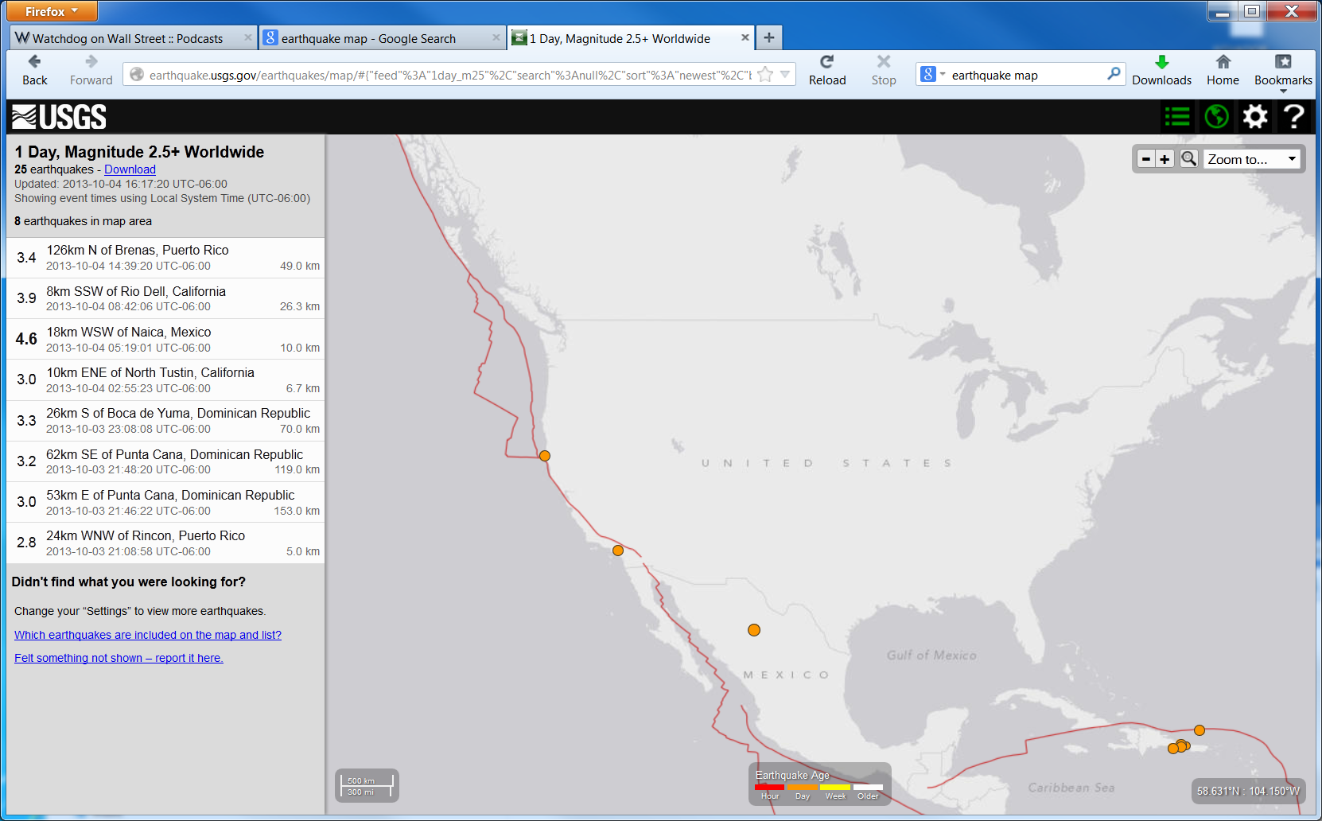

- Select the Options menu (upper right corner of screen) and change the settings to select the following parameters (see screen shot below):

Auto Update
7 Days, Magnitude 4.5+ Worldwide
TimeZone: UTC (Universal Time Coordinated – Greenwich, England)

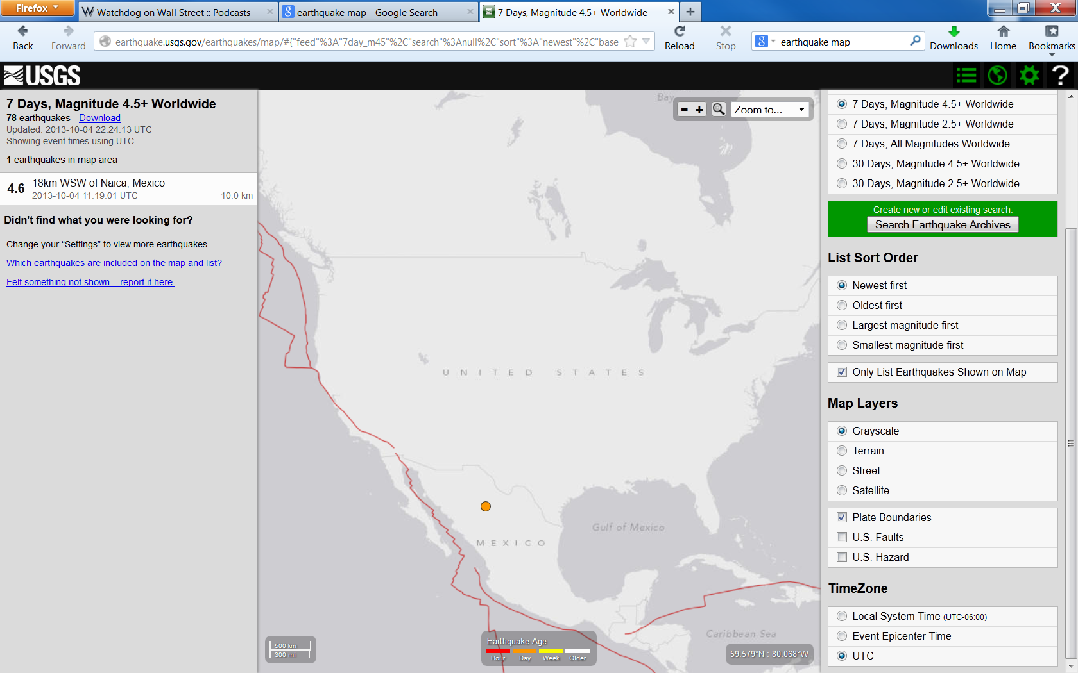

- ZOOM to World scale so you can see all the magnitude 4.5+ earthquakes over the last 7 days.

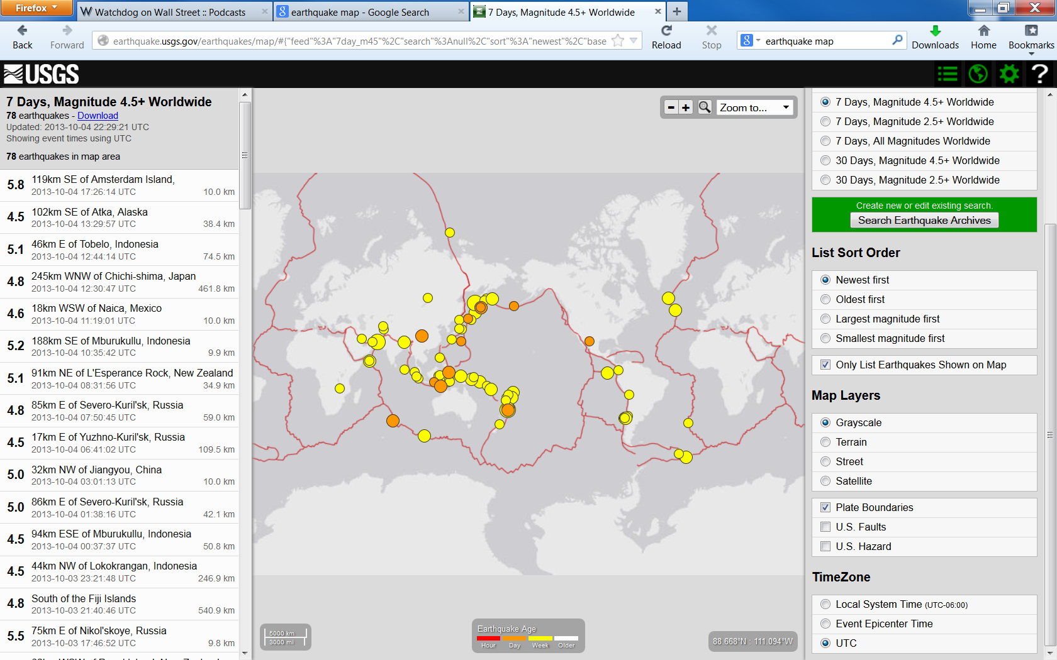

- Each day after 5:00 pm Mountain Standard Time OR 6:00 pm Mountain Daylight Time (after midnight UTC), SELECT each earthquake and write down OR print out the following information about EACH EARTHQUAKE:

  - Magnitude of earthquake
  - Time of earthquake initiated rupture (“origin” time) in UTC (not local time)
  - Depth of focus
  - Region/Nearest City (in the title of the earthquake event)

**You can find the required information by clicking on the LINK (blue text) in the lower left of the screen ONCE you select each earthquake in the list (left side of web page).

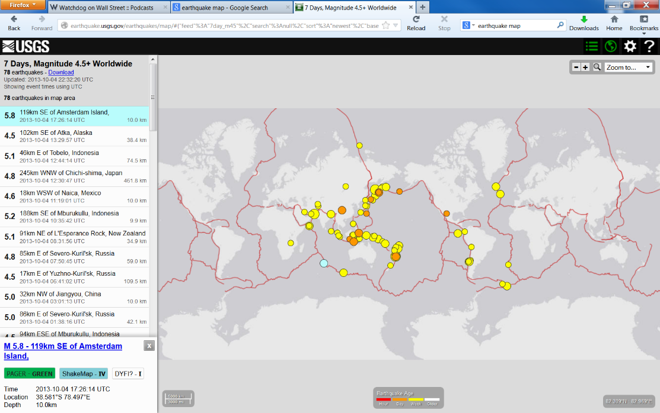

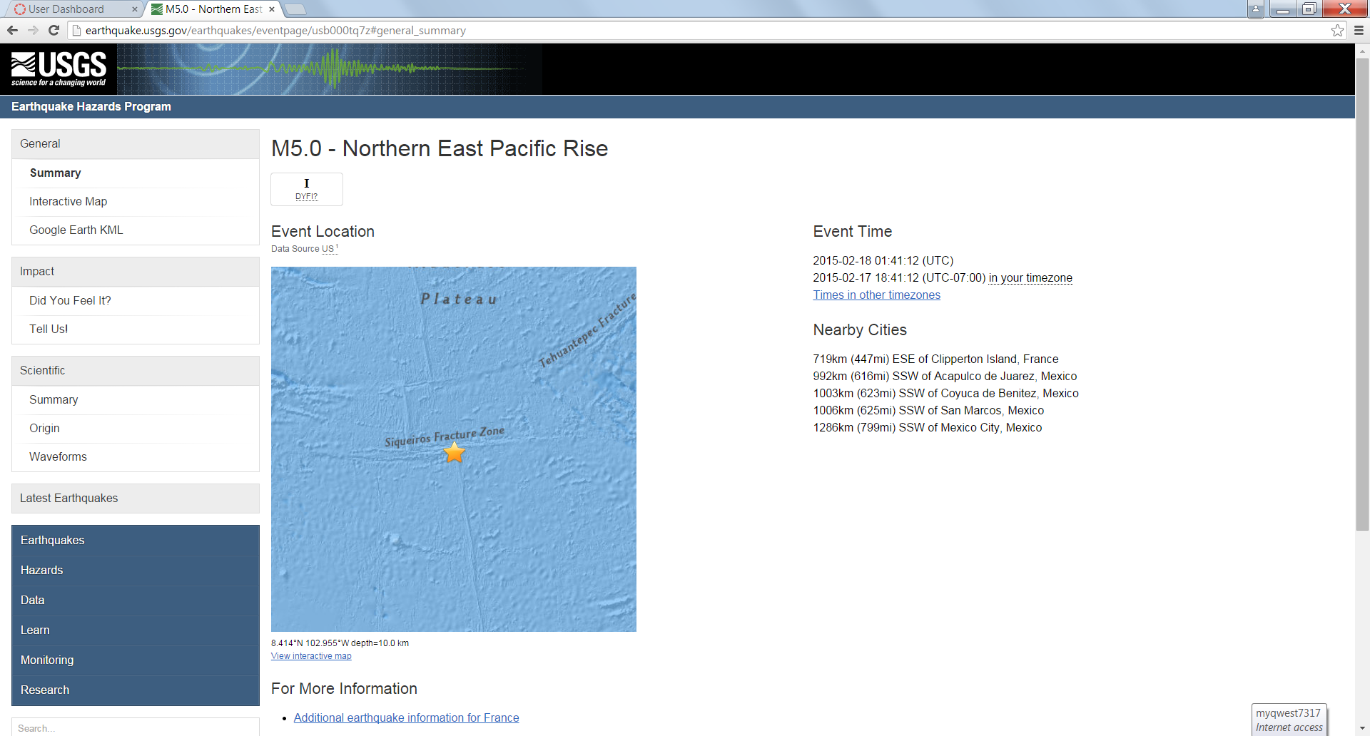

- QUESTIONS TO ANSWER:
  - What is the total number of M5.0+ earthquakes that occurred worldwide during the specified time period?
  - What part of the Earth did most earthquakes occur? (e.g., Pacific Rim, intraplate, etc.)
  - What type of Plate Tectonic plate did most earthquakes occur? (e.g., convergent subduction zones, strike-slip boundaries, divergent plate boundaries, etc.)

- WSUOnline (Canvas): Submit your assignment file (e.g., geo1030-SmithJoe.pdf) as an attachment under the Assignment 4 link.

